
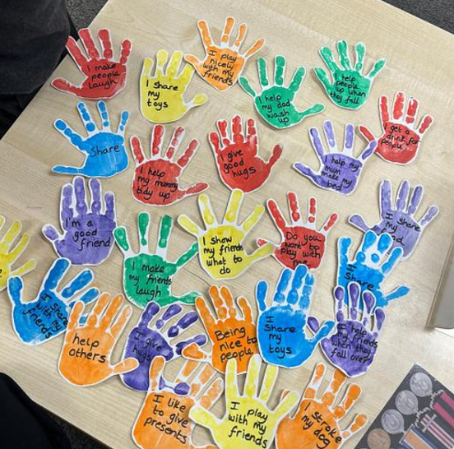
EYFS at Summerfields Primary Academy

Here at Summerfields Primary Academy the children are at the centre of everything we do. Our fundamental aim is that our school values of Enjoyment, Growth, Resilience and Respect will support each individual on their learning journey.
Through our curriculum we aim to ‘Open up the world’ to our pupils.







Our curriculum will be imaginative, flexible and provide support for the needs of all our children. Play will be an essential part of each day where a child can explore their interests and fascinations. We will provide a balance of approaches including play, modelling, guided learning and direct teaching. We will enable all children to know more, remember more and be able to do more.
To provide a happy and safe environment where learners are proud and feel valued as part of our school family and they respect, tolerate and care for one another.
Resilience
The role of the adult is to guide children on their individual learning journey, encourage a love of learning and enjoy learning alongside children. They will enable high quality interactions and modelling and be responsive to what each child needs.
All adults will be an inspirational role model.
To enable learners to acquire strong foundations in communication, reading, writing and mathematics. To provide opportunities for learners to become an ‘expert’ as they gain subject specific knowledge, skill and understanding. They will become successful lifelong learners who have high expectations and aspirations.
To provide a safe and secure learning environment where adults support children to take risks and challenge themselves to learn more and know more.
Respect
Growth
Enjoyment
To give our learners exciting and memorable experiences which develops a love, curiosity and thirst for learning and provides an awe and wonder of the world. This will allow them to grow spiritually, morally, socially and culturally, helping them to become independent thinkers.

