
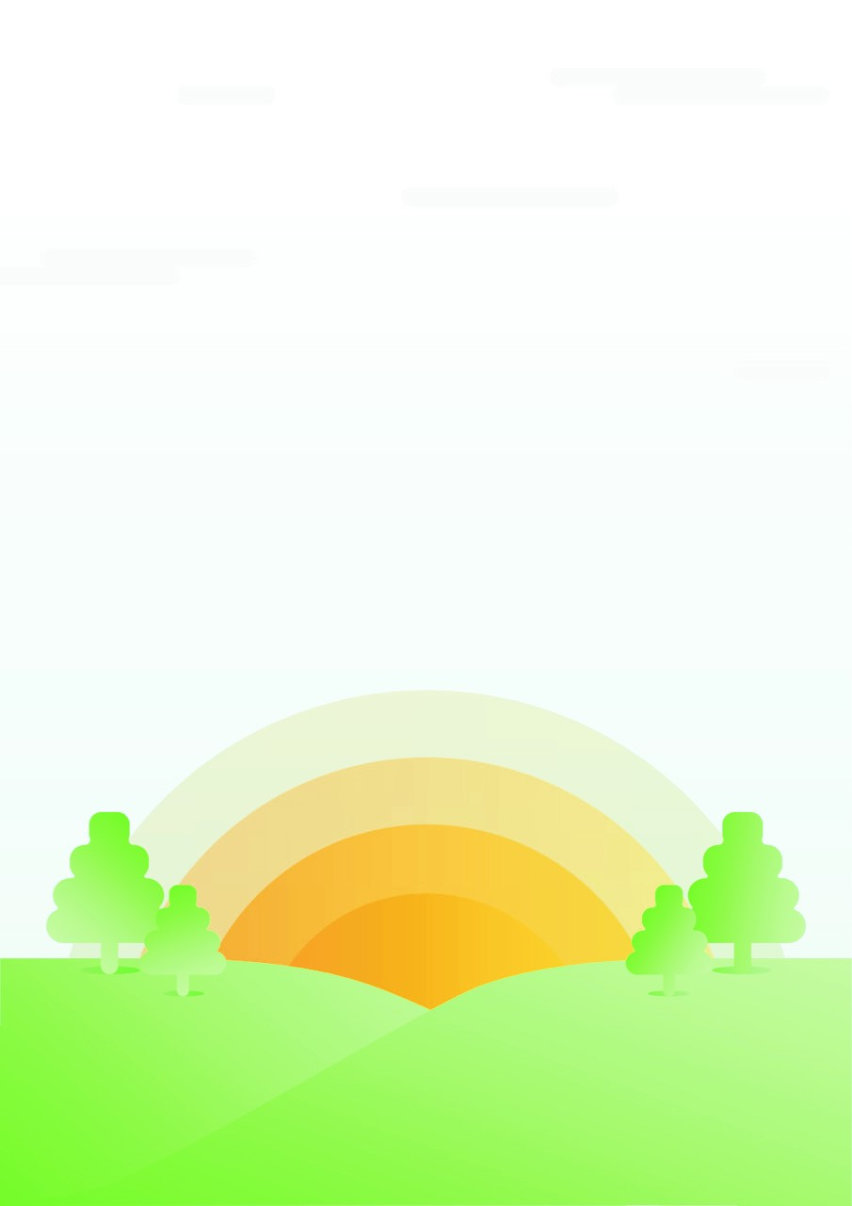

Geography Policy
TO BE REVIEWED September 2023
Introduced: September 2022
Written by A.Whitehead Signed…….
Approved by the Governing Body on:
Signed……………………………………



Intent:
Purpose of study Summerfields Primary School understands the need for all pupils to develop their Geographic ability as an essential component of all subjects and as a subject in its own right. Through learning, we aim to develop an understanding of the impact of the world’s physical and human processes: past, present and future. A good understanding of geographic knowledge and conceptual understanding helps to support the pupils work across the curriculum. At Summerfields Primary school we believe that geography is a body of knowledge built up through stimulating children’s interest in their surroundings and developing a knowledge and understanding of the physical and human processes which shape places. Geography in our school is about allowing children to work geographically in a range of appropriate contexts, using a variety of materials and equipment including other people’s experiences and knowledge. We offer them the opportunity to use a variety of data, such as maps, statistics, graphs, pictures, aerial photographs, geographical footage and we enable them to use IT in geography lessons where this serves to enhance their learning.
We believe that a broad and balanced geographic education is the entitlement of all children, regardless of ethnic origin, gender, class, aptitude or disability.

During these unprecedented times, Summerfields Primary Academy has adjusted the Geography policy. Pupils of all ages should follow the guidelines set out in the Health and Safety Risk Assessment.
The children’s well-being, enjoyment of school and the feeling of safety is our priority, whilst ensuring that each individuals needs are continued to be met and that progress is made.

Implementation:
- Teachers follow ‘Key Skills Document’ to plan and implement next steps.
- When relevant to the exploration, teachers display the Geography work within the classrooms.
- Geography will also be taught as discrete units and lessons where needed to ensure coverage.
- Giving clear and accurate teacher explanations and offering skilful questioning.
- Making clear links between geography and other subjects. In particular, science, maths and computing.
- Teaching Geography outdoors as well as in the classroom.
- Allowing children the time and opportunity to go into the local environment to develop the geographical skills, including how to use, draw and interpret maps of different scales, and the vocabulary necessary to carry out effective geographical enquiry.

Impact:
Children are involved in the process of self-improvement, recognising their achievements and acknowledging where they could improve. Activities during, and at the end of, each topic record achievement and celebrate success. We follow a Geography tracker where teachers record assessments and focus on next steps. By following the Geography curriculum, the children will develop an understanding of the impact of the world’s physical and human processes: past, present and future.

