
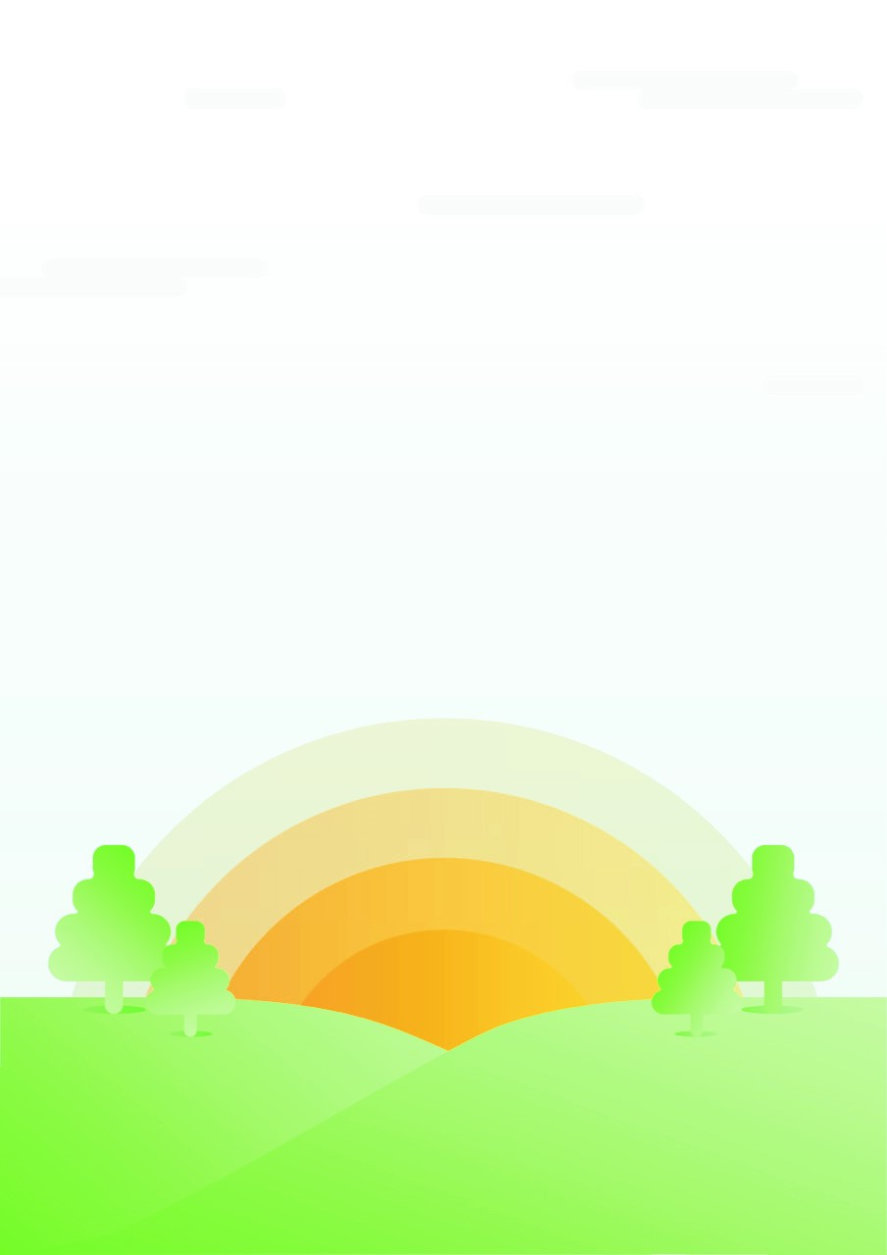

PHSE and RSE policy
Written: September 2022
To be reviewed: September 2023
Written by K. Rose
Approved by the Governing Body on:
Signed……………………………………

Personal, Health and Social Education and Sexual and Relationships Education
Intent
At Summerfields Primary Academy, children follow PHSE and RSE curriculums. The RSE curriculum became compulsory in September 2020, as outlined in government guidelines. To ensure effective provision, the new compulsory elements of RSE are integrated within a broader PHSE education programme. The PHSE curriculum, as identified by the school provision, forms part of the basic curriculum and contributes to the spiritual, moral, social and cultural development of children, giving them the knowledge, skills and understanding to lead confident, healthy, independent lives becoming informed, active and responsible citizens. This underpins all of the work that we do in school, including our behaviour policy, to ensure that our learners are life-ready when they leave Y6 and that they play an active and successful role in the wider community.
TEACHING AND LEARNING METHODS
A combination of methods are used by class teachers and Higher Level Teaching Assistants to provide pupils with a broad and balanced PSHE curriculum:
• Separately timetabled PSHE/Circle time
• In combination with other subjects through cross-curriculum planning
• Through visits, visitors and special events, e.g. Crucial Crew, South Yorkshire Police, The Big Talk
• Through the Pupil Parliament and pupil voice
• Special themed weeks like ‘friendship week’, ‘enterprise week’, anti-bullying week.
ACCESSABILITY
At Summerfields, it is vital that PSHE is accessible for all. This is why high quality teaching is differentiated and personalised for the needs of all children, including pupils with special educational needs and disabilities. We take into account the preparing for adulthood outcomes, which are set out in the SEND code of practice, when teaching this subject to those with SEND. We are aware that some pupils are more vulnerable to exploitation, bullying and other issues due to the nature of their SEND, therefore we take these factors into account when planning the PSHE curriculum.
Implementation
CULTURAL CAPITAL PHSE OFFER, RSE TO FORM PART OF THE OFFER
Summerfields Primary Academy implements the Oxford Global Curriculum throughout school. The objectives taught through this have intrinsic PHSE links and are covered through 5 explorations per year. Other key documents are also used to inform provision throughout school. In the Foundation Stage the children follow the Early Years Foundation Stage document. At Key Stages 1 and 2, the framework is based upon the guidelines from the National Curriculum document and the Sexual and Relationships Education framework guidance from the Department for Education (2020), supplemented by Circle Time, discrete teaching of objectives and cross curricular teaching where objectives complement other national curriculum areas. Planning is documented on a medium term planning sheet with daily/weekly experiences enhanced by staff. “Fundamental British Values” are within the offer. These are further explored through Discovery RE units of work.
- Democracy
- Rule of law
- Individual liberty
- Mutual respect
- Tolerance of those of different faiths and beliefs

 | EYFS | KS1 | Lks2 | Uks2
Big talk program coverage | - differences between boys and girls  - naming body parts  - what areas of the body are private and should not be touched (unless the child is happy and gives consent). | - The differences between boys and girls  - naming body parts  - what areas of the body are private and should not be touched (unless the child gives consent).  - situations which may be risky (e.g. other children or adults taking inappropriate photographs of them)  - who they can talk to if they are worried | - situations which may be risky (e.g. other children or adults taking inappropriate photographs of them)  - who they can talk to if they are worried  - different kinds of families  Y4  - the emotional and physical changes of growing up  - similarities and differences between boys and girls  - coping with strong emotions (puberty)  - how babies are made from ovums and sperm, then develop in the womb (reproduction)  - Looking after our bodies  - how to be safe and healthy | - Reproduction and puberty  Potential coverage linking from opportunities for questions:  - Conception  - how babies develop and are born  - how people can get infections from sex and how they can be prevented  - curiosity about feelings or body image  - they know there is someone in school as well as at home if they want help, advice or information about puberty, reproduction etc.

The SRE curriculum focuses on 5 key areas. Each area has been allocated to one of the 5 explorations to be covered by each year group.. The objectives will be taught at an age appropriate level within the class, in line with recommendations by PHSE association.
Exploration 1  What makes a community great? Who do you think you are? | Exploration 2  Can a person change the world? How do our actions shape our future? | Exploration 3  What on earth is going on? What makes the world go round? | Exploration 4  What makes us powerful? What shapes a new world? | Exploration 5  How does change help us to learn, grow and succeed?
Families and people who care for me | Caring friendships | Respectful relationships | Being safe | Online relationships
• that families are important for children growing up because they can give love, security and stability.  • the characteristics of healthy family life, commitment to each other, including in times of difficulty, protection and care for children and other family members, the importance of spending time together and sharing each other’s lives.  • that others’ families, either in school or in the wider world, sometimes look different from their family, but that they should respect those differences and know that other children’s families are also characterised by love and care.  • that stable, caring relationships, which may be of different types, are at the heart of happy families, and are important for children’s security as they grow up.  • that marriage represents a formal and legally recognised commitment of two people to each other which is intended to be lifelong.  • how to recognise if family relationships are making them feel unhappy or unsafe, | how important friendships are in making us feel happy and secure, and how people choose and make friends.  • the characteristics of friendships, including mutual respect, truthfulness, trustworthiness, loyalty, kindness, generosity, trust, sharing interests and experiences and support with problems and difficulties.  • that healthy friendships are positive and welcoming towards others, and do not make others feel lonely or excluded.  • that most friendships have ups and downs, and that these can often be worked through so that the friendship is repaired or even strengthened, and that resorting to violence is never right.  • how to recognise who to trust and who not to trust, how to judge when a friendship is making them feel unhappy or uncomfortable, managing conflict, how to manage these situations and how to seek help or advice from others, if needed. | • the importance of respecting others, even when they are very different from them (for example, physically, in character, personality or backgrounds), or make different choices or have different preferences or beliefs.  • practical steps they can take in a range of different contexts to improve or support respectful relationships.  • the conventions of courtesy and manners.  • the importance of self-respect and how this links to their own happiness.  • that in school and in wider society they can expect to be treated with respect by others, and that in turn they should show due respect to others, including those in positions of authority.  • about different types of bullying (including cyberbullying), the impact of bullying, responsibilities of bystanders (primarily reporting bullying to an adult) and how to get help.  • what a stereotype is, and how stereotypes can be unfair, negative or destructive.  • the importance of permission-seeking and giving in relationships with friends, peers and adults. | • what sorts of boundaries are appropriate in friendships with peers and others (including in a digital context).  • about the concept of privacy and the implications of it for both children and adults; including that it is not always right to keep secrets if they relate to being safe.  • that each person’s body belongs to them, and the differences between appropriate and inappropriate or unsafe physical, and other, contact.  • how to respond safely and appropriately to adults they may encounter (in all contexts, including online) whom they do not know.  • how to recognise and report feelings of being unsafe or feeling bad about any adult.  • how to ask for advice or help for themselves or others, and to keep trying until they are heard.  • how to report concerns or abuse, and the vocabulary and confidence needed to do so.  • where to get advice e.g. family, school and/or other sources. | • that people sometimes behave differently online, including by pretending to be someone they are not.  • that the same principles apply to online relationships as to face-to-face relationships, including the importance of respect for others online including when we are anonymous.  • the rules and principles for keeping safe online, how to recognise risks, harmful content and contact, and how to report them.  • how to critically consider their online friendships and sources of information including awareness of the risks associated with people they have never met.  • how information and data is shared and used online.
KS1
- To identify and respect the differences and similarities between people  - Identify their special people (family, friends, carers), what makes them special and how special people should care for one another  - That they belong to different groups and communities such as family and school  - About people who look after them, their family networks, who to go to if they are worried and how to attract their attention | - To identify their special people (family, friends, carers), what makes them special and how special people care for one another.  - To recognise that their behaviour can affect other people  - To recognise what is fair and unfair, kind and unkind, what is right and wrong  - That peoples bodies and feelings can be hurt (including what makes them feel comfortable and uncomfortable)  - To listen to other people and play and work cooperatively (including strategies to resolve simple arguments through negotiation)  - To recognise different types of teasing and bullying and to understand that these are wrong and unacceptable  - To recognise when people are being unkind either to them or others, how to respond, who to tell and what to say | - To identify and respect the differences and similarities between people  - That people and other living things have rights and that everyone has responsibilities to protect those rights (including protecting others’ bodies and feelings; being able to take turns, share and understand the need to return things that have been borrowed)  - Recognise different types of teasing and bullying, to understand that these are wrong and unacceptable  - Strategies to resist teasing or bullying if they experience or witness it, whom to go to and how to get help | - What is meant by privacy, their right to keep things private, the importance of respecting others’ privacy  - The difference between secrets and nice surprises (that everyone will find out about eventually) and the importance of not keeping any secret that makes them feel uncomfortable, anxious or afraid  - To judge what kind of physical contact is acceptable, comfortable, unacceptable and uncomfortable and how to respond  - About people who look after them, their family networks, who to go to if they are worries and how to attract their attention  - To recognise that they share a responsibility for keeping themselves and others safe, when to say yes, no, I’ll ask them and I’ll tell. | - Rules for and ways of keeping physically and emotionally safe including responsible IT use and online safety  - To recognise that they share a responsibility for keeping themselves and others safe, when to say yes, no, I’ll ask and I’ll tell.
KS2
- To recognise different types of relationships, including those between acquaintances, friends, relatives and families  - That civil partnerships and marriages are examples of a public demonstration of the commitment made by two people who love and care for each other and want to spend their lives together and who are of legal age to make that commitment  - To recognise ways in which a relationship can be unhealthy and whom to talk to if they need support | - To recognise what constitutes positive, healthy relationship and develop the skills to form and maintain positive and healthy relationships  - To develop strategies to resolve disputes and conflict through negotiation and appropriate compromise  - To recognise ways in which a relationship can be unhealthy and whom to talk to if they need support | - To listen and respond respectfully to a wide range of people, to feel confident to raise their own concerns, to recognise and care about other people’s’ feelings and if necessary constructively challenge others’ points of view  - To understand personal boundaries; to identify what they are willing to share with their most special people; friends; classmates and others and that we all have rights to privacy  - To realise the nature and consequences of discrimination, teasing, bullying and aggressive behaviours (including cyber bullying, use of prejudice based language, trolling, how to respond and to ask for help)  - To recognise bullying and abuse in all its forms (including prejudice based bullying both in person, online and through social media)  - To realise the consequences of anti-social, aggressive and harmful behaviours such as bullying and discrimination of individuals and communities; to develop strategies for getting support themselves or for others who are at risk. | - The concept of keeping something confidential or secret, when they should or should not agree to this and when it is right to break a confidence or share a secret  - To understand personal boundaries; to identify what they are willing to share with their most special people, friends, classmates and others and that we all have a right to privacy.  - How to manage requests for images of themselves or others; what is and is not appropriate to ask for or share; who to talk to if they feel uncomfortable  - About taking care of their body, understanding that they have their right to protect their body from inappropriate or unwan6ed contact  - To recognise when they need help and to develop the skills to ask for help  - About people who are responsible for helping them stay healthy and safe, how they can help these people to keep them healthy and safe | - To recognise that constitutes a positive, healthy relationship and develop the skills to form and maintain positive and healthy relationships  - To realise the nature and consequences of discrimination, teasing, bullying and aggressive behaviours (including cyber bullying, sue of prejudice based language, trolling, how to respond and how to ask for help  - To recognise how images in the media and online tod not always reflect reality  - To recognise ways in which a relationship can be unhealthy and whom to talk to if they need support  - How pressure to behave in unacceptable, unhealthy or risky ways can come from a variety of sources, including people they know and the media  - To critically examine what is presented to them in social media and why it is important to do so; understand how information contained in social media can misinterpret or mislead; the importance of being careful what they forward to others  - Strategies for keeping safe online; the importance of protecting personal information, including passwords, addresses and the distribution of images of themselves or others  - About people who are responsible for helping them stay healthy and safe; how they can help these people keep them healthy and safe

Impact
There is continuous, ongoing assessment by teachers. Reporting to parents happens verbally at parents’ meetings and in written format annually on the child’s academic report, as well as ongoing communication on dojo. Teachers make continual formative assessments to capture progress in a range of ways, for example, tests, written work, self-evaluations and questioning, especially linked to each of the explorations throughout the year. Our aim is to have children who can articulate their feelings and communicate effectively with others. They demonstrate an ability to self- regulate, enabling them to confidently go in to the world. Through the school provision, our learners will be life-ready when they leave Y6 and play an active and successful role in the wider community, recognising the importance of safe relationships and ways of keeping themselves safe.

