This is me!
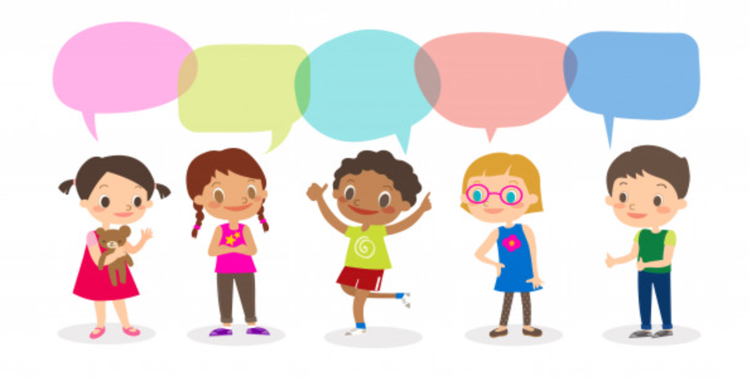
This is me!
I am special
Me and my family
Same and different
Royston

Cycle A: Exploration 1
Fs2

Cycle A - Exploration 1 – Fs2 – This is me!

Exploration Objectives Overview
Curriculum Drivers: Global (Identity & diversity), Understanding the World: The Natural World, People, Culture & Communities and Past & Present

Area | Fs2 | Area | Fs2
Global  To open up the world | Identity and diversity  * Uniqueness and value of every person.  * Similarities and differences between self and other. | Personal, Social and Emotional Development | ELG: Self-Regulation:  * Show an understanding of their own feelings and those of others, and begin to regulate their behaviour accordingly  ELG: Managing Self:  * Manage their own basic hygiene and personal needs, including dressing, going to the toilet and understanding the importance of healthy food choices.  ELG: Building relationships:  * Form positive attachments to adults and friendships with peers  * Show sensitivity to their own and to others’ needs
Understanding the World  Through investigation, develop a sense of excitement and curiosity of natural phenomena | ELG: The Natural World  * Explore the natural world around them, making observations and drawing pictures of animals and plants  * Know some similarities and differences between the natural world around them and contrasting environments, drawing on their experiences and what has been read in class  * Understand some important processes and changes in the natural world around them, including the seasons and changing states of matter. | Understanding the World  To develop an understanding of the impact of the world’s physical and human processes: past, present and future | ELG: People, Culture and Communities  * Describe their immediate environment using knowledge from observation, discussion, stories, non-fiction texts and maps  * Know some similarities and differences between different religious and cultural communities in this country, drawing on their experiences and what has been read in class  * Explain some similarities and differences between life in this country and life in other countries, drawing on knowledge from stories, non-fiction texts and – when appropriate – maps.
Understanding the World  To learn from the past in order to impact the future | ELG: Past & Present  * Talk about the lives of the people around them and their roles in society  * Know some similarities and differences between things in the past and now, drawing on their experiences and what has been read in class.  * Understand the past through settings, characters and events encountered in books read in class and storytelling. | Expressive Arts & Design  To learn how Art & Design reflect and shape our world | ELG: Creating with Materials  * Safely use and explore a variety of materials, tools and techniques, experimenting with colour, design, texture, form and function  * Share their creations, explaining the process they have used  * Make use of props and materials when role playing characters in narratives and stories.

Cycle A - Exploration 1 – Fs2  This is me!  Throughout the exploration, children learn about themselves, exploring their own uniqueness, value and place in the world. They learn about their self-identity and sense of belonging within their family tree, thinking about themselves as humans including similarities and differences with others. They learn about their local area, while exploring the idea of themselves as part of a family and community to show “This is me!” |  |  |  |  |  | Learning - Identity & Diversity  Understanding the World (Royston)
What should pupils already know? |  | What will pupils learn? |  | Where will this learning go?
* Name and understanding of who they live with |  | * uniqueness and value of every person  * Similarities and differences between self and others |  | Later in Fs2  Children will build on their learning of themselves to explore what is fair and unfair, how their actions have consequences and how they can take care of their local environment.  Ks1  Children will build on their knowledge of self-identity and belonging to explore fairness and inequality, the uneven sharing of power, how some people are excluded from decision-making and the positive and negative impact of people’s actions in the world.  LKs2  Extending their learning to include Europe and beyond, pupils will build on Ks1 knowledge to think about the diversity of different cultures and societies within and beyond own experience; the contribution of different cultures to our lives; and the nature of prejudice, racism and sexism and ways to combat these.
SOLO Taxonomy | Uni-structural knowledge |  | Multi-Structural knowledge |  | Relational knowledge |  | Extended | Abstract
SOLO Taxonomy |   I have one relevant bit of knowledge |  |   I have several bits of key knowledge |  | 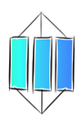  I can see links between my bits of key knowledge |  | 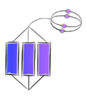  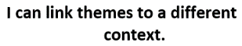
Spaced Questions | - Me and my family |  | - Royston |  | - Same and different |  | - I am special | - This is me!
Key substantive knowledge | ELG: Past & Present  * Talk about the lives of the people around them and their roles in society  ELG: Managing Self:  * Manage their own basic hygiene and personal needs, including dressing, going to the toilet and understanding the importance of healthy food choices.  * Knows they are a human, which is part of the animal kingdom  * Understands their family tree |  | ELG: The Natural World  * Explore the natural world around them, making observations and drawing pictures of animals and plants  * Know some similarities and differences between the natural world around them and contrasting environments, drawing on their experiences and what has been read in class  * Understand some important processes and changes in the natural world around them, including the seasons and changing states of matter.  * Knows address including that they live in England  * Knows that London is the capital of England  * Recognises the England flag  * names some local trees, flowers and wildlife |  | ELG: People, Culture and Communities  * Describe their immediate environment using knowledge from observation, discussion, stories, non-fiction texts and maps  * Know some similarities and differences between different religious and cultural communities in this country, drawing on their experiences and what has been read in class  * Explain some similarities and differences between life in this country and life in other countries, drawing on knowledge from stories, non-fiction texts and – when appropriate – maps. |  | * Explains what makes them special as a person including their bodies, their families, the way they look, what religion they are etc  * Explain what makes Royston special | * Explains how what they are, what they look like, the make-up of their family and where they live contribute to who they are as a person  * Discusses what makes them unique
Answer Guideline: | Understands that they are humans, which is an animal, discussing basic hygiene and personal needs of humans. Understands their family tree and their position within the family with understanding of family relationships (grandma is mother of mother; uncle is brother of mother, etc) and identifies who is special to them and who looks after them if they are worried. Understands that families can look different and respects this. |  | Says their address including village, and knows that the live in England. Describes own locality using simple geographical words and pictures of: key local physical features such as church, farm, shop; local flora and fauna; weather patterns, explaining what they like and dislike throughout. Names the capital city as London, recognising the national flag. Recognises sycamore trees, daffodils, roses, hedgehogs, squirrels and owls. |  | Names similarities and differences between themselves and others by describing their features. Knows that families look different: some children will only have one parent, have step families, have same sex parents, be adopted, be only children or have siblings, that some members of the family may have died etc. Explains how their locality is similar and different to others in relation to a village, a town and a city, and describes key physical features (river, hill, trees, farms, seas etc.) including discussing that there are different religions. |  | Explains how being them special; how they are special to their family and their relatives make them look the way they do which is unique; their beliefs make them special; their locality is special as it helps their family, friends and neighbours to work and live well; how the local trees and wildlife makes where they live special. | Brings all their learning together to explain what they are, what they look like, how they live with their families, what they believe in and where they live make them who they are as a person. Discusses how we are all humans but are all different as a result of their families, their beliefs and where they live. Discusses how it’s good that we are all different and it’s important to keep your beliefs (sense of identity) and feel that you belong, while looking after each other and the places we live. Eventually bring all learning together to celebrate “This is me!”

Anchor novel/s | 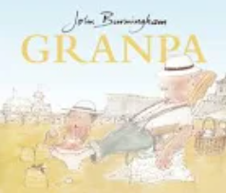 | 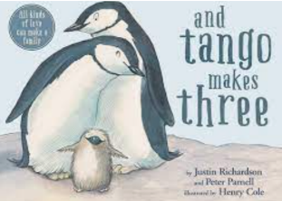
Purpose to areas in provision

Key people linked to Curriculum areas for Explore
Global |   I think everybody is weird. We should all celebrate our individuality and not be embarrassed or ashamed of it.  Johnny Depp | 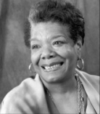  It is time for us to teach young people that in diversity there is beauty and there is strength.  Maya Angelou | 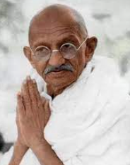  Our ability to reach unity in diversity will be the beauty and the test of our civilization.  Mahatma Ghandi |  | 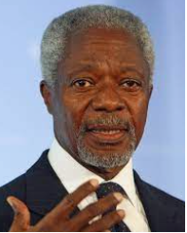  We may have different religions, different languages, different coloured skin, but we all belong to one human race.  Kofi Annan | 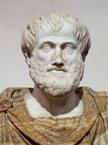  Knowing yourself is the beginning of all wisdom Aristotle | 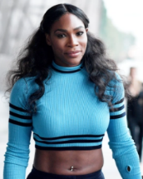  I love me, and I would never change anything about me. I’m not asking you to like me. I’m just asking you to let me be me.  Serena Williams
Literacy | 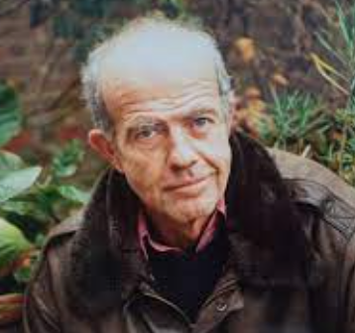  John Burningham was an English author and illustrator of children’s books. He lived between 1936 and 2019 in North London with his wife Helen Oxenbury – the illustrator of “We’re going on a Bear hunt”. He was the person who first drew the car from “chitty chitty bang band” after its creator Ian Fleming asked him to illustrate the books. |  |  | 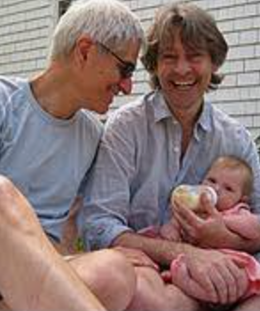  Justin Richardson and Peter Parnell are married. They live in America with their daughter. Peter, born in 1953, is a playwright, television writer and children’s book author. Justin Richardson is an author and psychiatrist. They have also written about the true story of Christian the Lion.
Science | 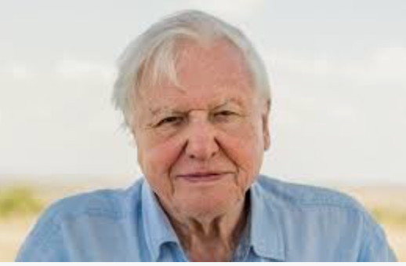  David Attenborough, born in 1926, is an English broadcaster and natural historian. He is best known for writing and presenting documentaries for the BBC. His earlier work focused more on the wonders of the natural world, while his later work has been more vocal in support of environmental causes. |  |  | 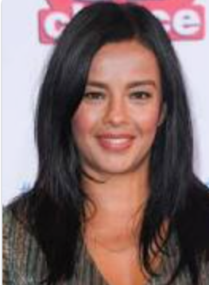  Elizabeth (Liz) Bonnin, born 1976, is a French-Irish science, wildlife and natural history presenter. She has a bachelor’s degree in biochemistry and holds a master’s degree in wild animal biology and conservation for which she tracked tigers in Nepal.
Art | 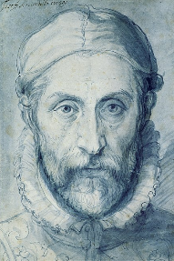  Guiseppe Arcimboldo (1526-1593) was an Italian painter best known for creating imaginative portrait heads made entirely of objects such as fruits, vegetables, flowers, fish and books. |  |  | 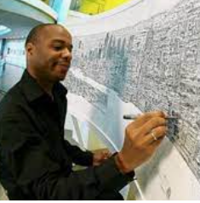  Stephen Wiltshire is a British artist who was born in London in 1974. After being a mute in childhood, Stephen was diagnosed with Autism aged 3. At 5, he attended a school where it was noticed that he enjoyed drawing and it soon became apparent that he could communicate with the world through his drawings. He now draws and paints detailed cityscapes, and has received a MBE from the queen.

Understanding of the World – ELG: The Natural World
What should pupils already know? |  | What will pupils learn? |  | Where will this learning go?
* Names of common animals (pig, cow, dog, lion etc.)  * Parts of the body (arms, legs, head etc.)  * parts of plants (leaves, flowers) |  | ELG: The Natural World  * Explore the natural world around them, making observations and drawing pictures of animals and plants  * Know some similarities and differences between the natural world around them and contrasting environments, drawing on their experiences and what has been read in class  * Understand some important processes and changes in the natural world around them, including the seasons and changing states of matter. |  | Ks1  Children will build on their leaning to look at the differences between different animals in order to classify common animals including vertebrates, invertebrates, mammals, fish, birds, reptiles, amphibians. They will name main parts of an animal’s body including humans, thinking about basic survival needs and the importance of exercise and a balanced diet. They will build on their knowledge of common, local flora and fauna.
Key Vocabulary |  | 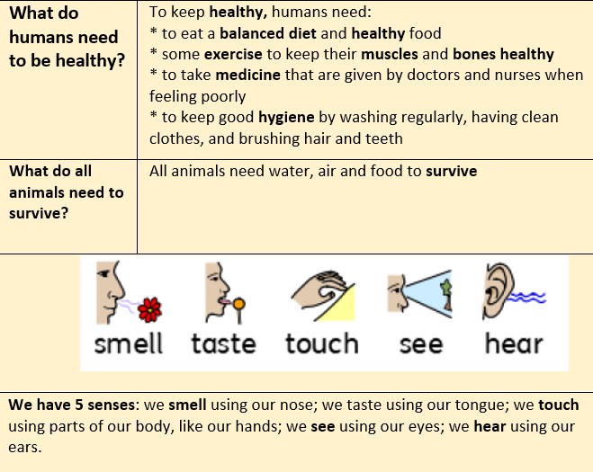  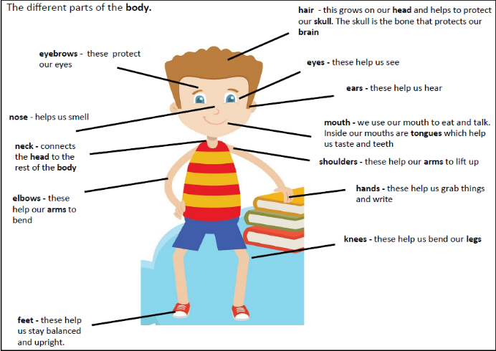 | 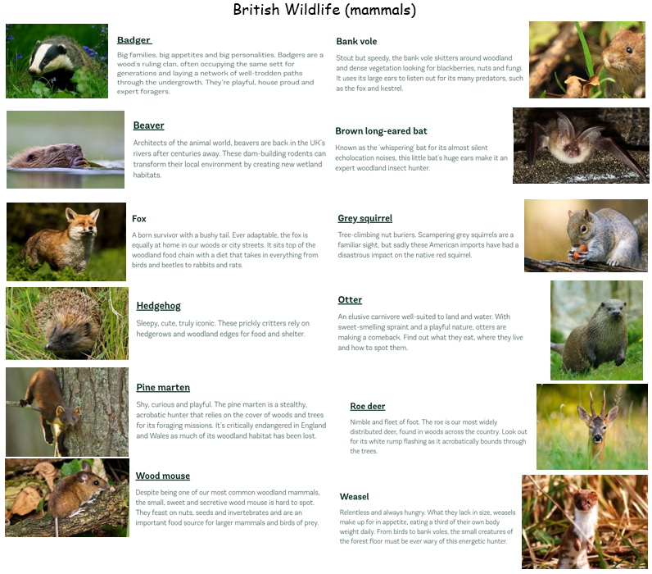 | 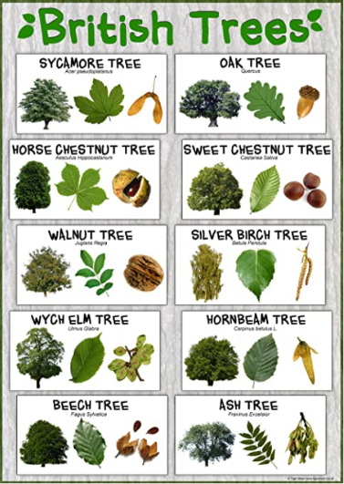  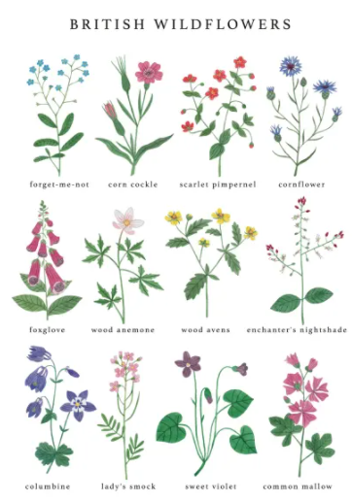  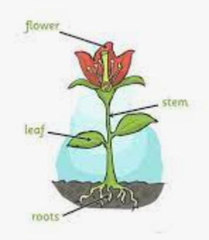
body | The main part of an animal including bones, flesh and organs
human | A person rather than an animal
senses | How the body knows what is happening around it
Plant | Living things including trees, grass, herbs and shrubs
Leaf | The flat, usually green, part of a plant which grows from the stem in order to make food for the plant
flower | The part of the plant which holds the seeds. It is usually brightly coloured
stem | The trunk of the plant which carries water up
root | The part of the plant which holds it upright and takes water from the soil.
farm | an area of land used to produce crops or to breed animals and livestock
environment | all the circumstances, people, things, and events around them that influence their life
temperature | a measure of how hot or cold something is
pet | a tame animal kept in a household
wild | animals or plants that live or grow in natural surroundings and are not looked after by people
bones | the hard parts inside your body which form your skeleton
backbone | the column of small linked bones down the middle of your back
skeleton | The framework of bones in your body
muscles | something inside your body which connects two bones and which you use when you make a movement
balanced diet | a variety of food that you regularly eat
exercise | when you exercise, you move your body energetically in order to get fit and to remain healthy
healthy | well and not suffering from any illness
hygiene | keeping yourself and your surroundings clean, especially in order to prevent illness or the spread of diseases
medicine | the treatment of illness and injuries by doctors and nurses
survive | continue to exist

Understanding of the World – ELG: People, Culture and Communities
What should pupils already know/do? |  | What will pupils learn/do? |  | Where will this learning go?
* Know that they live in Royston  * know who they live with and the immediate family tree |  | * Describe their immediate environment using knowledge from observation, discussion, stories, non-fiction texts and maps  * Know some similarities and differences between different religious and cultural communities in this country, drawing on their experiences and what has been read in class  * Explain some similarities and differences between life in this country and life in other countries, drawing on knowledge from stories, non-fiction texts and – when appropriate – maps.  * Knows address including that they live in England  * Knows that London is the capital of England  * Recognises the England flag |  | Ks1  Children will build on their learning to identify features of their locality saying what they like and don’t like. They will know and locate the 4 countries of the UK, naming the capitals and recognising the flags, describing weather patterns including basic cloud formations.
Key Vocabulary |  |  | 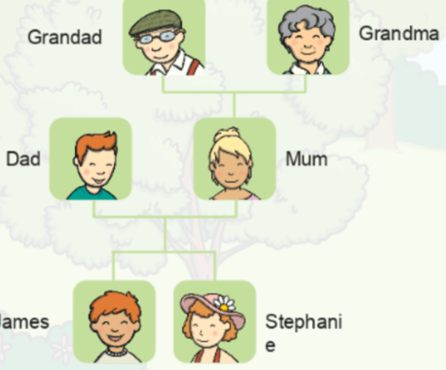  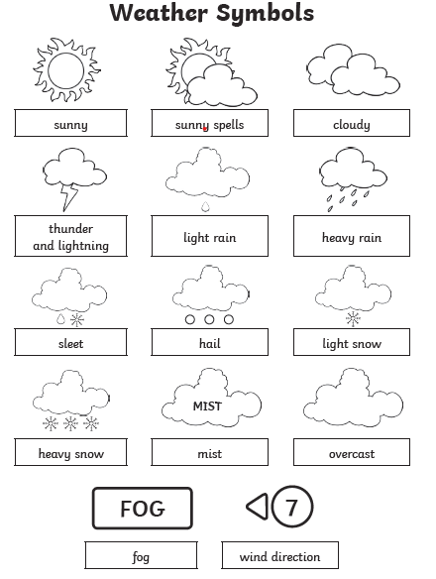    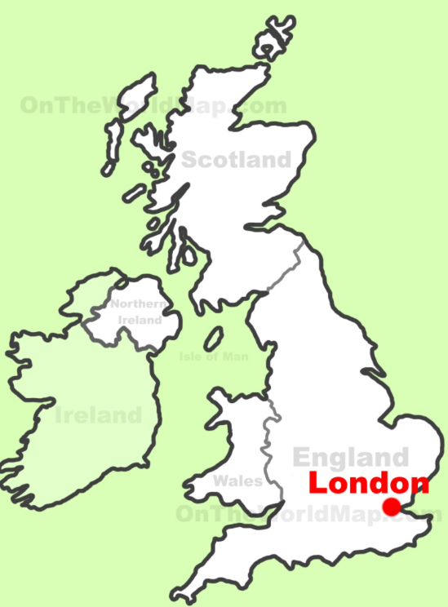  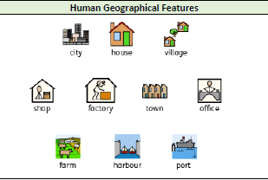  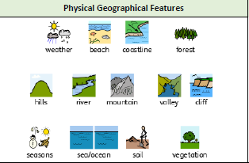  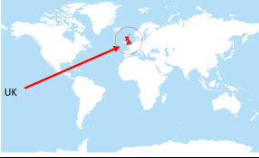  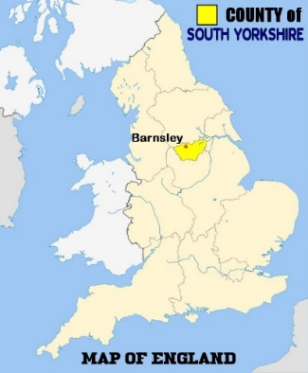  v  Weather  * The four seasons are Spring, Summer, Autumn and Winter.  * Colder weather comes in the autumn and the winter. Warmer weather comes in the spring and the summer.  * Our days of sunlight are longest in the summer and shortest in the winter.  * Many trees see their leaves change colour in the autumn months and fall off in the winter.  * Much of the fruit and vegetables that we eat grow and are harvested in the summer or the autumn.  * Lambs are born in the spring.  * A rain gauge measures how much rain has fallen  * A wind vane shows which way the wind is blowing.  * A thermometer measures the temperature.  * It is warmer in the south of the UK than the north. It gets even warmer the further south you go. It rains a lot more where there are mountains.  The flag of England is called the St. George’s Cross after the patron saint of England. England’s national anthem is called “God save the Queen”  https://www.youtube.com/watch?v=GHcuaV3qRlA  Royston/Barnsley  Royston is a village in Barnsley. It has shops, fast food outlets, sports clubs and sports centres, leisure centre, library, parks, schools, houses amd churches. Barnsley is larger than Royston. It is a town near the city of Sheffield in the county of South Yorkshire. Barnsley is in the North of England. It has more shops, offices and houses than Royston. It has a large river called the river Dearne. It has factories and industry. It doesn’t have many fields in the town centre but there are lots of fields, hills and even mountains (High Stones, Higger Tor) in South Yorkshire. Many people work in factories, shops and offices in the towns, and they work on farms in the countryside. There is also a hospital, a police station and a fire station in Barnsley where people work to help other people. In the past, many people in Barnsley worked in coal mines such as Monkton colliery.
village | a small group of houses, perhaps with a few shops, that are often in the countryside.
town | a large group of houses, shops and buildings where people live and work. Towns are larger than villages but smaller than cities
city | a large town
country | an area of land that is controlled by its own government
England | a country in the United Kingdom
capital city | the city where the government sits
flag | a piece of cloth which can be attached to a pole and which is used as a symbol of a country
physical features | natural features of land
human features | features of land that have been impacted by human activity
landscape | everything you can see when you look across an area of land, including hills, rivers, buildings, trees and plants
hill | a naturally raised area of land, which is not as high as a mountain
forest | a large area where trees grow close together
farm | an area of land used to produce crops or to breed animals and livestock
port | a harbour area where ships load and unload goods or passengers
river | a large, natural stream of fresh water that flows into the sea or a lake
sea | a large area of salty water that is part of an ocean
train station | a plane on a railway line where trains stop for people to get on and off trains
airport | a place where aeroplanes land and take off
family | Group of people who may live together and care for each other. Traditionally parents and children

Understanding of the World – ELG: Past & Present
What should pupils already know/do? |  |  | What will pupils learn? | Where will this learning go?
* Understand that older people lived before they were born  * Know who the older people in their families are.  * Know that things have changed over time. |  |  | * Talk about the lives of the people around them and their roles in society  * Know some similarities and differences between things in the past and now, drawing on their experiences and what has been read in class.  * Understand the past through settings, characters and events encountered in books read in class and storytelling. | Ks1  Children will build on their learning to explore things that happened when they were little, and how they have changed since they were born. They will use words and phrases like: before I was born, when I was younger as well as a range of appropriate words and phrases to describe the past. They will explore how their local area was different in the past, giving examples of things that are different in their life from that of their grandparents when they were young
Key Vocabulary |  | 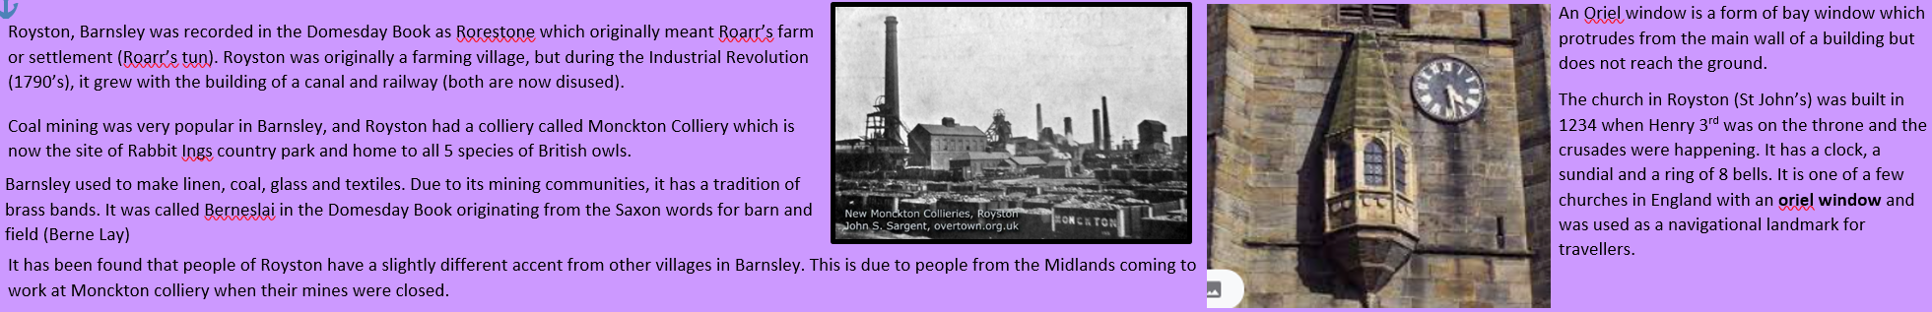  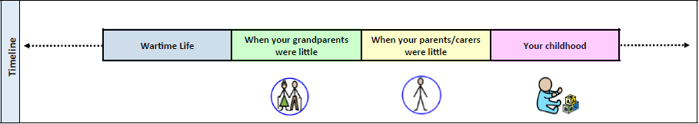  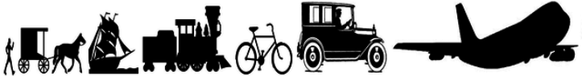  The way our grandparents travelled was different to how we travel today, and technology was very different. Not many people had fridges, t.v’s or phones in their homes until 1960’s
after | later in time than, or behind in order
before | at an earlier time, in the past
new | having recently arrived, been produced, or come into being
now | at this time or in these times
old | having existed for many years; not new
older | having lived for many years
past | having happened or gone by at an earlier time
present | existing at this time; current
sibling | a sister or a brother
similarity | likeness
technology | devices which are the result of scientific knowledge being used for practical purposes
then | soon after; next
usually | most common or expected
younger | earlier stage of life

Expressive Arts & Design - ELG: Creating with Materials
What should pupils already know/do? |  |  | What will pupils learn/do? | Where will this learning go?
* safely use a variety of materials  * understanding of primary colours |  |  | * Safely use and explore a variety of materials, tools and techniques, experimenting with colour, design, texture, form and function  * Share their creations, explaining the process they have used  * Make use of props and materials when role playing characters in narratives and stories. | Ks1  Children will build on their learning to communicate something about themselves in their drawing and create mood through different tones, pattern and textures. They will describe what they can see and like in the work of another artist, saying how other artists have used colour, pattern and shape, and reate a piece of work in response to another artist’s work
Key Vocabulary |  | 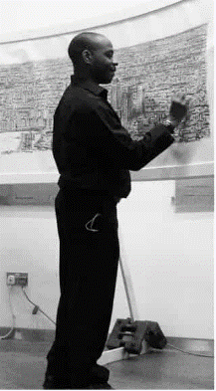  Stephen Wiltshire, an architectural illustrator, is an artist who draws detailed cityscapes which include landmarks from around the UK and Europe. His drawings are popular all over the world, and are held in a number of important art collections and museums. He was born in 1974 in London to West Indian parents. As a child, he was mute and did not relate to other people. Living in a world with no communication, he began to draw. Aged 3 he was diagnosed with autism, and aged 7, he sold his first piece of artwork. He was awarded an MBE for services to the art world in 2006.  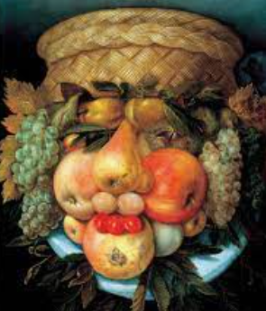  Guiseppe Arcimboldo (1526-1593) was an Italian painter best known for creating imaginative portrait heads made entirely of objects such as fruits, vegetables, flowers, fish and books.  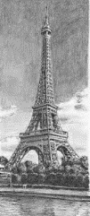  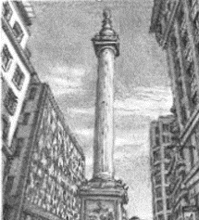  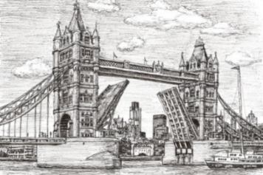
investigate | To examine something carefully to find out more about it.
discuss | To talk about something in detail to another person or people.
line | Using different types of lines to create an image (curved or straight).
shape | A 2D area with an outline.
pattern | A design where lines, shapes or colours are repeated.
design | To sketch and plan a piece of art work.
primary colours | One of the three colours, red, yellow, and blue, that can be mixed together in different ways to make any other colour.
secondary colours | One of the three colours – orange, green, or purple – that can be made by mixing together two of the primary colours.
artist | Somebody who paints, draws, or makes sculptures.
mix | To combine things (paint) together so they can’t be easily separated.
landscape | The longer sides of a piece of paper at the top and bottom.
portrait | The shorter sides of a piece of paper at the top and bottom.
landmark | An object on land that marks a locality
cityscapes | A piece of art work showing a city.
illustrator | A person who draws or creates pictures.

