Who do you think you are?
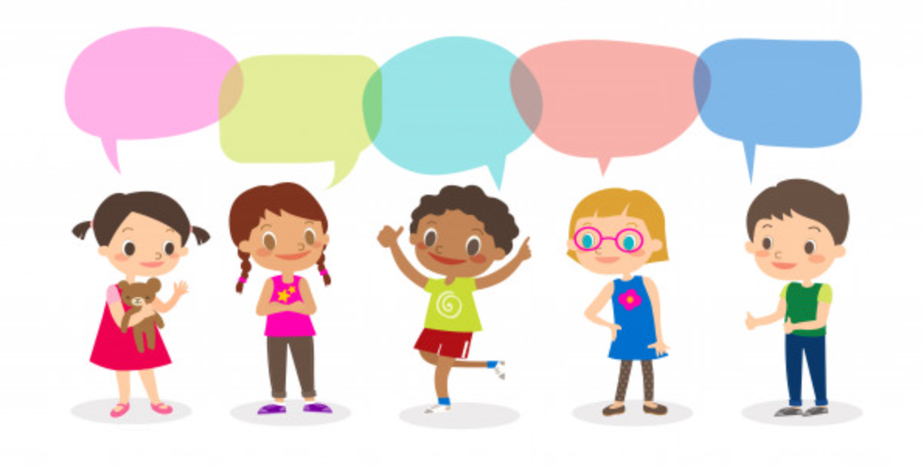

Who do you think you are?
What makes me the same or different?
What makes me special?
Who am I?
Where do I live?

Cycle A: Exploration 1
Ks1

Cycle A - Exploration 1 – Ks1 - Who do you think you are?
Exploration Objectives Overview
Curriculum Drivers: Global (Identity & diversity), Science (Animals including humans) & Geography (Local area study)

Subject | Yr1 | Yr2 | Subject | Yr1 | Yr2
Global  To open up the world | Identity and diversity  * similarities and differences between peoples in local setting and also in wider contexts  * what contributes to self-identity and belonging |  | RSE | Families and people who care for me:  * identify and respect the differences and similarities between people.  * identify their special people (family, friends, and carers), what makes them special and how special people should care for one another.  * Understand that they belong to different groups and communities such as family and school.  * Understand about people who look after them, their family networks, who to go to if they are worried and how to attract attention.
Science  Through investigation, develop a sense of excitement and curiosity of natural phenomena | Animals including humans:  * point out some differences between different animals  * classify common animals (fish, amphibians, birds, reptiles, mammals, invertebrates)  * describe how an animal is suited to its environment  * name the parts of the body that they can see  * identify main parts of the human body and link them to the senses  * name the parts of an animal’s body  * classify animals by what they eat (carnivore, herbivore, omnivore)  * compare the bodies of different animals  Observing closely:  * Talk about what they can see, touch, smell or taste  * use simple equipment to help them make observations  Performing tests:  * perform a simple test  * tell other people about what they have done  Recording findings:  * show their work using pictures, labels and captions  * record their findings using standard units  * put some information in a chart/table  Identifying and classifying:  * Identify and classify things they see  * think of some scientific questions and answers  * explain that they have found out | Animals including humans:  * describe what animals need to survive  * explain that animals grow and reproduce  * explain why animals have offspring  * describe the life cycle of some living things (E.g. egg, chick, chicken)  * explain the basic needs of animals, including humans  * describe why exercise and a balanced diet are important for humans  Observing closely:  * Use what they can see, touch, smell or taste to answer questions  * use some scientific words to describe what they have seen and measured  * compare several things  Performing tests:  * carry out a simple fair test  * explain why it might not be fair to compare two things  * say whether things happened as they expected  * suggest how to find things out  * use prompts to find things out  Recording findings:  * use text, diagrams, pictures, charts and tables to record observations  * measure using simple equipment  Identifying and classifying:  * organise things into groups  * find simple patterns  * identify animals and plants by specific criteria (lay eggs, have feathers)  * explain that they have found out | Geography  To develop an understanding of the impact of the world’s physical and human processes: past, present and future | Geographical Enquiry:  * Say what they like about their locality.  * Sort things they like and don’t like.  * Answer some questions using different resources, such as books, the internet and atlases.  * Thinks of a few good questions to ask about a locality.  * Answer questions about the weather.  * Keep a weather chart.  Physical Geography:  * Tell someone their address.  * Describe a locality using words and pictures.  * Explain how the weather changes with each season.  * Name key features associated with a town or village, eg, church, farm, shop, and house.  Geographical Knowledge:  * identify the four countries making up the United Kingdom.  * name some of the main towns and cities in the United Kingdom. | Geographical Enquiry:  * Label a diagram or photograph using some geographical words  * Finds out about a locality by using different sources of evidence like aerial images, plan perspectives, maps and atlases  * Thinks of a few relevant questions to ask someone about a locality  * Says what they like and dislike about their local area and another area  * Looks down on objects to make a plan view map  * Uses 2 figure grid reference to explain the location of a place  * Uses class agreed symbols to make a simple key  Physical Geography:  * Describe some physical features of own locality.  * Explain what makes a locality special.  *Describe some places which are not near the school.  *Describe the key features of a place, using words like, beach, coast forest, hill, mountain, ocean, and valley.  Human Geography:  * Describe some human features of own locality, such as the jobs people do.  * Explain how the jobs people do may be different in different parts of the world.  *Think how people ever spoil the area and how  * Think how people try to make the area better and how.  * Explain what facilities a town or village might need.  Geographical Knowledge:  * Name the main cities of England, Wales, Scotland and Ireland.  *Find where they live on a map of the UK.
History  To learn from the past in order to impact the future | Chronological Understanding:  * use words and phrases like: old, new and a long time ago  * tell me about things that happened when they were little  * explain how they have changed since they were born  Knowledge and Interpretation:  * begin to identify the main differences between old and new objects  * identify objects from the past, such as vinyl record  Historical Enquiry:  * spot old and new things in a picture  * answer questions using an artefact/ photograph provided | Chronological Understanding:  * use words and phrases like: before I was born, when I was younger  * use phrases and words like: ‘before’, ‘after’, ‘past’, ‘present’, ‘then’ and ‘now’; in their historical learning  * use the words past and present correctly  * use a range of appropriate words and phrases to describe the past  Knowledge and Interpretation:  * explain how their local area was different in the past  * give examples of things that are different in their life from that of their grandparents when they were young  Historical Enquiry:  * find out something about the past by talking to an older person  * answer questions by using a specific source, such as an information book | Art  To learn how Art & Design reflect and shape our world | Drawing:  * Communicate something about themselves in their drawing.  * draw using pencil and crayons  * draw lines of different shapes and thickness, using 2 different grades of pencil  Knowledge:  * describes what they can see and like in the work of another artist  * ask sensible questions about a piece of art | Drawing:  * use three different grades of pencil in their drawing (4B, 8B, HB)  * create different tones using light and dark  * show patterns and texture in their drawings  * use a viewfinder to focus on a specific part of an artefact before drawing it  Knowledge  * create a piece of work in response to another artist’s work

Cycle A - Exploration 1 – Ks1  Who do you think you are?  Throughout the exploration, children learn about themselves, exploring their own uniqueness, value and place in the world. They learn about their self-identity and sense of belonging within their family tree, thinking about themselves as humans including similarities and differences within the human race. They learn about the Geographical features of their local area and wider while exploring the idea of themselves as part of a community to answer the question of who they think they are. |  |  |  |  |  | Learning - Identity & Diversity  Science driver – Animals including humans (Biology)  Geography driver - Study of Local areas and UK (Royston, Barnsley, South Yorkshire, Cornwall, UK)
What should pupils already know? |  | What will pupils learn? |  | Where will this learning go?
* uniqueness and value of every person  * Similarities and differences between self and others |  | * Similarities and differences between people in local setting and also in wider settings in the UK  * what contribute to self-identity and belonging |  | Later in Ks1  Children will build on their knowledge of self-identity and belonging to explore fairness and inequality, the uneven sharing of power, how some people are excluded from decision-making and the positive and negative impact of people’s actions in the world.  LKs2  Extending their learning to include Europe and beyond, pupils will build on Ks1 knowledge to think about the diversity of different cultures and societies within and beyond own experience; the contribution of different cultures to our lives; and the nature of prejudice, racism and sexism and ways to combat these.  Uks2  Again extending their learning to a global community and world migration, pupils will build on previous knowledge to think about the benefits and challenges of diversity; the impacts of stereotyping, prejudice and discrimination and how to challenge these; and the importance of language, beliefs and values in cultural identities.
SOLO Taxonomy | Uni-structural knowledge |  | Multi-Structural knowledge |  | Relational knowledge |  | Extended | Abstract
SOLO Taxonomy |   I have one relevant bit of knowledge |  |   I have several bits of key knowledge |  | 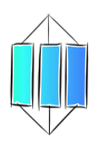  I can see links between my bits of key knowledge |  | 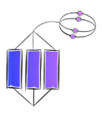  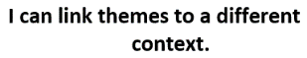
Spaced Questions | - What am I?  2 weeks |  | - Where do I live?  2 weeks |  | - What makes me the same or different?  1 weeks |  | - What makes me special?  1 week | - Who do you think you are?  1 week
Key substantive knowledge | Yr1  * Classifies common animals  * Identifies main parts of the animal and human body  * Understands their family tree  Yr2  * Describes what animals need to survive  * Explains that animals grow and produce offspring  * Describes life cycles  All Ks1 at own level:  * identify and respect the differences and similarities between people.  * identify their special people (family, friends, and carers), what makes them special and how special people should care for one another.  * Understand that they belong to different groups and communities such as family and school.  * Understand about people who look after them, their family networks, who to go to if they are worried and how to attract attention |  | Yr1  * Knows address including country  * Describes own locality including physical features and human features  * describe their route to school  * Explains how the weather changes with each season  * Names the 4 UK countries  * Names capital cities and some main towns of UK  * Recognises the UK flags  * names some local trees, flowers and wildlife  Yr2  * Finds where they live on a map  * draws their route to school from above  * Names the main cities of the UK and find them on a map  * names some trees, flowers and wildlife indigenous to UK  * recognises basic cloud formations |  | All Ks1 at own level:  * Names similarities and differences between different animals and humans including diet, exercise, parts of body, families  * Names similarities and difference of own setting and others including physical and human features of localities  Yr1:  * Explains how they have changed since they were born  * Explains about things that happened when they were little  * Explains how locality has changed and was different in the past  Yr2:  * Explains how their local area was different in the past  * Gives examples of things that are different in their life from that of their grandparents when they were young  All Ks1 at own level:  * similarities and differences between peoples in local setting and also in wider contexts |  | All Ks1 at own level:  * Explains what makes them special as a person including their bodies, their families, the way they look, what religion they are etc  * Explain what makes their locality special | All Ks1 at own level:  * Explains how what they are, what they look like, the make-up of their family and where they live contribute to who they are as a person  * Discusses what contributes to self-identity and belonging
Answer Guideline:  Assessment at each stage will allow children to show their learning in relation to the spaced question.  Assessment of children’s learning can be gained from oral discussion and writing, but must also be gained through curriculum activities such as worksheets, quizzes and short tests etc.  This ensures that children who struggle to express their learning through speaking or writing are not at a disadvantage when expressing their learning in relation to the taught curriculum objectives. | Yr1 – Understands that they are animals and a mammal as opposed to a fish, an amphibian, a bird, a reptile or an invertebrate. Knows that they are a mammal by identifying and comparing parts of the body and explaining that different animals can be carnivores, herbivores or omnivores. Understands their family tree and their position within the family with understanding of family relationships (grandma is mother of mother; uncle is brother of mother, etc) and identifies who is special to them and who looks after them if they are worried. Understands that families can look different and respects this.  Yr2 – Knows that animals need air, water, food and shelter to survive, explaining this in relation to themselves and other animals. Understands why it is important for animals to grow and have offspring, discussing life cycles of animals and relating this knowledge to their own family tree and life. Identifies who is special to them and who looks after them if they are worried. Understands that families can look different and respects this. |  | Yr1 – Says their address including village, town and country. Describes own locality using geographical words and pictures of: key local physical features such as church, farm, shop; local flora and fauna indigenous to locality; weather patterns including the names of basic cloud formation; and human features such as jobs, explaining what they like and dislike throughout. Names England, Scotland, Wales and Northern Ireland as the 4 countries of the UK, naming their capital cities as London, Edinburgh, Cardiff and Belfast, naming some other main towns of the UK and recognising the countries’ national flag. Recognises sycamore and oak trees, forget-me-nots and foxgloves, foxes, hedgehogs, squirrels, badgers, robins, magpies and owls.  Yr2 – Finds where they live using maps of the UK and 2 figure grid reference, aerial images, maps and atlases. Develops description of locality to include features such as forest, hill, mountain, valley ect, stating what they like and dislike. Names main towns and cities of the UK such as Birmingham, Glasgow, Liverpool, Newcastle, Bristol, Southampton, Derry etc. Recognises horse chestnut trees, cornflowers, roe deers, beavers, otters, wood pigeons and sparrows. |  | Yr1 – Names similarities and differences between common animals including mammals, fish, amphibians, birds, reptiles and invertebrates by describing parts of the bodies and diet. Knows that families look different: some children will only have one parent, have step families, have same sex parents, be adopted, be only children or have siblings, that some members of the family may have died etc. Explains how their locality is similar and different to others in relation to a village, a town and a city, and describes key physical features (river, hill, trees, wildlife, farm, shop, factory, house and flat) of each locality including comparing places of worship and discussing that there are different religions within UK. Explains how they have changed and how the locality has changed spotting old and new things in a picture.  Yr2 – Names all similarities and differences as Yr1 developing explanations to include how different animals including humans gain air, water, food and shelter to survive. Develops understanding of different family structures to explain different life cycles. Explains how their locality is similar and different to others not near school in relation to a village, a town and a city, and describes key physical features (landscape, homes, facilities and buildings) and human features (jobs) of each locality including comparing places of worship and understanding some different religions within UK. Explains how their locality was different in the past, using a range of appropriate words and phrases to give examples and talk to older people about the locality. |  | Ks1 – Explains how being a mammal is special; how their bodies work is special; they are special to their family and their relatives make them look the way they do which is unique; their beliefs make them special; their locality is special as it helps their family, friends and neighbours to work and live well; how the local trees and wildlife makes where they live special.  Yr2 – As Yr1 with development to explain how our bodies are special for survival and life cycles; how locality is special compared to others. Explains how the locality can be spoiled or made better. | Ks1 – Brings all their learning together to explain what they are, what they look like, how they live with their families, what they believe in, where they live and their history contributes to who they are as a person and their sense of belonging. Discusses how humans are made the same in terms of their bodies but are all different as a result of their families, their beliefs and where they live. Discusses how it’s good that we are all different and it’s important to keep your beliefs (sense of identity) and feel that you belong, while looking after each other and the places we live. Eventually bring all scientific, geographical , historical and global learning together to answer the question “Who do you think you are?”

Anchor novel/s | Yr1 | 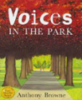  Through the non-linear story “Voices in the park” by Anthony Browne, pupils will explore the different voices of the different people and animals in the text. They will explore their own setting and think about the different people within it, imagining how their voices/thoughts might be different to each other’s. They will begin to think about how we might judge others and how others may judge us on how we look. |  |  | 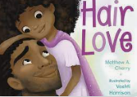  Through the BAME book “Hair Love” by Matthew A Cherry, pupils will begin to think about what makes people similar and what makes people different. They will begin to explore how culture impacts on what you look like and your features. |  | 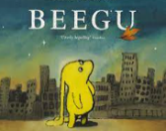  Through the migration strand book “Beegu” by Alexis Deacon, pupils will explore a sense of self-identity and belonging. They will discuss how Beegu feels lost in a different place and how a sense of not belonging can make us feel uncomfortable. They will explore how Beegu is similar and different to themselves and what is special and unique about her, understanding how people who are different can accept each other’s differences and be good friends.
Anchor novel/s | Yr2 | 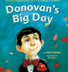  Through the BAME themes book “Donovan’s big day” by Leslea Newman, pupils will explore the nature of families, how each family can be different and what true family means. |  | 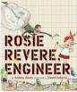  Through the strong female strand book “Rosie Revere, Engineer” by Andrea Beaty, pupils consider their strengths and uniqueness. |  | 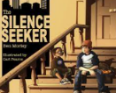  Through the migration/belonging themed book “The Silence Seeker” by Ben Morley, pupils will build on their learning through Beegu in Yr1 to further explore a sense of self-identity and belonging. Again, they will consider how the character feels lost having moved to a different place, how people are similar and different and develop their understanding of other people’s culture. They will begin to explore the plight of refugees and begin to think about how different cultures travel around the world, and what they themselves can learn from the different cultures that they encounter.
Writing Purpose | Yr1 | To inform (2 Weeks)  Simple statement sentences about animals and fmaily tree. | To inform (2 weeks)  Simple statement sentences about Royston. |  | To inform/entertain (2 weeks)  Simple statement sentences to describe themselves |  |  | To offer a viewpoint  Collage to represent selves
Writing Purpose | Yr2 | To inform (2 weeks)  Non-chronological report about themselves. | To inform (2 weeks)  Tourist Leaflet for the Uk. |  | Character description of themselves |  |  | To offer a viewpoint  Collage to represent selves

Key people linked to Curriculum areas for Explore
Global |   I think everybody is weird. We should all celebrate our individuality and not be embarrassed or ashamed of it.  Johnny Depp |  | 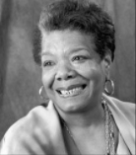  It is time for us to teach young people that in diversity there is beauty and there is strength.  Maya Angelou |  |  |  | 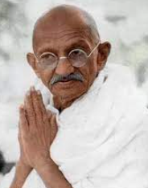  Our ability to reach unity in diversity will be the beauty and the test of our civilization.  Mahatma Ghandi |  |  | 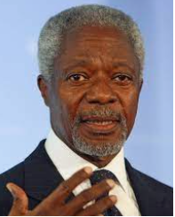  We may have different religions, different languages, different coloured skin, but we all belong to one human race.  Kofi Annan |  |  | 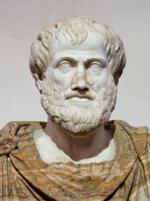  Knowing yourself is the beginning of all wisdom Aristotle |  |  | 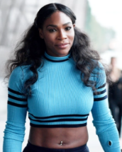  I love me, and I would never change anything about me. I’m not asking you to like me. I’m just asking you to let me be me.  Serena Williams
Literacy | 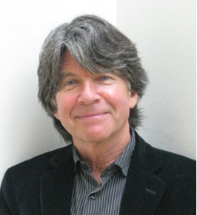  Anthony Browne is an author and illustrator born in Sheffield in 1946. He writes about a range of diverse characters and tackles issues with identity and diversity within his books. He was children’s Laureate from 2009-2011, and he was awarded a CBE (Commander of the British Empire) in 2021 for his services to literature. |  |  |  | 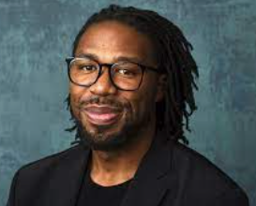  Matthew A. Cherry is an American film director and writer born in Chicago in 1981. His films and books are often based on themes of family and diversity, with an aim to represent young men and women of colour in the mainstream, and promote a love of their culture. |  |  |  |  |  |  | 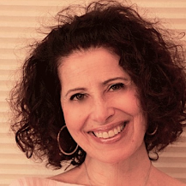  Leslea Newman is an American author born in New York in 1955. She is Jewish and married to Mary Vazquez with who she has children. Her books aim to represent children who are raised by same-sex couples.
Science | 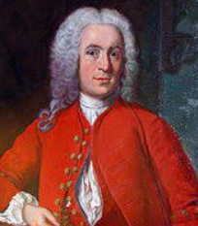  Carl Linnaeus was a Swedish botanist and zoologist who lived from 1707 to 1778. He was the first person to classify animals and plants. | 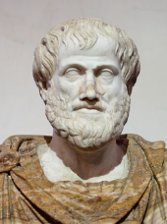  Aristotle was a Greek philosopher who lived from 384 -322 BC. He first classified animals into blood animals (vertebrates) and non-blood animals (invertebrates) |  |  |  | 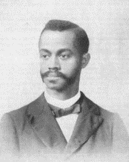  Charles Henry Turner was an American Zoologist who lived from 1867-1923. He was best known for his studies on the behaviour of insects, particularly bees and ants. He was the first person to discover that bees could see colour patterns in order to remember where pollen was. |  |  |  |  | 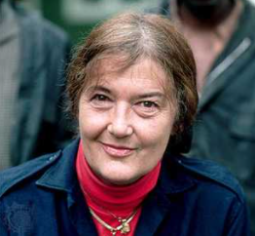  Dian Fossey was an American zoologist who lived from 1932-1985. She studied mountain gorillas extensively and wrote the book “Gorillas in the mist”. She was key in identifying how primates behave and live in family groups. |  |  |  | 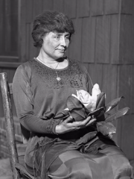  Helen Keller lived from 1880-1968. She was born in Alabama, America and lost both her sight and hearing when she was 19 months old. Despite this, Helen earned a degree, was a prolific writer and travelled the world advocating for disabled people’s rights.
History | 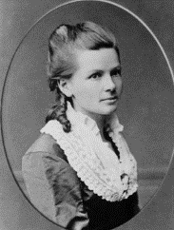  Bertha Benz (1849-1944) was a German pioneer and inventor in relation to cars. She was the business partner and wife of Karl Benz and in 1888, she was the first person to drive a car over a long distance |  |  | 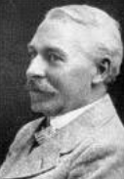  Edgar Hooley was a Welsh inventor who lived from 1860-1942. He invented tarmac which transformed the roads of Britain. |  |  |  | 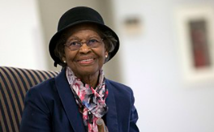  Gladys Mae West, born in 1930, is an American mathematician who developed satellite use to create a Global Positioning System (GPS) which is the basis for all modern SatNavs. |  |  |  |  |  | 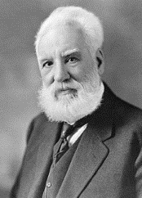  Alexander Graham Bell (1847-1922) was a Scottish inventor, scientist and engineer who invented the first telephone in 1876.
Art | 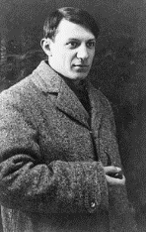  Pablo Ruiz Picasso lived from 1881-1973 was a Spanish painter and sculptor who lived in France. He helped to invent Cubism and collage, and was inspired by Henri Matisse. |  |  |  |  |  |  |  | 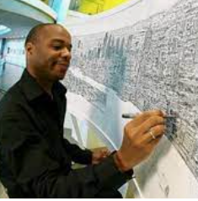  Stephen Wiltshire is a British artist who was born in London in 1974. After being a mute in childhood, Stephen was diagnosed with Autism aged 3. At 5, he attended a school where it was noticed that he enjoyed drawing and it soon became apparent that he could communicate with the world through his drawings. He now draws and paints detailed cityscapes, and has received a MBE from the queen.

Science driver – Animals including humans (Biology)
What should pupils already know? |  | What will pupils learn? |  |  |  | Where will this learning go?
Yr1  * similarities and difference in relation to living things  * the importance for good physical exercise and a healthy diet  * ways to keep healthy and safe  * manage own basic hygiene and personal needs  Yr2  * differences between different animals  * classification of common animals  * main parts of an animal’s body including humans  * a range of domestic animals  * common, local flora and fauna |  | Yr1  * differences between different animals  * classification of common animals including vertebrates, invertebrates, mammals, fish, birds, reptiles, amphibians  * main parts of an animal’s body including humans  * a range of domestic animals  * common, local flora and fauna  Yr2  * Basic survival needs of animals  * Life cycles of some living things  * Importance of exercise and a balanced diet  * Common flora and fauna indigenous to UK |  |  |  | Lks2  Children will build on their Ks1 knowledge of the body to learn about skeletons, digestive system and function of teeth in different animals. They will classify living things discussing feeding patterns including food chains and life cycles including all animal and plant reproduction.  UKs2  Children will then build on all previous knowledge again to identify the 5 kingdoms of all living things, the function and health of major organs in the body, evolution and inheritance thinking about climate change and how to care for the environment.
Key Vocabulary |  | 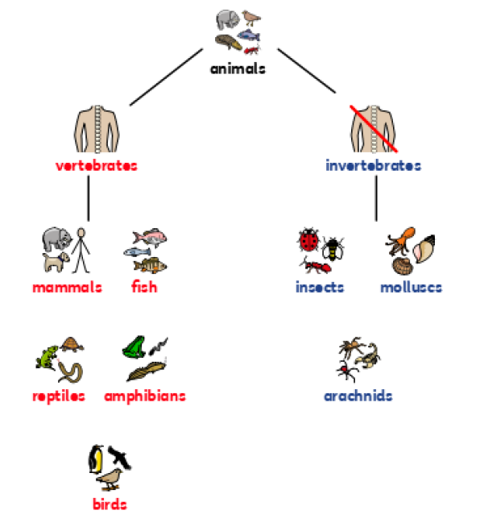 |  | What are fish? | * have fins and scales  * breathe underwater using gills  * lay eggs in water  * cold-blooded  * some common fish are salmon, cod and tuna |  | 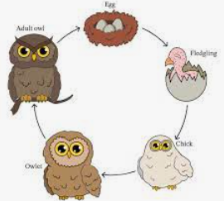  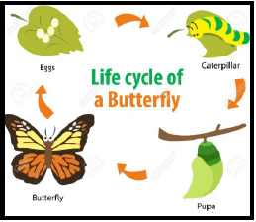  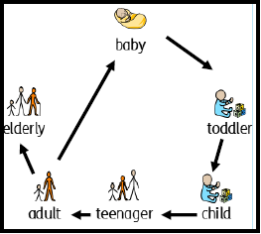  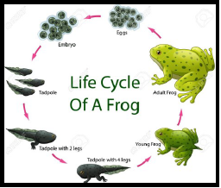  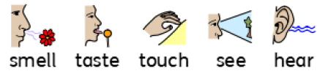  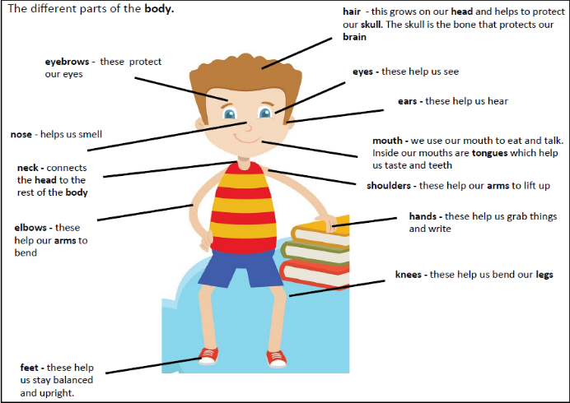  We have 5 senses: we smell using our nose; we taste using our tongue; we touch using parts of our body, like our hands; we see using our eyes; we hear using our ears.
backbone | the column of small linked bones down the middle of your back
carnivore | an animal that eats meat
cold-blooded | a body temperature that changes according to the surrounding temperature
environment | all the circumstances, people, things, and events around them that influence their life |  |  | What are birds? | * warm-blooded  * have wings and beaks  * have feathers  * lay eggs  * some common birds are ducks, chickens, penguins and pigeons
farm | an area of land used to produce crops or to breed animals and livestock
gills | the organs on the sides of fish and other water creatures through which they breathe
herbivore | an animal that only eats plants |  |  | What are reptiles? | * cold-blooded  * lay eggs  * have scales  * cannot breathe underwater  * some common reptiles are snakes and lizards
invertebrate | a creature that does not have a spine, for example an insect, a worm, or an octopus
omnivore | person or animal eats all kinds of food, including both meat and plants
pet | a tame animal kept in a household
temperature | a measure of how hot or cold something is |  |  | What are amphibians? | * cold-blooded  * lay eggs  * live on land and water - can breathe underwater through gills  * some common amphibians are frogs and toads
vertebrate | a creature which has a backbone
warm-blooded | a fairly high body temperature which does not change much and is not affected by the surrounding temperature
wild | animals or plants that live or grow in natural surroundings and are not looked after by people | What are vertebrates? | Vertebrates are animals that have a backbone.  There are five groups of vertebrates:  * mammals  * fish  * birds  * reptiles  * amphibians | What are invertebrates? | * Invertebrates are animals that do not have a backbone.  They include:  * insects such as flies, ladybirds and bees  * arachnids such as spiders  * molluscs such as snails
balanced diet | a variety of food that you regularly eat
bones | the hard parts inside your body which form your skeleton
skeleton | The framework of bones in your body
disease | an illness which affects people, animals or plants | What are vertebrates? |  | What do humans need to be healthy? | To keep healthy, humans need:  * to eat a balanced diet and healthy food  * some exercise to keep their muscles and bones healthy  * to take medicine that are given by doctors and nurses when feeling poorly  * to keep good hygiene by washing regularly, having clean clothes, and brushing hair and teeth
exercise | when you exercise, you move your body energetically in order to get fit and to remain healthy | What are mammals? | * give birth to live young  * usually have hair or fur  * warm-blooded  * cannot breathe underwater  * some common mammals are:  * pets such as dogs, cats, hamsters  * farm animals such as cows, sheep and horses  * wild animals such as foxes, hedgehogs, lions and giraffes  * humans | What do humans need to be healthy?
healthy | well and not suffering from any illness
medicine | the treatment of illness and injuries by doctors and nurses
hygiene | keeping yourself and your surroundings clean, especially in order to prevent illness or the spread of diseases
muscles | something inside your body which connects two bones and which you use when you make a movement | What are mammals? |  | What is a life cycle? | A life cycle is the series of changes that an animal or plant passes through from the beginning of its life until its death.  Animals, including humans, have offspring which grow into adults
life cycle | the series of changes that an animal or plant passes through from the beginning of its life until its death | What are mammals? |  | What do animals eat? | * Animals that only eat meat (other animals) are called carnivores (examples include lions and eagles.  * Animals that only eat plants are called herbivores (examples include cows and giraffes)  * Animals that eat plants and meat are called omnivores (examples include humans and squirrels)
offspring | a person’s children or an animal’s young | What do all animals need to survive? | All animals need water, air and food to survive | What do animals eat?
pet | a tame animal kept in a household
survive | continue to exist
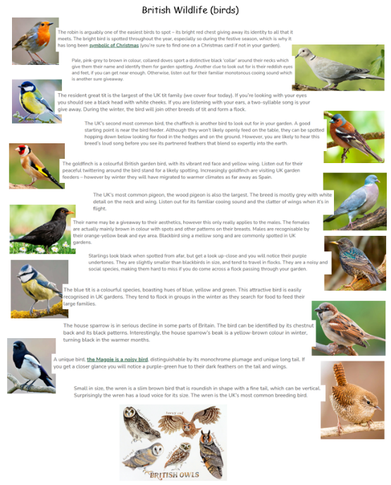
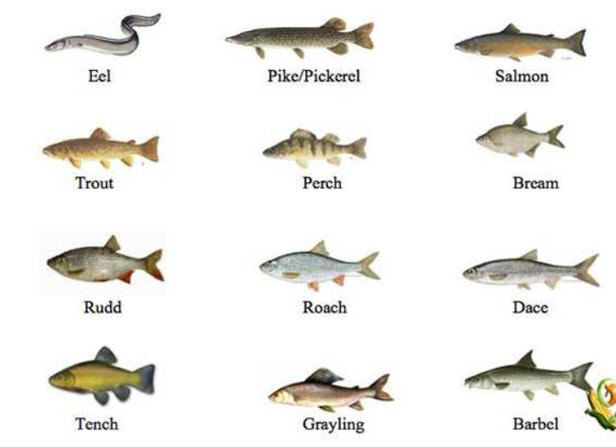
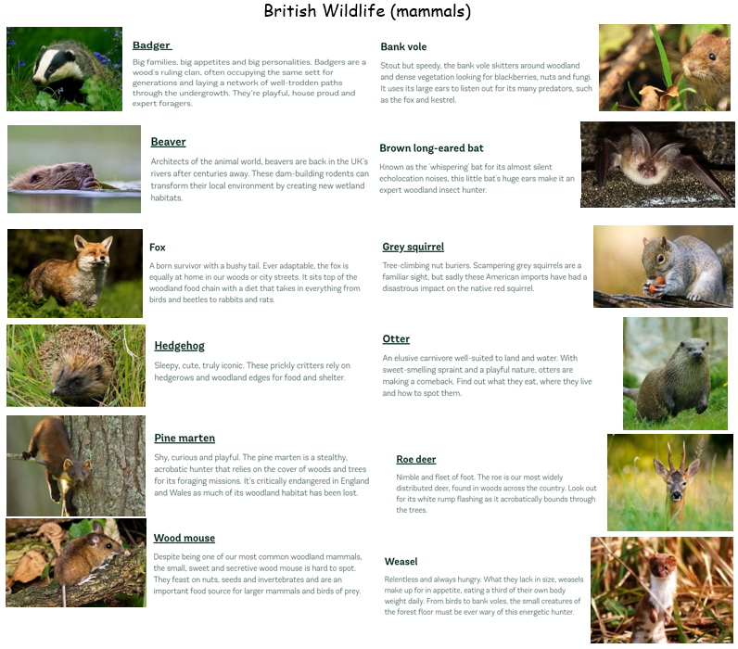
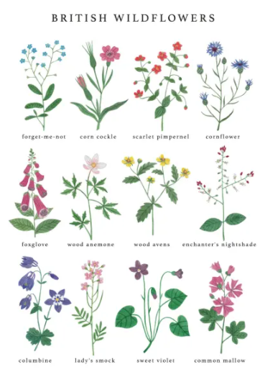
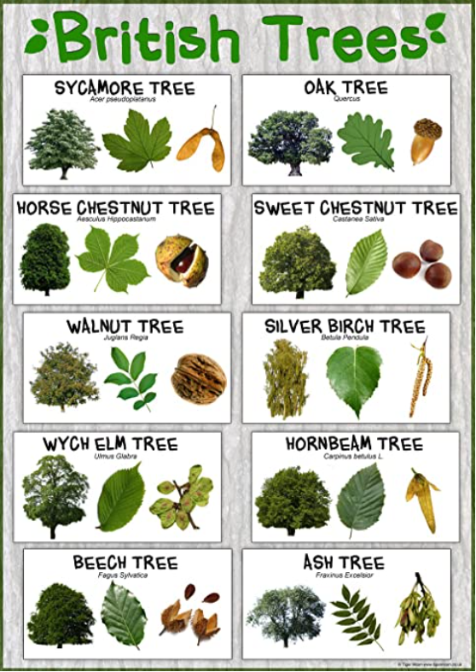
https://www.farmingplan.com/freshwater-fish/

https://www.woodlandtrust.org.uk/trees-woods-and-

wildlife/animals/mammals/

https://www.rspb.org.uk/birds-and-wildlife/wildlife-guides/bird-a-z/ The Rabbit Ings Country Park is home to all 5 species of British owls.

Geography driver – Study of local area and UK (locational knowledge/human and physical geography)
What should pupils already know/do? |  | What will pupils learn/do? |  | Where will this learning go?
Yr1  * features of own immediate environment and how environments might vary from one another  Yr2  * features of their locality saying what they like and don’t like  * how to use different resources such as books, the internet and atlases  * how to ask questions about locality  * how keep a weather chart  * their address (number, street, village, town, county, country)  * their route to school  * key physical and human features associated with a village/town  * 4 countries of the UK, naming the capitals and recognising the flags  * some of the main towns and cities in the UK  * some local trees, flowers and wildlife |  | Yr1  * features of their locality saying what they like and don’t like  * how to use different resources such as books, the internet and atlases  * how to ask questions about locality  * how keep a weather chart  * their address (number, street, village, town, county, country)  * their route to school  * key physical and human features associated with a village/town  * 4 countries of the UK, naming the capitals and recognising the flags  * some of the main towns and cities in the UK  Yr2  * how to use different sources of evidence to find and describe a locality including 2 figure grid reference map  * draw their route to school from above  * compare own locality with another by asking questions, giving preferences, describing human and physical features, and facilities  * what makes a locality special, discussing how people can spoil/improve an area  * main cities of England, Wales, Scotland and Ireland and find them on a map  * basic cloud formations |  | Lks2  Children will build on their Ks1 knowledge to use a 4 figure grid reference and basic OS map symbols to name and UK islands and European countries/flags/capital cities. They will learn how to plot NSEW on a map, recognising all 8 points of the compass and make accurate measurements. They will develop their knowledge of physical features to learn about volcanoes, earthquakes and main features of locations within Europe. They will develop their knowledge of human features to learn about lives of people in locations within Europe thinking about different ethnic groups and why people travel to live in different places.  UKs2  Children will then build on all previous knowledge again to use a range of resources including scaled maps and atlases to name and locate the equator/tropics of Cancer and Capricorn/Arctic and Antarctic circles, continents and countries of the world/capital cities/flags. They will develop their knowledge of physical features to learn about oceans, rivers, mountains, deserts and time zones of the world. They will develop their knowledge of human features to learn about land use and economics.
Key Vocabulary |  |  | 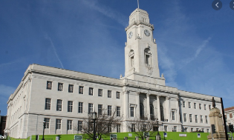  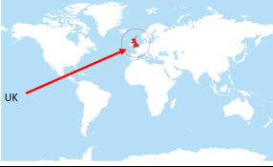  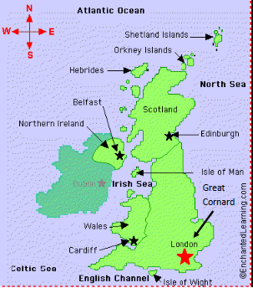  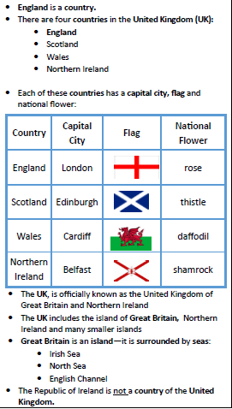  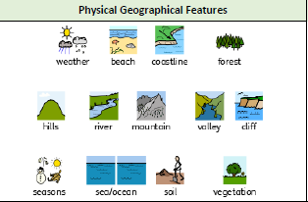  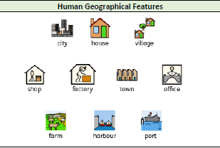    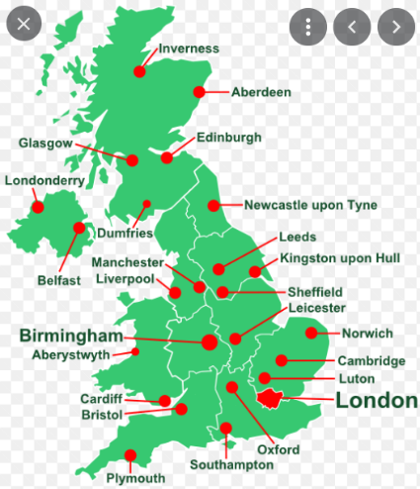  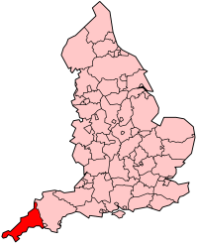  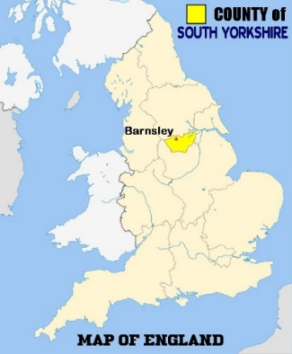  The flags of the 4 countries of the UK are combined into one flag. When this flag is flown on a ship at sea, it is called the “Union Jack”. When the flag is flown on land, it is called the “Union Flag”.  Other than the capital cities of the UK, there are many other main cities and towns:  Scotland: Inverness, Aberdeen, Glasgow, Dumfries  England: Newcastle-upon-Tyne, Leeds, Hull, Manchester, Liverpool, Sheffield, Birmingham, Leicester, Norwich, Cambridge, Luton, Oxford, Bristol, Southampton, Plymouth  Wales: Aberystwyth  Northern Ireland: Londonderry  Cornwall (Cornish: Kernow)  Cornwall is a county in the far south west of England in the UK. It has all the same human features as Barnsley, but it also has lots of hotels, campsites and shops for tourists. Truro is the only city and has the cathedral of the Diocese of Truro. Cornwall is split from Devon by the River Tamar. Some people in Cornwall have revived Cornish, a very old recently extinct Celtic language. Tintagel Castle is on the north coast of Cornwall. Falmouth harbour is one of the largest natural harbours in the world. Newquay is one of the larger holiday resorts and popular with surfers.  Royston/Barnsley  Royston is a village in Barnsley. It has shops, fast food outlets, sports clubs and sports centres, leisure centre, library, parks, schools, houses amd churches. Barnsley is larger than Royston. It is a town near the city of Sheffield in the county of South Yorkshire. Barnsley is in the North of England. It has more shops, offices and houses than Royston. It has a large river called the river Dearne. It has factories and industry. It doesn’t have many fields in the town centre but there are lots of fields, hills and even mountains (High Stones, Higger Tor) in South Yorkshire. Many people work in factories, shops and offices in the towns, and they work on farms in the countryside. There is also a hospital, a police station and a fire station in Barnsley where people work to help other people. In the past, many people in Barnsley worked in coal mines such as Monkton colliery.
village | a small group of houses, perhaps with a few shops, that are often in the countryside.
town | a large group of houses, shops and buildings where people live and work. Towns are larger than villages but smaller than cities
city | a large town
county | a region of Britain or Ireland which has its own local government
country | an area of land that is controlled by its own government
England | a country in the United Kingdom
capital city | the city where the government sits
Great Britain | an island made up of England, Scotland and Wales
United Kingdom | the UK is officially known as the United Kingdom of Great Britain and Northern Ireland.
flag | a piece of cloth which can be attached to a pole and which is used as a symbol of a country
physical features | natural features of land
human features | features of land that have been impacted by human activity
landscape | everything you can see when you look across an area of land, including hills, rivers, buildings, trees and plants
hill | a naturally raised area of land, which is not as high as a mountain
forest | a large area where trees grow close together
farm | an area of land used to produce crops or to breed animals and livestock
port | a harbour area where ships load and unload goods or passengers
river | a large, natural stream of fresh water that flows into the sea or a lake
sea | a large area of salty water that is part of an ocean
harbour | a sheltered port so that boats can be left there safely
coastal | an area of land close to the sea
train station | a plane on a railway line where trains stop for people to get on and off trains
airport | a place where aeroplanes land and take off
vegetation | plants, trees and flowers
climate | the general weather conditions that are typical of a place
tourist | a person who is visiting a place for pleasure and interest, especially when they are on holiday
compass point | any of the main points of a compass (North, South, East, West)
aerial view | a view from above
floor plan | the layout of rooms on one floor of a building
grounds | the land around a building
route | a way from one place to another
National Anthem
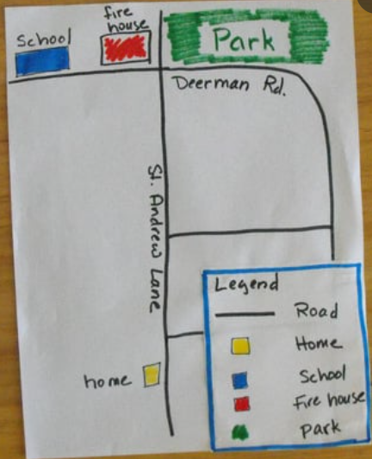
“God Save the Queen” is the offical anthem of Great Britain and Northern Ireland
https://www.youtube.com/watch?v=GHcuaV3qRlA
However, each country in the UK, does also have their own special song which represents their country.
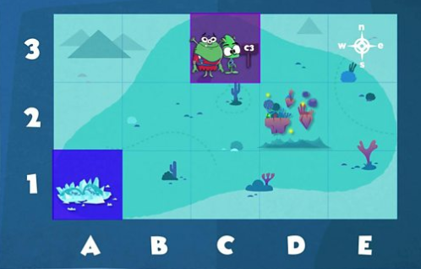
Below are the national anthems and the national emblems
2 figure grid references
* along the bottom to find the first reference
* up the side to find the second reference.
Country in the United Kingdom | National Anthem | National emblem
England | God Save the Queen | Rose
Scotland | Flower of Scotland | Thistle
Wales | Land of my Fathers | Leek and Daffodil
Northern Ireland | Londonderry Air | Shamrock

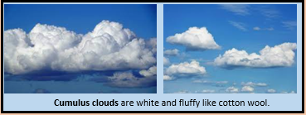
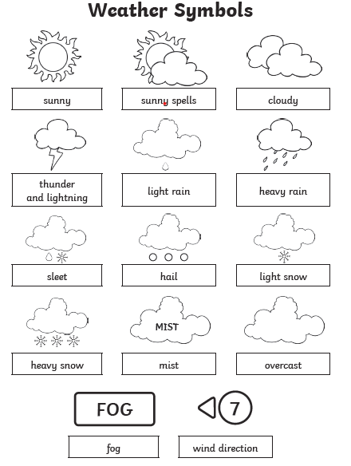
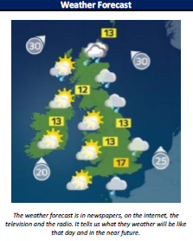
Plans
Use aerial views and create plans of classroom, school grounds and route to school using an agreed key
Weather
* The four seasons are Spring, Summer, Autumn and Winter.
* Colder weather comes in the autumn and the winter. Warmer weather comes in the spring and the summer.
* Our days of sunlight are longest in the summer and shortest in the winter.
* Many trees see their leaves change colour in the autumn months and fall off in the winter.
* Much of the fruit and vegetables that we eat grow and are harvested in the summer or the autumn.
* Lambs are born in the spring.
* A rain gauge measures how much rain has fallen
* A wind vane shows which way the wind is blowing.
* A thermometer measures the temperature.
* It is warmer in the south of the UK than the north. It gets even warmer the further south you go. It rains a lot more where there are mountains.

Clouds
* Clouds are made up of tiny droplets of water than float in the air.
* Dark clouds are carrying more water.

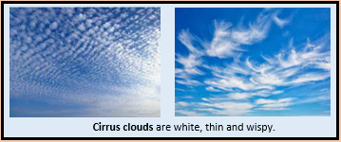
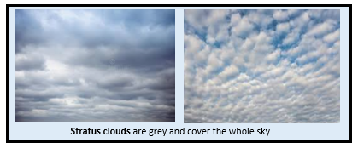

History – local history
What should pupils already know/do? |  |  | What will pupils learn? | Where will this learning go?
Yr1  -Talk about past and present events in their own lives and in the lives of family members.  -Know that other children don’t always enjoy the same things, and are sensitive to this.  -know about similarities and differences between themselves and others, and among families, communities and traditions.  Yr2  Chronological Understanding  * words and phrases like: old, new and a long time ago  * things that happened when they were little  * how they have changed since they were born  Historical Enquiry  * how to spot old and new things in a picture  * to use an artefact/ photograph as a source |  |  | Yr1  Chronological Understanding  * words and phrases like: old, new and a long time ago  * things that happened when they were little  * how they have changed since they were born  Historical Enquiry  * old and new things in a picture  * to use an artefact/ photograph as a source  Yr2  Chronological Understanding  * words and phrases like: before I was born, when I was younger  * phrases and words like: ‘before’, ‘after’, ‘past’, ‘present’, ‘then’ and ‘now’; in their historical learning  * words past and present correctly  * a range of appropriate words and phrases to describe the past  Knowledge and Interpretation  * how their local area was different in the past  * examples of things that are different in their life from that of their grandparents when they were young  Historical Enquiry  * something about the past by talking to an older person  * to use a specific source, such as an information book  Royston, Barnsley was recorded in the Domesday Book as Rorestone which originally meant Roarr’s farm or settlement (Roarr’s tun). Royston was originally a farming village, but during the Industrial Revolution (1790’s), it grew with the building of a canal and railway (both are now disused).  Coal mining was very popular in Barnsley, and Royston had a colliery called Monckton Colliery which is now the site of Rabbit Ings country park and home to all 5 species of British owls. | Lks2  Children will build on their Ks1 knowledge to explore local history in relation to communities and significant aspects of work within the locality such as coal mining and steel works. They will build on their skills in relation to using different sources of information to explore what life in Royston, Barnsley and the UK was like in the past and how these events help to shape our lives today.  UKs2  Children will then build on all previous knowledge again to use a range of historical sources to explore the local cultures and diversity within the local area. They will explore where these cultures were first introduced to Europe from across the globe comparing different historical periods and thinking about how cultures, including British culture, has had a major influence on world history and shaped countries.
Key Vocabulary |  | 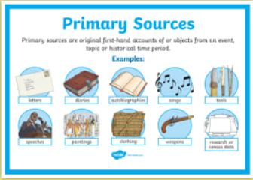  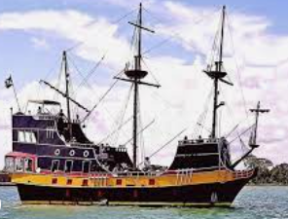  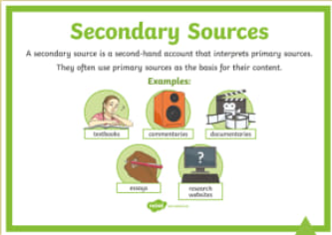  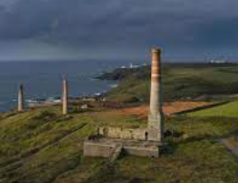  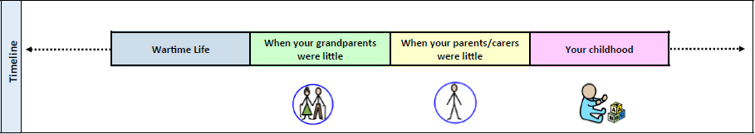  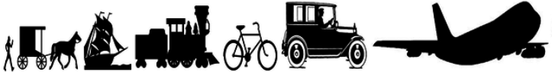  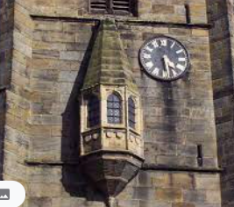  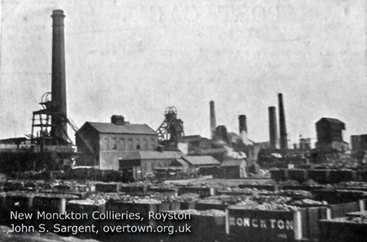  To find out about history, we look at information. If the information comes from somebody or thing which was at the event (diary, photo, newspaper, artefact, video, letter etc) then this is a primary source. If the information comes from after the event by someone who was not there (newspaper, biography, recount), then this is a secondary source.  Cornwall was also famous for piracy and smuggling during the Elizabethan era. It was the job of the wrecker to prey on ships passing Cornwall’s rocky coastline. Many boats could be easily hidden in the many coves and inlets, which also made for great hiding places for smuggled goods. Cornwall was so famous for pirates that the accent is now universally recognised as the voice of a pirate. Many famous pirates traded from Cornwall including Edward Teach, better known as Blackbeard, who died in 1718.  Cornwall was famous for its tin mines in the 1700’s and supplied much of England during the Middle Ages.  The way our grandparents travelled was different to how we travel today, and technology was very different. Not many people had fridges, t.v’s or phones in their homes until 1960’s  The church in Royston (St John’s) was built in 1234 when Henry 3rd was on the throne and the crusades were happening. It has a clock, a sundial and a ring of 8 bells. It is one of a few churches in England with an oriel window and was used as a navigational landmark for travellers.  An Oriel window is a form of bay window which protrudes from the main wall of a building but does not reach the ground.  It has been found that people of Royston have a slightly different accent from other villages in Barnsley. This is due to people from the Midlands coming to work at Monckton colliery when their mines were closed.  Barnsley used to make linen, coal, glass and textiles. Due to its mining communities, it has a tradition of brass bands. It was called Berneslai in the Domesday Book originating from the Saxon words for barn and field (Berne Lay)
after | later in time than, or behind in order
before | at an earlier time, in the past
century | equal to one hundred years
chronology | the order of events in time
differences | the condition of being different from or not alike
during | throughout the entire time of
new | having recently arrived, been produced, or come into being
now | at this time or in these times
old | having existed for many years; not new
older | having lived for many years
past | having happened or gone by at an earlier time
present | existing at this time; current
sibling | a sister or a brother
similarity | likeness
technology | devices which are the result of scientific knowledge being used for practical purposes
then | soon after; next
usually | most common or expected
younger | earlier stage of life
primary source | tells you about an event from the past and is from the time of that event
secondary source | tells you about an event from the past, but was written by after the event by someone who was not present at the event
Oriel window | form of a bay window which does not touch the ground
Domesday book | a survey commissioned by Edward the Conqueror to assess the wealth and assets of the people across England

Art
What should pupils already know/do? |  |  | What will pupils learn/do? |  |  | Where will this learning go?
Yr1  * use what they have learned about media and materials in purposeful and original ways.  * represent their own ideas, thoughts and feelings through art and design  * use and explore a variety of materials, experimenting with colour, design, texture, shape and form.  Yr2  Drawing  * communicates something about themselves in their drawing  * Creates moods in their drawings  * draws using pencil and crayons  * draws lines of different shapes and thickness, using 2 different grades of pencil  Knowledge  * describes what they can see and like in the work of another artist  * asks sensible questions about a piece of art |  |  | Yr1  Drawing  * communicates something about themselves in their drawing  * Creates moods in their drawings  * draws using pencil and crayons  * draws lines of different shapes and thickness, using 2 different grades of pencil  Knowledge  * describes what they can see and like in the work of another artist  * asks sensible questions about a piece of art  Yr2  Drawing  * uses three different grades of pencil in their drawing (4B, 8B, HB)  * uses charcoal, pencil and pastels  * creates different tones using light and dark  * shows patterns and texture in their drawings  * uses a viewfinder to focus on a specific part of an artefact before drawing it  Knowledge  * link colours to natural and man-made objects  * say how other artists have used colour, pattern and shape  * create a piece of work in response to another artist’s work |  |  | Lks2  Children will build on their Ks1 knowledge to explore how to show facial expression and body language in their own and others’ drawings. They will explain their sketches in relation to using different tones, lines, shapes, colours and textures to represent figures and forms in movement. They will explore work from other cultures across Europe and begin to think about the viewpoints of an artist by exploring their use of techniques.  UKs2  Children will then build on all previous knowledge again communicate emotions and a sense of self with accuracy and imagination through their sketches. They will explore how to use shading to create mood, exploring the effect of different line, tone, shape and colour and explaining how their work is influenced by other artists and their use of techniques.
Key Vocabulary |  | 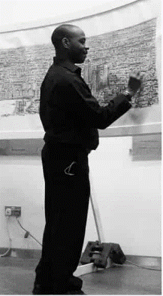  Stephen Wiltshire, an architectural illustrator, is an artist who draws detailed cityscapes which include landmarks from around the UK and Europe. His drawings are popular all over the world, and are held in a number of important art collections and museums. He was born in 1974 in London to West Indian parents. As a child, he was mute and did not relate to other people. Living in a world with no communication, he began to draw. Aged 3 he was diagnosed with autism, and aged 7, he sold his first piece of artwork. He was awarded an MBE for services to the art world in 2006.  Pablo Picasso is one of the most famous artists of the 21st century. He likes to experiment and try out lots of new ideas. Picasso was born in Malaga in Spain in 1881, but in 1904 when he was 23, he moved to Paris. This was because Paris was capital of the avant-garde, which means cutting-edge! Picasso became friends with lots of artists and writers, like George Braque, who he invented Cubism with. He became interested in art from other continents and you can see some of these influences in his paintings.  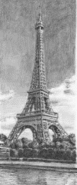  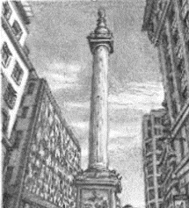  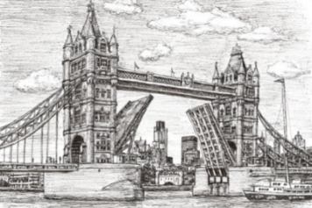  One of Picasso’s most famous periods in art, is the Cubist period. Cubism is when the artist paints an object, like a bottle, from lots of different angles all in the same picture. So you see the front, the back and the sides of the bottle at the same time! He painted lots of portraits this way.  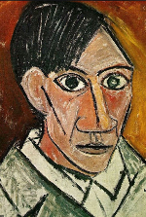  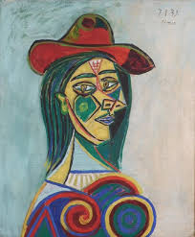
investigate | To examine something carefully to find out more about it.
discuss | To talk about something in detail to another person or people.
media | Material used to create something.
line | Using different types of lines to create an image (curved or straight).
shape | A 2D area with an outline.
pattern | A design where lines, shapes or colours are repeated.
design | To sketch and plan a piece of art work.
primary colours | One of the three colours, red, yellow, and blue, that can be mixed together in different ways to make any other colour.
secondary colours | One of the three colours – orange, green, or purple – that can be made by mixing together two of the primary colours.
examine | Look carefully at something in detail to find something out.
artist | Somebody who paints, draws, or makes sculptures.
mix | To combine things (paint) together so they can’t be easily separated.
landscape | The longer sides of a piece of paper at the top and bottom. | cross-hatching |  | A method of line drawing that describes light and shadow | 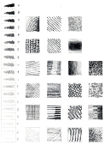  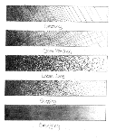  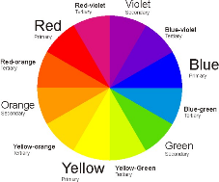
portrait | The shorter sides of a piece of paper at the top and bottom. |  |  | A method of line drawing that describes light and shadow
Cubism | A style of modern art in which an object or person is shown as a set of geometric shapes. | blending/smudging |  | Gently mingling two or more colours to soften lines
cityscapes | A piece of art work showing a city. |  |  | Gently mingling two or more colours to soften lines
architecture | The design and construction of buildings. | hatching |  | Technique used to shade in lines
illustrator | A person who draws or creates pictures. |  |  | Technique used to shade in lines
perspective | Creating or representing 3D shapes, on a 2D surface. | scumbling |  | Shading technique achieved by overlapping lots of little circles
proportion | The correct relationship of the parts of a work of art to each other, especially in their size.
texture | The surface of the art work. It can be made to look flat or 3D. | stippling |  | Use of dots to create texture and shade
technique | The way of doing something that requires skill. |  |  | Use of dots to create texture and shade
form | The shape or appearance of an object. | landmark |  | An object on land that marks a locality

