Who do you think you are?


Who do you think you are?
What makes me the same or different?
What makes me special?
Who am I?
Where do I live?

Cycle A: Exploration 1
LKs2

Cycle A - Exploration 1 – LKs2 - Who do you think you are?
Exploration Objectives Overview
Curriculum Drivers: Global (Identity & diversity), Science (Animals including humans) & Geography (Local area study)

Subject | Yr3 | Yr4 | Subject | Yr3 | Yr4
Global  To open up the world | Identity and diversity  * diversity of cultures and societies within and beyond own experience  * contribution of different cultures to our lives  * nature of prejudice, racism and sexism and ways to combat these |  | RSE | Families and people who care for me:  * Recognise different types of relationships, including those between acquaintances, friends, relatives and families.  * That civil partnerships and marriages are examples of a public demonstration of the commitment made by 2 people who love and care for each other and want to spend their lives together and who are of legal age to make that commitment.
Science  Through investigation, develop a sense of excitement and curiosity of natural phenomena | Animals including humans:  * identify that humans and some animals have skeletons and have muscles for support, protection and movement  Planning:  * use different ideas and suggest how to find something out  * make and record a prediction before testing  * plan a fair test and explain why it was fair  * set up a simple fair test to make comparisons  * explain why they need to collect information to answer a question  Obtaining and presenting evidence:  * measure using different equipment and units of measure  * record their observations in different ways (labelled diagrams, charts)  * describe what they have found using scientific words  * make accurate measurements using standard units  Considering evidence and evaluating:  * explain what they have found out and use their measurements to say whether it helps to answer their question  * use a range of equipment (including a data-logger) in a simple test | Animals including humans:  * identify and name the basic parts of the human digestive system  * describe the function of the organs of the human digestive system  * identify the simple function of different types of human teeth  * compare the teeth of herbivores and carnivores  * explain what a simple food chain shows.  Planning:  * set up a simple fair test to make comparisons  * plan a fair test and isolate variables and explain why it was fair and explain which variables have been isolated  * suggest improvements and predictions  * decide which information needs to be collected and decide which is the best way for collecting it is  * use their findings to draw a simple conclusion  Obtaining and presenting evidence:  * take measurement using different equipment and units of measure and record what they have found in a range of ways  * make accurate measurements using standard units  * explain their findings in different ways (display, presentation and writing)  Considering evidence and evaluating:  * find any patterns in their evidence or measurements  * make a prediction based on something they have found out  * record and present what they have found using scientific language, drawings, labelled diagrams, bar charts and tables | Geography  To develop an understanding of the impact of the world’s physical and human processes: past, present and future | Geographical Enquiry  * use correct geographical words to describe a place and the things that happen there.  * identify key features of a locality by using a map  * begin to use a 4 figure grid references  * accurately plot NSEW on a map  * use some basic OS map symbols.  * make accurate measurement of distances within 100Km.  Physical Geography  * Use maps and atlases appropriately by using contents and indexes.  * Confidently describe physical features in a locality.  * Recognise the 8 points of the compass (N,NW, W, S, SW, SE, E, NE).  Human Geography  * Confidently describe human features in a locality.  *Explain why a locality has certain human features.  *Explain why a place is like it is.  Geographical Knowledge  * Name a number of countries in the Northern Hemisphere.  * Name and locate some well-known European countries.  * Name and locate the capital cities of neighbouring European countries.  * be aware of different weather in different parts of the world, especially Europe. | Geographical Enquiry  * Carry out a survey to discover features of cities and villages.  * Find the same place on a globe and in an atlas.  * Label the same features on an aerial photograph as on a map.  * Plan a journey to a place in England.  * Accurately measure and collect information (e.g. rainfall, temperature, wind speed, noise levels etc.).  Physical Geography  * Describe the main features of a well-known city.  * Describe the main features of a village.  * Describe the main physical differences between cities and villages.  * Use appropriate symbols to represent different physical features on a map.  Human Geography  * Explain why people are attracted to live in cities.  * Explain why people may choose to live in a village rather than a city.  * Explain how a locality has changed over time with reference to human features.  Geographical Knowledge  * locate the Tropic of Cancer and the Tropic of Capricorn.  * Know the difference between the British Isles.  *Locate and name some of main islands that surround the UK.  * Name the areas of origin of the main ethnic groups in Great Britain and UK.  * Know the countries that make up the European Union.  * name up to six cities in the UK and locate them on a map of the UK
History  To learn from the past in order to impact the future | Chronological Understanding:  * describe events from the past using dates when things happened  * describe events and periods using the words: ancient and century  * use a timeline within a specific time in history to set out the order things may have happened  * use their mathematical knowledge to work out how long ago events would have happened  Knowledge and interpretation:  * suggest why certain events happened as they did in history  Historical Enquiry:  * use various sources of evidence to answer questions  * use various sources to piece together information about a period in history  * research a specific event from the past  * use their ‘information finding’ skills in writing to help them write about historical information  * through research, identify similarities and differences between given periods in history | Chronological Understanding  * plot recent history on a timeline using centuries  * place periods of history on a timeline showing periods of time  * use their mathematical skills to round up time differences into centuries and decades  Knowledge and Interpretation  * explain how events from the past has helped shape our lives  * know that people who lived in the past cooked and travelled differently  Historical Enquiry  * research two versions of an event and say how they differ  * research what it was like for a child in a given period from the past and use photographs and illustrations to present their findings  * give more than one reason to support an historical argument  * communicate knowledge and understanding orally and in writing and offer points of view based upon what they have found out | Art  To learn how Art & Design reflect and shape our world | Drawing:  * show facial expression in their drawings  * use their sketches to produce a final piece of work  * write an explanation of their sketch in notes  * use different grades of pencil shade to show different tones and texture  Sketch books:  * use their sketch books to express feelings about a subject and to describe likes and dislikes  * make notes in their sketch books about techniques used by artists  * suggest improvements in their work by keeping notes in their sketch books  Knowledge:  * compare the work of different artists  * explore work from other cultures  * explore work from other periods of time  * begin to understand the viewpoints of others by looking a images of people and understand how they are feeling and what the artist is trying to express in their work | Drawing  * begin to show facial expressions and body language in their sketches  * identify and draw simple objects, and use marks and lines to produce texture  * organise line, tone, shape and colour to represent figures and forms in movement  * show reflections  * explain why they have chosen specific materials to draw with  Sketch books:  * use their sketch books to express their feelings about various subjects and outline likes and dislikes  * produce a montage all about themselves  * use their sketch books to adapt and improve their original ideas  * keep notes about the purpose of their work in their sketch books  Knowledge  * experiment with different styles which artists have used  * explain art from other periods of history

Cycle A - Exploration 1 – LKs2  Who do you think you are?  Throughout the exploration, children continue to learn about themselves and begin to think about diversity, both across different bodies and European localities. They learn about diversity within the human race in relation to the functions of different parts of the body, and explore the nature of prejudice, racism and sexism, thinking about ways to combat these. They learn about the Geographical features of their local area, the UK and Europe, exploring diversity of culture and society, exploring the idea of themselves as part of a community to answer the question of who they think they are. |  |  |  |  | Learning - Identity & Diversity  Science driver – Animals including humans (Biology)  Geography driver - Study of Local areas, UK and Europe (Barnsley, South Yorkshire, UK, Europe)
What should pupils already know? |  | What will pupils learn? | Where will this learning go?
* uniqueness and value of every person  * Similarities and differences between self and others  * Similarities and differences between people in local setting and also in wider settings in the UK  * what contribute to self-identity and belonging |  | * diversity of cultures and societies within and beyond own experience  * contribution of different cultures to our lives  * nature of prejudice, racism and sexism and ways to combat these | Later in LKs2  Pupils will build on their knowledge of diversity to explore causes of inequality and why some people have their rights denied. They will think about global connections and how people can take part in making and changing rules in the wider society.  Uks2  Again extending their learning to a global community and world migration, pupils will build on previous knowledge to think about the benefits and challenges of diversity; the impacts of stereotyping, prejudice and discrimination and how to challenge these; and the importance of language, beliefs and values in cultural identities.  As lifelong citizens  Pupils will be equipped to understand the importance of self-identity and belonging across the world. They will understand the need for migration and seeking refuge, and have empathy towards the different people that they meet throughout life, embracing diversity and culture. They will challenge forms of stereotyping, prejudice and discrimination in order to be an active, important member of society.
SOLO Taxonomy | Uni-structural knowledge |  | Multi-Structural knowledge | Relational knowledge |  | Extended | Abstract
SOLO Taxonomy |   I have one relevant bit of knowledge |  |   I have several bits of key knowledge | 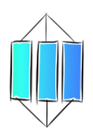  I can see links between my bits of key knowledge |  | 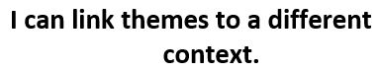  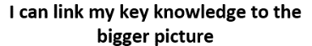  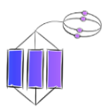
Spaced Questions | - What am I?  2 weeks |  | - Where do I live?  2 weeks | - What makes me the same or different?  2 weeks |  | - What makes me special?  1 week | - Who do you think you are?  1 week
Key substantive knowledge | Yr3  * identifies that humans and some animals have skeletons and have muscles for support, protection and movement  Yr4  * identifies and names the basic parts of the human digestive system  * describes the function of the organs of the human digestive system  * identifies the simple function of different types of human teeth  * compares the teeth of herbivores and carnivores  * explains what a simple food chain shows. |  | Yr3:  * Uses geographical words to identify key physical features of the UK by using maps and atlases  * Explains why UK is like it is, identifying certain human features  * Names a number of countries in the Northern Hemisphere.  * Names and locates some well-known, neighbouring European countries, including capital cities and flags  * recognises cloud formations  * names trees, flowers and wildlife indigenous to UK  Yr4  * Names up to 6 cities in the UK and locates them on a map  * Describes the main features of and physical differences between a city and a village, explaining why people are attracted to live in both.  * Locates and names some of the main islands that surround the UK, knowing the difference between the British Isles  * Knows the countries that make up the European Union, including capital cities and flags  * Locates the Tropic of Cancer and the Tropic of Capricorn  * names some trees, flowers and wildlife indigenous to Europe | All LKs2 at own level:  * Names similarities and differences between humans including sex, race, illness and disability  * Names similarities and difference of UK and Europe including physical and human features of localities, and culture.  Yr3:  * Explains how Barnsley has changed over the years with reference to the closure of the coal mines  * Is aware of different weather in Europe.  Yr4:  * Explains how South Yorkshire has changed over time with reference to the closure of the mines and Sheffield steel works  * Name the areas of origin of the main ethnic groups in Great Britain and UK.  All LKs2 at own level:  * diversity of cultures and societies within and beyond own experience  * Recognise different types of relationships, including those between acquaintances, friends, relatives and families.  * That civil partnerships and marriages are examples of a public demonstration of the commitment made by 2 people who love and care for each other and want to spend their lives together and who are of legal age to make that commitment. |  | All LKs2 at own level:  * Explains what makes them special as a person including how their body’s work, the way they look, their sex, their race, their tradition and culture, what religion they are etc  * Explain what makes locality, UK and Europe special  * contribution of different cultures to our lives  * nature of prejudice, racism and sexism and ways to combat these | All LKs2 at own level:  * Explains how what they are, what they look like, where they live and the impact of cultures contribute to who they are as a person  * Discusses what contributes to self-identity and diversity
Answer Guideline:  Assessment at each stage will allow children to show their learning in relation to the spaced question.  Assessment of children’s learning can be gained from oral discussion and writing, but must also be gained through curriculum area activities such as worksheets, quizzes and short tests etc.  This ensures that children who struggle to express their learning through speaking or writing are not at a disadvantage when expressing their learning in relation to the taught curriculum objectives. | Yr3 – Knows that some animals including humans have backbones, and that some animals don’t. Knows that animals with backbones are called vertebrates, and that these backbones can be endoskeletons (on the inside of the body) or exoskeletons (on the outside of the body) giving examples of animals with these different skeletons.  Knows that the skeleton gives us support and shape. Names and recognises the different bones of the human skeleton: cranium, clavicle, ribs, elbow, spine, pelvis, hip, femur, knee, ankle. Knows where bones join and that these are joints. Knows how muscles are connected joints by tendons, and that they contract and relax to allow us to move, explaining what would happen if a muscles didn’t work correctly.  Yr4 – Describes a simple food chain, knowing how energy passes producers to consumers. Knows why animals including humans have a digestive system naming and recognising the different parts and their function within it: mouth; tongue and teeth to chew food (including the need for different teeth: molars and premolars to grind and crush food, canine to chew and break lumps down, incisors to tear and bite, and how teeth are different dependent on diet of food being eaten and how to keep them healthy discussing plague; knowing that saliva helps food to be ingested; the oesophagus uses muscles to push food to the stomach; the stomach mixes food with bile to break it down; the small intestine absorbs nutrients; the large intestine moves food to the rectum where muscles turn it to faeces which is then excreted through the anus. |  | Yr3 – Finds countries of UK using 4 figure grid reference, aerial images, maps, atlases and compass points, describing human and physical features of them countries including capital cities and key landmarks. Names and locates neighbouring European countries such as France, Spain, Italy, Germany, Portugal, Netherlands, Belgium and Denmark, knowing their capital cities and recognising their flags and knowing that they are in the Northern Hemisphere. Recognises cloud formations: cirrus, cumulus, stratocumulus. Recognises horse chestnut trees, sycamore trees, oak trees, Beech trees, cornflowers, forget-me-nots, foxgloves, columbine, foxes, hedgehogs, squirrels, badgers, roe deers, beavers, otters, bats, robins, magpies, owls, wood pigeons, sparrows, blackbirds and sparrows.  Yr4 – Finds UK cities on maps describing how their physical and human features are different to a village. Locates and names British islands of Britain, Ireland, the Hebrides, the Shetland islands, the Orkney islands, the isles of Scilly and the Isle of Man, knowing that these islands as a group are called the British Isles. Knows that the 6 founding countries of the European Union are Belgium, France, Germany, Italy, Luxemburg and the Netherlands, knowing their capital cities, landmarks and flags. Locates countries of Europe on a 4-figure grid map, globe, atlas discussing their position in relation to the equator, understanding that they are in the northern hemisphere. Knows that the tropic of Cancer the most northerly circle on Earth at which the sun can be directly overheard. Names trees, flowers, mammals and birds as Yr3 as well as Silver Birch trees, scarlet pimpernels, wood mouse, great tit and animals indigenous to Europe: bison, brown bear, eagles and moose. | Yr3 – Names similarities and differences between animals including humans, developing explanations to include how skeletons and muscles work in different animals and how illness and/or disability in relation to the skeleton and muscles makes our lives different. Continues to develop understanding of different family structures including civil partnerships. Explains how their locality is similar and different to others across UK describing key physical features (landscape, homes, facilities and buildings) and human features (coal mining) of each locality including comparing places of worship and understanding some different religions within UK. Explains how their locality was different in the past with reference to the coal mining industry.  Yr4 - – Names similarities and differences between animals including humans, developing explanations to include how the digestive system works in different animals and how illness and/or disability in relation to digestion makes our lives different. Continues to develop understanding of different family structures including civil partnerships. Explains how their locality is similar and different to others across Europe describing key physical features (landscape, homes, facilities and buildings) and human features (steel industry) of each locality including comparing places of worship and understanding some different religions within UK. Knows that the origin of the main ethnic groups in Britain is Europe, Asia (Indian, Pakistani, Bangladeshi, Chinese), Africa and Caribbean. Explains how their locality was different in the past with reference to the Sheffield Steel industry. |  | Lks2 - Explains how our bodies are special for survival, that the way our body works and looks is unique to us including our sex and race; how our families and history are special and contribute to our identities; how our locality is special compared to others including the contribution of other ethnic groups, culture and traditions. How everyone is unique and special and that this knowledge can help to combat prejudice, racism and sexism. | Lks2 – Brings all their learning together to explain that what they are, what they look like, how they live with their families, what they believe in, where they live and their history contributes to who they are as a person and their sense of belonging. Discusses how humans are made the same but are all different in relation to their families, their heritage, their beliefs, where they live and/or as a result of disability/illness. Discusses how it’s good that we are all different and it’s important to keep your heritage and beliefs (sense of identity) and feel that you belong, while accepting everyone’s uniqueness to combat prejudice, racism and sexism. Eventually bring all scientific, geographical , historical and global learning together to answer the question “Who do you think you are?”

Anchor novel/s | Yr3 | 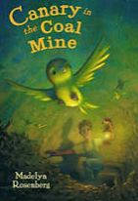  Through the complex novel “Canary in the Coal mine” by Madelyn Rosenberg, pupils will explore how uniqueness, courage and strength of character can help to improve others’ lives. They will explore their own setting and history in relation to the coal mining within Barnsley, thinking about the perilous working conditions and the plight of the miners which led to the strikes and became a large part of their heritage. They will begin to think about how we might judge others on their actions and where they are from. | 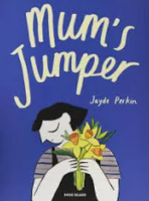  Through the novel “Mum’s Jumper” by Jayde Perkin, pupils will explore the theme of loss and grief and think about the uniqueness of their own family. Exploring who is special in their lives and how they contribute to self-identity. They will explore how we deal with their own grief and who can support them through times when they feel sad in life.
Anchor novel/s | Yr4 | 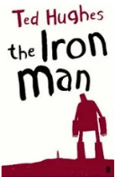  Through the complext novel “The Iron Man” by Ted Hughes, pupils will explore the theme of belonging and identity alongside making pre judgements on people and combatting prejudice as the Iron Man befriends a small boy and helps the town where he has settled.
Writing Purpose | Yr3 | To inform (4 Weeks)  Report on the UK including the coal mining industry in Barnsley | To inform/entertain (2 weeks)  Character description of themselves | To offer a viewpoint  Collage to represent selves
Writing Purpose | Yr4 | To inform (4 Weeks)  Report on Western Europe including the Steel industry in Sheffield. |  | To offer a viewpoint  Collage to represent selves

Key people linked to Curriculum areas for Explore
Global |   I think everybody is weird. We should all celebrate our individuality and not be embarrassed or ashamed of it.  Johnny Depp |  | 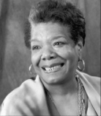  It is time for us to teach young people that in diversity there is beauty and there is strength.  Maya Angelou |  |  | 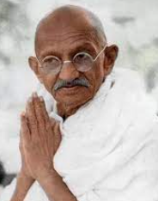  Our ability to reach unity in diversity will be the beauty and the test of our civilization.  Mahatma Ghandi |  |  |  | 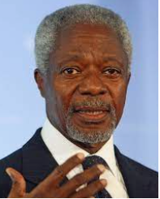  We may have different religions, different languages, different coloured skin, but we all belong to one human race.  Kofi Annan |  |  |  | 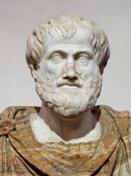  Knowing yourself is the beginning of all wisdom Aristotle |  |  |   I love me, and I would never change anything about me. I’m not asking you to like me. I’m just asking you to let me be me.  Serena Williams
Literacy | 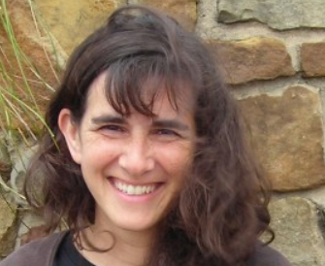  Madelyn Roesenburg is an American author who wanted to be a writer from being very young. She often writes about events in history using animals or child characters in order for children to access the themes of identity and standing up for others’ rights. |  |  |  | 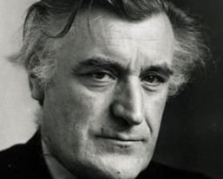  Edward (Ted) Hughes was an English poet who lived from 1930-1998 and was born in West Yorksire, later living in Mexborough. He has been hailed as one of the best poets of his generation. He was married to another famous poet, Silvia Plath until 1956, and received an OBE for his services to literature. |  |  |  |  |  |  |  | 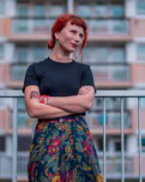  Jayde Perkin is an author and illustrator based in Bristol, England. She is well-known around the world for her comics and books which deal with loss, following her own mum’s death from cancer in 2016.
Science | 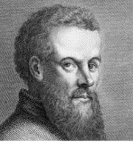  Andreas Vesalius was a Flemish scientist living from 1514-1564. He is often referred to as the founder of modern human anatomy being interested in the bones of the human body. |  |  | 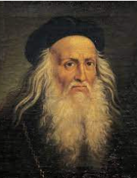  Leonardo Da Vinci was an Italian artist, engineer and scientist living from 1452-1519. As well as painting famous pieces such as the Mona Lisa painting, Da Vinci was the first person to draw the human skeleton correctly. |  |  |  | 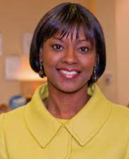  Dr. Samantha Tross, born 1968, is the first black female to becom an orthopaedic surgeon in Britain, and is regularly recognized as one Britain’s most influential black Britons. |  |  | 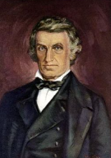  William Beaumont (1785-1853) was an American surgeon who is known as the father of gastric science following his research on human digestion. |  |  |  | 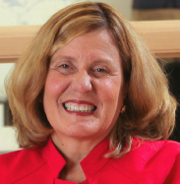  Rebecca D. Jackson, born in America in 1955, is a medical researcher and professor of diabetes and metabolism. Her research has been significant in the treatment of osteoporosis. She received a spinal cord injury in the 1970’s and has used a wheelchair ever since.
History | 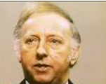  Arthur Scargill (born 1938) is a British trade unionist who is best known for leading the 1984-85 miners’ strike. | 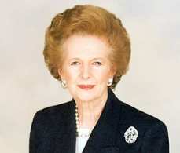  Margaret Thatcher who lived from 1925-2013 was the first female prime minister of the UK (1979-1990). Her plans to close many coal mines led to the miners’ strike in 1984-85. |  |  |  |  | 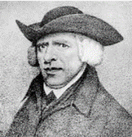  Benjamin Huntsman (1704-1776) was an English inventor who created the process of melting steel to improve the quality and allow it to be poured into moulds. This crucible steel meant that items such as cutlery, tools and machinery could be made on mass and paved the way for the industrial revolution. |  |  |  |  | 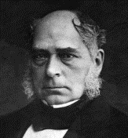  Sir Henry Bessemer was an English inventor who lived from 1813-1898. He created a process which made steel easier, quicker and cheaper to make, establishing Sheffield as a major industrial centre. |  |  |  |   Sonya Malvick is the international president of “women in the metal industry” and has been in the steel industry for over 29 years, promoting females in STEM jobs.
Art | 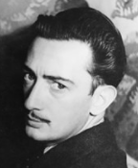  Salvador Dali (1904-1989) was a Spanish surrealist artist reknowned for his striking and bizarre images. He was interested in Cubism by Pablo Picasso and then moved closer to Surrealism in the late 1920’s. |  |  |  |  |  |  |  | 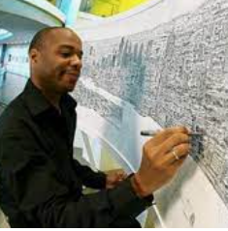  Stephen Wiltshire is a British artist who was born in London in 1974. After being a mute in childhood, Stephen was diagnosed with Autism aged 3. At 5, he attended a school where it was noticed that he enjoyed drawing and it soon became apparent that he could communicate with the world through his drawings. He now draws and paints detailed cityscapes, and has received a MBE from the queen.

Science driver – Animals including humans (Biology)
What should pupils already know? |  | What will pupils learn? |  |  |  |  |  | Where will this learning go?
Yr3  * differences between different animals  * classification of common animals  * main parts of an animal’s body including humans  * a range of domestic animals  * common, local flora and fauna  Yr4  * Basic survival needs of animals  * Life cycles of some living things  * Importance of exercise and a balanced diet  * Common flora and fauna indigenous to UK |  | Yr3  * humans and some animals have skeletons, and have muscles for support, protection and movement  Yr4  * the basic parts of the human digestive system  * the function of the organs of the human digestive system  * the simple function of different types of human teeth  * the teeth of herbivores and carnivores  * what a simple food chain shows. |  |  |  |  |  | UKs2  Pupils will then build on previous knowledge to identify the 5 kingdoms of all living things, the function and health of major organs in the body, evolution and inheritance thinking about climate change and how to care for the environment.  Ks3  Pupils will then build on all previous knowledge to explore the structure and function of living organisms including the skeletal and muscular systems, and nutrition and digestion, thinking about the tissues and organs of the human digestive system.
Key Vocabulary |  |  | 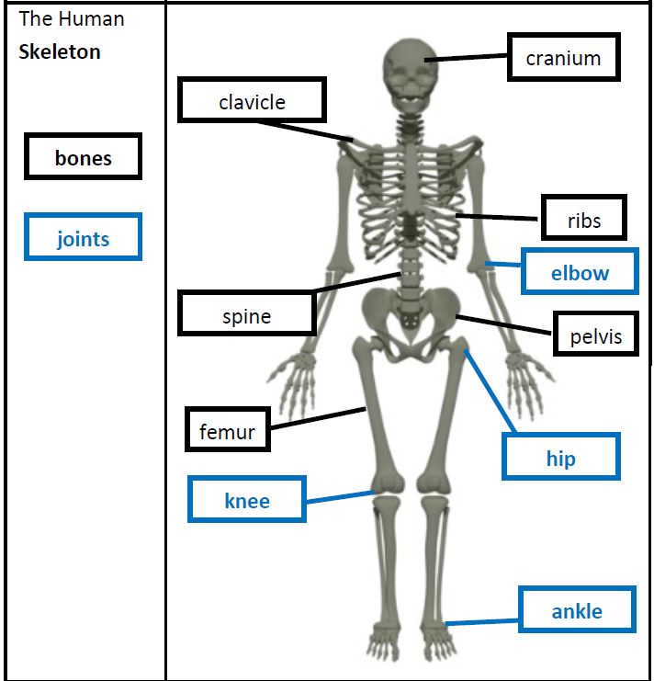 |  | 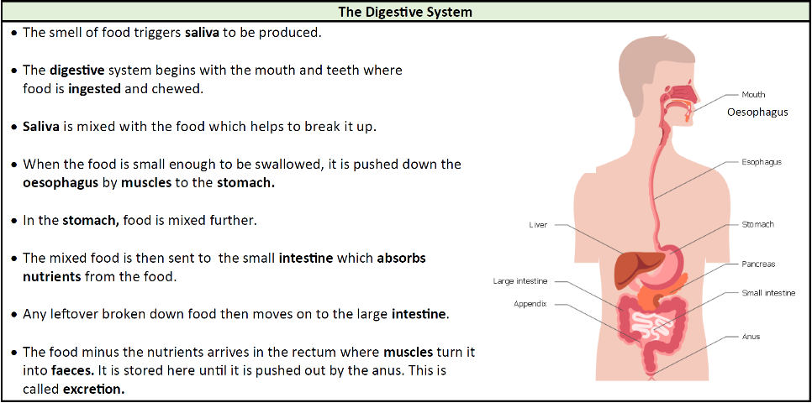  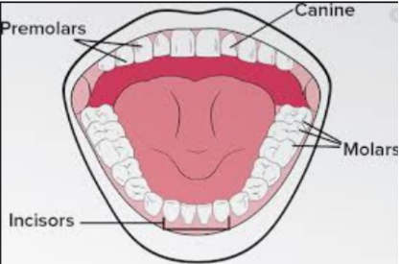  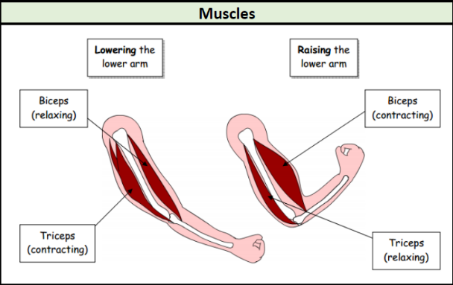
backbone | the column of small linked bones down the middle of your back
carnivore | an animal that eats meat
herbivore | an animal that only eats plants
omnivore | person or animal eats all kinds of food, including both meat and plants
vertebrate | a creature which has a backbone
bones | the hard parts inside your body which form your skeleton
skeleton | The framework of bones in your body
Endoskeleton | The internal skeleton of an animal
Exoskeleton | The protective or supporting structure covering the outside of the body of many animals
Contract | To make smaller by drawing together; shrink or make tighter
Elbow | The bend or joint between the upper arm and the lower arm
Joints | The junction between two or more bones
Muscles | Something inside your body which connects two bones and which you use when you make a movement
Organs | A part of your body that has a particular purpose
Protect | Prevent something/one from being harmed or damaged
Support | To hold something up
Tendons | A strong cord in a person’s or animal’s body which joins a muscle to a bone |  | What are the different types of skeletons? | 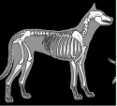  * Vertebrates are animals that have a backbone. These skeletons are called endoskeletons – this means that the skeletons are on the inside of the body. These skeletons grow with the body.  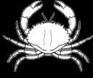  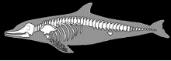  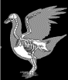  When the skeleton is outside the body, it is called an exoskeleton. An exoskeleton is a covering that supports and protects animals. These have to be shed and a new skeleton is grown.  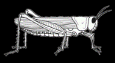 | What is the role of our teeth and how we do look after them? | * Teeth are used for cutting and chewing food  * They start the digestive process which gives us the energy we need to live  * Humans look after their teeth by brushing and flossing and ensuring that they do not eat foods high in sugar.  * Not looking after your teeth can lead to an increase in plaque and tooth decay. | 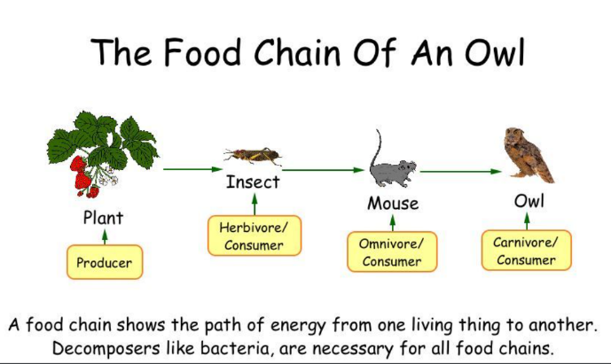  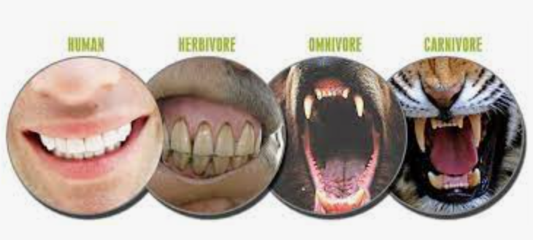
Absorb | Soak up or take in
Canine | Pointed teeth near the front of the mouth of humans and some animals
Decay | Gradually destroyed by a natural process
Digestion | Breaking down ingested food material
Enamel | The hard white substance that forms the outer part of a tooth
Excretion | The process of eliminating faeces, urine or sweat from the body
Faeces | The solid waste substance that people and animals get rid of from their body by passing it through the anus
Incisor | The teeth at the front of your mouth which you use for biting into food
Intestines | The tubes in your body through which food passes when it has left your stomach
Nutrition | The process of taking food into the body and absorbing the nutrients in those foods
Molar | The large flat teeth towards the back of your mouth that you use for chewing food
Oesophagus | The part of your body which carries the food from the throat to the stomach |  | What does an endoskeleton do? | the three most important things a skeleton does are:  * provide support and shape to an animal’s body  * allow movement through the joints  * protect organs | What are the different names and functions of human teeth? | * Canines are pointed for tearing and ripping food – these are usually used when chewing meat.  * incisors are shovel shaped and help bite lumps out, and cutting food  * Premolars and molars are flat and they grind and crush food.
Plaque | A substance containing bacteria that forms on the surface of your teeth
Premolar | Teeth situated on each side of the jaw between the first molar and the canine
Saliva | The watery liquid that forms in your mouth and helps you to chew and digest food
Stomach | The organ inside your body where food is digested before it moves into the intestines |  | How do we move? | * Joints, where bones meet, allow us to bend  * muscles contract and relax  * muscles are connected to bones by tendons | What are the different names and functions of human teeth?
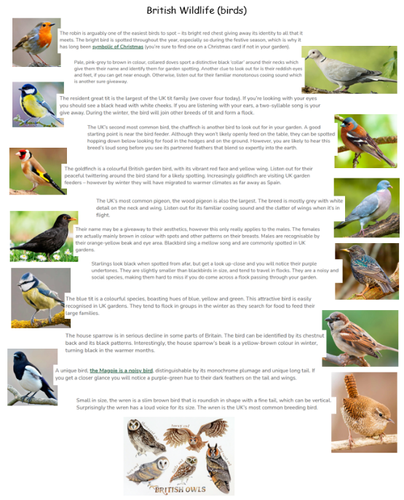
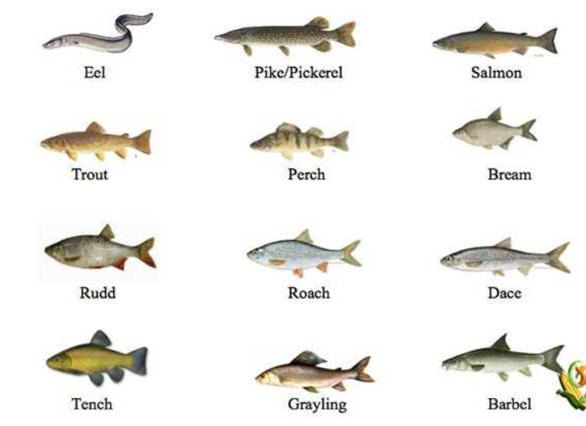
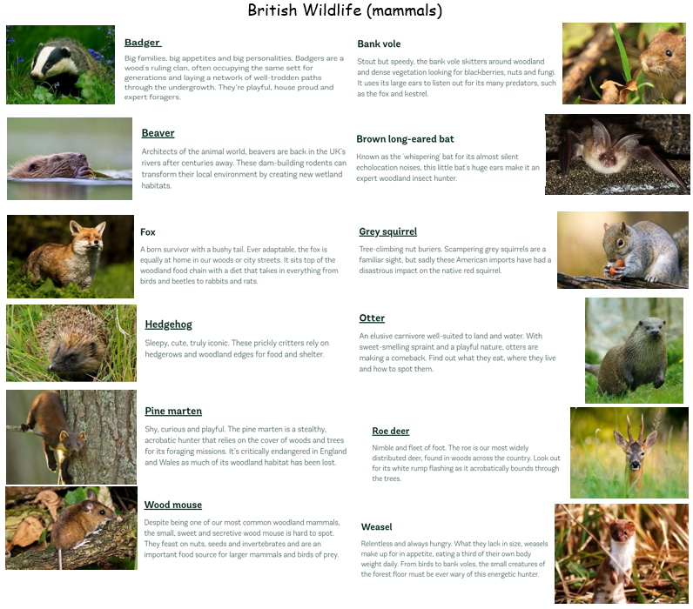
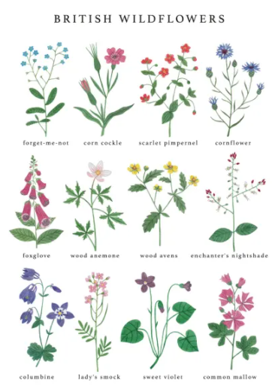
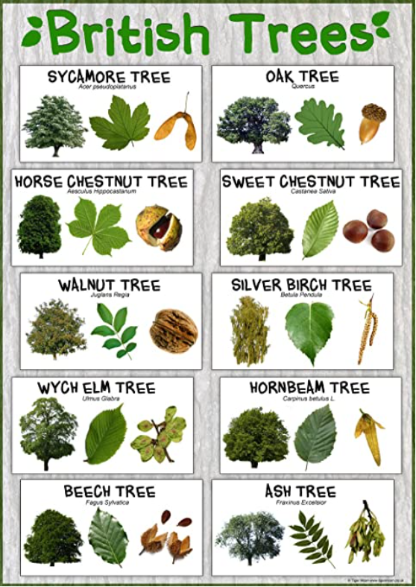
https://www.farmingplan.com/freshwater-fish/

https://www.woodlandtrust.org.uk/trees-woods-and-

wildlife/animals/mammals/

https://www.rspb.org.uk/birds-and-wildlife/wildlife-guides/bird-a-z/ The Rabbit Ings Country Park is home to all 5 species of British owls.

Geography driver – Study of local area and UK (locational knowledge/human and physical geography)
What should pupils already know/do? |  | What will pupils learn/do? |  | Where will this learning go?
Y3  * 4 countries of the UK, including capital cities, main towns and cities, flags and anthems.  * Locates equator, North pole and South pole, oceans and continents on a globe and in an atlas.  * uses 2 figure grid reference maps  * Key physical and human features of localities  * basic cloud formations  * use aerial images, perspectives, maps, atlases and simple keys.  Yr4  * use 4 figure grid references, plotting 4 compass points  * recognise 8 points of compass  * number of countries in the Northern hemisphere  * Well-known European countries.  * capital cities of neighbouring European countries  * different weather patterns in different parts of the world, especially Europe |  | Yr3  * identify key features of a locality by using a atlases and maps with 4 figure grid references  * use some basic OS map symbols and accurately plot NSEW on a map, recognising the 8 points.  * Confidently describe physical and humans features in a locality.  * Countries in the Northern Hemisphere.  * Well-known European countries.  * Capital cities of neighbouring European countries.  * Different weather patterns in different parts of the world, especially Europe.  Yr4  * Carry out a survey to discover and name features of cities and villages, explaining why people are attracted to both.  * Find the same place on a globe and in an atlas, labelling the same features on aerial photos and maps.  * Plan a journey to a place in England.  * Use appropriate symbols to represent different physical features on a map.  * Explain how a locality has changed over time with reference to human features.  * locate the Tropic of Cancer and the Tropic of Capricorn.  * Know the difference between the British Isles.  *Locate and name some of main islands that surround the UK.  * Name the areas of origin of the main ethnic groups in Great Britain and UK.  * Know the countries that make up the European Union.  * name up to six cities in the UK and locate them on a map of the UK |  | UKs2  Children will then build on all previous knowledge again to use a range of resources including scaled maps and atlases to name and locate the equator/tropics of Cancer and Capricorn/Arctic and Antarctic circles, continents and countries of the world/capital cities/flags. They will develop their knowledge of physical features to learn about oceans, rivers, mountains, deserts and time zones of the world. They will develop their knowledge of human features to learn about land use and economics.
Key Vocabulary |  |  | 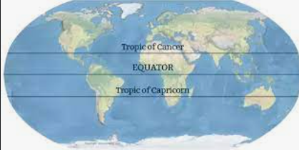  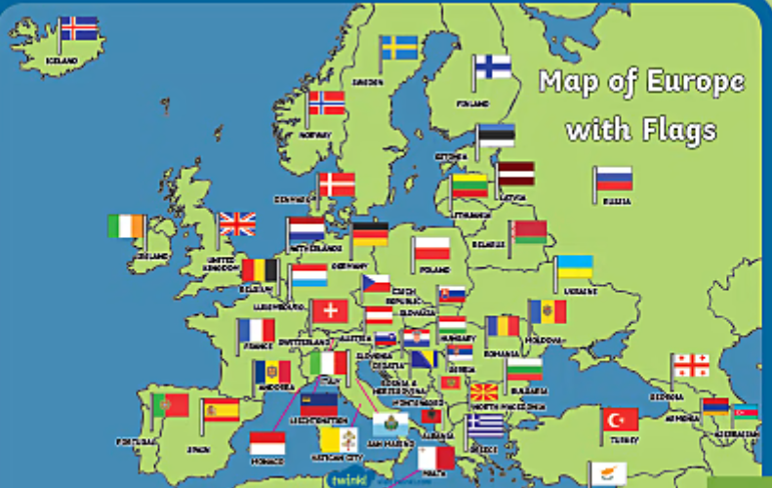  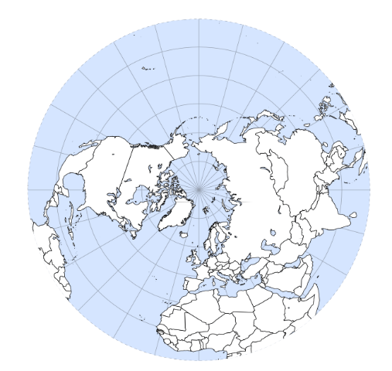  The Northern hemisphere is the part of the Earth that is north of the Equator. It has about 90% of the world’s population and most of the world’s land. All of North America and Europe are in the Northern Hemisphere. Most of Asia, two-thirds of Africa and 10% of South America are also in this hemisphere. The 3 largest countries by population: China, India and the United States are in the Northern Hemisphere.  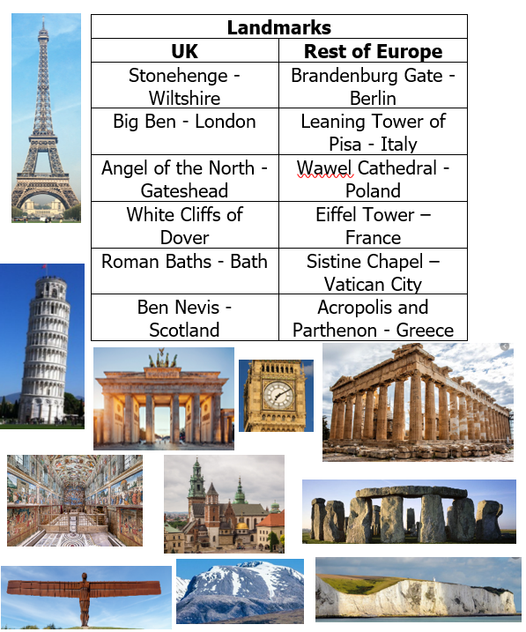  The British Isles are the group of islands which consist of the UK. These include. Britain, Ireland, the Hebrides, the Shetland islands, the Orkney islands, the isles of Scilly and the Isle of Man.  Europe is made up of 49 countries. It’s most well-known countries are England, Scotland, Wales, Ireland, France, Spain, Italy, Belgium, Czech Republic, Denmark, Finland, Germany, Greece, Iceland, Luxemburg, Malta, Netherlands, Norway, Poland, Portugal, Russia, and Sweden.  The United Kingdom’s neighbours are France, Spain, Italy, Germany, Portugal, Netherlands, Belgium and Denmark.  The 6 founding countries of the European Union are Belgium, France, Germany, Italy, Luxemburg and the Netherlands.
  France | Paris | 
  Spain | Madrid | 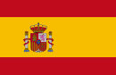
  Italy | Rome | 
  Germany | Berlin | 
  Portugal | Lisbon | 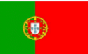
  Netherlands | Amsterdam | 
  Belgium | Brussels | 
  Denmark | Copenhagen | 
capital city | the city where the government sits
continent | a very large area of land that consists of many countries.
physical features | natural features of land
human features | features of land that have been impacted by human activity
landscape | everything you can see when you look across an area of land, including hills, rivers, buildings, trees and plants
vegetation | plants, trees and flowers
climate | the general weather conditions that are typical of a place
atlas | book of maps
climate | the general weather conditions that are typical of a place.
equator | an imaginary line around the middle of the Earth at an equal distance from the North pole and the South Pole.
globe | a ball-shaped object with a map of the world on it.
landmark | a building or feature which is easily recognised
language | the communication of a particular country or people
ocean | one of the five very large areas of salt water on the Earth’s surface
population | all the people who live in a country or area
sea | a large area of salty water that is part of an ocean
temperate | a place which is neither extremely hot or extremely cold
tourist | a person who is visiting a place for pleasure and interest, especially when they are on holiday
trade | the activity of buying, selling or exchanging goods or services
vegetation | plants, trees and flowers
estuary | the mouth of a large river where the sea meets the river.
hemisphere | the division of the Earth based on the equator
Tropic of Cancer | the most northerly circle on Earth at which the sun can be directly overheard
Tropic of Capricorn | the most southernmost circle on Earth which the sun can be directly overhead.
Gulf stream | a strong ocean current that brings warm water from the Gulf of Mexico into the Atlantic Ocean
Mediterranean | region of the Mediterranean sea with a climate of hot dry summers and humid, cool winters, with generally hilly landscape
ordnance survey | printed maps
isle | an island or peninsula, especially a small one
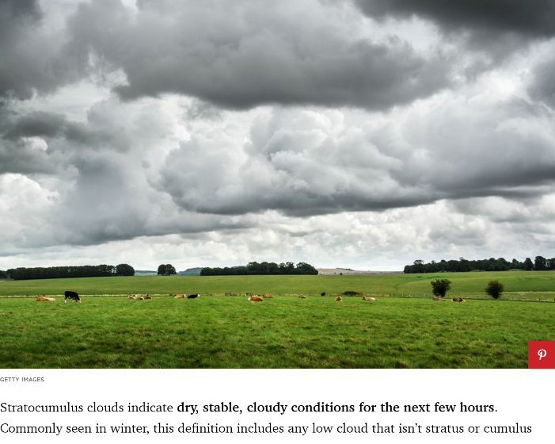
Weather
Europe is generally characterized by a temperate climate. Most of Western Europe has an Oceanic climate, in the Köppen climate classification, featuring cool to warm summers and cool winters with frequent overcast skies. Southern Europe has a distinctively Mediterranean climate, which features warm to hot, dry summers and cool to mild winters and frequent sunny skies. Central-eastern Europe is classified as having a Continental climate, which features warm to hot summers and cold winters. The climate of western Europe is strongly conditioned by the Gulf Stream, which keeps mild air (for the latitude) over Northwestern Europe in the winter months, especially in Ireland, the United Kingdom and coastal Norway.
Parts of the central European plains have a hybrid oceanic/continental climate. Four seasons occur in most of Europe away from the Mediterranean. The coastal lowlands of the Mediterranean Basin have more of a wet and dry season pattern, the rainy season extends from October to February while the dry season is mainly noticeable in the summer months where precipitation can, in some years, become extremely scarce.

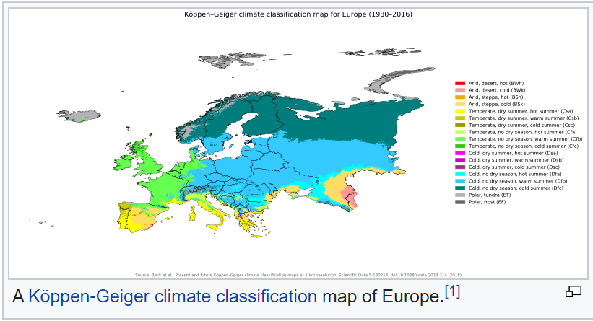
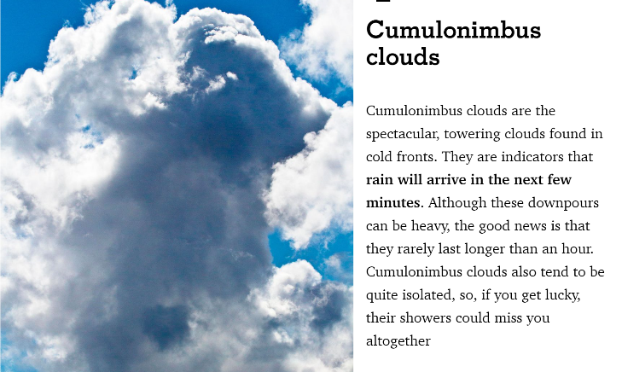

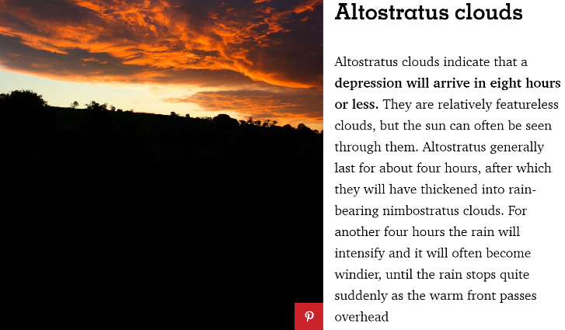
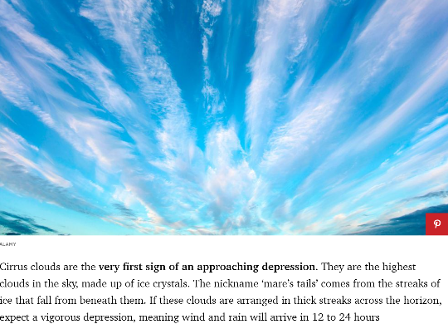
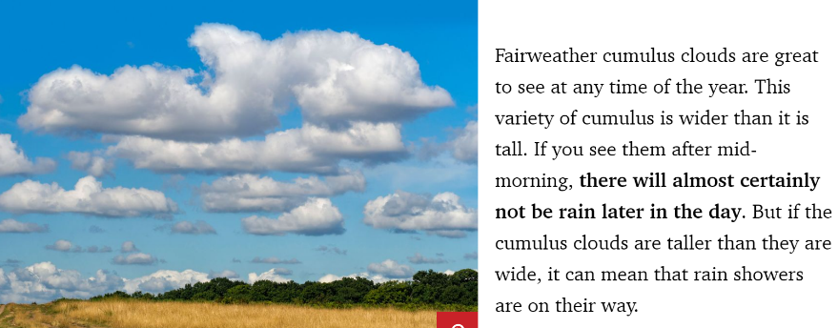
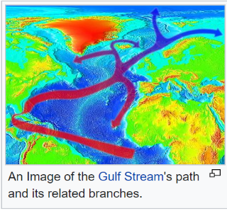
The climate of Western Europe is milder in comparison to other areas of the same latitude around the globe due to the influence of the Gulf Stream. Mediterranean waters are not as deep as the large oceans allowing them to become a heat storage, but because the Atlantic Ocean is largely influenced by the gulf stream, it makes Europe’s climate warmer and wetter than it would otherwise be.
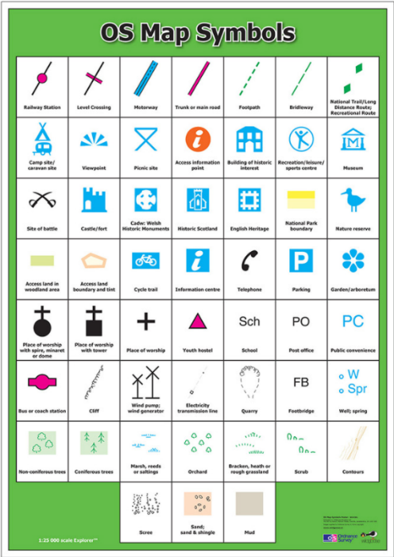
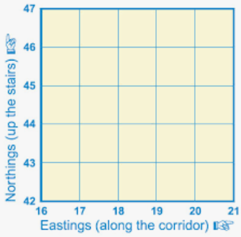
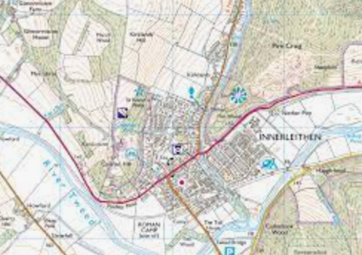
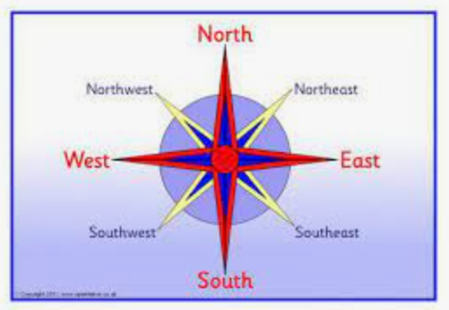

History – local history
What should pupils already know/do? |  |  | What will pupils learn? | Where will this learning go?
Yr3  * appreciate that some famous people have helped our lives be better today  * recognise that we celebrate certain events because of what happened many years ago  * sequence events in chronological order  * explain how a local area was different in the past  * recount some interesting facts from an historical event  * explain what Britain has a special history by naming some famous people  Yr4  * describe events from the past using dates when things happened  * use a timeline within a specific time in history to set out the order things may have happened  * suggest why certain events happened as they did in history  * use various sources of evidence to answer questions  * use various sources to piece together information about a period in history  * research a specific event from the past |  |  | Yr3  Chronological Understanding:  * describe events from the past using dates when things happened  * use a timeline within a specific time in history to set out the order things may have happened  Knowledge and interpretation:  * suggest why certain events happened as they did in history  Historical Enquiry:  * use various sources of evidence to answer questions  * use various sources to piece together information about a period in history  * research a specific event from the past  Yr4  Chronological Understanding  * plot recent history on a timeline using centuries  * place periods of history on a timeline showing periods of time  Knowledge and Interpretation  * explain how events from the past has helped shape our lives  * know that people who lived in the past cooked and travelled differently  Historical Enquiry  * research two versions of an event and say how they differ  * research what it was like for a child in a given period from the past and use photographs and illustrations to present their findings  Royston, Barnsley was recorded in the Domesday Book as Rorestone which originally meant Roarr’s farm or settlement (Roarr’s tun). Royston was originally a farming village, but during the Industrial Revolution (1790’s), it grew with the building of a canal and railway (both are now disused).  Coal mining was very popular in Barnsley, and Royston had a colliery called Monckton Colliery which is now the site of Rabbit Ings country park and home to all 5 species of British owls. | UKs2  Children will then build on all previous knowledge again to use a range of historical sources to explore the local cultures and diversity within the local area. They will explore where these cultures were first introduced to Europe from across the globe comparing different historical periods and thinking about how cultures, including British culture, has had a major influence on world history and shaped countries.
Key Vocabulary |  | 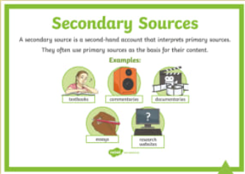  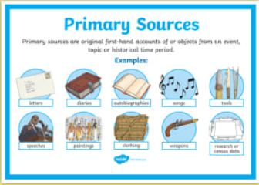  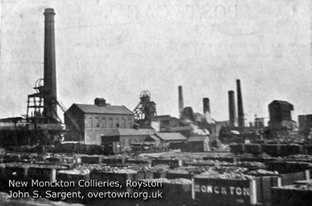  Sheffield is a big city in a region called South Yorkshire in the North of England. 534,500 people live there. Sheffield is in the middle of lots of hills. The city centre is where the River Sheaf meets the River Don, and Sheffield gets its name from the River Sheaf. The city is east of the Peak District National Park. It is estimated that Sheffield has over two million trees, which is more than any city in Europe per each person. 61% of the city is green space, such as parks and forests.  The area of Sheffield used to be the Anglo-Saxon shire of Hallamshire, the city itself was founded later.  Sheffield is famous for making cutlery (like knives and spoons). People in Sheffield have made cutlery for a very long time (a Sheffield-made knife is referred to in Chaucer's "Canterbury Tales", a book from the Middle Ages). Sheffield is also famous for making steel. In 1912, Harry Brearly invented stainless steel in Sheffield.  The first football team in the world is from Sheffield, Sheffield F.C., set up in 1857. Sheffield currently has two big professional football teams: Sheffield United and Sheffield Wednesday.  There are lots of famous bands from Sheffield. Some of them are Pulp, the Human League, Def Leppard and the Arctic Monkeys. Michael Palin is also from Sheffield. During the First World War the Sheffield City Battalion suffered heavy losses at the Somme and Sheffield itself was bombed by a German zeppelin. As the Second World War loomed, the steel factories of Sheffield were set to work making weapons and ammunition for the war. As a result, once war was declared, the city once again became a target for bombing raids. In total there were 16 raids over Sheffield, but it was the heavy bombing over the nights of 12 and 15 December 1940 (now known as the Sheffield Blitz) when the most substantial damage occurred. More than 660 lives were lost and numerous buildings were destroyed.  The building of the Meadowhall shopping centre on the site of a former steelworks in 1990 was a mixed blessing, creating much needed jobs but speeding the decline of the city centre. Attempts to regenerate the city were kick-started by the hosting of the 1991 World Student Games and the associated building of new sporting facilities such as the Sheffield Arena, Don Valley Stadium and the Ponds Forge complex. Sheffield began construction of a tram system in 1992, with the first section opening in 1994.  On 25 June 2007, flooding caused millions of pounds worth of damage to buildings in the city and led to the loss of two lives.  Steel making https://www.youtube.com/watch?v=qR6IxO_GqU0 History of the steelworks  By 1600 Sheffield was the main centre of cutlery production in England outside London, and in 1624 The Company of Cutlers in Hallamshire was formed to oversee the trade.  In the 1740s, Benjamin Huntsman, a clock maker in Handsworth, invented a form of the crucible steel process for making a better quality of steel than had previously been available. At around the same time, Thomas Boulsover invented a technique for fusing a thin sheet of silver onto a copper ingot producing a form of silver plating that became known as Sheffield plate. Originally hand-rolled Old Sheffield Plate was used for making silver buttons. In 1773 Sheffield was given a silver assay office. In the late 18th century, Britannia metal, a pewter-based alloy similar in appearance to silver, was invented in the town. In 1856, Henry Bessemer invented the Bessemer converter steelmaking furnace. Henry moved to Sheffield to make steel.  To find out about history, we look at information. If the information comes from somebody or thing which was at the event (diary, photo, newspaper, artefact, video, letter etc) then this is a primary source. If the information comes from after the event by someone who was not there (newspaper, biography, recount), then this is a secondary source.  https://www.ncm.org.uk/learning/learning-resources/mining-factsheets  Barnsley was well known for mining due to the Industrial revolution and the building of the railways for steam engines in the 1800’s  It has been found that people of Royston have a slightly different accent from other villages in Barnsley. This is due to people from the Midlands coming to work at Monckton colliery when their mines were closed.  Barnsley used to make linen, coal, glass and textiles. Due to its mining communities, it has a tradition of brass bands. It was called Berneslai in the Domesday Book originating from the Saxon words for barn and field (Berne Lay)
century | equal to one hundred years
chronology | the order of events in time
similarity | likeness
technology | devices which are the result of scientific knowledge being used for practical purposes
primary source | tells you about an event from the past and is from the time of that event
secondary source | tells you about an event from the past, but was written by after the event by someone who was not present at the event
Domesday book | a survey commissioned by Edward the Conqueror to assess the wealth and assets of the people across England
Steel | A material modified from iron
Crucible | Container of metal employed for heating substances to high temperature
Industrial | Anything related to industries
Coal | Combustible sedimentary rock, formed as rock strata called coal seams
Mining | Process of extracting useful minerals from the surface of the Earth
Strike | Refuse to work until demands are met
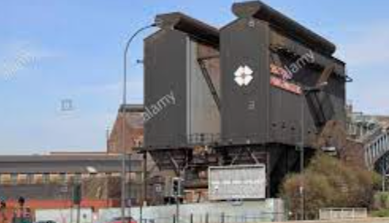

Art
What should pupils already know/do? |  |  | What will pupils learn/do? |  |  | Where will this learning go?
Yr3  Drawing  * communicates something about themselves in their drawing  * Creates moods in their drawings  * draws using pencil and crayons  * draws lines of different shapes and thickness, using 2 different grades of pencil  Knowledge  * describes what they can see and like in the work of another artist  * asks sensible questions about a piece of art  Yr3  Drawing:  * show facial expression in their drawings  * use their sketches to produce a final piece of work  * write an explanation of their sketch in notes  * use different grades of pencil shade to show different tones and texture  Sketch books:  * use their sketch books to express feelings about a subject and to describe likes and dislikes  * make notes in their sketch books about techniques used by artists  * suggest improvements in their work by keeping notes in their sketch books  Knowledge:  * compare the work of different artists  * explore work from other cultures  * explore work from other periods of time  * begin to understand the viewpoints of others by looking a images of people and understand how they are feeling and what the artist is trying to express in their work |  |  | Yr3  Drawing:  * show facial expression in their drawings  * use their sketches to produce a final piece of work  * write an explanation of their sketch in notes  * use different grades of pencil shade to show different tones and texture  Sketch books:  * use their sketch books to express feelings about a subject and to describe likes and dislikes  * make notes in their sketch books about techniques used by artists  * suggest improvements in their work by keeping notes in their sketch books  Knowledge:  * compare the work of different artists  * explore work from other cultures  * explore work from other periods of time  * begin to understand the viewpoints of others by looking a images of people and understand how they are feeling and what the artist is trying to express in their work  Yr4  Drawing  * begin to show facial expressions and body language in their sketches  * identify and draw simple objects, and use marks and lines to produce texture  * organise line, tone, shape and colour to represent figures and forms in movement  * show reflections  * explain why they have chosen specific materials to draw with  Sketch books:  * use their sketch books to express their feelings about various subjects and outline likes and dislikes  * use their sketch books to adapt and improve their original ideas  * keep notes about the purpose of their work in their sketch books  Knowledge  * experiment with different styles which artists have used  * explain art from other periods of history |  |  | UKs2  Children will then build on all previous knowledge again communicate emotions and a sense of self with accuracy and imagination through their sketches. They will explore how to use shading to create mood, exploring the effect of different line, tone, shape and colour and explaining how their work is influenced by other artists and their use of techniques.
Key Vocabulary |  | 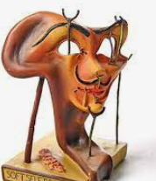  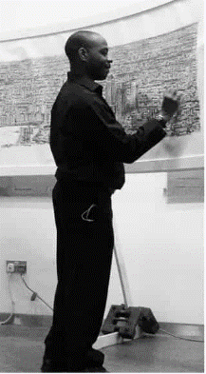  Stephen Wiltshire, an architectural illustrator, is an artist who draws detailed cityscapes which include landmarks from around the UK and Europe. His drawings are popular all over the world, and are held in a number of important art collections and museums. He was born in 1974 in London to West Indian parents. As a child, he was mute and did not relate to other people. Living in a world with no communication, he began to draw. Aged 3 he was diagnosed with autism, and aged 7, he sold his first piece of artwork. He was awarded an MBE for services to the art world in 2006.  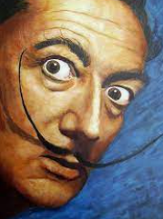  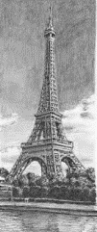  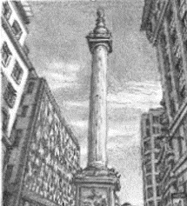  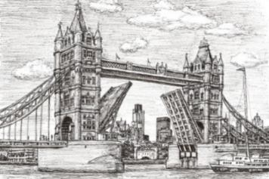
investigate | To examine something carefully to find out more about it.
discuss | To talk about something in detail to another person or people.
media | Material used to create something.
line | Using different types of lines to create an image (curved or straight).
shape | A 2D area with an outline.
pattern | A design where lines, shapes or colours are repeated.
design | To sketch and plan a piece of art work.
primary colours | One of the three colours, red, yellow, and blue, that can be mixed together in different ways to make any other colour.
secondary colours | One of the three colours – orange, green, or purple – that can be made by mixing together two of the primary colours.
examine | Look carefully at something in detail to find something out.
artist | Somebody who paints, draws, or makes sculptures.
mix | To combine things (paint) together so they can’t be easily separated.
landscape | The longer sides of a piece of paper at the top and bottom. | cross-hatching |  | A method of line drawing that describes light and shadow  Salvador Dali was a Spanish surrealist artist renowned for his technical skill, precise draftsman ship and the striking and bizarre images in his work. Born in Catalonia in 1904, Dali received a formal education in fine arts in Madrid. Influenced by impressionism from a young age, he became increasingly attracted to Cubism created by Pablo Picasso. Which then led to moving towards Surrealism in the late 1920’s soon becoming one of its leading exponents. | 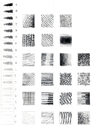  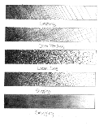  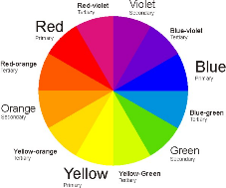
portrait | The shorter sides of a piece of paper at the top and bottom.
Cubism | A style of modern art in which an object or person is shown as a set of geometric shapes. | blending/smudging |  | Gently mingling two or more colours to soften lines
cityscapes | A piece of art work showing a city. |  |  | Gently mingling two or more colours to soften lines
architecture | The design and construction of buildings. | hatching |  | Technique used to shade in lines
illustrator | A person who draws or creates pictures. |  |  | Technique used to shade in lines
perspective | Creating or representing 3D shapes, on a 2D surface. | scumbling |  | Shading technique achieved by overlapping lots of little circles
proportion | The correct relationship of the parts of a work of art to each other, especially in their size.
texture | The surface of the art work. It can be made to look flat or 3D. | stippling |  | Use of dots to create texture and shade
technique | The way of doing something that requires skill. |  |  | Use of dots to create texture and shade
form | The shape or appearance of an object. | landmark |  | An object on land that marks a locality

