Who do you think you are?
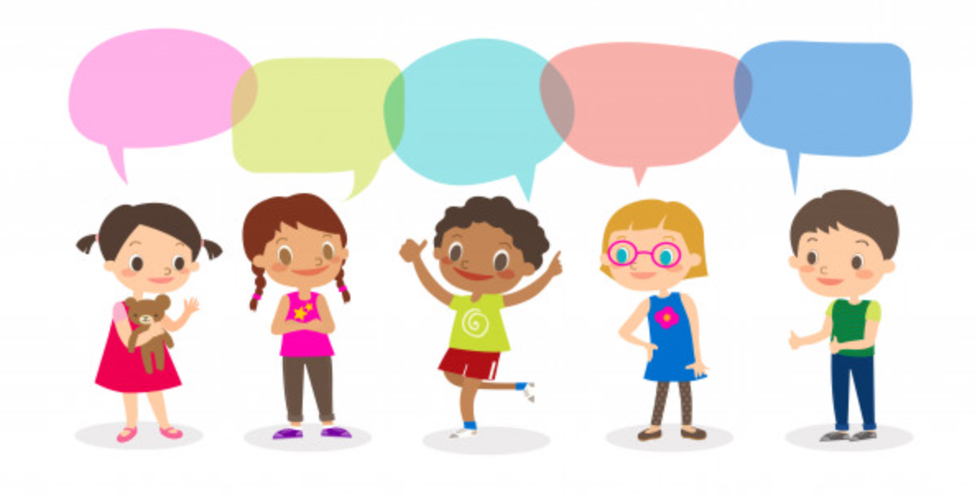

Who do you think you are?
What makes me the same or different?
What makes me special?
Who am I?
Where do I live?

Cycle A: Exploration 1
UKs2

Cycle A - Exploration 1 – UKs2 - Who do you think you are?
Exploration Objectives Overview
Curriculum Drivers: Global (Identity & diversity), Science (Animals including humans) & Geography (Local area study)

Subject | Yr5 | Yr6 | Subject | Yr3 | Yr4
Global  To open up the world | Identity and diversity  * benefits and challenges of diversity  * impacts of stereotyping, prejudice and discrimination and how to challenge these  * importance of language, beliefs and values in cultural identities |  | RSE | Families and people who care for me:  * Recognise different types of relationships, including those between acquaintances, friends, relatives and families.  * That civil partnerships and marriages are examples of a public demonstration of the commitment made by 2 people who love and care for each other and want to spend their lives together and who are of legal age to make that commitment.
Science  Through investigation, develop a sense of excitement and curiosity of natural phenomena | Animals including humans:  * identify and explain the function of the organs of the human gaseous exchange system (lungs, nose, throat, bronchi, bronchial tubes, diaphragm, ribs, breathing)  Planning:  * plan and carry out an investigation by controlling variables fairly and accurately  * make a prediction with reasons  * use test results to make further predictions and set up further comparative tests  * present a report of their findings through writing, display and presentation  Obtaining and presenting evidence:  * take measurements using a range of scientific equipment with increasing accuracy and precision  * record more complex data and results using scientific diagrams, classification keys, tables, bar charts, line graphs and models  Considering evidence and evaluating:  * report findings from investigations through written explanations and conclusions  * use a graph to answer scientific questions | Animals including humans:  * identify and explain the function of the organs of the human circulatory system (heart, blood vessels, blood, blood pressure, clotting)  * name the major organs in the human body  * locate the major human organs  * make a diagram that outlines the main parts of a body  Planning:  * explore different ways to test an idea and choose the best way, and give reasons  * vary one factor whilst keeping the others the same in an experiment? Can they explain why they do this  * plan and carry out an investigation by controlling variables fairly and accurately  *make a prediction with reasons  * use information to help make a prediction  * use test results to make further predictions and set up further comparative tests  * explain (in simple terms) a scientific idea and what evidence supports it  * present a report of their findings through writing, display and presentation  Obtaining and presenting evidence:  * explain why they have chosen specific equipment (incl ICT based equipment)  *decide which units of measurement they need to use  * explain why a measurement needs to be repeated  * record their measurements in different ways (incl bar charts, tables and line graphs)  * take measurements using a range of scientific equipment with increasing accuracy and precision  Considering evidence and evaluating:  * link what they have found out to other science  * suggest how to improve their work and say why they think this  * record more complex data and results using scientific diagrams, classification keys, tables, bar charts, line graphs and models  * report findings from investigations through written explanations and conclusions | Geography  To develop an understanding of the impact of the world’s physical and human processes: past, present and future | Geographical Enquiry  * Collect information about a place and use it in a report.  * Map land use.  * Find possible answers to their own geographical questions.  * Make detailed sketches and plans; improving their accuracy later.  * Plan a journey to a place in another part of the world, taking account of distance and time.  Physical Geography  * Explain why many cities of the world are situated by rivers.  * Explain how a location fits into its wider geographical location; with reference to physical features.  * Explain why water is such a valuable commodity.  Human Geography  * Explain why people are attracted to live by rivers.  * Explain how a location fits into its wider geographical location; with reference to human and economical features.  Geographical Knowledge  * Name and locate many of the world’s major rivers on maps.  * Name and locate many of the world’s most famous mountain regions on maps. | Geographical Enquiry  * Confidently explain scale and use maps with a range of scales.  * Use OS maps to answer questions.  * Use maps, aerial photos, plans and web resources to describe what a locality might be like.  Physical Geography  * Give extended description of the physical features of different places around the world.  * Describe how some places are similar and others are different in relation to their human features.  * Accurately use a 4 figure grid reference.  * Create sketch maps when carrying out a field study.  Human Geography  * Give an extended description of the human features of different places around the world.  * Map land use with their own criteria.  * Describe how some places are similar and others are different in relation to their physical features.  Geographical Knowledge  * Recognise key symbols used on ordnance survey maps.  * Name the largest desert in the world.  * Identify and name the Tropics of Cancer and Capricorn as well as the Arctic and Antarctic circles.  * Explain how the time zones work.
History  To learn from the past in order to impact the future | Chronological Understanding:  * use dates and historical language in their work  * draw a timeline with different time periods outlined which show different information, such as, periods of history, when famous people lived, etc.  Knowledge and interpretation:  * suggest why certain events happened as they did in history  Historical Enquiry:  * use various sources of evidence to answer questions  * use various sources to piece together information about a period in history  * research a specific event from the past  * use their ‘information finding’ skills in writing to help them write about historical information  * through research, identify similarities and differences between given periods in history | Chronological Understanding  * say where a period of history fits on a timeline?  * place a specific event on a timeline by decade?  * place features of historical events and people from past societies and periods in a chronological framework  Knowledge and Interpretation  * summarise the main events from a specific period in history, explaining the order in which key events happened  * summarise how Britain has had a major influence on world history  * summarise what Britain may have learnt from other countries and civilizations through time gone by and more recently  * describe features of historical events and people from past societies and periods they have studied  * recognise and describe differences and similarities/ changes and continuity between different periods of history  Historical Enquiry  * look at two different versions and say how the author may be attempting to persuade or give a specific viewpoint  * identify and explain their understanding of propaganda  * describe a key event from Britain’s past using a range of evidence from different sources | Art  To learn how Art & Design reflect and shape our world | Drawing:  * identify and draw simple objects, and use marks and lines to produce texture  * successfully use shading to create mood and feeling  * organise line, tone, shape and colour to represent figures and forms in movement  * show reflections  * explain why they have chosen specific materials to draw with  Sketch books:  * keep notes in their sketch books as to how they might develop their work further  * use their sketch books to compare and discuss ideas with others Knowledge:  * experiment with different styles which artists have used  * learn about the work of others by looking at their work in books, the internet, visits to galleries and other sources of information | Drawing  * communicate emotions and a sense of self with accuracy and imagination through their sketches  * explain why they have combined different tolls to create their drawings  * explain why they have chosen specific drawing techniques  Sketch books:  * keep detailed notes, and quotes explaining about items  * compare their methods to those of others and keep notes in their sketch books  * combine graphics and text based research of commercial design (magazines etc) to influence the layout of their sketch books  * adapt and refine their work to reflect its meaning and purpose, keeping notes and annotations in their sketch books  Knowledge  * make a record about the styles and qualities in their work  * say what their work is influenced by  * include technical aspects in their work (e.g. architectural design)

Cycle A - Exploration 1 – UKs2  Who do you think you are?  Throughout the exploration, children continue to learn about themselves and will think about culture and diversity, both across different their bodies and local areas. They learn about diversity within the human race in relation to the functions of different parts of the body, and explore the nature of prejudice, racism and sexism, thinking about ways to combat these. They learn about the Geographical features of Europe and the Northern Hemisphere, exploring diversity of culture and society, exploring the idea of themselves as part of a community to answer the question of who they think they are. |  |  |  |  |  | Learning - Identity & Diversity  Science driver – Animals including humans (Biology)  Geography driver - Study of Northern Hemisphere (Europe, N. America, China and India)
What should pupils already know? |  | What will pupils learn? |  | Where will this learning go?
* diversity of cultures and societies within and beyond own experience  * contribution of different cultures to our lives  * nature of prejudice, racism and sexism and ways to combat these |  | * benefits and challenges of diversity  * impacts f stereotyping, prejudice and discrimination and how to challenge these  * importance of language, beliefs and values in cultural identities |  | Uks2  Again extending their learning to a global community and world migration, pupils will build on previous knowledge to think about the benefits and challenges of diversity; the impacts of stereotyping, prejudice and discrimination and how to challenge these; and the importance of language, beliefs and values in cultural identities.  As lifelong citizens  Pupils will be equipped to understand the importance of self-identity and belonging across the world. They will understand the need for migration and seeking refuge, and have empathy towards the different people that they meet throughout life, embracing diversity and culture. They will challenge forms of stereotyping, prejudice and discrimination in order to be an active, important member of society.
SOLO Taxonomy | Uni-structural knowledge |  | Multi-Structural knowledge |  | Relational knowledge |  | Extended | Abstract
SOLO Taxonomy |   I have one relevant bit of knowledge |  |   I have several bits of key knowledge |  | 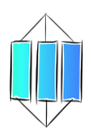  I can see links between my bits of key knowledge |  | 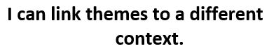  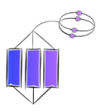  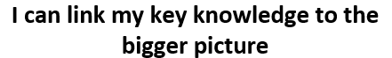
Spaced Questions | - What am I?  2 weeks |  | - Where do I live?  2 weeks |  | - What makes me the same or different?  2 weeks |  | - What makes me special?  1 week | - Who do you think you are?  1 week
Key substantive knowledge | Yr5  * identifies and explains the function of the organs of the human gaseous exchange system.  Yr6  * identifies and explains the function of the organs of the human circulatory system  * names the major organs in the human body  * locates the major human organs  * makes a diagram that outlines the main parts of a body |  | Yr5  * Finds countries of Europe and the Northern Hemisphere on 4-figure reference grids, maps, atlases, globes, naming and locating capital cities, major landmarks, major rivers and mountain regions and recognising flags.  * Explain physical, human and economical features, explaining how a location fits into its wider geographical location.  * Identifies and names the Tropics of Cancer and Capricorn as well as the Arctic circle.  * recognises cloud formations  * names trees, flowers and wildlife indigenous to UK, Europe and Northern Hemisphere  Yr6  * Finds countries of the Northern Hemisphere on 4-figure reference grids, maps, atlases, globes, naming and locating capital cities, major landmarks, major rivers, mountain regions, deserts and recognising flags.  * Identifies and names the Tropics of Cancer and Capricorn as well as the Arctic circle.  * Explain how the time zones work.  * Explain physical, human and economical features, explaining how a location fits into its wider geographical location.  * recognises cloud formations  * names some trees, flowers and wildlife indigenous to Northern Hemisphere |  | All UKs2 at own level:  * Names similarities and differences between humans including sex, race, religion, illness and disability  * Names similarities and difference of Europe and other northern hemisphere countries including physical, human and economical features of localities, and culture.  Yr5  * draws a timeline with different time periods outlined, suggesting why certain events happened as they did in history in order to explain migration across the Northern Hemisphere and the impact on culture.  Yr6  * says where a period of history fits on a timeline, summarising what Britain may have learnt from other countries when explaining migration across the Northern Hemisphere  * benefits and challenges of diversity  * impacts of stereotyping, prejudice and discrimination and how to challenge these  * importance of language, beliefs and values in cultural identities |  | All UKs2 at own level:  * Explains what makes them special as a person including how their body’s work, the way they look, their sex, their race, their tradition and culture, their heritage, what religion they are etc  * Recognise different types of relationships, including those between acquaintances, friends, relatives and families.  * That civil partnerships and marriages are examples of a public demonstration of the commitment made by 2 people who love and care for each other and want to spend their lives together and who are of legal age to make that commitment.  * Explain what makes locality Europe and northern hemisphere special  * contribution of diversity on our lives  * impacts of stereotyping, prejudice and discrimination and how to challenge these  * importance of language, beliefs and values in cultural identities | All UKs2 at own level:  * Explains how what they are, what they look like, where they live and the impact of cultures contribute to who they are as a person  * Discusses what contributes to self-identity and diversity
Answer Guideline:  Assessment at each stage will allow children to show their learning in relation to the spaced question.  Assessment of children’s learning can be gained from oral discussion and writing, but must also be gained through curriculum activities such as worksheets, quizzes and short tests etc.  This ensures that children who struggle to express their learning through speaking or writing are not at a disadvantage when expressing their learning in relation to the taught curriculum objectives. |  |  | Europe, northern hemisphere – Europe, Northern America, China, India |  |  |  | Uks2 - Explains how our bodies are special for survival, that the way our body works and looks is unique to us including our sex and race; how our families and history are special and contribute to our identities; how our locality is special compared to others including the contribution of other ethnic groups, culture, language and traditions. How everyone is unique and special and that this knowledge can help to combat stereotyping, prejudice and discrimination. | Uks2 – Brings all their learning together to explain that what they are, what they look like, how they live with their families, what they believe in, where they live and their history contributes to who they are as a person and their sense of belonging. Discusses how humans are made the same but are all different in relation to their families, their heritage, their beliefs, where they live and/or as a result of disability/illness. Discusses how it’s good that we are all different and it’s important to keep your heritage and beliefs (sense of identity) and feel that you belong, while accepting everyone’s uniqueness to combat stereotyping, prejudice and discrimination. Eventually bring all scientific, geographical , historical and global learning together to answer the question “Who do you think you are?”

Anchor novel/s | Yr5/6 | 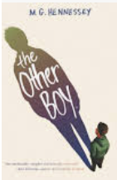  Through the novel “The other Boy” by M.G.Hennessey, pupils will explore themes regarding LGBTQ+ and the issues surrounding gender. Pupils will think about the benefits and challenges of diversity, the importance of self-identity and what this means to different people, the impact of stereotyping, prejudice and discrimination and ways to combat these in their lives. |  | 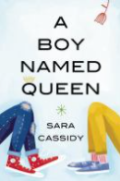  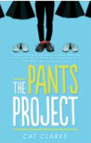  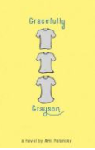  Other books with transgender characters are: “Gracefully Grayson” by Ami Polonsky, “The Pants Project” by Cat Clarke and “A boy named Queen” by Sara Cassidy.  https://seattle.bibliocommons.com/list/share/114354577/940206117
Writing Purpose | Yr5/6

Key people linked to Curriculum areas for Explore
Global |   I think everybody is weird. We should all celebrate our individuality and not be embarrassed or ashamed of it.  Johnny Depp | 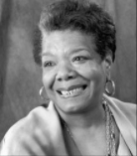  It is time for us to teach young people that in diversity there is beauty and there is strength.  Maya Angelou |  |  | 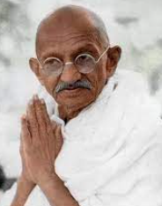  Our ability to reach unity in diversity will be the beauty and the test of our civilization.  Mahatma Ghandi |  |  |  | 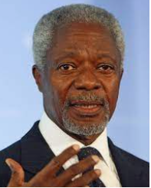  We may have different religions, different languages, different coloured skin, but we all belong to one human race.  Kofi Annan |  |  | 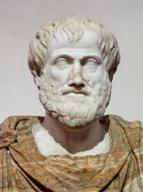  Knowing yourself is the beginning of all wisdom Aristotle |  |  | 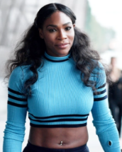  I love me, and I would never change anything about me. I’m not asking you to like me. I’m just asking you to let me be me.  Serena Williams
Literacy |   M.G. Hennessey lives in Los Angeles with two children. She feels that there is a critical need for more stories with transgender and gender expansive characters. She feels that children who identify as LGBTQ+ need to see themselves reflected in books and that cisgender children need a window into the lives of trans characters to understand and develop compassion for them. |  |  |  |  | 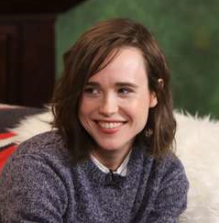  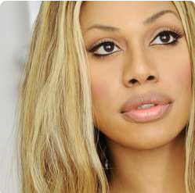  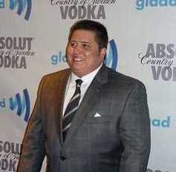  Famous transgender people include Canadian Elliot Page, Laverne Cox who is the first Transgender actress who was nominated for an Emmy award, Chaz Bono (son of Cher) among many other famous musicians, actors, athletes and artists.
Science | 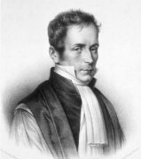  Rene Laennec was a French physician (1781-1826). His skill for carving wooden flutes led him to invent the stethoscope in 1816. He pioneered its use diagnosing various chest infections including lung cancer, blood clots in the lung and tuberculosis which he eventually died from. |  | 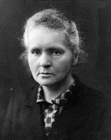  Marie Curie was a Polish physicist (1867-1934). She was the 1st woman to win the Nobel Prize and the only woman to ever win it twice. She developed radiography units to provide x-rays and treat cancer. |  |  |  | 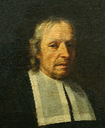  Marcello Malpighi (1628-1694) was an Italian physician who was one of the earliest scientists to observe red blood cells, exploring blood composition and how blood clots form. |  |  |  | 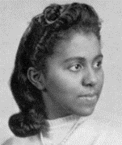  Marie Maynard Daly (1921-2003) was the first African-American woman to gain a PHD in the effect of cholesterol on the heart. |  | 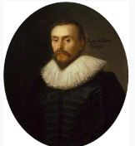  William Harvey was an English physician (1578-1657) who was the first known person to describe completely, and in detail, the circulatory system, explaining the properties of blood being pumped to the brain and the rest of the body by the heart.
Geography | 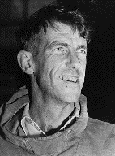  Sir Edmund Hilary (1919-2008) was a New Zealand mountaineer who, alongside sherpa Tenzing Norgay. was the first climber to reach the summit of Mount Everest on 29th May 1953. |  |  | 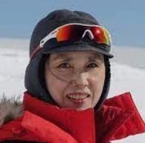  Junko Tabei was a Japanese mountaineer (1939-2016) was the first woman to reach the summit of Mount Everest. |  |  |  |  |  | 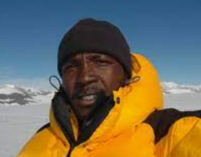  Sibusiso Vilane is a South African advernturer born in 1970. On 26th May 2003, he became the first Black person to reach the summit of Everest. Since then he has climbed the seven highest peaks in the world and reached both the north and south poles. |  |  |  | 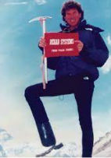  Tom Whittaker, born in 1948, was the first disabled person to reach the summit of Mount Everest having had his foot amputated following a car accident when he was 31.
Art | 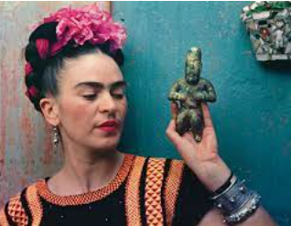  Magdalena Carmen Frida Kahlo (Frida) was a Mexican painter known for her many portraits. She lived from 1907-1954. Inspired by Mexico’s nature and artefacts, she employed a folk art style to explore questions of identity, post colonialism, gender, class and race in Mexican society. Her paintings often had strong autobiographical elements and mixed realism with fantasy. She became an icon for Chicanos, the feminist movement and the LGBTQ+ movement. |  |  |  |  |  |  | 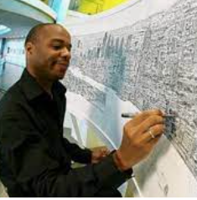  Stephen Wiltshire is a British artist who was born in London in 1974. After being a mute in childhood, Stephen was diagnosed with Autism aged 3. At 5, he attended a school where it was noticed that he enjoyed drawing and it soon became apparent that he could communicate with the world through his drawings. He now draws and paints detailed cityscapes, and has received a MBE from the queen.

Science driver – Animals including humans (Biology)
What should pupils already know? |  | What will pupils learn? |  |  |  | Where will this learning go?
Yr5  * classification of common animals  * function of different body structures including skeletons, muscles, digestive systems, teeth  * importance of healthy lifestyles  * Life cycle of some living things including what a simple food chain shows  * common flora and fauna  Yr6  * function of the organs of the human gaseous exchange system |  | Yr5  * identify and explain the function of the organs of the human gaseous exchange system (lungs, nose, throat, bronchi, bronchial tubes, diaphragm, ribs, breathing)  Yr6  * identify and explain the function of the organs of the human circulatory system (heart, blood vessels, blood, blood pressure, clotting)  * name the major organs in the human body  * locate the major human organs  * make a diagram that outlines the main parts of a body |  |  |  | Ks3  Pupils will then build on all previous knowledge to explore the structure and function of living organisms including the skeletal and muscular systems, and nutrition and digestion, thinking about the tissues and organs of the human digestive system.
Key Vocabulary |  |  | 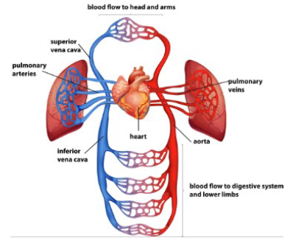  1. The right atrium collects the deoxygenated blood from the body via the vena cava. It sends the blood to the right ventricle.  2. The right ventricle pumps the deoxygenated blood to the lungs. Here the blood picks up oxygen and disposes of carbon dioxide.  3. The lungs send oxygenated blood back to the left atrium which pumps it to the left ventricle.  4. The left ventricle pumps the blood to the rest of the body via the aorta. | What is the circulatory system? | The circulatory system is made of the heart, lungs and the blood vessels.  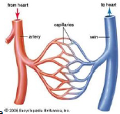  Arteries carry oxygenated blood from the heart to the rest of the body.  Veins carry deoxygenated blood from the body to the heart.  Nutrients, oxygen and carbon dioxide are exchanged via the capillaries. |  | 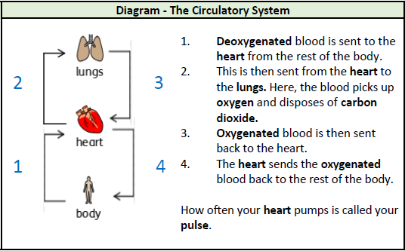
aorta | The main artery through which blood leaves your heart before it flows through the rest of your body.
arteries | A tube in your body that carries oxygenated blood from your heart to the rest of your body
blood vessels | The narrow tubes through which your blood flows. Arteries, veins and capillaries are blood vessels.
capillaries | Tiny blood vessels in your body
carbon dioxide | A gas produced by animals and people breathing out
circulatory system | The system responsible for circulating blood through the body, that supplies nutreients and oxygen to the body and removes waste products such as carbon dioxide.
deoxygenated | Blood that does not contain oxygen |  |  | Choices that can harm the circulatory system | Some choices such as smoking and drinking alcohol can be harmful to our health.  Tobacco can cause short-term effects such as shortness of breath, difficulty sleeping and loss of taste and long-term effects such as lung disease, cancer and death. |  | 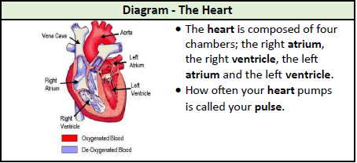
heart | The organ in your chest that pumps the blood around your body
lungs | Two organs inside your chest which fills with air when you breathe in. They oxygenate the blood and remove carbon dioxide from it.
nutrients | Substances that help plants and animals to grow.
organ | A part of your body that has a particular purpose. |  |  | Why is exercise so important? | Exercise can tone your muscles and reduce fat, increase fitness, make you feel physically and mentally healthier, strengthen the heart, improve lung function, improve skin.
oxygen | A colourless gas that plants and animals need to survive
oxygenated | Blood that contains oxygen
pulse | The regular beating of blood through your body. How fast or slow your pulse is depends on the activity you are doing
respiration | Process of respiring, breathing, inhaling and exhaling air
vein | A tube in your body that carries deoxygenated blood to your heart from the rest of your body.
vena cava | A large vein through which deoxygenated blood reaches your heart from the body |  | 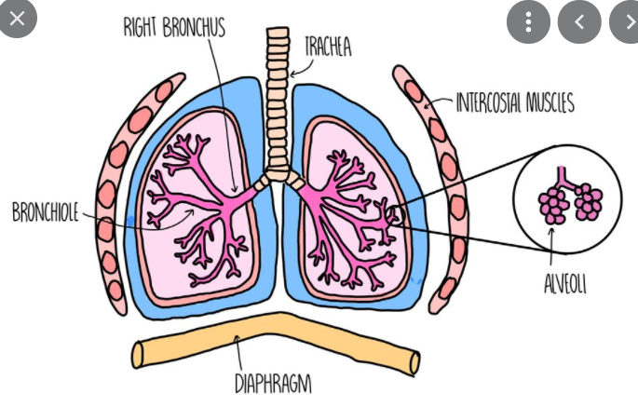  Gas exchange is the process by which oxygen and carbon dioxide move between the bloodstream and the lungs. This is the primary function of the respiratory system and is essential for ensuring a constant supply of oxygen to tissues, as well as removing carbon dioxide to prevent its accumulation.  The respiratory system is made up of: nose, mouth, throat (pharynx), voice box (larynx), windpipe (trachea), large airways (bronchi), small airways (bronchioles), alveoli and lungs.  The upper respiratory tract is made up of the: nose, nasal cavity, sinuses, larynx and trachea  The lower respiratory tract is made up of the lungs, bronchi and bronchioles, and air sacs (alveoli)  The process of breathing, or respiration, is divided into 2 phases:  - Inhaling – the diaphragm contracts (tightens) and moves downwards. This increases the space in the chest cavity into which your lungs expand. As the lungs expand, air enters the nose or mouth. It then travels down the windpipe to the bronchial tubes – the tubes that connect your windpipe to your lungs. When the air reaches your lungs, it enters the alveoli (air sacs) where oxygen is passed into your bloodstream, and carbon dioxide is passed into your lungs.  - Exhaling – the diaphragm relaxes and moves up into the chest cavity. As the space in the chest gets smaller, air rich in carbon dioxide is forced out of your lungs and windpipe, and then out of your nose or mouth.
via | through
atrium | One of the chambers in the heart
ventricle | One of the chambers in the heart
trachea | Commonly known as the windpipe, is a tube which carries oxygen down the cheat. It then splits into two smaller tubes: the bronchi and the bronchus.
intercostal muscles | Muscles that run between the ribs to help form and move the chest wall. They expand as we breathe in and shrink as we breathe out.
bronchiole | Minute branches at the end of the bronchial tubes
diaphragm | Thin skeletal muscle at the base of the chest. It contracts to pull air into the lungs as we inhale, and then relaxes to push air out of the lungs as we exhale.
gas exchange | Is the process of oxygen and carbon dioxide moving between the blood stream and the lungs.
nose | Air enters the nose and is cleaned
throat | Also known as the pharynx is a tube that runs from the back of the nose to the neck
bronchial tubes | tubes leading from the trachea into each lung
ribs | One of 24 flat bones which form the rib cage to help protect internal organs.
alveoli | Tiny air sacs where the lungs and the blood exchange oxygen and carbon dioxide.
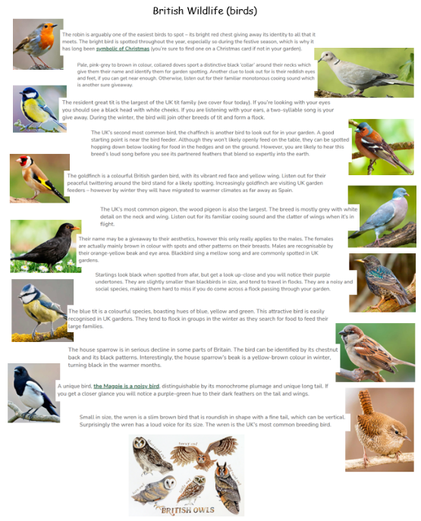
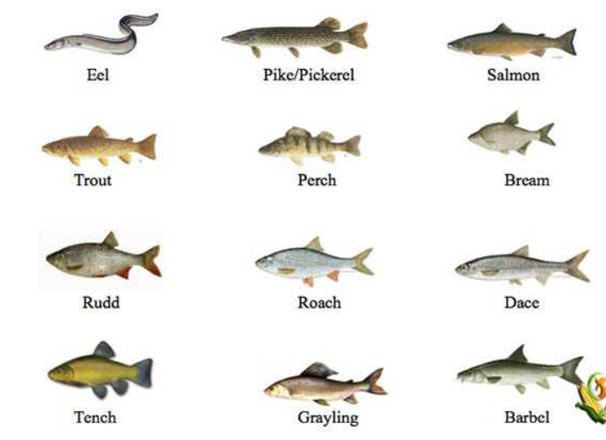
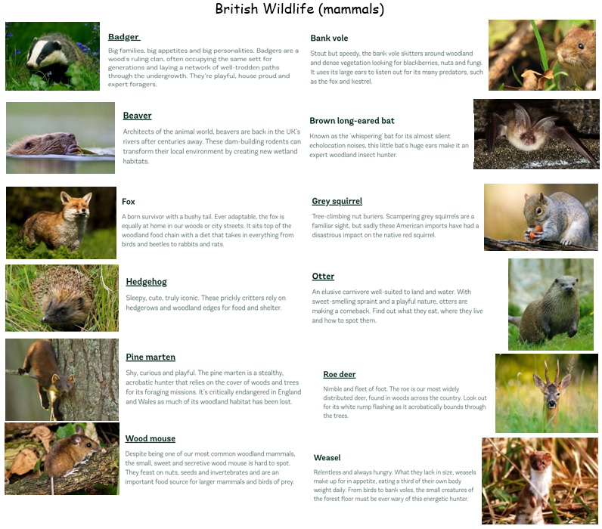
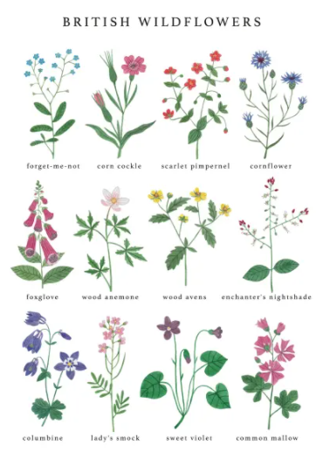
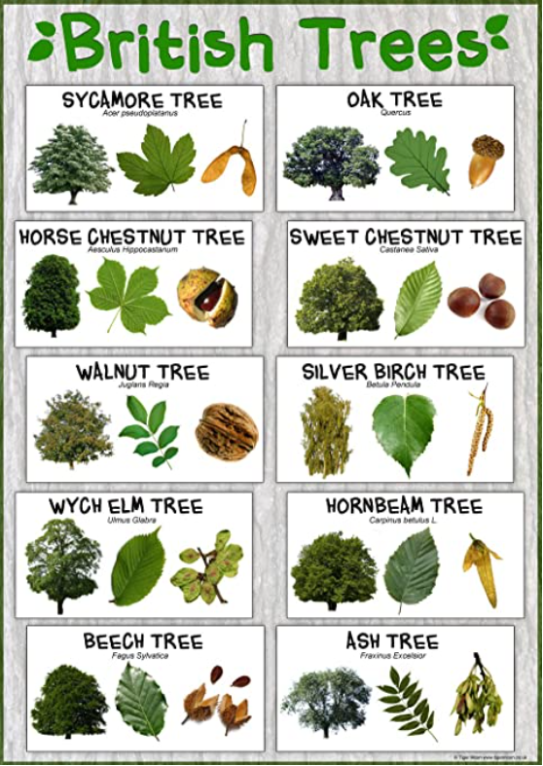
https://www.farmingplan.com/freshwater-fish/

https://www.woodlandtrust.org.uk/trees-woods-and-

wildlife/animals/mammals/

https://www.rspb.org.uk/birds-and-wildlife/wildlife-guides/bird-a-z/ The Rabbit Ings Country Park is home to all 5 species of British owls.

Geography driver – Study of local area and UK (locational knowledge/human and physical geography)
What should pupils already know/do? |  |  | What will pupils learn/do? | Where will this learning go?
Y5  * Knows and locates well known European countries, including capital cities, main towns and cities, flags and anthems, and the countries which make up the European Union.  * Locates equator, the Tropic of Cancer and the Tropic of Capricorn, North pole and South pole, oceans and continents on a globe and in an atlas.  *Locate and name some of main islands that surround the UK, knowing the difference between them and the British Isles.  * uses 4 figure grid reference maps  * Key physical and human features of localities  * basic cloud formations and different weather patterns in different parts of the world, especially Europe  * use aerial images, perspectives, maps, atlases and OS keys.  * number of countries in the Northern hemisphere  * Name the areas of origin of the main ethnic groups in Great Britain and UK.  Yr6  * Plan a journey to a place in another part of the world, taking account of distance and time.  * Explain why many cities of the world are situated by rivers.  * Explain how a location fits into its wider geographical location; with reference to physical features.  * Explain why water is such a valuable commodity.  * Explain why people are attracted to live by rivers.  * Explain how a location fits into its wider geographical location; with reference to human and economical features.  * Name and locate many of the world’s major rivers on maps.  * Name and locate many of the world’s most famous mountain regions on maps. |  |  | Yr5  * Plan a journey to a place in another part of the world, taking account of distance and time.  * Explain why many cities of the world are situated by rivers.  * Explain how a location fits into its wider geographical location; with reference to physical features.  * Explain why water is such a valuable commodity.  * Explain why people are attracted to live by rivers.  * Explain how a location fits into its wider geographical location; with reference to human and economical features.  * Name and locate many of the world’s major rivers on maps.  * Name and locate many of the world’s most famous mountain regions on maps.  Yr6  * Give extended description of the physical features of different places around the world.  * Describe how some places are similar and others are different in relation to their human features.  * Give an extended description of the human features of different places around the world.  * Describe how some places are similar and others are different in relation to their physical features.  * Recognise key symbols used on ordnance survey maps.  * Identify and name the Tropics of Cancer and the Arctic circles.  * Explain how the time zones work. | UKs2  Pupils will then build on all previous knowledge again to use a range of resources including scaled maps and atlases to name and locate the equator/tropics of Cancer and Capricorn/Arctic and Antarctic circles, continents and countries of the world/capital cities/flags. They will develop their knowledge of physical features to learn about oceans, rivers, mountains, deserts and time zones of the world. They will develop their knowledge of human features to learn about land use and economics.  Beyond:  Pupils will build on their learning to understand key processes in physical geography relating to: geological timescales and plate tectonics; rocks, weathering and soils; weather and climate, including the change in climate from the Ice Age to the present; and glaciation, hydrology and coasts. They will learn human geography relating to: population and urbanisation; international development; economic activity in the primary, secondary, tertiary and quaternary sectors; and the use of natural resources. And finally understand how human and physical processes interact to influence, and change landscapes, environments and the climate; and how human activity relies on effective functioning of natural systems
Key Vocabulary |  | 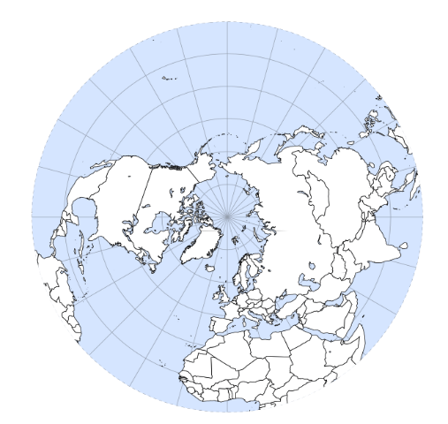  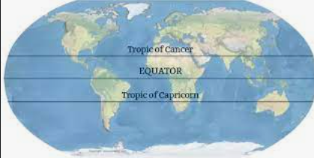  Europe is made up of 49 countries. It’s most well-known countries are England, Scotland, Wales, Ireland, France, Spain, Italy, Belgium, Czech Republic, Denmark, Finland, Germany, Greece, Iceland, Luxemburg, Malta, Netherlands, Norway, Poland, Portugal, Russia, and Sweden  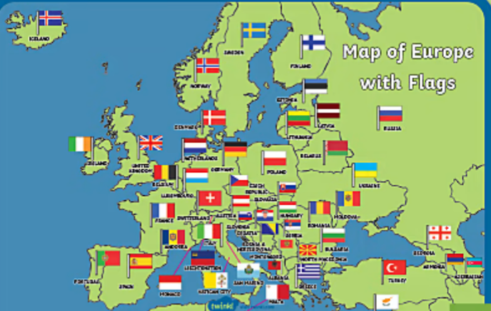  The Northern hemisphere is the part of the Earth that is north of the Equator. It has about 90% of the world’s population and most of the world’s land. All of North America and Europe are in the Northern Hemisphere. Most of Asia, two-thirds of Africa and 10% of South America are also in this hemisphere. The 3 largest countries by population: China, India and the United States are in the Northern Hemisphere.  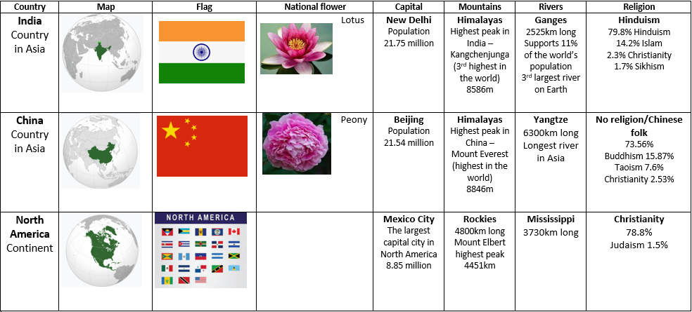
capital city | the city where the government sits
continent | a very large area of land that consists of many countries.
physical features | natural features of land
human features | features of land that have been impacted by human activity
landscape | everything you can see when you look across an area of land, including hills, rivers, buildings, trees and plants
vegetation | plants, trees and flowers
climate | the general weather conditions that are typical of a place
atlas | book of maps
climate | the general weather conditions that are typical of a place.
equator | an imaginary line around the middle of the Earth at an equal distance from the North pole and the South Pole.
globe | a ball-shaped object with a map of the world on it.
landmark | a building or feature which is easily recognised
language | the communication of a particular country or people
ocean | one of the five very large areas of salt water on the Earth’s surface
population | all the people who live in a country or area
sea | a large area of salty water that is part of an ocean
temperate | a place which is neither extremely hot or extremely cold
tourist | a person who is visiting a place for pleasure and interest, especially when they are on holiday
trade | the activity of buying, selling or exchanging goods or services
vegetation | plants, trees and flowers
estuary | the mouth of a large river where the sea meets the river.
hemisphere | the division of the Earth based on the equator
Tropic of Cancer | the most northerly circle on Earth at which the sun can be directly overheard
Tropic of Capricorn | the most southernmost circle on Earth which the sun can be directly overhead.
Gulf stream | a strong ocean current that brings warm water from the Gulf of Mexico into the Atlantic Ocean
Mediterranean | region of the Mediterranean sea with a climate of hot dry summers and humid, cool winters, with generally hilly landscape
ordnance survey | printed maps
isle | an island or peninsula, especially a small one
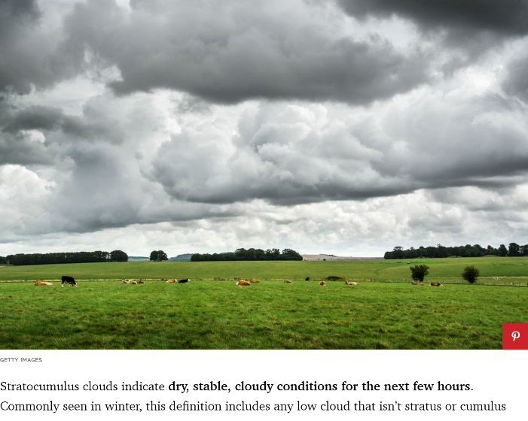
Weather
Europe is generally characterized by a temperate climate. Most of Western Europe has an Oceanic climate, in the Köppen climate classification, featuring cool to warm summers and cool winters with frequent overcast skies. Southern Europe has a distinctively Mediterranean climate, which features warm to hot, dry summers and cool to mild winters and frequent sunny skies. Central-eastern Europe is classified as having a Continental climate, which features warm to hot summers and cold winters. The climate of western Europe is strongly conditioned by the Gulf Stream, which keeps mild air (for the latitude) over Northwestern Europe in the winter months, especially in Ireland, the United Kingdom and coastal Norway.
Parts of the central European plains have a hybrid oceanic/continental climate. Four seasons occur in most of Europe away from the Mediterranean. The coastal lowlands of the Mediterranean Basin have more of a wet and dry season pattern, the rainy season extends from October to February while the dry season is mainly noticeable in the summer months where precipitation can, in some years, become extremely scarce.

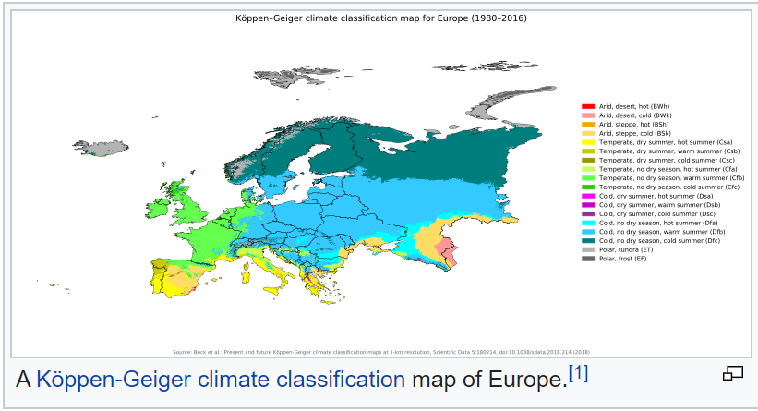
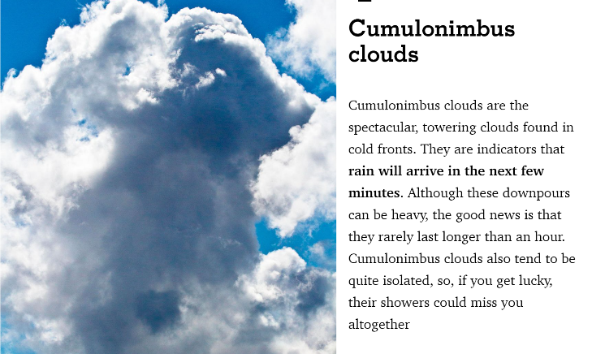

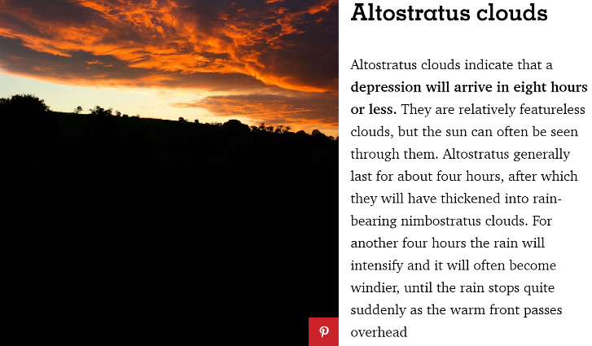
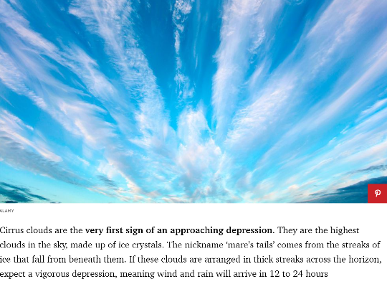
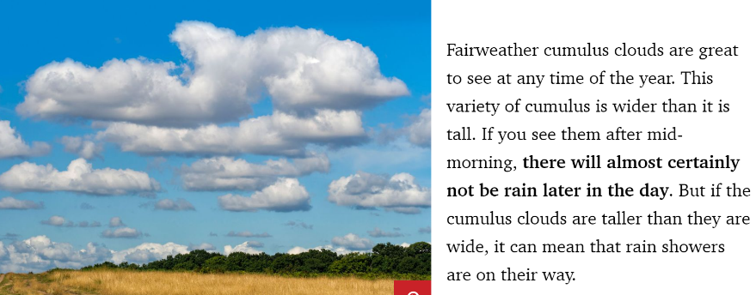
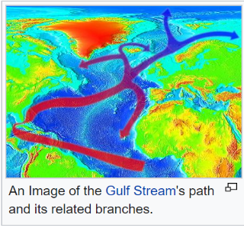
The climate of Western Europe is milder in comparison to other areas of the same latitude around the globe due to the influence of the Gulf Stream. Mediterranean waters are not as deep as the large oceans allowing them to become a heat storage, but because the Atlantic Ocean is largely influenced by the gulf stream, it makes Europe’s climate warmer and wetter than it would otherwise be.
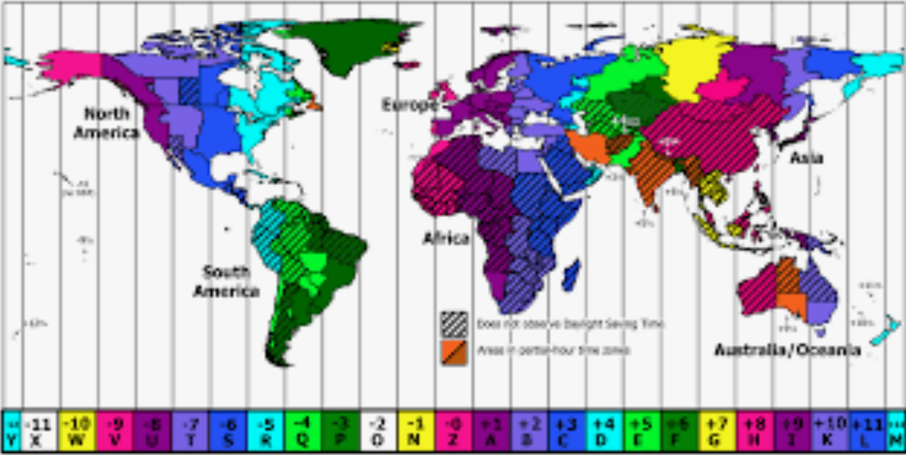
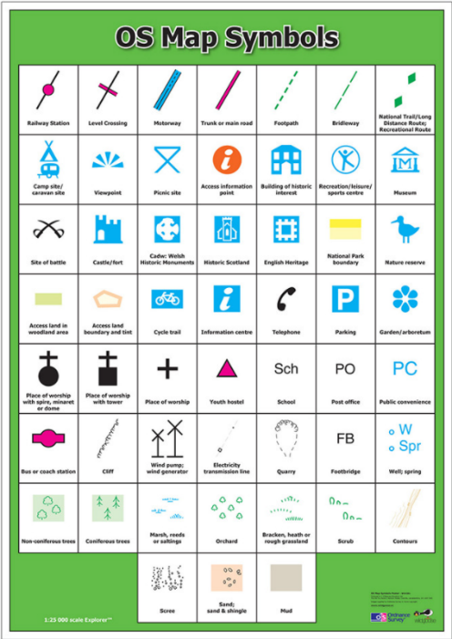
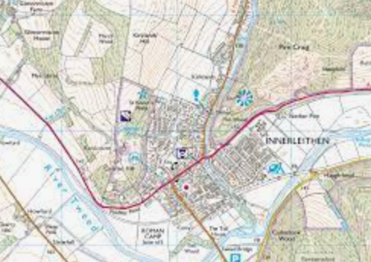
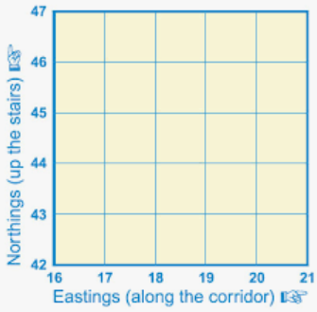
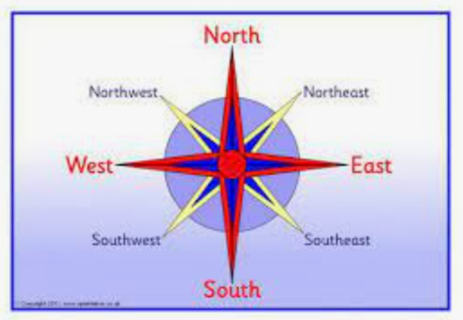

History – migrations
What should pupils already know/do? |  |  | What will pupils learn? | Where will this learning go?
Yr5  * suggest why certain events happened as they did in history  * place periods of history on a timeline showing periods of time  * explain how events from the past has helped shape our lives  Yr6  * summarise what Britain may have learnt from other countries and civilizations through time gone by and more recently  * recognise and describe differences and similarities/ changes and continuity between different periods of history |  |  | Yr5  * suggest why certain events happened as they did in history  * through research, identify similarities and differences between given periods in history  Yr6  * summarise what Britain may have learnt from other countries and civilizations through time gone by and more recently  * recognise and describe differences and similarities/ changes and continuity between different periods of history | UKs2  Children will then build on all previous knowledge again to use a range of historical sources to explore the local cultures and diversity within the local area. They will explore where these cultures were first introduced to Europe from across the globe comparing different historical periods and thinking about how cultures, including British culture, has had a major influence on world history and shaped countries.  Beyond  Pupils should extend and deepen their chronologically secure knowledge and understanding of British, local and world history, so that it provides a well-informed context for wider learning.
Key Vocabulary |  | 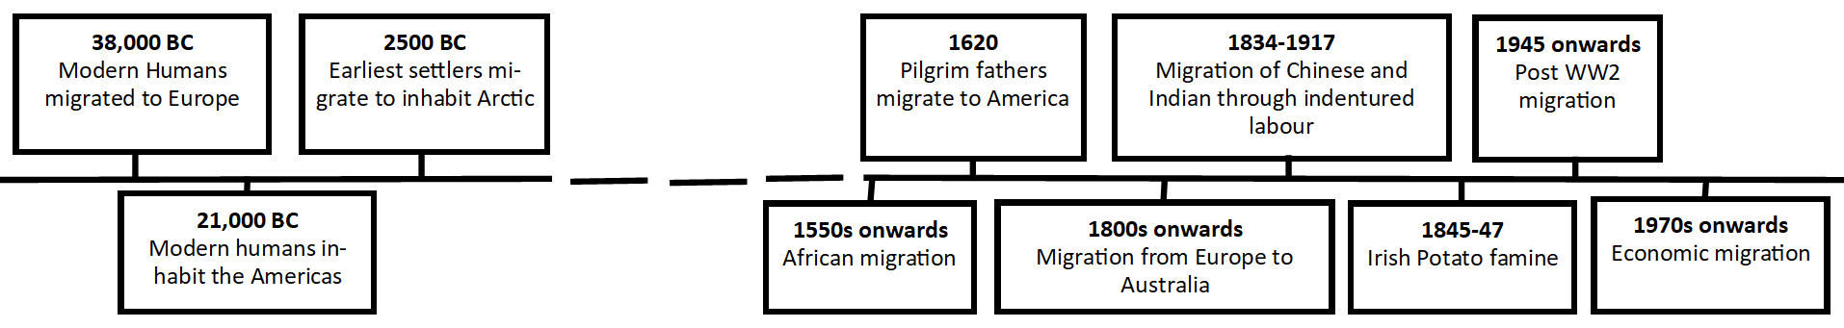  These migrations have ensured that languages, cultures, religions, food and traditions have crossed the Northern hemisphere and impacted peoples’ identities and how people live their lives today.  20th Century Migration  - Starting in the 1550s-1850s, Europe colonised America with the Pilgrim Fathers leaving Plymouth in 1620. Britain, Spain, Portugal, Germany, the Netherlands and France all settled in America.  - Starting 1550-1700s, the African slave trade saw the migration of African to the Americas.  - From the 16th century, seasonal migration saw farm workers migrating across Europe and then returning home each year.  - 1800s-1930 saw the migration of Europeans to Australia.  - 1834-1917 was the time of indentured labour whereby people from British colonies migrated from India and China on the promise of work and a return passage after 5 years. This rarely actually happened.  - In the 1840s there was the Great Atlantic migration to America of Germans and Irish due to the Irish Potato famine (1845-47)  - 1945 onwards saw the post WW2 migration where many people from Asia migrated to Britain to help rebuild it economically.  - Post 1970s saw many migrations for economy including from Bangladesh for chances of employment in richer Western countries.  Migration:  Migration has been a feature of human existence for centuries to seek freedom from war and conflict, to escape hunger and poverty, to flee persecution (refugee), to find new economic opportunities, employment or to trade.  Early Migration  - Modern humans migrated to Europe around 40,000 years ago from central Asia and the Middle East as a result of cultural adaptation to big game hunting. They entered Eurasia by the Zagros mountains (present day Iran/Eastern Turkey)  - 23,000 years ago, modern humans crossed the Beringia land bridge between Eastern Siberia and present day Alaska to live throughout the Americas.  - 2500 BC saw the earliest inhabitants of Arctic.
century | equal to one hundred years
chronology | the order of events in time
similarity | likeness
technology | devices which are the result of scientific knowledge being used for practical purposes
primary source | tells you about an event from the past and is from the time of that event
secondary source | tells you about an event from the past, but was written by after the event by someone who was not present at the event
migration | Movement from one place to another
refugee | Someone who has been forced to leave their country in order to escape war, persecution or natural disaster.
poverty | The state of being extremely poor
persecution | Ill treatment, especially because of race, political or religious beliefs
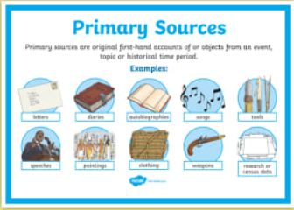
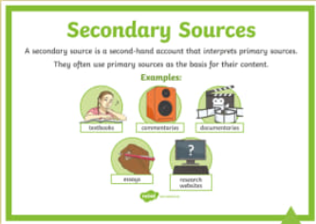
To find out about history, we look at information. If the information comes from somebody or thing which was at the event (diary, photo, newspaper, artefact, video, letter etc) then this is a primary source. If the information comes from after the event by someone who was not there (newspaper, biography, recount), then this is a secondary source.

Art
What should pupils already know/do? |  |  | What will pupils learn/do? |  |  | Where will this learning go?
Yr5  Drawing  * begin to show facial expressions and body language in their sketches  * identify and draw simple objects, and use marks and lines to produce texture  * organise line, tone, shape and colour to represent figures and forms in movement  * show reflections  * explain why they have chosen specific materials to draw with  Sketch books:  * use their sketch books to express their feelings about various subjects and outline likes and dislikes  * use their sketch books to adapt and improve their original ideas  * keep notes about the purpose of their work in their sketch books  Knowledge  * experiment with different styles which artists have used  * explain art from other periods of history  Yr6  Drawing:  * identify and draw simple objects, and use marks and lines to produce texture  * successfully use shading to create mood and feeling  * organise line, tone, shape and colour to represent figures and forms in movement  * show reflections  * explain why they have chosen specific materials to draw with  Sketch books:  * keep notes in their sketch books as to how they might develop their work further  * use their sketch books to compare and discuss ideas with others  Knowledge:  * experiment with different styles which artists have used  * learn about the work of others by looking at their work in books, the internet, visits to galleries and other sources of information |  |  | Yr5  Drawing:  * identify and draw simple objects, and use marks and lines to produce texture  * successfully use shading to create mood and feeling  * organise line, tone, shape and colour to represent figures and forms in movement  * show reflections  * explain why they have chosen specific materials to draw with  Sketch books:  * keep notes in their sketch books as to how they might develop their work further  * use their sketch books to compare and discuss ideas with others  Knowledge:  * experiment with different styles which artists have used  * learn about the work of others by looking at their work in books, the internet, visits to galleries and other sources of information  Yr6  Drawing  * communicate emotions and a sense of self with accuracy and imagination through their sketches  * explain why they have combined different tolls to create their drawings  * explain why they have chosen specific drawing techniques  Sketch books:  * keep detailed notes, and quotes explaining about items  * compare their methods to those of others and keep notes in their sketch books  * combine graphics and text based research of commercial design (magazines etc) to influence the layout of their sketch books  * adapt and refine their work to reflect its meaning and purpose, keeping notes and annotations in their sketch books  Knowledge  * make a record about the styles and qualities in their work  * say what their work is influenced by  * include technical aspects in their work (e.g. architectural design) |  |  | UKs2  Pupils will then build on all previous knowledge again communicate emotions and a sense of self with accuracy and imagination through their sketches. They will explore how to use shading to create mood, exploring the effect of different line, tone, shape and colour and explaining how their work is influenced by other artists and their use of techniques.  Beyond  Pupils will then develop their creativity and ideas, and increase proficiency in their execution. They will develop a critical understanding of artists, architects and designers, expressing reasoned judgements that can inform their own work.
Key Vocabulary |  | 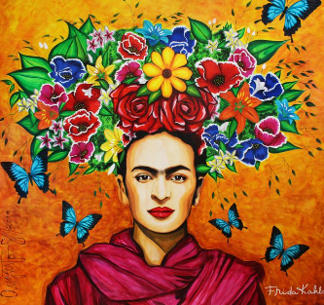  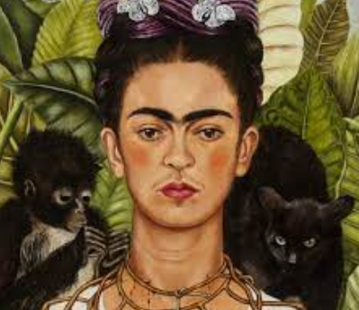  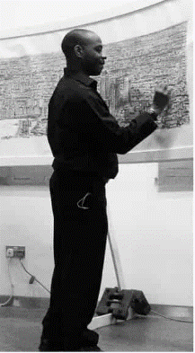  Stephen Wiltshire, an architectural illustrator, is an artist who draws detailed cityscapes which include landmarks from around the UK and Europe. His drawings are popular all over the world, and are held in a number of important art collections and museums. He was born in 1974 in London to West Indian parents. As a child, he was mute and did not relate to other people. Living in a world with no communication, he began to draw. Aged 3 he was diagnosed with autism, and aged 7, he sold his first piece of artwork. He was awarded an MBE for services to the art world in 2006.  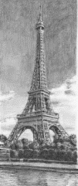  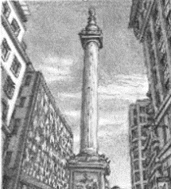  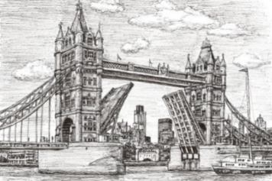  Frida Khalo was a Mexican painter (1907-1954) known for her many portraits and self-portraits. She was inspired by Mexico’s popular culture and employed a naïve folk art style to explore question of identity, postcolonialism, gender, class and race in Mexican society. Her paintings mix realism with fantasy.
investigate | To examine something carefully to find out more about it.
discuss | To talk about something in detail to another person or people.
media | Material used to create something.
line | Using different types of lines to create an image (curved or straight).
shape | A 2D area with an outline.
pattern | A design where lines, shapes or colours are repeated.
design | To sketch and plan a piece of art work.
primary colours | One of the three colours, red, yellow, and blue, that can be mixed together in different ways to make any other colour.
secondary colours | One of the three colours – orange, green, or purple – that can be made by mixing together two of the primary colours.
examine | Look carefully at something in detail to find something out.
artist | Somebody who paints, draws, or makes sculptures.
mix | To combine things (paint) together so they can’t be easily separated.
landscape | The longer sides of a piece of paper at the top and bottom. | cross-hatching |  | A method of line drawing that describes light and shadow | 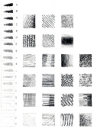  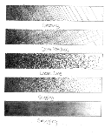  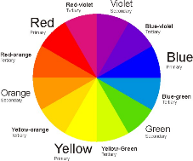
portrait | The shorter sides of a piece of paper at the top and bottom. |  |  | A method of line drawing that describes light and shadow
Cubism | A style of modern art in which an object or person is shown as a set of geometric shapes. | blending/smudging |  | Gently mingling two or more colours to soften lines
cityscapes | A piece of art work showing a city. |  |  | Gently mingling two or more colours to soften lines
architecture | The design and construction of buildings. | hatching |  | Technique used to shade in lines
illustrator | A person who draws or creates pictures. |  |  | Technique used to shade in lines
perspective | Creating or representing 3D shapes, on a 2D surface. | scumbling |  | Shading technique achieved by overlapping lots of little circles
proportion | The correct relationship of the parts of a work of art to each other, especially in their size.
texture | The surface of the art work. It can be made to look flat or 3D. | stippling |  | Use of dots to create texture and shade
technique | The way of doing something that requires skill. |  |  | Use of dots to create texture and shade
form | The shape or appearance of an object. | landmark |  | An object on land that marks a locality

