Superheroes!
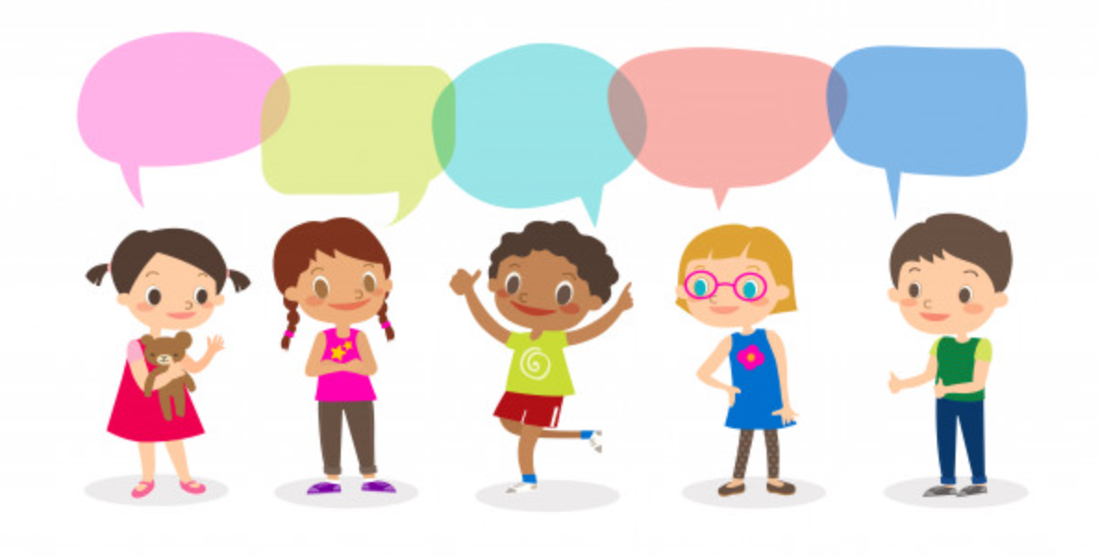
Amazing people
Things I need
Superheroes!
Things we all need
People who help us

Cycle A: Exploration 2
Fs2

Cycle A - Exploration 2 – Fs2 – Superheroes!

Exploration Objectives Overview
Curriculum Drivers: Global (Identity & diversity), Understanding the World: People, Culture & Communities and Past & Present

Area | Fs2 | Area | Fs2
Global  To open up the world | Social Justice & equity:  * what is fair and unfair  * importance of caring and sharing  Human Rights:  * basic needs for human life | Personal, Social and Emotional Development | ELG: Managing Self:  * Explain the reasons for rules, know right from wrong and try to behave accordingly  ELG: Building relationships:  * Show sensitivity to their own and to others’ needs.
Understanding the World  To learn from the past in order to impact the future | ELG: Past & Present  * Talk about the lives of the people around them and their roles in society  * Know some similarities and differences between things in the past and now, drawing on their experiences and what has been read in class.  * Understand the past through settings, characters and events encountered in books read in class and storytelling. | Expressive Arts & Design  To learn how Art & Design reflect and shape our world | ELG: Creating with Materials

Cycle A - Exploration 2 – Fs2  Superheroes!  Throughout the exploration, children learn about themselves, exploring their own uniqueness, value and place in the world. They learn about their self-identity and sense of belonging within their family tree, thinking about themselves as humans including similarities and differences with others. They learn about their local area, while exploring the idea of themselves as part of a family and community to show “This is me!” |  |  |  |  |  | Learning – Social Justice & equity  Human Rights
What should pupils already know? |  | What will pupils learn? |  | Where will this learning go?
 |  | * what is fair and unfair  * importance of caring and sharing  * basic needs for human life |  | Later in Fs2  Ks1  LKs2
SOLO Taxonomy | Uni-structural knowledge |  | Multi-Structural knowledge |  | Relational knowledge |  | Extended | Abstract
SOLO Taxonomy |   I have one relevant bit of knowledge |  |   I have several bits of key knowledge |  | 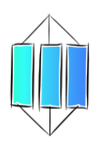  I can see links between my bits of key knowledge |  | 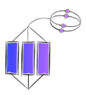  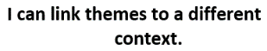
Spaced Questions | - Things I need |  | - Things we all need |  | - People who help us |  | - Amazing people | - Superheroes!
Key substantive knowledge | * basic needs for human life |  | * what is fair and unfair  * importance of caring and sharing  * Explain the reasons for rules, know right from wrong and try to behave accordingly |  | Talk about the lives of the people around them and their roles in society |  | * Talk about the lives of the people around them and their roles in society  * Know some similarities and differences between things in the past and now, drawing on their experiences and what has been read in class.  * Understand the past through settings, characters and events encountered in books read in class and storytelling.
Answer Guideline: | Difference between need and want  Basic needs: air, food, water, shelter, sleep  abstract needs: love, friendship, care |  | Importance of fairness and equality in getting the things we need  Need for rules in order to ensure that everyone gets what they need  How some people don’t always get what they need and others get more – rich/poor |  | People who help us get the things that we need in the children’s lives and in society: police, fire, ambulance, doctors, farmers, supermarket workers |  | People who go above and beyond to help people and who fight for fairness.  People within the local area and beyond - foodbanks | Traits of people who are “superheroes” and how the children themselves can display these traits to help people in need.

Key people linked to Curriculum areas for Explore
Global | 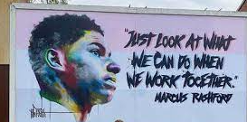  Marcus partnered with FareShare – a charity fighting hunger and food waste by redistributing surplus food to frontline charities. Marcus became an ambassador for the charity in March 2020. | 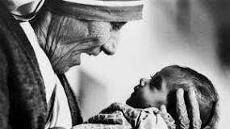  During her lifetime Mother Teresa became famous as the Catholic nun who dedicated her life to caring for the destitute and dying in the slums of Calcutta - now known as Kolkata. In 1979 she received the Nobel Peace Prize and after her death was canonised as Saint Teresa. |  |  | 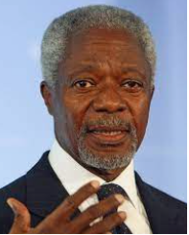  We may have different religions, different languages, different coloured skin, but we all belong to one human race.  Kofi Annan
Literacy | 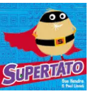  Sue Hendra and Paul Linnett: Paul Linnet was born in Brighton and grew up in the  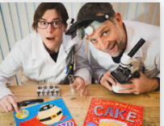  Midlands, reading Tintin and playing classic 80s video games, before becoming obsessed with scribbling, writing, guitars and motorcycles. He studied Graphic Design at Derby University, and later moved back to Brighton where he met Sue Hendra  Sue Hendra grew up in Wimbledon and has always loved making up stories and drawing pictures. ... She graduated from Brighton University in 1994 and has been creating picture books ever since. In 2006 she met Paul Linnet and could instantly see that she'd met a fellow nitwit who liked talking nonsense. |  |  | Juniper Jupiter by Lizzy Stewart  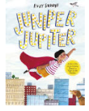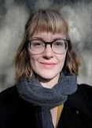  Always loved drawing. Went to art college and has earned a living drawing ever since. Lives in London. |  | 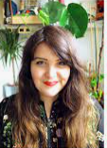  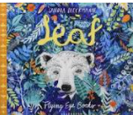  Sandra Dieckmann  enjoys observing the world, creating creatures and anything else that involves creative play. Her work mainly revolves around nature and wildlife.  Born in Germany and lived in a tree house!
Knowledge and Understanding- People | 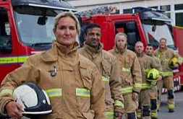  Firefighters |  |   Doctors/ Nurses | 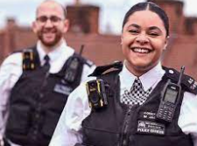  Police |  |  |   Dentists
Art | Pharaohs in Egypt first use henna around 9000 years ago. Used henna trees to mark bodies. Now used by Hindus and Sikhs in dressing up for Diwali celebrations to draw mehndi patterns on skin. |  |  | 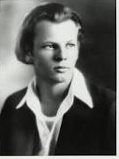  Jackson Pollock  Paul Jackson Pollock was an American painter and a major figure in the abstract expressionist movement. He was widely noticed for his "drip technique" of pouring or splashing liquid household paint onto a horizontal surface, enabling him to view and paint his canvases from all angles.

Expressive Arts & Design - ELG: Creating with Materials
What should pupils already know/do? |  | What will pupils learn/do? |  | Where will this learning go?
* safely use a variety of materials  *experience of mixing primary colours  *make simple representations of themselves |  | * Safely use and explore a variety of materials, tools and techniques, experimenting with colour, design, texture, form and function  * Share their creations, explaining the process they have used  * Make use of props and materials when role playing characters in narratives and stories. |  | Ks1  Children will build on their learning to communicate something about themselves in their drawing and create mood through different tones, pattern and textures. They will describe what they can see and like in the work of another artist, saying how other artists have used colour, pattern and shape, and reate a piece of work in response to another artist’s work
 | Jackson Pollock  Paul Jackson Pollock was an American painter and a major figure in the abstract expressionist movement. He was widely noticed for his "drip technique" of pouring or splashing liquid household paint onto a horizontal surface, enabling him to view and paint his canvases from all angles. |  | Pharaohs in Egypt first use henna around 9000 years ago. Used henna trees to mark bodies. Now used by Hindus and Sikhs in dressing up for Diwali celebrations to draw mehndi patterns on skin.  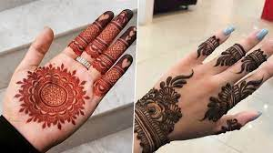
  Key Vocabulary
  investigate | To examine something carefully to find out more about it.
  discuss | To talk about something in detail to another person or people.
  line | Using different types of lines to create an image (curved or straight).
  shape | A 2D area with an outline.
  pattern | A design where lines, shapes or colours are repeated.
  design | To sketch and plan a piece of art work.
  primary colours | One of the three colours, red, yellow, and blue, that can be mixed together in different ways to make any other colour.
  secondary colours | One of the three colours – orange, green, or purple – that can be made by mixing together two of the primary colours.
  artist | Somebody who paints, draws, or makes sculptures.
  mix | To combine things (paint) together so they can’t be easily separated.
  landscape | The longer sides of a piece of paper at the top and bottom.
  portrait | The shorter sides of a piece of paper at the top and bottom.
  landmark | An object on land that marks a locality
  cityscapes | A piece of art work showing a city.
  illustrator | A person who draws or creates pictures.

Understanding of the World – ELG: People and Communities
What should pupils already know/do? |  |  | What will pupils learn? | Where will this learning go?
* Show interest in different occupations  *Continue developing attitudes about the differences between people.  Know there are different countries in the world and talk about the differences they have experienced or seen in photos. |  |  | *Talk about immediate family and members of their community.  *Recognise that people have different beliefs and celebrate special times in different ways. | Ks1  Children will build on their learning to explore how their community works together and their role within their community.
 | later in time than, or behind in order
before | at an earlier time, in the past
new | having recently arrived, been produced, or come into being
now | at this time or in these times
old | having existed for many years; not new
older | having lived for many years
past | having happened or gone by at an earlier time
present | existing at this time; current
sibling | a sister or a brother
similarity | likeness
technology | devices which are the result of scientific knowledge being used for practical purposes
then | soon after; next
usually | most common or expected
younger | earlier stage of life

