How do our actions shape our futures?
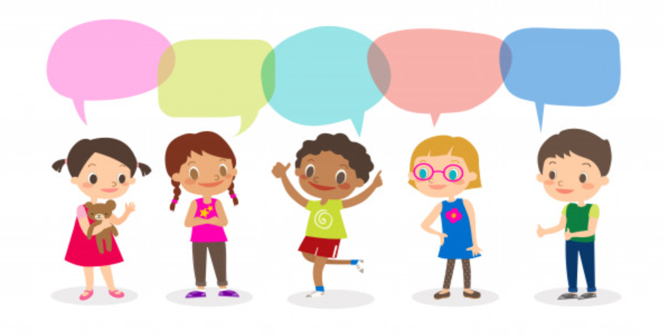
What was the fire of London?
How do our actions shape our futures?
How did actions at this time shape our future?

What were the key events leading up to the Fire of London?

How do people’s actions shape the future?

Cycle A: Exploration 2
Ks1

Cycle A - Exploration 2 – Ks1 – How do our actions shape our futures?

Exploration Objectives Overview
Curriculum Drivers: Global (Social Justice & equity, Human Rights), History (Guy Fawkes/Plague/The Fire of London)

Subject | Yr1 | Yr2 |  | Subject | Yr1 | Yr2
Global  To open up the world | Social Justice & Equity  * what fairness means with examples of what it can mean to be rich or poor in local and other contexts  Human Rights  * rights in class and school  * the need to respect the rights of others  * basic human rights and how some people have these denied |  |  | RSE | Respectful relationships:  * That people and other living things have rights and that everyone has responsibilities to protect those rights (including protecting others’ bodies and feelings; being able to take turns, share and understand the need to return things that have been borrowed)  * Recognise different types of teasing and bullying, to understand that these are wrong and unacceptable  Caring Friendsip:  * To identify their special people (family, friends, carers), what makes them special and how special people care for one another. ·  * To recognise that their behaviour can affect other people  * To recognise what is fair and unfair, kind and unkind, what is right and wrong
History  To learn from the past in order to impact the future | Chronological Understanding:  * put up to three objects in chronological order (recent history)  * use words and phrases like: old, new and a long time ago  * recognise that a story that is read to them may have happened a long time ago  * know that some objects belonged to the past  Knowledge and interpretation:  * appreciate that some famous people have helped our lives be better today  * recognise that we celebrate certain events, such as bonfire night, because of what happened many years ago  * understand that we have a queen who rules us and that Britain has had a king or queen for many years  Historical Enquiry:  * spot old and new things in a picture  * answer questions using an artefact/ photograph provided  * give a plausible explanation about what an object was used for in the past |  | Chronological Understanding:  * use words and phrases like: before I was born, when I was younger  * use phrases and words like: ‘before’, ‘after’, ‘past’, ‘present’, ‘then’ and ‘now’; in their historical learning  * use the words past and present correctly  * use a range of appropriate words and phrases to describe the past  * sequence a set of events in chronological order and give reasons for their order  Knowledge and Interpretation:  * recount some interesting facts from an historical event, such as where the fire of London started  * explain why Britain has a special history by naming some famous events and some famous people  * explain what is meant by a parliament?  Historical Enquiry:  * answer questions by using a specific source, such as an information book  * Research the life of a famous Briton from the past using different resources to help them?  * research about a famous event that happens in Britain and why it has been happening for some time

Cycle A - Exploration 2 – Ks1  How do our actions shape our actions?  Throughout the exploration, children build on their learning about themselves, culture and diversity to further explore the nature of prejudice and inequality, and how these affected key events in history. |  |  |  |  |  | Learning – Social Justice & equity/Humans Rights  History driver – Guy Fawkes/Plague/Fire of London
What should pupils already know? |  | What will pupils learn? |  | Where will this learning go?
* what is fair and unfair  * importance of caring and sharing  * basic needs for human life |  | * what fairness means with examples of what it can mean to be rich or poor in local and other contexts  * rights in class and school  * the need to respect the rights of others  * basic human rights and how some people have these denied
SOLO Taxonomy | Uni-structural knowledge |  | Multi-Structural knowledge |  | Relational knowledge |  | Extended | Abstract
SOLO Taxonomy |   I have one relevant bit of knowledge |  |   I have several bits of key knowledge |  | 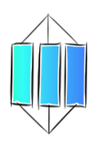  I can see links between my bits of key knowledge |  | 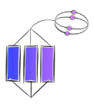  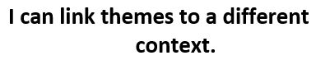  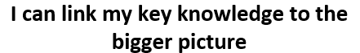
Spaced Questions | - What was the fire of London?  1 week |  | - What were the key events leading up to the Fire of London?  3 weeks |  | - How did actions at this time shape our future?  2 weeks |  | - How do people’s actions shape the future? | - How do our actions shape our futures  1 week
Key substantive knowledge | Yr1  * use words and phrases like: old, new and a long time ago  * recognise that a story that is read to them may have happened a long time ago  * recognise that we celebrate certain events, such as bonfire night, because of what happened many years ago  * understand that we have a queen who rules us and that Britain has had a king or queen for many years  * spot old and new things in a picture  * answer questions using an artefact/ photograph provided  * give a plausible explanation about what an object was used for in the past  Yr2  * use words and phrases like: before I was born, when I was younger  * use phrases and words like: ‘before’, ‘after’, ‘past’, ‘present’, ‘then’ and ‘now’; in their historical learning  * use the words past and present correctly  * recount some interesting facts from an historical event, such as where the fire of London started  * answer questions by using a specific source, such as an information book |  | All Ks1 at own level:  * what fairness means with examples of what it can mean to be rich or poor in local and other contexts  * basic human rights and how some people have these denied  Yr1  * use words and phrases like: old, new and a long time ago  * recognise that a story that is read to them may have happened a long time ago  * spot old and new things in a picture  * answer questions using an artefact/ photograph provided  * give a plausible explanation about what an object was used for in the past  Yr2  * use words and phrases like: before I was born, when I was younger  * use phrases and words like: ‘before’, ‘after’, ‘past’, ‘present’, ‘then’ and ‘now’; in their historical learning  * use the words past and present correctly  * use a range of appropriate words and phrases to describe the past  * sequence a set of events in chronological order and give reasons for their order  * explain why Britain has a special history by naming some famous events and some famous people |  | All Ks1 at own level:  * the need to respect the rights of others  * To recognise that their behaviour can affect other people  * To recognise what is fair and unfair, kind and unkind, what is right and wrong  Yr1  * appreciate that some famous people have helped our lives be better today  Yr2  * explain why Britain has a special history by naming some famous events and some famous people  * Research the life of a famous Briton from the past using different resources to help them |  | All Ks1 at own level:  * what fairness means with examples of what it can mean to be rich or poor in local and other contexts  * rights in class and school  * the need to respect the rights of others  * basic human rights and how some people have these denied  * To recognise that their behaviour can affect other people  * To recognise what is fair and unfair, kind and unkind, what is right and wrong
Answer Guideline:  Assessment at each stage will allow children to show their learning in relation to the spaced question.  Assessment of children’s learning can be gained from oral discussion and writing, but must also be gained through curriculum activities such as worksheets, quizzes and short tests etc.  This ensures that children who struggle to express their learning through speaking or writing are not at a disadvantage when expressing their learning in relation to the taught curriculum objectives. | The Great Fire of London was a fire, which swept through London from the 2nd to the 6th of September 1666. The fire started shortly after midnight on Sunday 2nd at Thomas Farriner’s bakery in Pudding Lane, and spread rapidly through the medieval city of London inside the old Roman wall. The Mayor, Sir Thomas Bloodworth, did not make a decision quickly enough and didn’t want to use the King’s (Charles II) soldiers to help due to not trusting his father, so the fire spread further. However, as Bloodworth fled the city, the king took control creating teams of firefighters and creating firebreaks by blowing up houses. However, the fire still took St.Paul’s cathedral due to the wooden scaffolding due to its ongoing restoration by Christopher Wren  It destroyed 13000 houses and the whole event was recorded by Samuel Pepys (who buried his wine and parmesan cheese in the garden to protect it) in his diary. |  | London was an overcrowded warren of narrow, winding, cobbled alleys. The houses were made of wood with thatched roofs. They were 6 or 7 stories and the upper floors projected out over the lower – this meant that the upper floors nearly touched across the narrow streets.  London had experienced many fires in the past and had banned thatch roofing, but these materials were cheap and were still used in the poorer parts of the city where buildings were unregulated. The only buildings made of stone were where the wealthy people lived. In the poor areas, there was also work places, which were fire hazards – these were illegal but no-one cared in the poorer areas.  Along the river, there were paper shacks of the poorest and in cellars, gunpowder was stored in wooden barrels.  London had been a Roman settlement for 400 years and had become crowded within the city wall, which was built to defend the city, but acted as a barrier to people trying to flee the fire.  There was no fire brigade and it was usually left to volunteers to gather ladders, buckets, axes and “firehooks” for pulling houses down to create fire breaks. However due to the mayor not making a decision, no one acted.  There was a high wind. |  | The fire got rid of cramped areas of poverty for new, more modern housing constructed of brick and stone rather than medieval housing. Building regulations came into force and modern architecture was allowed within the city – Christopher wren – St. Paul’s cathedral  There was the birth of home insurance (the fire office) in 1667 and the creation of a fire brigade  King Charles II decreed that all other cities and towns had to receive homeless people enabling work opportunities elsewhere in the country.  There were improvements of hygiene and safety – wider streets, open and accessible river with no houses on the edge.  No outbreaks of plague after the fire – thought to have killed the rats and slum like conditions, which contributed to the disease spreading. |  | By insisting on the same conditions for everyone, rich or poor, we can make sure that everyone is safe and healthy – not just the rich people, or one group of people in the future.  By being brave, decisive and taking action, we can help people quicker and shape their futures better.  By working together, we can overcome the biggest challenges and know that something great can come out of something bad, and that the future can be better than before.

Anchor novel/s | Yr1/2 | 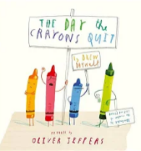 | 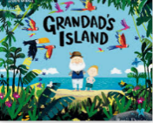 |  | 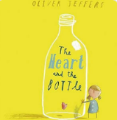
Writing Purpose | Yr1/2

