How do our actions shape our futures?
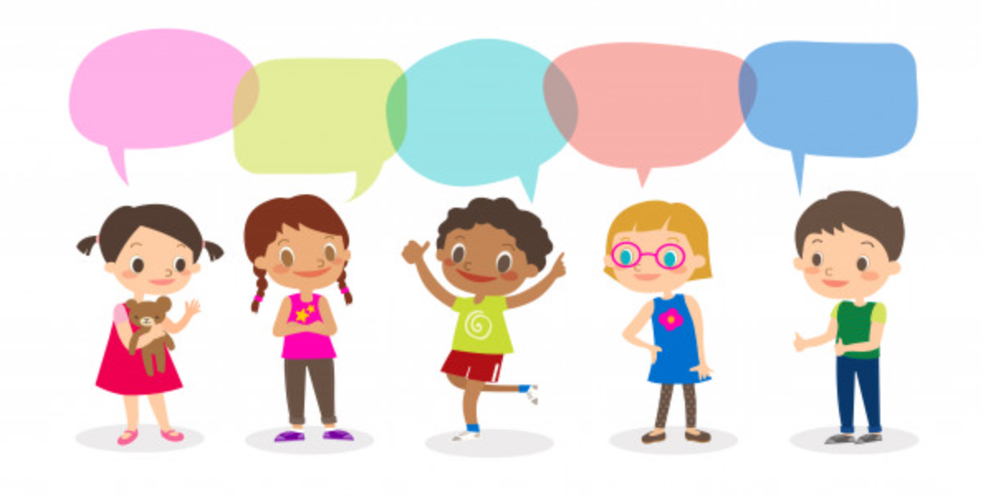
What is equality?
How do our actions shape our futures?
Where does inequality happen?
How do people’s actions shape the future?
How is inequality overcome?

Cycle A: Exploration 2
UKs2

Cycle A - Exploration 2 – UKs2 – How do our actions shape our futures?

Exploration Objectives Overview
Curriculum Drivers: Global (Social Justice & equity, Human Rights), History (themes of civil rights over the years)

Subject | Yr5 | Yr6 |  | Subject | Yr5 | Yr6
Global  To open up the world | Social Justice & Equity  * ways of defining and measuring poverty (relative and absolute) and inequality  * in equalities within and between societies and how these change wider causes and effects of poverty, inequality and exclusion  Human Rights  * universal declaration of human rights  * importance of citizens, societies and governments respecting and defending people’s human rights  * current and historical human rights issues and movements in own country and elsewhere |  |  | RSE | Respectful relationships:  * About different types of bullying; the impact of bullying, responsibilities of bystanders (primarily reporting bullying to an adult) and how to get help.  * what a stereotype is, and how stereotypes can be unfair, negative or destructive  * the importance of permission-seeking and giving in relationships with friends, peers and adults  Bring safe:  * How to report concerns or abuse, and the vocabulary and confidence needed to do so  * where to get advice e.g. family, school and/or other sources
History  To learn from the past in order to impact the future | Chronological Understanding:  * use dates and historical language in their work  * draw a timeline with different time periods outlined which show different information, such as, periods of history, when famous people lived, etc.  Knowledge and interpretation:  * describe historical events from the different period/s they are studying/have studied  * make comparisons between historical periods; explaining things that have changed and things which have stayed the same  * appreciate that significant events in history has helped shape the country we have today  Historical Enquiry:  * appreciate how historical artefacts has helped us understand more about British lives in the present and past? |  | Chronological Understanding  * say where a period of history fits on a timeline  * place a specific event on a timeline by decade  * place features of historical events and people from past societies and periods in a chronological framework  Knowledge and Interpretation  * summarise the main events from a specific period in history, explaining the order in which key events happened  * describe features of historical events and people from past societies and periods they have studied  * recognise and describe differences and similarities/ changes and continuity between different periods of history  Historical Enquiry  * look at two different versions and say how the author may be attempting to persuade or give a specific viewpoint | PSHE | Relationships (families and close positive relationships)  * R13 the importance of seeking support if feeling lonely or excluded  * R14 that healthy friendships make people feel included; recognise when others may feel lonely or excluded; strategies to include them  (managing hurtful behaviour and bullying)  * R19 the impact of bullying, including offline and online, and the consequences of hurtful behaviour  * R20 strategies to respond to hurtful behaviour experienced or witnessed, offline or online (including teasing, name-calling, bullying, trolling, harassment or the deliberate excluding of others); how to report concerns and get support  * R21 about discrimination: what it means and how to challenge it  (respecting self and others)  * R30 that personal behaviour can affect other people; to recognise and model respectful behaviour online  * R31 to recognise the importance of self-respect and how this can affect their thoughts and feelings about themselves; that everyone, including them, should expect to be treated politely and with respect by others in school and in wider society; strategies to improve or support courteous, respectful relationships.  * R32 about respecting the differences and similarities between people and recognising what they have in common with others  * R33 to listen and respond respectfully to a wide range of people, including those whose traditions, beliefs and lifestyle are different to their own.  Living in the wider world (shared responsibilities)  * L2 to recognise there are human rights, that are there to protect everyone  * L3 about the relationship between rights and responsibilities  * L4 the importance of having compassion towards others; shared responsibilities we all have for caring for other people; how to show care and concern for others  (communities)  * L9 About stereotypes; how they can negatively influence behaviours and attitudes towards others; strategies for challenging stereotypes  * L10 about prejudice; how to recognise behaviours/actions which discriminate against others; ways of responding to it if witnessed or experienced  * L27 about stereotypes in the workplace and that a person’s career aspirations should not be limited by them  * L28 about what might influence people’s decisions about a job or career

Cycle A - Exploration 2 – UKs2  How do our actions shape our actions?  Throughout the exploration, children build on their learning about themselves, culture and diversity to further explore the nature of prejudice, racism and sexism, and ways to combat these. They build on the themes of fairness, human rights and the unequal sharing of power to explore inequality on a global level, learning about events in the past in relation to civil rights, how key people from history fought to resolve conflict and the importance of non-violent protest. |  |  |  |  |  | Learning – Social Justice & equity/Humans Rights  History driver – Theme across British History (civil rights)
What should pupils already know? |  |  |  |  | What will pupils learn? |  |  | Where will this learning go?
* how fairness may not always mean equal treatment  * some causes and effects of poverty and inequality (including gender inequalities) at local, national and global levels  * UN convention on the rights of the child  * reasons why some people have their rights denied  * those responsible for rights being met (teachers, local and national government)  LKS2 related topics to build on – Victorian era and the abolishment of the slave trade, Vikings, Ancient Egyptians, Romans, Tudors, Stone age to Iron age  KS1 related topics to build on – Nursing (Florence Nightingale, Mary Seacole, Edith Cavell), Christopher Columbus, fire of London, Queens Victoria and Elizabeth 1st and 2^{nd,} first aeroplane flight (Wright brothers/Amelia Earhart/Amy Johnson and  Flight into space (Neil Armstrong/ Helen Sharman) |  |  |  |  | * ways of defining and measuring poverty (relative and absolute) and inequality  * inequalities within and between societies and how these change wider causes and effects of poverty, inequality and exclusion  * universal declaration of human rights  * importance of citizens, societies and governments respecting and defending people’s human rights  * current and historical human rights issues and movements in own country and elsewhere |  |  | Uks2  Again extending their learning to a global community and world issues, pupils will build on previous knowledge to continue to think about the nature of prejudice, racism and sexism in the past, the present and the consequences of their futures. They will build in their learning about evolution to explore what the future may look like, and how they can contribute to it with their actions now.  As lifelong citizens  Pupils will be equipped to understand the importance of equality and respecting human rights across the world. They will understand the need to understand people who have different cultures, beliefs and lifestyles from their own, and have empathy towards the different people that they meet throughout life, embracing difference, diversity and culture. They will challenge forms of stereotyping, prejudice and discrimination in order to be an active, important member of society.
SOLO Taxonomy |  | Uni-structural knowledge | Multi-Structural knowledge |  |  |  |  |  |  | Relational knowledge |  | Extended | Abstract
 |  |   I have one relevant bit of knowledge |   I have several bits of key knowledge |  |  |  |  |  |  |   I can see links between my bits of key knowledge |  | 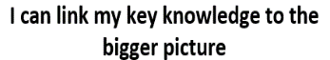    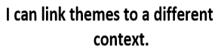
Spaced Questions |  | - What is equality?  1 week | - Where does inequality happen?  3 weeks |  |  |  |  |  |  | - How is inequality overcome?  2 weeks |  | - How do people’s actions shape the future? | - How do our actions shape our futures?  1 week
Key substantive knowledge |  | All UKs2 at own level:  * universal declaration of human rights  * importance of citizens, societies and governments respecting and defending people’s human rights  * L2 to recognise there are human rights, that are there to protect everyone  * L3 about the relationship between rights and responsibilities  Yr5  * use dates and historical language in their work  * draw a timeline with different time periods outlined which show different information, such as, periods of history, when famous people lived, etc.  Yr6  * say where a period of history fits on a timeline  * place a specific event on a timeline by decade | All UKs2 at own level:  * ways of defining and measuring poverty (relative and absolute) and inequality  * inequalities within and between societies and how these change wider causes and effects of poverty, inequality and exclusion  * current and historical human rights issues and movements in own country and elsewhere  * what a stereotype is, and how stereotypes can be unfair, negative or destructive  * About different types of bullying; the impact of bullying  * R19 the impact of bullying, including offline and online, and the consequences of hurtful behaviour  * R21 about discrimination: what it means and how to challenge it  * L9 About stereotypes; how they can negatively influence behaviours and attitudes towards others; strategies for challenging stereotypes  * L10 about prejudice; how to recognise behaviours/actions which discriminate against others; ways of responding to it if witnessed or experienced  * L27 about stereotypes in the workplace and that a person’s career aspirations should not be limited by them  * L28 about what might influence people’s decisions about a job or career  Yr5  * use dates and historical language in their work  * draw a timeline with different time periods outlined which show different information, such as, periods of history, when famous people lived, etc.  * describe historical events from the different period/s they are studying/have studied  Yr6  * say where a period of history fits on a timeline  * place a specific event on a timeline by decade  * place features of historical events and people from past societies and periods in a chronological framework  * summarise the main events from a specific period in history, explaining the order in which key events happened  * describe features of historical events and people from past societies and periods they have studied |  |  |  |  |  |  | All UKs2 at own level:  * current and historical human rights issues and movements in own country and elsewhere  * Responsibilities of bystanders (primarily reporting bullying to an adult) and how to get help.  * the importance of permission-seeking and giving in relationships with friends, peers and adults  * How to report concerns or abuse, and the vocabulary and confidence needed to do so  * where to get advice e.g. family, school and/or other sources  Yr5  * make comparisons between historical periods; explaining things that have changed and things which have stayed the same  Yr6  * recognise and describe differences and similarities/ changes and continuity between different periods of history |  | All UKs2 at own level:  * current and historical human rights issues and movements in own country and elsewhere  * Responsibilities of bystanders (primarily reporting bullying to an adult) and how to get help.  * the importance of permission-seeking and giving in relationships with friends, peers and adults  * How to report concerns or abuse, and the vocabulary and confidence needed to do so  * where to get advice e.g. family, school and/or other sources  * R13 the importance of seeking support if feeling lonely or excluded  * R14 that healthy friendships make people feel included; recognise when others may feel lonely or excluded; strategies to include them  * R20 strategies to respond to hurtful behaviour experienced or witnessed, offline or online (including teasing, name-calling, bullying, trolling, harassment or the deliberate excluding of others); how to report concerns and get support  * R30 that personal behaviour can affect other people; to recognise and model respectful behaviour online  * R31 to recognise the importance of self-respect and how this can affect their thoughts and feelings about themselves; that everyone, including them, should expect to be treated politely and with respect by others in school and in wider society; strategies to improve or support courteous, respectful relationships.  * R32 about respecting the differences and similarities between people and recognising what they have in common with others  * R33 to listen and respond respectfully to a wide range of people, including those whose traditions, beliefs and lifestyle are different to their own.  L4 the importance of having compassion towards others; shared responsibilities we all have for caring for other people; how to show care and concern for others
Answer Guideline:  Assessment at each stage will allow children to show their learning in relation to the spaced question.  Assessment of children’s learning can be gained from oral discussion and writing, but must also be gained through curriculum activities such as worksheets, quizzes and short tests etc.  This ensures that children who struggle to express their learning through speaking or writing are not at a disadvantage when expressing their learning in relation to the taught curriculum objectives. |  | Equality is every individual having the right to equal treatment, opportunities or life chances regardless of their gender, race, wealth, beliefs, ability or sexual orientation. Equality is about everyone benefiting, not just a few people.  Britain have worked hard to promote equality, they have introduced many laws which try to promote equality, resulting in the Equality Act of 2010 which finally brought all these Acts together to protect anyone from discrimination in the workplace and wider society, making it unlawful to treat someone different to another based on 9 protected characteristics.  Human rights are basic rights and freedoms that belong to every single person in the world; from the day we're born until the day we die, we all have human rights. You have human rights regardless of where you're from, what you believe or how you live your life. Human rights can't be taken away. However, they can be restricted - for instance, if a person breaks the law, or in the interests of national security. Human rights are protected by law, and are based on values like fairness, equality, respect, dignity and independence.  The first Human rights charter is considered to be Cyrus Cylinder  https://www.twinkl.co.uk/teaching-wiki/equality | An antonym of equality is inequality. Inequality refers to situations where some people have more money, rights, or opportunities than others. Another antonym is discrimination which means treating someone unfairly because of who they are or because they possess certain characteristics. This often happens when there is a lack of understanding for different cultures, beliefs and lifestyles which results in certain groups being treated less fairly than others.  Inequality across people is things like wealth and income (poverty) known as economic inequality. This has happened across history with Lords and Nobles being given land from the Norman Conquest and others living as peasants; in the Victorian times, industrialisation meant that factory owners became very wealthy while others remained extremely poor, resulting in living in the workhouses. Even today, a quarter of all the world’s wealth is owned by billionaires, including the world’s richest man, Jeff Bezos creator of Amazon, while other people struggle to afford shelter, medicines, food and clothes.  Inequality across groups of people are things like racial, gender, sexual orientation, disability, beliefs and age. Again, these have been unequal across history with people from different races being segregated in the apartheids and most recently in the issues which started the Black Lives Matter movement; Throughout history, females have been not allowed to have access to education, work or the right to vote with this still happening in some places today; people have been treat unfairly due to their sexual orientation and gender identity, having jobs and opportunities regularly denied to them and still being seen as unlawful in some places today; People have been discriminated in relation to their religion and beliefs since time began including persecution of protestants and Catholics during various royal reigns, Jewish persecution during WW2 and a number of religions continue to be persecuted across the world today. |  |  |  |  |  |  | People need to understand where inequality happens and respect the rights of others. Speaking out about where inequality happens and challenging negative attitudes helps people who are being discriminated.  Some key people who have helped to overcome inequality are:  Economic inequality – Marcus Rashford, Obama (Obamacare)  Racial inequality – Ghandi, Rosa Parks, Martin Luther King, Nelson Mandela, black lives matter (Edwrd Colston statue being pulled down), Doreen Lawrence  Gender inequality – Malala, suffragettes (Emmeline Pankhurst)  Religious inequality – Schindler, Dalai Lama, Sir Nicholas Winton https://www.youtube.com/watch?v=z5c2Lds_ax8 |  | By respecting others’ rights and understanding what was unfair, people took positive action to tell people and change what was happening within their time, resulting in their actions beginning to change the future.  Therefore, by working to understand and respect others, by not judging or stereotyping, by speaking out about issues which concern us and challenging negative attitudes and language, we can make sure that our actions help shape our futures for the better.
Anchor novel/s | Yr5/6 | 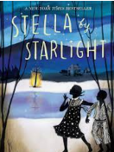  Through the novel Stella by Starlight, part of our “Tell me your story: BAME” strand, pupils will be introduced to the civil rights movement through African American characters, helping them to understand how the character is feeling, and think about how we feel about BAME issues also. |  |   Another book addressing racial inequality is “Windrush Child” by Benjamin Zephaniah. |  | 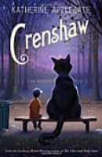  A book with the theme of economic inequality is Crenshaw by Catherine Applegate |  |  | 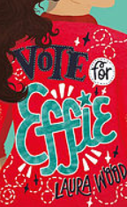  A book with the theme of gender equality is “Vote for Effie” by Laura Wood. |  | 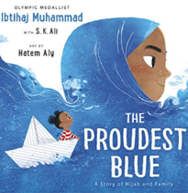  A book about religious equality is “The Proudest Blue” by Ibtihaj Muhammad. |  | 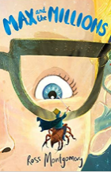  A book with a disabled character is “Max and the millions” by Ross Montgomery.
Writing Purpose | Yr5/6

Key people linked to Curriculum areas for Explore
Global | 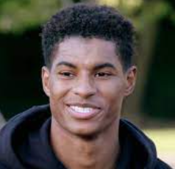  Marcus Rshford launched a campaign encouraging England’s poorest families to be provided with food vouchers to support them through the lockdown. His petition to end food poverty gained over a million signatures. |  | 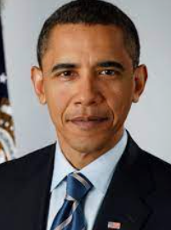  Barack Obama signed Obamacare into law in 2010.  The act aimed to provide affordable health insurance coverage for all Americans and protect consumers from insurance company driving up patient costs or restrict care.  Millions of unemployed or low-paid Americans have benefitted, including people who couldn’t work because of a disability or family obligation, and others who couldn’t get decent health insurance because of a pre-existing medical condition. |  |  |  |  | 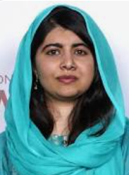  Malala Yousafzai (1997) is a Pakistani activist for female education and a Nobel Peace Prize laureate. |  |  | 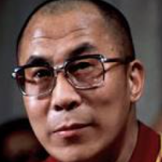  The 14th Dalai Lama (19350 is the spiritual leader of Tibetan Buddhism and has spent his entire life committed to benefitting humanity. In 1989, the Dalai Lama was awarded the Nobel Peace Prize for his nonviolent efforts for the liberation of Tibet and his concern or global environmental problems.
Global | 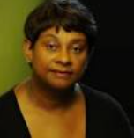  Doreen Lawrence (1952) Baroness Lawrence of Clarendon, OBE is a British Jamaican campaigner and the mother of Stephen Lawrence, a black British teenager who was murdered in a racist attack in London in 1993. She has promoted reforms of the police service and founded the Stephen Lawrence Charitable Trust. |  |  |  |   Leslie Thomas (1965) is one of the UK’s top human rights barristers today. He has used his career to fight for people in society whose voices are not always recognised or heard. |  |  |  |  |  |  |  | 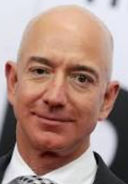  Jeff Bezos (1964) is an American entrepreneur and founder of Amazon. He has a net worth of over $200 billion and is the richest person in the world.
Literacy | 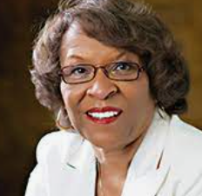  Sharon Mills Draper is an American children’s writer, professional educator and the 1997 National Teacher of the Year. She is a five-time winner of the Coretta Scott King Award for books about the young and adolescent African-American experience. |  |  |  |  | 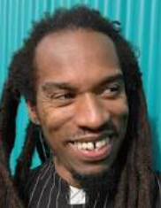  Benjamin Zephaniah (1958) is a British writer and dub poet, meaning his poems are performed over music (often Reggae). He was included in the Times list of Britain’s top 50 post-war writers in 2008, and often writes about issues facing Black British people. Benjamin is dyslexic and struggled at school. |  |  |  |   Jessica Kensky is an author who is a double amputee after losing both her legs in the Boston Marathon attacks in 2013.
History | 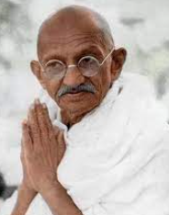  Mohandas Karamchand Ghandi (1869-1948) was an Indian lawyer and anti-colonial nationalist who employed nonviolent resistance to lead the successful campaign for India’s independence from British rule and in turn inspired movements for civil rights and freedom across the world. |  |  | 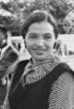  Rosa Louise McCauley Parks (1913-2005) was an African-American activist in the civil rights movement best known for her pivotal role in the Montgomery bus boycott. The US congress has honoured her as “the first lady of civil rights” and “the mother of the freedom movement”. |  |  | 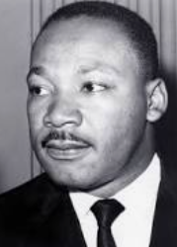  Martin Luther King Jr (1929-1968) was an American Baptist minister and activist who became the most visible spokesperson and leader in the American civil rights movement from 1955 until his assassination in 1968. |  |  |  |  | 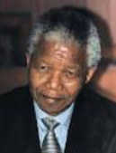  Nelson Rolihlahla Mandela (1918-2013) was a South African anti-apartheid revolutionary statesman and philanthropist who served as the first president of South Africa from 1994-1999. He was the country’s first black head of state, and the first elected in a fully representative democratic election.
History | 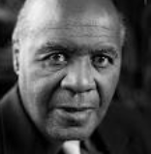  Paul Stephenson (1937) OBE is a community worker, activist and long-time campaigner for civil rights for the British African-Caribbean community in Bristol, and well known for the Bristol Bus Boycott. | 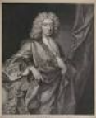  Edward Colston (1636-1721) was an English merchant who was involved in the Atlantic Salve trade. His statue was erected in Bristol in 1895 to commemorate how much money he had given to the area. |  |  |  | 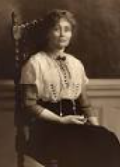  Emmeline Pankhurst (1858-1928) was an English political activist. She is best remembered for organising the UK Suffragette movement and helping women win the right to vote. |  |  | 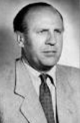  Oskar Schindler (1908-1974) was a German industrialist and a member of the Nazi Party who is credited with saving the lives of 1200 Jews during the Holocaust by employing them in his factories. |  |  |  |  | 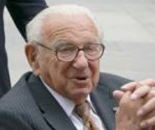  Sir Nicholas Winton (1909-2015) MBE was a British banker and humanitarian who established an organisation to rescue children at risk from Nazi Germany.

History – British civil rights
What should pupils already know/do? |  |  | What will pupils learn? | Where will this learning go?
Yr5  Chronological Understanding:  * plot recent history on a timeline using centuries  * place periods of history on a timeline showing periods of time  Knowledge and Interpretation:  * explain how events from the past has helped shape our lives  * appreciate that wars have happened from a very long time ago and it is often associated with invasion, conquering or religious differences  * know that people who lived in the past cooked and travelled differently and used different weapons from ours  * recognise that the lives of wealthy people were very different from those of poor people  * appreciate how items found belonging to the past are helping us to build up an accurate picture of how people lived in the past  Historical Enquiry:  * research two versions of an event and say how they differ  * research what it was like for a child in a given period from the past and use photographs and illustrations to present their findings  * give more than one reason to support an historical argument  * communicate knowledge and understanding orally and in writing and offer points of view based upon what they have found out  Yr6  Chronological Understanding:  * use dates and historical language in their work  * draw a timeline with different time periods outlined which show different information, such as, periods of history, when famous people lived, etc.  Knowledge and interpretation:  * describe historical events from the different period/s they are studying/have studied  * make comparisons between historical periods; explaining things that have changed and things which have stayed the same  * appreciate that significant events in history has helped shape the country we have today |  |  | Yr5  Chronological Understanding:  * use dates and historical language in their work  * draw a timeline with different time periods outlined which show different information, such as, periods of history, when famous people lived, etc.  Knowledge and interpretation:  * describe historical events from the different period/s they are studying/have studied  * make comparisons between historical periods; explaining things that have changed and things which have stayed the same  * appreciate that significant events in history has helped shape the country we have today  Yr6  Chronological Understanding  * say where a period of history fits on a timeline  * place a specific event on a timeline by decade  * place features of historical events and people from past societies and periods in a chronological framework  Knowledge and Interpretation  * summarise the main events from a specific period in history, explaining the order in which key events happened  * describe features of historical events and people from past societies and periods they have studied  * recognise and describe differences and similarities/ changes and continuity between different periods of history  Historical Enquiry  * look at two different versions and say how the author may be attempting to persuade or give a specific viewpoint | UKs2  Children will then build on all previous knowledge again to use a range of historical sources to explore inequality across the globe and history. They will explore where inequality still occurs across the globe comparing different historical periods and thinking about how cultures, including British culture, has had a major influence on world history and shaped countries.  Beyond  Pupils should extend and deepen their chronologically secure knowledge and understanding of British, local and world history, so that it provides a well-informed context for wider learning.
Key Vocabulary |  | 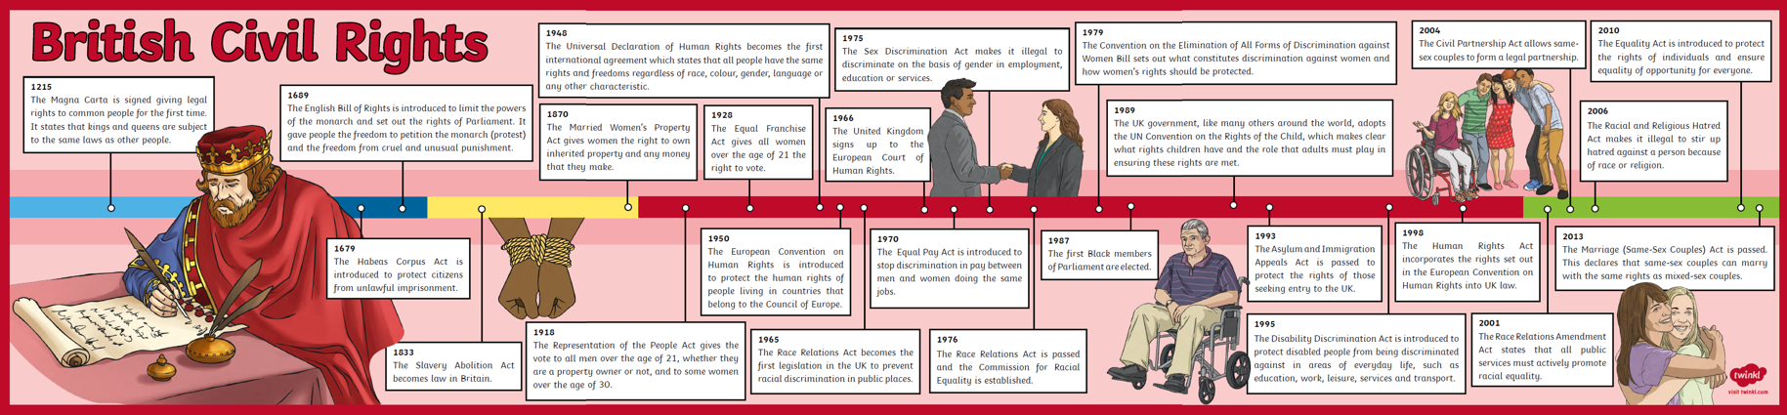  There are different types of inequality:  - Economic (rich/poor)  - Racial (Culture & ethnicity)  - Gender (male/female)  - Religious (beliefs)  - Ability (disabilities)  Economic Inequality:  This has happened across history with Lords and Nobles being given land from the Norman Conquest and others living as peasants; in the Victorian times, industrialisation meant that factory owners became very wealthy while others remained extremely poor, resulting in living in the workhouses. Even today, a quarter of all the world’s wealth is owned by billionaires, including the world’s richest man, Jeff Bezos creator of Amazon, while other people struggle to afford shelter, medicines, food and clothes. Poorer people may also have limited access to safe housing as options are limited and housing they are given may not be suitable, an issue highlighted by the Grenfell fire in 2017.  It is important that we try to achieve equality as poverty can lead to worse opportunities, discrimination, stigma, health issues and negative social stereotypes, which stop people from achieving their full potential and creating poverty traps and shortening life expectancy.  Following the Covid pandemic, poverty has increased as people lost jobs and increased spending on food and heating due to being at home. Free school meals were not supported by the government and needed celebrities such as Marcus Rashford to campaign to keep children fed during the lockdowns. Approx. 2.5 million people now use foodbanks in the UK more than 600,000 more than last year.  https://barnsley.foodbank.org.uk/ Barnsley foodbank help local people in crisis.
century | equal to one hundred years
chronology | the order of events in time
similarity | likeness
primary source | tells you about an event from the past and is from the time of that event
secondary source | tells you about an event from the past, but was written by after the event by someone who was not present at the event
poverty | The state of being extremely poor
persecution | Ill treatment, especially because of race, political or religious beliefs
Civil rights | The rights of people to freedom and equality
Slavery | A condition in which one human being is owned by another
abolition | The act of terminating a system, practice or institution
discrimination | The unjust treatment of groups of people, especially on the grounds of race, sex, age or disability
equality | The state of being equal
segregation | Setting someone apart from others
apartheid | A policy or system of segregation on the grounds of race
Magna Carta | Latin for “Great Charter” was a document that gave certain rights to the English people stating that the king must follow the law, and was one of the first documents to state that people had rights.
disability | A physical or mental condition that limits a person’s movements, senses or activity
gender | An identity which corresponds with established ideas of male and female
poverty | The state of being extremely poor
holocaust | Destruction on a mass scale
heritage | A possession (property or characteristic) which is inherited
income | Money received
stigma | A mark of disgrace associated with a particular circumstance, quality or person
stereotype | A fixed idea of a particular type of person or thing
foodbank | A place where food is supplied free of charge to peple in need
Colony | A country or area under the control of another country  Racial Inequality:  Black people and people of race have been part of British history for thousands of years since Roman times, including: Henry V111’s Trumpeter (John Blanke); Queen Charlotte (Queen Victoria’s great grandmother) who is thought to be from African descent; Francis William, an Afro-Caribbean scholar and poet who took British citizenship in 1723; and Ignatius Sancho a black writer, composer and the first black person to vote in Britain in 1774. However, unfortunately there has also been racial inequality across history with people from different races being used as slaves in Britain as far back as pre-Roman times, and then during the Roman conquest of Britain. A thousand years later, British merchants (in Glasgow, Liverpool and Bristol) then became major participants in the Atlantic Slave Trade as well as wealthy British people living in the British colonies owning African slaves.  Although slavery was abolished in 1865, people of race were still segregated in apartheids and treat as second class. Even today, the streets, buildings and schools of cities such as Glasgow, Liverpool and Bristol are named after famous slave owners, resulting in the pulling down of the statue of Edward Colston last year in Bristol.  Jamaicans, who were brought to England to fight in WW1, received little acknowledgement and violence in their communities once the war ended, while many Indian soldiers fighting for Britain were not given recognition for their bravery and efforts. After WW2, people from the Caribbean and India were invited to Britain to help rebuild the country, put to work in the NHS and on public transport. However, Bristol refused to employ black and Asian drivers (this was not illegal at the time), resulting in a boycott of buses across the while city inspired by Rosa Parks and led by Paul Stephenson. In 1948, there was a large black migration from the Caribbean, known as the Windrush generation, where people were again invited to Britain on the promise of work. This made the news in 2018 as many people who arrived on the Empire Windrush were wrongly detained, denied legal rights, deported, lost their jobs or homes and had their passports confiscated despite having lived and worked in Britain for 70 years!  Recent issues concerning racial inequality have included concerns over racism in the police force with black people being arrested and treat harshly much more frequently than white people. Events such as the murder of Stephen Lawrence and George Floyd, which started the current Black Lives Matter movement
Suffrage | The right to vote in political elections
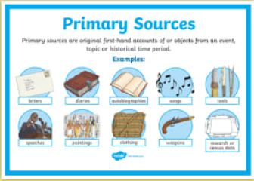
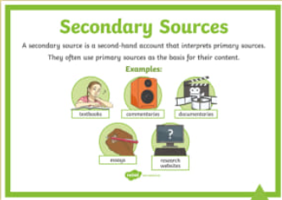
To find out about history, we look at information. If the information comes from somebody or thing which was at the event (diary, photo, newspaper, artefact, video, letter etc) then this is a primary source. If the information comes from after the event by someone who was not there (newspaper, biography, recount), then this is a secondary source.
Religious inequality:
Before 1689, religious persecution was a large part of British history with different leaders changing the religion of the country and persecuting anyone who believed different. Romans brought Christianity, which was then replaced by paganism by the Anglo-Saxons. However, by the 7th Century, Christianity was again the main religion with pagan temples destroyed. Up to the 1500’s, Britain became a catholic nation until Henry V111 began the church of England and began a time of turmoil and unrest with each king or queen following changing the religion and burning people of other faiths at the stake. This led to years of persecution and gave rise to events such as the Gunpowder Plot when Guy Fawkes was part of a conspiracy to kill King James 1 and restore a Catholic monarch to the throne after years of Catholics being persecuted.
Eventually in 1689, the toleration Act granted freedom of worship in Britain paving way for the right for everyone to worship and believe what they wanted without fear of persecution. However, there are still events beyond this time when the World has witnessed huge religious persecution such as the Jewish Holocaust during the second world war and more recently, world events which make religions such as Islam targets for hate.
Gender inequality:
Throughout history, the only females with access to education were from wealthy families, although they often learnt at home rather than at school like males, and were taught music, dancing and needlework to prepare them for married life in society. Poorer females have had little or no access to education. In Britain, women were only first allowed to attend university in 1868 but were still not awarded degrees until 1880 with Eliza Orme becoming the first British woman to gain a law degree in 1888. However, education for poorer females did not improve until 1918 when the minimum age for leaving school was raised to 14. It was again raised in 1948 to 15, and again in 1973 to 16. In the late 20th century, women had far more opportunities for education than ever. There are still parts of the world where females do not go to school - in Sub-Saharan Africa; nearly 75% of girls do not attend school
Throughout history, women have also been denied the right to vote with only males voting in elections. This leads only to male voices being represented in the decisions of the country. In 1872, the fight for women’s right to vote (women’s suffrage) gained momentum, when in 1903 Emmeline Pankhurst and Millicent Fawcett led the suffragist movement. Their motto was “deeds not words” which included handcuffing themselves to railings and going on hunger strikes. In 1918, some women were finally allowed to vote (they had to be over 30 and own property or be married to someone who owned property). However, it was another 10 years until women had equal suffrage as men (1928). Although there is nowhere left in the world, where women do not have the legal right to work, in countries such as Afghanistan, Pakistan, Uganda and Kenya, women often face strict rules, harassment and punishment for voting.
Gender inequality does not only affect women. People have also been treated unfairly due to their sexual orientation and gender identity, having jobs and opportunities regularly denied to them, not being allowed to legally marry and still being seen as unlawful in some places and religions today.

