


Reading policy, including phonics
TO BE REVIEWED September 2023
Introduced: September 2022
Written by K. Rose Signed…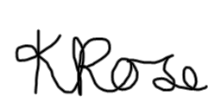….
Approved by the Governing Body on:
Signed……………………………………



Aims
This policy expresses the school’s purpose for the teaching and learning of reading. It sets out the aims, planning of the curriculum and assessment and monitoring. Our reading curriculum enables children to enjoy and grow whilst developing their resilience. Children will gain knowledge, understanding and respect for differences in culture, religion, ethnicity and society through research and the carefully planned range of ‘core books’ which explore and link many areas of the curriculum and embrace themes such as loss, migration, BAME, strong females and LGBT where it is evident that we break down language barriers, cultural prejudices and societal differences.

Legal requirements
School half termly progression documents (see appendices) have been created using the National Curriculum standards and expectations, SEND code of practice, equality act and EYFS framework (see relevant policies) and have been tailored to meet the needs and context of the school in an aspirational, challenging way.
Stories, poems, rhymes and non-fiction are chosen for reading to develop pupils’ vocabulary, language comprehension and love of reading. These are all planned, chosen and sequenced in a progressive manner to ensure challenge at all levels. By the end of each key stage, children will be familiar with and enjoy listening to a wide range of stories, poems, rhymes and non-fiction.
Implementation
The EEF highlights that reading skills need to be taught by developing a student’s language capability and understanding, by supporting students to develop their fluency skills and by teaching reading comprehension strategies through modelling and supported practice (EEF 2017). At Summerfields, our reading provision focuses on the following key principles throughout the primary phase, and is consciously underpinned through a desire to promote a love of reading as well.
SSP
The aims of our SSP are clear and taken from the relevant National Curriculum. The Read Write Inc. programme has been revalidated by the DFE as a Systematic Synthetic Phonics Programme that is supported by robust research. It is evident throughout Summerfields Primary Academy that staff of all levels and relevant governors are aware of the Read Write Inc. rationale and aims. At our school, our curriculum is ambitious and designed to give all pupils the knowledge and skills they need to succeed. We have high expectations that all children will be fluent readers by the age of 6 or 7. The use of Read Write Inc. is continually developing to embrace and apply new innovations. The chosen SSP programme has been planned to support and challenge children on their reading journey. All children will have access to a consistent set of organised resources, will be taught by ‘reading experts’ with fidelity and a consistent approach and will take home the correct level book bag book – where all red, green and alien words and phonemes have been taught.

Lesson structure
- From Reception to Year Two, the programme is meticulously planned to progress children to be able to decode, read sight words and be a confident reader by the age of 6 or 7.
- Each RWI session follows a consistent approach. There are some slight variations that are specific to teaching Set One, Two or Three sounds but the structure of the session is followed with fidelity and consistency.
- All children are grouped by ‘stage’ not ‘age’.
Each RWI sessions uses the following structure:
- Word Time Session
- A new sound / phoneme is taught from Set One, Two or Three. Say, connect, read and review.
- Read the new sound green words, multisyllabic words, review words and alien words.
- Children will be taught correct letter formation or to spell using the taught phonemes of the day
- Book Time Session
- Teaching the children to read the green words, speedy green words, multisyllabic words and red words from the RWI book.
- Reading with fluency and expression – modelling to the children how to do this.
- Teaching the children how to apply comprehension skills to answer the questions specifically designed for that RWI book.
Feedback, marking and assessment
- Children are baselined at the start of the year for grouping purposes.
- In each RWI session the children are constantly having their reading and phonic knowledge assessed throughout the lesson. This can be in the whole class group session on the carpet or one to one when they are working at the table.
- Assessment for Learning is conducted in the spelling part of the session – live feedback to the children as they are writing the words and the reading section where children read one to one with the adult leading the session. Live feedback on strengths and next steps are given.
- RWI is assessed on a six week cycle. Once the children have been assessed they are then regrouped and the teachers are selected to teach the appropriate group depending on their teaching strengths. This then leads into which children are selected to be in the one to one tutoring programme; focusing upon ‘keep up’ not catch up. Within the assessment cycle we have three mock PSC checks in November, February and May. Once again this data is used to specifically identify the sounds that the children need to be re-taught and practice.

Reading provision
As a minimum requirement, as well as phonics and/or guided reading sessions, KS1 children are listened to twice a week with at least one of these being 1:1, KS2 children are listened to weekly and target readers, including the bottom 20%, are identified for additional reading as often as possible. All reading is to be recorded in the children’s planner. Parents have had guidance on how these should be used and workshops to support home reading are run on a yearly basis. TA’s and class teachers use our end of year expectation document to make comments and challenge children that they read with. Parents are provided with questions which they can use to support children’s reading at home using the VIPERS model. They are also provided with the fluency rubric to support targets linked to reading aloud. See appendices for examples.
Lesson structure
- Teachers plan guided reading sessions to focus on a particular skill linked to assessment criteria, the national curriculum coverage and VIPERS. Planning is based on class and cohort needs, gaps in learning and progression through the curriculum.
- The structure of a reading session is to teach a specific reading domain skill and then allow the children to apply it using carefully chosen extracts of text.
- Guided reading texts chosen will be picked specifically to meet and cover the needs of the objectives to be covered and will be age appropriate and challenging at all levels. This gives children the opportunity to develop subject knowledge, recognition of text type features and become familiar with subject specific vocabulary. Texts chosen to teach during guided reading may underpin and support the writing unit and/or explore unit being covered. This could be to develop vocabulary, understanding of a genre or structural features. The text may also be sections of the current anchor novel to allow deeper exploration where relevant.
- The objective will be introduced to the children and discussed to ensure understanding, alongside success criteria where appropriate to enable the children to understand how they are achieving and how to progress
- Teachers will model how to answer specific styles and types of questions and will teach the key components of the particular objective covered as with other lessons. Children will then have the opportunity to develop and practise their own skills through the removal of scaffolding – I do, we do, you do. Questions will be differentiated to encourage challenge and support, particularly for SEND and GD.
- Differentiation will also be delivered through the use of support, pitch of questions and identifying specific needs of individual children.
- SEND needs will be catered for through in class provision and planning to ensure appropriate support and inclusivity.
- The reading of texts can be done in many ways – modelled by the teacher for fluency and expression, volunteer reading, chosen reading, reciprocal reading, paired reading, silent reading, echo reading etc. The teacher will choose a strategy that is most appropriate for the text and needs of the children and the session at hand. Pre-reading may be used to support specific learners and the fluency rubric is used to support the development and progression of fluency.
- Children will have the opportunity to explore and develop newly learnt vocabulary to support their understanding of the text. Appropriate, linked vocabulary will be displayed and referred to around the classroom using a tiered model of language system created by Isabel Beck and Margaret McKeown – see below.
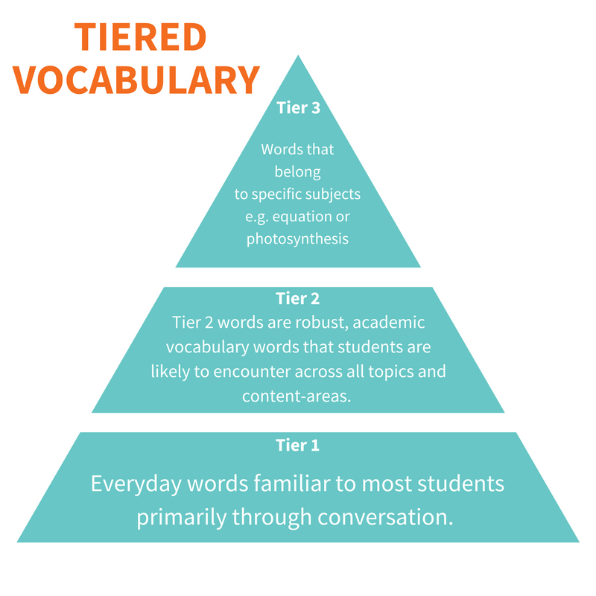
Feedback, marking and assessment
- Teachers use formative and summative assessment to identify next steps in learning for the teaching of reading skills, always questioning why this, why now in order to tailor provision to the needs of the children in their class. Sequences of lessons are then planned to ensure progress for all abilities. Bronze, silver and gold medal challenges are used to support accelerated progress and agile provision.
- Marking of comprehension will often be completed on a whole class, self and peer basis. Teachers will mark comprehension books as appropriate alongside this. As the children progress through the primary phases, teachers will guide children in what is expected at assessment points and how to look at answers for number of marks given to support their understanding of answering questions.
- Feedback will be given on whole class, small group and individual basis. They may link to a specific objectives coverage or individual need. Targets and interventions will link to feedback given. Children will be set feedforward tasks at regular points. This may be on a while class level or as individual feedback.
- Years 1, 3, 4, 5 will have termly NFER assessments to measure progress. Year 2 and 6 will complete practice mock stats at key assessment points throughout the year.

Remote learning
Where appropriate, remote learning will be through the delivery of the in school lessons via Teams with work uploaded to ClassDojo or the appropriate groups on Teams for the children to access. If this is not appropriate, work will be uploaded to Teams and Dojo and staff will be on hand to guide, support and instruct the lesson delivery. Group chat is only available on Live lessons via Microsoft Teams and is monitored by staff throughout the lesson. To protect our pupils and staff we also have SLT/DSL administrators that have access to every pupil/teacher account to ensure that safe practices are happening. Children are asked to turn videos off and mute microphones

RSE and PHSE
RSE and PHSE objectives underpin and feed through our curriculum offer as we firmly believe all leaders and stakeholders in school are also leaders of RSE. We feel that this is vital in order to open up the world to our learners and embed key skills taught through these subjects. This can be seen in planning of explorations, unit plans and work produced by the children.
Vulnerable Groups
Summerfields Primary Academy provides an outstanding education and serves a local community with changing and varied levels of socio-economic deprivation and speech and language needs. Staff and governors are committed to ensuring the pastoral, social and academic needs of every student are met, irrespective of background, need or disability in line with SEND Code of Practice. Pupil premium and the wider school budget is therefore directed to ensuring an equality of opportunity for all learners through breaking down barriers to learning. Staff work with the literacy coordinator and SENDCOs to ensure that children are appropriately supported in their reading.
Parental engagement
We recognise and celebrate the importance of working collaboratively as the Summerfields community to support the development of children. We engage and inform parents of strategies, initiatives and successes through the social media stream ‘Class Dojo’. We run support workshops at key ages and stages to develop parental understanding of subject content and ways in which they can support children at home. We regularly communicate ideas and support materials via newsletters and the school website, including teams meetings and in school initiatives – such as reading rewards and challenges. As the world changes post Covid, we are further engaging parents by holding workshops in person rather than via teams. Book fairs are run on a yearly basis to encourage a love of the subject and to help replenish the shelves with up-to-date resources.
Resources
The subject leader is responsible for coordinating the purchasing of new resources and organising existing resources. From planning meetings, leaders prioritise what each phase needs at a particular time and purchases accordingly. The Subject leader is responsible for the auditing of the resources for their subject, however, general resources, and the storage, distribution and auditing of said resources, is the responsibility of the Business Manager.
Training
Staff skills audits are completed at least twice during the year to identify any CPD needs identified by the staff, and this is linked to performance management targets and class need.
Online training is recorded and saved for staff to access at later points as needed.
The literacy coordinator keeps up to date records of training, specialisms, and current needs of staff and is active in the delivery, planning and researching of appropriate training, across and outside of the trust.
There is a clear, systematic induction using the policy, working with the literacy lead and shared planning opportunities for all new staff, which is continuously updated as relevant changes are made.
Assessment and how quality is monitored
Staff undertake weekly RWI training using the portal to ensure quality, consistency and fidelity to the scheme. Children are assessed and regrouped using RWI assessment on a 6 week cycle. Assessment is regarded as an integral part of teaching and learning, and is a continuous process. It is the responsibility of the class teacher to assess all pupils in their class. We strive to make our assessment purposeful, allowing us to match the correct level of work to the needs of the pupils, thus ensuring success and progression.
Children on Y1, 3, 4, 5 complete termly NFER assessments, which then feed into QLAs, pupil progress meetings, target setting, and planning adaptation.
PM Benchmarking is used to assess both fluency and comprehension skills and identify appropriate books for home reading from KS1 upwards. This feeds into the half termly progression documents to help identify any interventions needed.
Summerfields uses a colour coded reading scheme that the children read as their individual reading books. This is linked to the PM benchmarking scheme. Staff undertook up-to-date training in summer 2021 to ensure consistency and accuracy of judgements.
Children are benchmarked at least three times a year in line with explorations to ensure that they are on the correct book band for their reading age. Books that are taken home are read at a 95%+ accuracy rate with a good standard of comprehension skill to ensure practice, motivation, enjoyment and consolidation. Texts read at school are based at 90-94% accuracy and therefore are at instructional level. Children are also encouraged to take a reading for pleasure book home from the school library which does not meet any banded system. No books should be off limits to children.
Guided reading texts may be shared via Class Dojo to encourage prereading and support at home. Prereading may be undertaken in school to support the bottom 20% in accessing guided reading objectives.
Once children complete the banded scheme, they become a ‘free reader’ where they are encouraged to read a range of books from the school library, classroom library and home.
Children that are being taught RWI are to be given a phonic phase book bag book to take home as well as a read for enjoyment book. Children are encouraged to reread books to build upon their bank of known words and sounds
Readers requiring additional support are identified from data and teacher knowledge and given further opportunities and support to develop their fluency and comprehension skills through specific intervention – fluency, comprehension, phonics etc. These interventions are regularly assessed and planned for in collaboration with all adults working with the children and the literacy coordinator to ensure that quality is monitored.
We are continually assessing our pupils and recording their progress. Information is gathered in various ways: questioning, lesson structure, talking to children, observing their work, live marking, and use of post-it notes and whiteboards. The current lesson structure promotes agile teaching, so that understanding is monitored throughout each lesson. Teachers use this assessment to adapt current provision, plan further work and set new targets to meet the needs of the pupils.
Children are provided with constructive and timely feedback in line with our assessment policy. Verbal feedback is given during lessons in addition to regular self and peer-assessment opportunities. Teachers provide parents with feedback on their child’s progress and achievement at parent’s evenings and the end of year report
The literacy coordinator monitors planning and data and regularly meets with staff and pupils to discuss the subject, training needs, support, strengths and successes.
Educater will be used as an ongoing formative assessment document for staff to make assessment judgements against. The literacy coordinator will have access to this data for moderation, target setting and support purposes.

Environment and community
At Summerfields, we value and celebrate reading for pleasure and recognise its importance for supporting the children’s enjoyment and progress.
Each classroom will house an inviting, well-stocked reading area with age appropriate resources that the children are able to regularly access. These will be refreshed throughout fund raining and budget allocation as the year progresses.
Each classroom environment will have a reading display which demonstrates objectives, text types and skills covered in order to support understanding.
A core book linked to each exploration with a breadth and diversity of content will be read daily to each class. See appendix for the curriculum and book lists. There will be a display in each room linked to the core book which is built up over the course of the exploration to help the children gain a better understanding of the book.
Staff use and maximise opportunities for modelling phraseology and making connections between books and content when reading aloud.
Reading ambassadors are chosen from throughout the school to develop and celebrate reading for pleasure. These are chosen at the start of the year and are involved in decisions and ideas running throughout school linked to reading. They will regularly meet with the literacy coordinator in role to support this.
The library has a timetable for staff and children to use when Covid restrictions allow.
The school is looking to develop a time for a lending library and potentially an adult section of the library.
Cyclical Benchmarking (Monitoring and Evaluation)

This is the process in which we monitor and evaluate provision in school. It is immersion into provision within school. It is done with, not to, staff and has regular feedback built in. It is given with respect and received with an understanding that it is developmental not judgmental. A variety of different Benchmark actions such as pupil voice, lesson study, planning samples, marking for impact scrutinies, data analysis etc. are used to gain a wide breadth of knowledge around a certain area so that decisions can be made of how to improve.

- 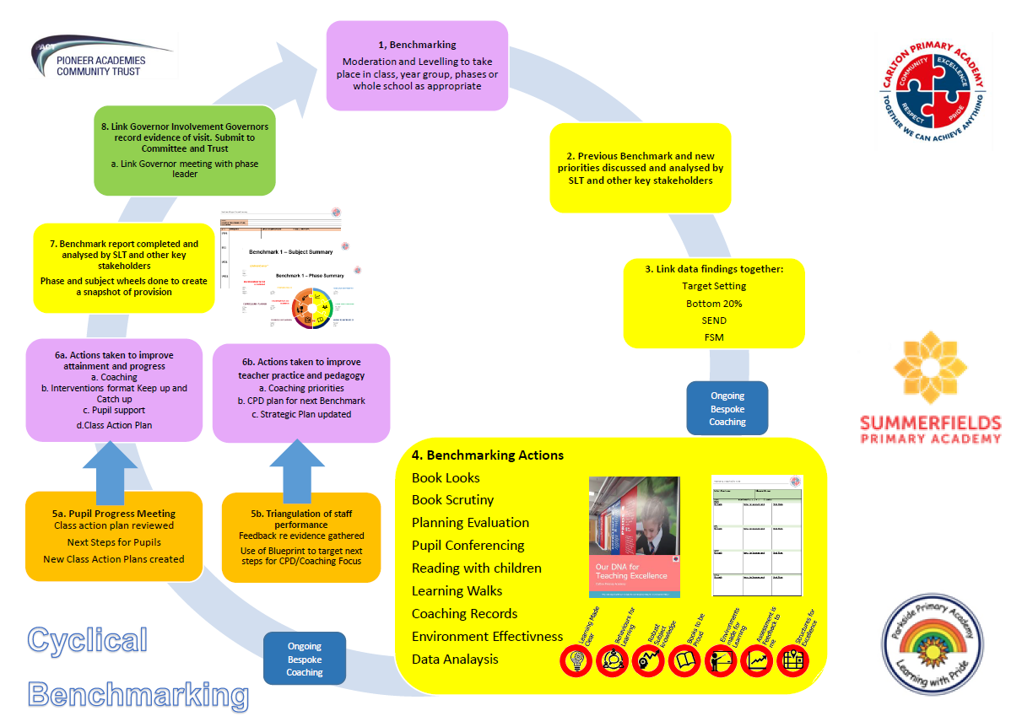

Yr1 Word Reading Progression
Early reader
* Early readers can tackle known and predictable texts with growing confidence but still need support with new and unfamiliar ones. They show a growing ability to make sense of what they read, drawing on illustrations, their knowledge of language and the world as well as the words on the page.
* Children within this stage are at an important transition from dependence on memory or on reading alongside an adult, to a growing independence in reading texts that are familiar but not known by heart.
* They are developing a growing enthusiasm for a wider range of reading material, which may include simple information books and picture books as well as text in the environment, in digital form and through media.
* They are beginning to evidence one-to-one correspondence, drawing on their developing phonic knowledge by linking graphemes and phonemes to help them decode simple words and recognition of a core of known words. They can read and understand simple sentences, and as fluency and understanding develop, children will begin to self-correct.
 | Baseline expectations | End of Autumn 1 | End of Autumn 2 | End of Spring 1 | End of Spring 2 | End of Summer 1 | End of Summer 2
Decoding | Children know all RWI Set 1 and Set 2 sounds as well as some Set 3 sounds (oi, a-e, ea, i-e, o-e). Using their phonic knowledge in relation to learnt sounds, they are able to segment and blend in order to decode regular words to read aloud accurately. Applying this learning, children are able to read and understand simple sentences. Children have completed the majority of the RWI book bands and are on the final books of RWI Blue/ORT Yellow book band. Some children are also further progressed with their phonic and decoding ability and will be reading within the RWI Grey book band or above. | Children have learnt all RWI Set 3 sounds (u-e, aw, are, ur, er, ow, ai, oa, ew, ire, ear, ure). Using their phonic knowledge, they can now read simple sentences involving all sounds and are beginning to respond at a developing pace with the correct sound to grapheme for the 40+ phonemes. Children are developing their ability to read aloud books that are consistent with the RWI Grey/ORT Blue book band and are beginning to apply phonic knowledge and blending skills well as the route to decode unfamiliar words. They are beginning to orally split two-syllable words into separate syllables to support their reading of these words (pocket, jumping, longer, boxes), and are beginning to recognise the different ways to pronounce the graphemes “ea” (bread/seat) and “ow” (snow/cow). Some children are also further progressed with their decoding ability and will be reading within the ORT Blue book band or above. | Children can confidently and speedily match all 40+ graphemes to their phonemes. They accurately read aloud books that are consistent within the ORT Blue book band, and confidently decode and blend sounds in unfamiliar words, consistently reading simple two-syllable words correctly. Children recognise and use the different ways to pronounce the graphemes “ea” (bread/seat) and “ow” (snow/cow) and are beginning to recognise the different ways to pronounce the graphemes “o” (post/slot) and “a” (hat/was/all) but may not yet be consistent.  Some children are also further progressed with their decoding ability and will be reading within the ORT Green book band or above. | Children can confidently blend sounds and decode unfamiliar words that are consistent within the ORT Green book band. They consistently pronounce the graphemes “o” (post/slot) and “a” (hat/was/all) differently where appropriate, and are beginning to recognise the correct pronunciation of “I” (fin/mind), “g” (giant/grand) and “ear” (pearl/hearing) although they will not yet be consistent. Children are beginning to orally split three-syllable words into separate syllables to support their reading of these words (September, Saturday, internet, animal, Africa).  Some children are also further progressed with their decoding ability and will be reading within the ORT Orange book band or above. | Children can confidently blend sounds and decode unfamiliar words that are consistent within the final books of the ORT Green book band. They consistently pronounce the graphemes “I” (fin/mind), “g” (giant/grand) and “ear” (pearl/hearing) differently where appropriate, and are beginning to recognise the correct pronunciation of “c” (ice/cream), “ch” (chef/ school/ church) and “ou” (could/ found/ you/ shoulder). Children are beginning to split three-syllable written words into separate syllables to support their reading of these words (September, Saturday, internet, animal, Africa). Some children are also further progressed with their decoding ability and will be reading within the ORT Turquoise book band or above. | Children can confidently blend sounds and decode unfamiliar words that are consistent within the ORT Orange book band. They consistently pronounce the graphemes “c” (ice/cream), “ch” (chef/ school/ church) and “ou” (could/ found/ you/ shoulder), and know most of the RWI complex speed sounds. Children consistently read three-syllable written words correctly by splitting the word into the correct syllables. Some children are also further progressed with their decoding ability and will be reading within the ORT Turquoise book band or above. | Children have consolidated all yr1 learning and know all the RWI complex speed sounds. Some children are also further progressed with their decoding ability and will be reading within the ORT Turquoise book band or above.
Spelling rules & Common Exception words | Children can read some common irregular words including: I, you, the, go, of, come, was, we, are, me, going, she, my, no, a, he, all, said. Some children are also further progressed with their phonics and their ability to read spelling rules and yr1 common exception words. | Children consistently read simple words and some compound words using all corresponding sounds of the alphabet and consonant digraphs: sh, th, ch, qu, ng, nk. They are beginning to correctly read words with the rule of adding –s to pluralise nouns and the spelling rule of adding –ing, -ed, -er, -s, -es to verbs. They confidently and rapidly read common exception words such as: the, a, do, to, today, of, says, was, is, his, has, I, be, he, me, she, we, no, go, do, ask, put, push, they, one. Some children are also further progressed with their ability to read spelling rules and yr1 common exception words. | Children confidently read words with the spelling rule for ending a word with –ff, -ll, -ss, -zz, y. They correctly read words with the rule of adding –s to pluralise nouns and the spelling rule of adding –ing, -ed, -er, -s, -es to verbs. Children divide simple two-syllable words correctly and read accordingly. They confidently and rapidly read common exception words such as: pull, full, you, your, there, house, our, by, my, and read the contraction “I’m”, beginning to understand that this can also be read as “I am”. Some children are also further progressed with their ability to read spelling rules and yr1 common exception words. | Children confidently read words which apply the spelling rule for ending a word with –tch and the sound v correctly, and they rapidly read words with the rule of adding –s to pluralise nouns and the spelling rule of adding –ing, -ed, -er, -s, -es to verbs, as well as common exception words such as: are, love, come, some. As children read the contraction “I’m”, they understand that the apostrophe represents the missing “a”. Some children are also further progressed with their ability to read spelling rules and yr1 common exception words. | Children read words using the prefix “un” and are beginning to understand when to read ph, wh and k correctly. They are beginning to recognise the syllables in written words with three syllables and read common exception words such as: said, were, here, where, confidently and rapidly. Children read contractions “I’ll” and “we’ll”, beginning to understand that these can also be read as “I will” and “we will”. Some children are also further progressed with their ability to read spelling rules and yr1 common exception words. | As children read the contractions “I’ll” and “we’ll”, they understand that the apostrophe represents the missing letters “wi”. They divide three-syllable words correctly and read accordingly, and they confidently and rapidly read common exception words such as: friend, school, once. Some children are also further progressed with their ability to read spelling rules and yr1 common exception words. | Children have consolidated all yr1 learning. Some children are also further progressed with their ability to read spelling rules and further common exception words.
Fluency and expression | Children can read simple sentences involving all RWI Set 1, Set 2 and some Set 3 (oi, a-e, ea, i-e, o-e) and some irregular words. However, their reliance on developing decoding and blending strategies results in little fluency and expression at this stage. Some children are also further progressed with their phonics and their ability to read fluently and with expression. | Children are beginning to develop fluency, accuracy and confidence when reading an appropriate book (RWI Grey/ORT Blue book band), and are taking note of full stops as a pause at the end of a sentence. They are beginning to recognise when a text does not make sense but do not yet re-read. Some children are also further progressed with their phonics and their ability to read fluently and with expression. | Children developing fluency, accuracy and confidence when reading an appropriate book (ORT Blue book band), reading up to 20 words a minute. They consistently take note of full stops as a pause at the end of a sentence. They consistently recognise when a text does not make sense. Some children are also further progressed with their phonics and their ability to read fluently and with expression. | Children continue to build fluency, accuracy and confidence when reading an appropriate book (ORT Green book band), and are beginning to take note of question marks and exclamation marks in their expression. They are beginning to self-correct and re-read sentences when text does not make sense. Some children are also further progressed with their phonics and their ability to read fluently and with expression. | Children are fluent, accurate and confident when reading an appropriate book (ORT Green book band), reading up to 40 words a minute. They consistently take note of question marks and exclamation marks in their expression and regularly self-correct and re-read sentences when text does not make sense. They are beginning to re-read whole books for enjoyment as well as beginning to read more challenging books. Some children are also further progressed with their phonics and their ability to read fluently and with expression. | Children are fluent, accurate and confident when reading an appropriate book (ORT Orange book band) and consistently self-correct and re-read sentences when text does not make sense. They often re-read whole books for enjoyment as well as reading more challenging books. Some children are also further progressed with their phonics and their ability to read fluently and with expression. | Children have consolidated all yr1 learning and can read 60 words in a minute. Some children are also further progressed with their phonics and their ability to read fluently and with expression.

Yr2 Word Reading Progression
Developing reader
* A developing reader is gaining control of the reading process. Children within this stage link reading to their own experiences and are able to read simple texts independently. They show interest in a growing range of reading material and are able to branch out into a variety of books and other texts, which include simple
information texts, poetry and picture books, as well as digital texts and print in the environment.
* Children apply their developing phonic knowledge when reading words containing known graphemes, recognising alternative graphemes for known phonemes and alternative pronunciations for graphemes, checking that the text makes sense. They read words containing common suffixes and contractions and understand their purpose.
* They have a more extensive vocabulary of sight words and fluency is beginning to develop through recognition of larger units within words. Children continue to develop self-correction strategies when reading does not make sense and are able to use more than one strategy.
 | Baseline expectations | End of Autumn 1 | End of Autumn 2 | End of Spring 1 | End of Spring 2 | End of Summer 1 | End of Summer 2
Decoding | Children confidently match all 40+ graphemes to their phonemes, read all RWI complex speed sounds and blend sounds in unfamiliar words that are consistent within the ORT Orange book band. They consistently read three-syllable written words correctly by splitting the word into the correct syllable. Some children are also further progressed with their decoding ability and will be reading within the RWI Turquoise book band or above. | Children decode high-frequency and unfamiliar words (including multi-syllabic and alternative grapheme sounds) without overt sounding and blending in order to read aloud texts consistent with the ORT Turquoise book band. Some children are also further progressed with their decoding ability and will be reading within the RWI Purple book band or above. | Children decode high-frequency and unfamiliar words (including multi-syllabic and alternative grapheme sounds) quickly without overt sounding and blending in order to read aloud texts consistent with the final books of the ORT Turquoise book band or the beginning of the ORT Purple book band. Some children are also further progressed with their decoding ability and will be reading the final books of RWI Purple book band or above. | Children are beginning to accurately and automatically decode high-frequency and unfamiliar words (including multi-syllabic and alternative grapheme sounds) in order to read aloud texts consistent with the ORT Purple book band. Some children are also further progressed with their decoding ability and will be reading within the RWI Gold book band or above. | Children accurately and automatically decode high-frequency and unfamiliar words (including multi-syllabic and alternative grapheme sounds) in order to fluently read aloud texts consistent with the ORT Gold book band. Some children are also further progressed with their decoding ability and will be reading within the RWI White book band or above. | Children decode high-frequency and unfamiliar words (including multi-syllabic and alternative grapheme sounds) automatically and without hesitation in order to fluently read aloud texts consistent with the final books of the ORT Gold book band or the beginning of the ORT White book band. Some children are also further progressed with their decoding ability and will be reading within the RWI Lime book band or above. | Children have consolidated all yr2 learning and are reading fluently within the ORT White book band. Some children are also further progressed with their decoding ability and will be reading within the RWI Lime book band or above.
Spelling rules & Common Exception words | Children confidently read common exception words (the, a, do, to, today, of, says, was, is, his, has, I, be, me, he, she, we, no, go, do, ask, put, push, they, one, pull, full, you, your, there, house, our, by, my, are, love, come, some, said, were, here, where, friend, school, once) noting the unusual correspondences between spelling and sound. They read words with the prefix “un”, and words that end with ‘s. –es. –ing, -ed, -er, -est. They read words with contractions, understanding which missing letters the apostrophe represents. Children divide three-syllable words correctly and read accordingly. Some children are also further progressed with their ability to read spelling rules and yr2 common exception words. | Children are beginning to read words containing common suffixes: –ness, -ment, -ful, -ly, and rapidly read common exception words: after, fast, last, past, class, grass, pass, plant, path, bath, again, hour, move, prove, improve, who, whole, old, cold, gold, hold, told, most, only, both, every, everybody, money, clothes, even, pretty, any, many, busy, water, noting the unusual correspondence between spelling and sound. Some children are also further progressed with their ability to read spelling rules and yr2 common exception words. | Children confidently read words containing common suffixes: –ness, -ment, -ful, -ly, and fluently read common exception words: door, floor, poor, find, kind, mind, behind, child, children, wild, climb, great, break, steak, Christmas, noting the unusual correspondence between spelling and sound. Some children are also further progressed with their ability to read spelling rules and yr2 common exception words. | Children are beginning to read words containing common suffixes: –tion, and fluently read common exception words: because, eye, could, should, half, Mr, Mrs, noting the unusual correspondence between spelling and sound. Some children are also further progressed with their ability to read spelling rules and yr2 common exception words. | Children confidently read words containing common suffixes: –tion, and fluently read common exception words: beautiful, people, half, parents, noting the unusual correspondence between spelling and sound. Some children are also further progressed with their ability to read spelling rules and yr2 common exception words. | Children confidently read words containing all common suffixes taught: –ness, -ment, -ful, -ly, -tion, and fluently read common exception words: father, sure, sugar, noting the unusual correspondence between spelling and sound. Some children are also further progressed with their ability to read spelling rules and yr2 common exception words. | Children have consolidated all yr2 learning. Some children are also further progressed with their ability to read spelling rules and yr3 common exception words and/or be beginning to understand the meaning of prefixes/suffixes.
Fluency and expression | Children are fluent, accurate and confident when reading an appropriate book (ORT Orange book band), reading up to 60 words a minute (average). They consistently self-correct and re-read sentences when text does not make sense. They often re-read whole books for enjoyment as well as reading more challenging books. Some children are also further progressed with their phonics and their ability to read fluently and with expression. | Children are fluent, accurate and confident when reading an appropriate book (ORT Turquoise book band), reading up to 65 words a minute (average) without overt sounding and blending. They consistently take note of question marks and exclamation marks in their expression, and consistently self-correct and re-read to build fluency and confidence. Some children are also further progressed with their ability to read fluently and with expression. They may also recognise the different use of exclamation marks (as an interjectory or in an exclamatory sentence). | Children are fluent, accurate and confident when reading an appropriate book (ORT Turquoise or Purple book band), reading up to 70 words a minute (average) without overt sounding and blending. They take note of question marks and exclamation marks confidently in their expression, and are beginning to take note of commas in a list when reading aloud. They consistently self-correct and re-read to build fluency and confidence. Some children are also further progressed with their ability to read fluently and with expression, and may also pause for commas in a list consistently. | Children are fluent, accurate and confident when reading an appropriate book (ORT Purple book band), reading up to 75 words a minute (average) without overt sounding and blending. They take note of question marks, exclamation marks and commas in a list confidently in their expression. They consistently self-correct and re-read, and are beginning to read longer and less familiar texts independently to build fluency and confidence. Some children are also further progressed with their ability to read fluently and with expression, and may also start to take note of apostrophes when reading aloud. | Children are fluent, accurate and confident when reading an appropriate book (ORT Gold book band), reading up to 80 words a minute (average) without overt sounding and blending. They take note of question marks, exclamation marks and commas in a list confidently in their expression, and are beginning to express apostrophes correctly when reading aloud. They consistently self-correct and re-read, and are reading longer and less familiar texts independently to build fluency and confidence. Some children are also further progressed with their ability to read fluently and with expression, and may also take note of apostrophes consistently when reading aloud. | Children are fluent, accurate and confident when reading an appropriate book (ORT Gold or White book band), reading up to 85 words a minute (average) without overt sounding and blending. They take note of question marks, exclamation marks, commas in a list and apostrophes confidently in their expression. They consistently self-correct and re-read, and are confidently reading longer and less familiar texts independently to build fluency and confidence Some children are also further progressed with their ability to read fluently and with expression. | Children have consolidated all yr2 learning and can read 90 words in a minute (average).  Some children are also further progressed with their phonics and their ability to read fluently and with expression.

Yr3 Word Reading Progression
Moderately Fluent reader
* Moderately fluent readers are well-launched on reading. They read with confidence for more sustained periods, but still need to return to a familiar range of texts, whilst at the same time beginning to explore new kinds of texts independently.
* Children at this stage will be looking at larger units of words to help them to decode more effectively and read more fluently.
* Moderately fluent readers are developing confidence in tackling new kinds of texts independently. They are showing evidence of growing enthusiasm for a wider range of reading material that they self-select; this may include but is not limited to information books, longer picture books, comics, graphic novels, age appropriate newspapers, short chapter books and a range of digital texts.
 | Baseline expectations | End of Autumn 1 | End of Autumn 2 | End of Spring 1 | End of Spring 2 | End of Summer 1 | End of Summer 2
Decoding | Within the ORT White book band, children decode automatically and fluently; they blend sounds in words that contain a range of alternative sounds for graphemes; and sound out most unfamiliar words accurately, without hesitation. Children accurately read words of two or more syllables. Some children are also further progressed with their decoding ability and will be reading within the RWI Lime book band or above. | Within the final books of the ORT White book band, children decode most words (including multi-syllabic words) automatically and fluently. They are beginning to separate root words from prefixes (un, dis, mis and re) and suffixes (-ly, -ous, -sure, -ture, -sion) to decode unfamiliar words. Some children are also further progressed with their decoding ability and will be reading within the RWI Lime book band or above | Within the ORT Lime book band, children decode most words (including multi-syllabic words) automatically and fluently. They are developing their ability to decode root words, prefixes (un, dis, mis and re) and suffixes (-ly, -ous, -sure, -ture, -sion) to read unfamiliar words, although may still be inaccurate or inconsistent. Some children are also further progressed with their decoding ability and will be reading final books of books of the RWI Lime book band or above | Within the final books of the ORT Lime book band, children decode most words (including multi-syllabic words) automatically and fluently. They separate root words from prefixes (un, dis, mis and re) and suffixes (-ly, -ous, -sure, -ture, -sion) to decode unfamiliar words mostly accurately. Some children are also further progressed with their decoding ability and will be reading within the RWI Brown book band or above | Within the ORT Brown book band, children decode most words (including multi-syllabic words) automatically and fluently. They separate root words from prefixes (un, dis, mis and re) and suffixes (-ly, -ous, -sure, -ture, -sion) to decode unfamiliar words mostly accurately. Some children are also further progressed with their decoding ability and will be reading within the final books of RWI Brown book band or above | Within the ORT Brown book band, children decode words (including multi-syllabic words) automatically and fluently. They separate root words from prefixes (un, dis, mis and re) and suffixes (-ly, -ous, -sure, -ture, -sion) to decode unfamiliar words accurately and consistently. Some children are also further progressed with their decoding ability and will be reading within the beginning books of the RWI Grey book band or above | Children have consolidated all yr3 learning and are reading fluently towards the end of the ORT Brown book band. Some children are also further progressed with their decoding ability and will be reading within the RWI Grey book band or above
Spelling rules & Common Exception words | Children confidently read words containing all common Ks1 prefixes (un-) and suffixes (‘s. –es. –ing, -ed, -er, -est, –ness, -ment, -ful, -ly, -tion) taught. They fluently read all Ks1 common exception words noting the unusual correspondence between grapheme and phoneme. They read words with contractions, understanding which missing letters the apostrophe represents. Children divide three-syllable words correctly and read accordingly. Some children are also further progressed with their ability to read spelling rules and yr3 common exception words and/or be beginning to understand the meaning of prefixes/suffixes. | Children are beginning to separate root words from prefixes (un, dis, mis and re) and suffixes (-ly, -ous, -sure, -ture, -sion) to decode unfamiliar words. They are beginning to use knowledge of root words to meaningfully read words such as limit/limiting/limited/limitation, and fluently read common exception words: bicycle, enough, favourite. Some children are also further progressed with their ability to read spelling rules and yr3/4 common exception words, and/or understand the meaning of the root words/suffixes/prefixes in order to read with more meaning. | Children are beginning to use their developing ability to decode prefixes (un, dis, mis to mean “not”; re to mean “again/back”; pre to mean “before”) and suffixes (-ly to mean “in this way”) in order to read more meaningfully. They use knowledge of root words to meaningfully read words such as limit/limiting/limited/ limitation, and fluently read common exception words: reign, weight. Some children are also further progressed with their ability to read spelling rules and yr3/4 common exception words, and/or understand the meaning of the root words/suffixes/prefixes in order to read with more meaning. | Children use their developing ability to decode prefixes (un, dis, mis to mean “not”; re to mean “again/back”; pre to mean “before”) and suffixes (-ly to mean “in this way”) to understand meaning. They are also beginning to meaningfully read words with suffixes: -ous to mean “full of”, -ture, -sure, -sion. They fluently read common exception words: regular, remember, disappear. Some children are also further progressed with their ability to read spelling rules and yr3/4 common exception words, and/or understand the meaning of the root words/suffixes/prefixes in order to read with more meaning. | Children are beginning to use their developed knowledge of root words to meaningfully read words such as base/basic/ basically; drama/dramatic/dramatically. They use suffixes such as: -ous, -ture, -sure, -sion, to understand meaning, and they fluently read common exception words: accident(ally), actual(ly), occasion(ally), breath, breathe, probably, woman, women. Some children are also further progressed with their ability to read spelling rules and yr3/4 common exception words, and/or understand the meaning of the root words/suffixes/prefixes in order to read with more meaning. | Children use their developed knowledge of root words to meaningfully read words such as: base/basic/ basically; drama/dramatic/dramatically. They use all taught suffixes and prefixes to understand meaning, and they fluently read common exception words: famous, possess(ion), pressure, various. Some children are also further progressed with their ability to read spelling rules and yr3/4 common exception words, and/or understand the meaning of the root words/suffixes/prefixes in order to read with more meaning. | Children have consolidated all yr3 learning. Some children are also further progressed with their ability to read spelling rules and yr4 common exception words, and/or understand the meaning of the root words/ suffixes/prefixes in order to read with more meaning.
Fluency and expression | Children are fluent, accurate and confident when reading an appropriate book (ORT White book band), reading up to 90 words a minute (average) without overt sounding and blending. They take note of question marks, exclamation marks, commas in a list and apostrophes confidently in their expression. They consistently self-correct and re-read, and are confidently reading longer and less familiar texts independently to build fluency and confidence Some children are also further progressed with their ability to read fluently and with expression. | Children are fluent, accurate and confident when reading an appropriate book (final books of ORT White book band), reading up to 90 words a minute (average). They are beginning to take note of inverted commas in their expression, and they consistently self-correct and re-read, confidently reading longer and less familiar texts independently to build fluency and confidence Some children are also further progressed with their ability to read fluently and with expression. | Children are fluent, accurate and confident when reading an appropriate book (ORT Lime book band), reading up to 90 words a minute (average). They consistently take note of inverted commas in their expression, beginning to take note of exclamation/question marks within speech. Children consistently self-correct and re-read, confidently reading longer and less familiar texts independently to build fluency and confidence Some children are also further progressed with their ability to read fluently and with expression, using a wide range of punctuation. | Children are fluent, accurate and confident when reading an appropriate book (final books of ORT Lime book band), reading up to 90 words a minute (average). They consistently take note of exclamation/question marks within speech when expressing their reading out loud, and consistently correct inaccurate reading independently. Some children also use a wide range of punctuation with increasing precision to express their reading out loud. They may also be beginning to pause when a comma is used before a co-ordinating conjunction. | Children are fluent, accurate and confident when reading an appropriate book (ORT Brown book band), reading up to 90 words a minute (average). They are beginning to pause appropriately when a comma is used before a co-ordinating conjunction, and consistently correct inaccurate reading independently. Some children also use a wide range of punctuation precisely to express their reading out loud. | Children are fluent, accurate and confident when reading an appropriate book (ORT Brown book band), reading up to 90 words a minute (average). They respond to a wide range of taught punctuation when expressing their reading out loud, and consistently correct inaccurate reading independently. Some children also use a wide range of higher punctuation precisely to express their reading out loud. | Children have consolidated all yr3 learning and can read 90 words in a minute (average). Some children also use a wide range of higher punctuation precisely to express their reading out loud.

Yr4 Word Reading Progression
Fluent reader
* Fluent readers are capable readers, who now approach familiar texts with confidence. They are developing stamina as readers, are able to read for longer periods and cope with more demanding texts.
* They will begin to read silently and monitor their own reading. This transition period is an important one: in the initial stages, they sub-vocalise the words reading at the same pace as if they were reading aloud, but with experience and maturity, the words become ‘thoughts in the head’ and the rate of reading increases. During this time, children still need support and guidance.
* Children at this stage use a fuller range of cueing systems, relying less on phonics, and are able to identify larger units such as syllables, using these to decode unknown words. Their increased fluency aids comprehension and allows them to start to self-correct.
* Readers within this stage are confident and independent with familiar kinds of texts, such as shorter chapter books, but may need support with the reading demands of information texts or longer and more complex fiction, poetry and digital texts. They select books independently and can use information books and materials for straightforward reference purposes, but still need help with unfamiliar material.
 | Baseline expectations | End of Autumn 1 | End of Autumn 2 | End of Spring 1 | End of Spring 2 | End of Summer 1 | End of Summer 2
Decoding | Towards the end of the ORT Brown book band, children decode words (including multi-syllabic words) automatically and fluently. They separate root words from prefixes (un, dis, mis and re) and suffixes (-ly, -ous, -sure, -ture, -sion) to decode unfamiliar words accurately and consistently. Some children are also further progressed with their decoding ability and will be reading within the beginning books of RWI Grey book band or above | Within the beginning books of the ORT Grey book band, children decode most words (including multi-syllabic words) automatically and fluently. They separate root words from prefixes (sub, inter, super, anti, auto, in, il, im, ir) to decode unfamiliar words Some children are also further progressed with their decoding ability and will be reading within the RWI Grey book band or above | Within the ORT Grey book band, children decode most words (including multi-syllabic words) automatically and fluently. They use root words and prefixes (sub, inter, super, anti, auto, in, il, im, ir) consistently and accurately to decode unfamiliar words. Some children are also further progressed with their decoding ability and will be reading within the final books of the RWI Grey book band or above | Within the ORT Grey book band, children decode most words (including multi-syllabic words) automatically and fluently. They separate root words from suffixes (-ation, -ic, -ally, -tion, -sion, -cian) to decode unfamiliar words. Some children are also further progressed with their decoding ability and will be reading within the beginning books of the RWI Dark Blue book band or above | Within the ORT Grey book band, children decode words (including multi-syllabic words) automatically and fluently. They separate root words from suffixes (-ation, -ic, -ally, -tion, -sion, -cian) consistently and accurately to decode unfamiliar words. Some children are also further progressed with their decoding ability and will be reading within the books of the RWI Dark Blue book band or above | Towards the end of the ORT Grey book band, children decode words (including multi-syllabic words) automatically and fluently. They separate root words from taught prefixes and suffixes consistently and accurately to decode unfamiliar words. Some children are also further progressed with their decoding ability and will be reading within the books of the RWI Dark Blue book band or above | Children have consolidated all yr4 learning and are reading fluently towards the end of the ORT Grey book band. Some children are also further progressed with their decoding ability and will be reading within the RWI Dark Blue book band or above
Spelling rules & Common Exception words | Children apply knowledge of root words, prefixes (un, dis, mis and re) and suffixes (-ly, -ous, -sure, -ture, -sion) to understand the meaning of unfamiliar words. They read further exception words (bicycle, enough, favourite, reign, weight, regular, remember, disappear, accident(ally), actual(ly), occasion(ally), breath, breathe, probably, woman, women, famous, possess(ion), pressure, various), noting the unusual correspondences between grapheme and phoneme. Some children are also further progressed with their ability to read spelling rules and yr4 common exception words, and/or understand the meaning of the root words/ suffixes/prefixes in order to read with more meaning. | Children consistently read and understand the prefixes: Sub- (under), inter- (between), super- (above), anti- (against), auto- (self/own), and they are beginning to understand prefixes: In- (not and into), il (root words begins with l so il not in), im- root words begin with m or p so im not in), ir- (root words begins with r so ir not in). Children are beginning to use their knowledge of root words to understand the meanings of other words such as: fame/famous/famously; decide/undecided/decision/indecisive. Some children are also further progressed with their ability to read spelling rules and yr4 common exception words, and/or understand the meaning of the root words/suffixes/prefixes in order to read with more meaning. | Children consistently read understand prefixes: In- (not and into), il (root words begins with l so il not in), im- root words begin with m or p so im not in), ir- (root words begins with r so ir not in). They use their knowledge of root words to understand the meanings of other words such as: fame/famous/famously; decide/undecided/decision/indecisive. Some children are also further progressed with their ability to read spelling rules and yr4 common exception words, and/or understand the meaning of the root words/suffixes/prefixes in order to read with more meaning. | Children are beginning to understand Suffixes: -ation (indicating action), -sion (act or state of), -cian (having a skill or art), and are beginning to use understand further root words such as: strange/ stranger/strangely/estranged. Some children are also further progressed with their ability to read spelling rules and yr4 common exception words, and/or understand the meaning of the root words/suffixes/prefixes in order to read with more meaning. | Children consistently understand Suffixes: -ation (indicating action), -sion (act or state of), -cian (having a skill or art), and use their knowledge of root words to understand words such as: strange/stranger/ strangely/estranged. They read common exception words: mention, position, question, possession. Some children are also further progressed with their ability to read spelling rules and yr4 common exception words, and/or understand the meaning of the root words/suffixes/prefixes in order to read with more meaning. | Children use their developed knowledge of root words to meaningfully read words such as: separate/separately/separation; continue/continually/continuation. They use all taught suffixes and prefixes to understand meaning, and they fluently read all yr3/4 common exceptions words correctly. Some children are also further progressed with their ability to read spelling rules and yr3/4 common exception words, and/or understand the meaning of the root words/suffixes/prefixes in order to read with more meaning. | Children have consolidated all yr4 learning. Some children are also further progressed with their ability to read spelling rules and yr5 common exception words, and/or understand the meaning of the root words/ suffixes/prefixes in order to read with more meaning.
Fluency and expression | Children are fluent, accurate and confident when reading an appropriate book (ORT Brown book band), reading up to 90 words a minute (average). They respond to a wide range of taught punctuation when expressing their reading out loud, and consistently correct inaccurate reading independently. Some children also use a wide range of higher punctuation precisely to express their reading out loud. | Children are fluent, accurate and confident when reading an appropriate book (ORT Grey book band), reading up to 90 words a minute (average). They respond to a wide range of all taught punctuation with developing precision when expressing their reading out loud, and consistently correct inaccurate reading independently. Some children also use a wide range of higher punctuation precisely to express their reading out loud, and are beginning to adapt their expression in response to different characters, settings, plots to create a sense of character and atmosphere. |  | Children are fluent, accurate and confident when reading an appropriate book (ORT Grey book band), reading up to 90 words a minute (average). They respond to a wide range of all taught punctuation precisely when expressing their reading out loud, and are beginning to express commas after fronted adverbials appropriately. Children consistently correct inaccurate reading independently, and are beginning to adapt their expression in response to different characters, settings and plot to create a sense of character and atmosphere. Some children also use a wide range of higher punctuation precisely, and confidently use expression to enhance a sense of character and atmosphere when reading aloud. |  | Children have consolidated all yr4 learning and can read 90 words in a minute (average). They are fluent, accurate and confident when reading an appropriate book (ORT Grey book band), reading up to 90 words a minute (average). They respond to a wide range of all taught punctuation precisely when expressing their reading out loud, expressing commas after fronted adverbials appropriately. Children consistently correct inaccurate reading independently, and adapt their expression in response to different characters, settings and plot to create a sense of character and atmosphere. Some children also use a wide range of higher punctuation precisely to express their reading out loud, and are beginning to explore intonation, tone and volume when reading aloud.

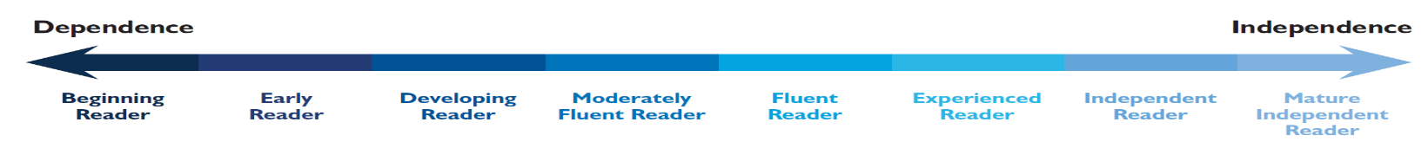

Yr5 Word Reading Progression
Experienced reader
* Experienced readers are avid readers; making choices from a wide range of material. They are comfortable with reading both silently and aloud to others.
* Students at this stage are fully launched as readers; they are able to read a wide range of texts independently and with ease. They are more able to cross check across a range of cues to ensure comprehension. They can confidently break up words in ways that support them in decoding unknown vocabulary without impeding their fluency.
* They are likely to be developing strong reading preferences and showing interest in new authors and genres. They recommend books to others based on their own reading preferences, giving reasons for their choices.
 | Baseline expectations | End of Autumn 1 | End of Autumn 2 | End of Spring 1 | End of Spring 2 | End of Summer 1 | End of Summer 2
Decoding | Towards the end of the ORT Grey book band, children decode words (including multi-syllabic words) automatically and fluently. They separate root words from taught prefixes (un, dis, mis, re, sub, inter, super, anti, auto, in, il, im, ir) and suffixes (-ly, -ous, -sure, -ture, -sion, -ation, -ic, -ally, -tion, -ssion, -cian) consistently and accurately to decode unfamiliar words. Some children are also further progressed with their decoding ability and will be reading within the books of the RWI Dark Blue book band or above | Within the beginning books of the ORT Dark Blue book band, children decode most words (including multi-syllabic words) automatically and fluently. They separate root words from suffixes (-cious, -tious, -cial, -ant, -ance, -ancy, -able, -ible, -ably, -ibly) to decode unfamiliar words. Some children are also further progressed with their decoding ability and will be reading within the RWI Dark Blue book band or above | Within the ORT Dark Blue book band, children decode most words (including multi-syllabic words) automatically and fluently. They are beginning to use root words and suffixes (-cious, -tious, -cial, -ant, -ance, -ancy, -able, -ible, -ably, -ibly) accurately to decode unfamiliar words. Some children are also further progressed with their decoding ability and will be reading within the final books of the RWI Dark Blue book band or above | Within the ORT Dark Blue book band, children decode all words (including multi-syllabic words) automatically and fluently. They are use root words and suffixes (-cious, -tious, -cial, -ant, -ance, -ancy, -able, -ible, -ably, -ibly) accurately to decode unfamiliar words. Some children are also further progressed with their decoding ability and will be reading within the beginning books of the RWI Dark Red book band or above | Within the ORT Dark Blue book band, children decode all words (including multi-syllabic words) automatically and fluently. They are use root words and suffixes (-cious, -tious, -cial, -ant, -ance, -ancy, -able, -ible, -ably, -ibly) accurately and consistently to decode unfamiliar words, and are beginning to use the suffix –ology. Some children are also further progressed with their decoding ability and will be reading within the books of the RWI Dark Red book band or above | Towards the end of the ORT Dark Blue book band, children decode all words (including multi-syllabic words and all taught prefixes/suffixes) automatically and fluently. Some children are also further progressed with their decoding ability and will be reading within the books of the RWI Dark Red book band or above | Children have consolidated all yr5 learning and are reading fluently towards the end of the ORT Dark Blue book band. Some children are also further progressed with their decoding ability and will be reading within the RWI Dark Red book band or above
Spelling rules & Common Exception words | Children apply knowledge of root words, prefixes (un, dis, mis, re, sub, inter, super, anti, auto, in, il, im, ir) and suffixes (-ly, -ous, -sure, -ture, -sion, -ation, -sion, -cian) to read aloud fluently and to understand the meaning of unfamiliar words. They read all yr3/4 exception words correctly, noting the unusual correspondences between spelling and sound. Some children are also further progressed with their ability to read spelling rules and yr5 common exception words, and/or understand the meaning of the root words/ suffixes/ prefixes in order to read with more meaning. | Children consistently read and are beginning to understand the suffixes: -cious (full of), -tious (having/to have), -cial/-tial (relates to), -ant (a person who), -ance (quality, action, state or process, -ancy (state or quality). Amongst other yr5/6 exception words, children can read and understand: conscious, convenience, disastrous, especially, excellent, existence, hindrance, marvellous, mischievous, nuisance, special. Some children are also further progressed with their ability to read spelling rules and yr5/6 common exception words, and/or understand the meaning of the root words/ suffixes/ prefixes in order to read with more meaning. | Children consistently read and are beginning to understand the suffixes: –able, -ible, -ably, -ibly (capable of) correctly and confidently. Amongst other yr5/6 exception words, children can read and understand: achieve, guarantee, persuade, recognise, suggest. Some children are also further progressed with their ability to read spelling rules and yr5/6 common exception words, and/or understand the meaning of the root words/suffixes/prefixes in order to read with more meaning. | Children confidently understand the suffixes (-cious, -tious, -cial, -ant, -ance, -ancy, -able, -ible, -ably, -ibly) in their reading. Children read words with hyphens correctly and are developing their ability to read words with silent letters, although this may be inconsistent. Amongst other yr5/6 exception words, children can read and understand, determined, dictionary, embarrass, exaggerate. Some children are also further progressed with their ability to read spelling rules and yr5/6 common exception words, and/or understand the meaning of the root words/ suffixes/ prefixes in order to read with more meaning. | Children read words with silent letters correctly and confidently. They are beginning to understand the suffix –ology (a branch of knowledge). Amongst other yr5/6 exception words, children can read and understand: amateur, conscience, foreign, leisure, muscle. Some children are also further progressed with their ability to read spelling rules and yr5/6 common exception words, and/or understand the meaning of the root words/ suffixes/ prefixes in order to read with more meaning. | Children read and understand further and near homophones correctly, including –ce nouns and –se verbs confidently and correctly. They confidently read and understand all taught prefixes/suffixes. Amongst other yr5/6 exception words, children can read and understand: criticise, sacrifice, existence. Some children are also further progressed with their ability to read spelling rules and yr5/6 common exception words, and/or understand the meaning of the root words/ suffixes/ prefixes in order to read with more meaning. | Children have consolidated all yr5 learning. Some children are also further progressed with their ability to read spelling rules and yr5 common exception words, and/or understand the morphology and etymology of words.
Fluency and expression | Children are fluent, accurate and confident when reading an appropriate book (ORT Grey book band), reading up to 90 words a minute (average). They respond to a wide range of all taught punctuation precisely when expressing their reading out loud, expressing commas after fronted adverbials appropriately. Children consistently correct inaccurate reading independently, and adapt their expression in response to different characters, settings and plot to create a sense of character and atmosphere. Some children also use a wide range of higher punctuation precisely to express their reading out loud, and are beginning to explore intonation, tone and volume when reading aloud. | Children are fluent, accurate and confident when reading an appropriate book (ORT Dark Blue book band), reading up to 90 words a minute (average). They respond to a wide range of all taught punctuation precisely, including expressing commas and brackets for parenthesis appropriately. Children consistently correct inaccurate reading independently, and are beginning to use intonation, tone and volume when reading aloud. Some children also use intonation, tone and volume when reading aloud precisely in relation to their audience. |  | Children are fluent, accurate and confident when reading an appropriate book (ORT Dark Blue book band), reading up to 90 words a minute (average). They respond to a wide range of all taught punctuation precisely, including expressing hyphens and dashes appropriately, and beginning to note colons, semi-colons in a list and bullet points. Children consistently correct inaccurate reading independently, and use intonation, tone and volume when reading aloud. Some children also use intonation, tone and volume when reading aloud precisely in relation to their audience, and express colons, semi-colons in lists and bullet points confidently. |  | Children have consolidated all yr5 learning. They are fluent, accurate and confident when reading an appropriate book (ORT Dark Blue book band), reading up to 90 words a minute (average). They respond to the full range of taught punctuation precisely, and consistently correct inaccurate reading independently. They use intonation, tone and volume effectively when reading aloud, taking into consideration their audience. Some children also precisely and confidently use intonation, tone and volume when reading aloud and performing a reading, understanding the impact this has on the audience. They may also read more than 90 words per minute at an appropriate pace.

Yr6 Word Reading Progression
Independent reader
* Independent readers are self-motivated, confident and experienced, and may be pursuing particular interests through reading. They are capable of tackling some demanding texts and can cope well with the reading of the wider curriculum. They read thoughtfully and appreciate shades of meaning.
* Students at this stage will be willing to take on more extended and more challenging texts. They become more fluent and experienced across the wide range of reading demands that exist in the primary classroom.
 | Baseline expectations | End of Autumn 1 | End of Autumn 2 | End of Spring 1 | End of Spring 2 | End of Summer 1 | End of Summer 2
Decoding | Towards the end of the ORT Dark Blue book band, children decode words (including multi-syllabic words) automatically and fluently. They separate root words from taught prefixes (un, dis, mis, re, sub, inter, super, anti, auto, in, il, im, ir) and suffixes (-ly, -ous, -sure, -ture, -sion, -ation, -ic, -ally, -tion, -ssion, -cian, -cious, -tious, -cial, -ant, -ance, -ancy, -able, -ible, -ably, -ibly) consistently and accurately to decode unfamiliar words. Some children are also further progressed with their decoding ability and will be reading within the books of the RWI Dark Red book band or above | Within the beginning books of the ORT Dark Red book band, children decode most words (including multi-syllabic words) automatically and fluently. They are beginning to understand the morphology and etymology of words in order to decode unfamiliar words. Some children are also further progressed with their decoding ability and will be reading within the RWI Dark Red book band or above | Within the ORT Dark Red book band, children decode most words (including multi-syllabic words) automatically and fluently. They understand the morphology and etymology of words in order to decode unfamiliar words. Some children are also further progressed with their reading ability and will be reading their own choices as free readers. | Towards the end of the ORT Dark Red book band, children decode all words (including multi-syllabic words) automatically and fluently. They are beginning to recognise patterns in the morphology and etymology of words in order to decode unfamiliar words. Some children are also further progressed with their reading ability and will be reading their own choices as free readers. | Children are now free readers and decode most words (including multi-syllabic words) within their chosen book automatically and fluently. They recognise patterns in the morphology and etymology of words in order to decode unfamiliar word. Some children are also further progressed with their reading ability and will be reading their own high level choices as free readers. | Children are now free readers and decode all words (including multi-syllabic words) within their chosen book automatically and fluently. They consistently use the patterns in the morphology and etymology of words in order to decode unfamiliar word. Some children are also further progressed with their reading ability and will be reading their own high level choices as free readers. | Children have consolidated all yr6 learning and are reading fluently in books of their own choice. Some children also choose and read books independently for challenge, interest and enjoyment (Ks3)
Spelling rules & Common Exception words | Children apply knowledge of root words, prefixes (un, dis, mis, re, sub, inter, super, anti, auto, in, il, im, ir) and suffixes (-ly, -ous, -sure, -ture, -sion, -ation, -sion, -cian, -cious, -tious, -cial/-tial, -ant, -ance, -ancy, -able, -ible, -ably, -ibly, -ology) to read aloud fluently and to understand the meaning of unfamiliar words. They read most yr5/6 exception words correctly (including silent letters, homophones and near homophones), noting the unusual correspondences between spelling and sound. Some children are also further progressed with their ability to read spelling rules and yr5/6 common exception words, and/or understand the morphology and etymology of words. | Children consistently and confidently read all previously taught root words, prefixes and suffixes, and are beginning to understand the etymology of words within taught spelling patterns. They read most of the yr5/6 exception words confidently. Some children are also further progressed with their ability to read spelling rules and yr5/6 common exception words, and/or understand the morphology and etymology of words. | Children understand the etymology of words within taught spelling patterns. They read most of the yr5/6 exception words confidently. Some children are also further progressed with their ability to read spelling rules and yr5/6 common exception words, and/or understand the morphology and etymology of words. | Children read all of the yr5/6 exception words confidently and are beginning to use all their knowledge of the morphology and etymology of words to investigate how words can change: dis+repute+able, re+engage+ment. Some children are also further progressed with their ability to read spelling rules and yr5/6 common exception words, and/or understand the morphology and etymology of words. | Children read all of the yr5/6 exception words confidently and are use their knowledge of the morphology and etymology of words to investigate how words can change: dis+repute+able, re+engage+ment. Some children are also further progressed with their ability to read spelling rules and yr5/6 common exception words, and/or understand the morphology and etymology of words. | Children read all yr5/6 exception words automatically and fluently. They confidently use their knowledge of the morphology and etymology of words to understand new words they meet and check them within context. Some children are also further progressed with their ability to read spelling rules and yr5/6 common exception words, and/or understand the morphology and etymology of words. | Children have consolidated all yr6 learning. Some children also relate new words to known patterns of the English language (Ks3)
Fluency and expression | Children have consolidated all yr5 learning. They are fluent, accurate and confident when reading an appropriate book (ORT Dark Blue book band), reading up to 90 words a minute (average). They respond to the full range of taught punctuation precisely, and consistently correct inaccurate reading independently. They use intonation, tone and volume effectively when reading aloud, taking into consideration their audience. Some children also precisely and confidently use intonation, tone and volume when reading aloud and performing a reading, understanding the impact this has on the audience. They may also read more than 90 words per minute at an appropriate pace. | Children are fluent, accurate and confident when reading an appropriate book (ORT Dark Red book band), reading 90 words a minute (average). They respond to the full range of taught punctuation precisely, expressing semi-colons to mark boundaries between independent clauses, and consistently correct inaccurate reading independently. They use intonation, tone and volume effectively when reading aloud, beginning to understand the impact on their audience. Some children also precisely and confidently use intonation, tone and volume when reading aloud and performing a reading, understanding clearly the impact this has on the audience. They may also be expressing dashes to mark boundaries between independent clauses, and reading more than 90 words per minute at an appropriate pace. |  | Children are fluent, accurate and confident when reading an appropriate book (ORT Dark Red book band), reading 90 words a minute (average). They respond to the full range of taught punctuation precisely, expressing dashes to mark boundaries between independent clauses, and consistently correct inaccurate reading independently. They use intonation, tone and volume precisely and confidently when reading aloud and performing a reading, understanding the impact on their audience. Some children also respond to the full range of punctuation in order to enhance meaning and avoid ambiguity and are beginning to manipulate intonation, tone and volume in response to their audience in order to develop atmosphere in their readings. They read more than 90 words per minute at an appropriate pace. |  | Children have consolidated all yr6 learning. They are fluent, accurate and confident when reading an appropriate book (ORT Dark Red book band), reading 90 words and more a minute (average). They respond to the full range of taught punctuation precisely and confidently, and consistently correct inaccurate reading independently. They use intonation, tone and volume precisely and confidently to develop atmosphere when reading aloud and performing a reading, understanding the impact on their audience. Some children also use role, intonation, tone, volume, mood, silence, stillness and action to add impact (Ks3)

KS2 VIPERS
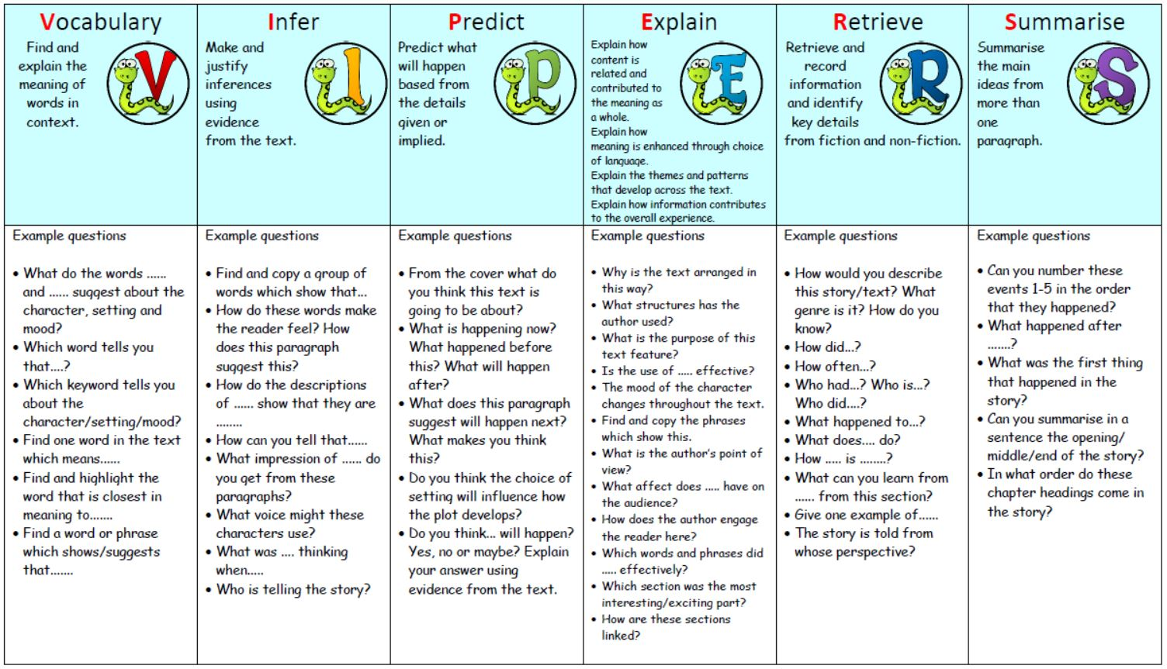

KS1 VIPERS
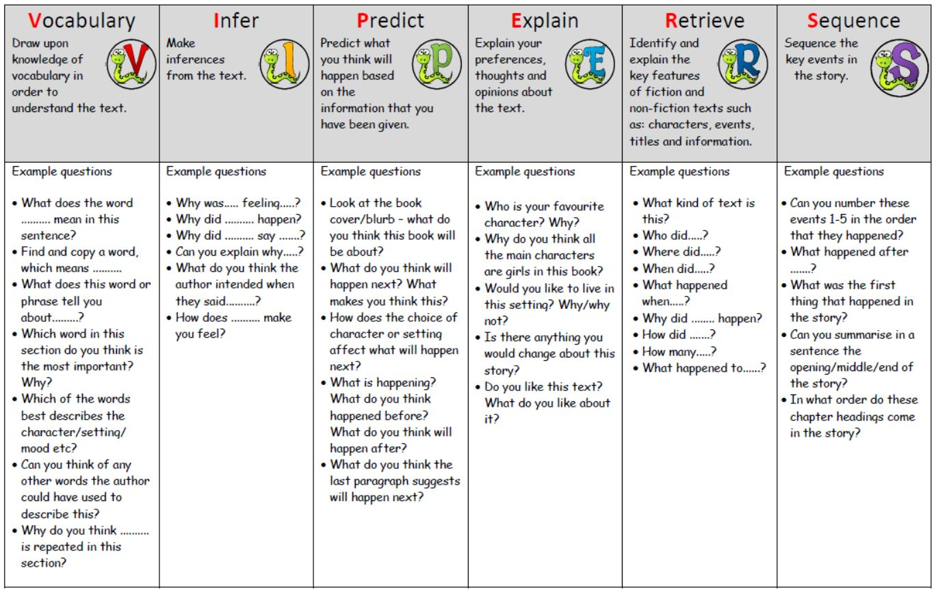
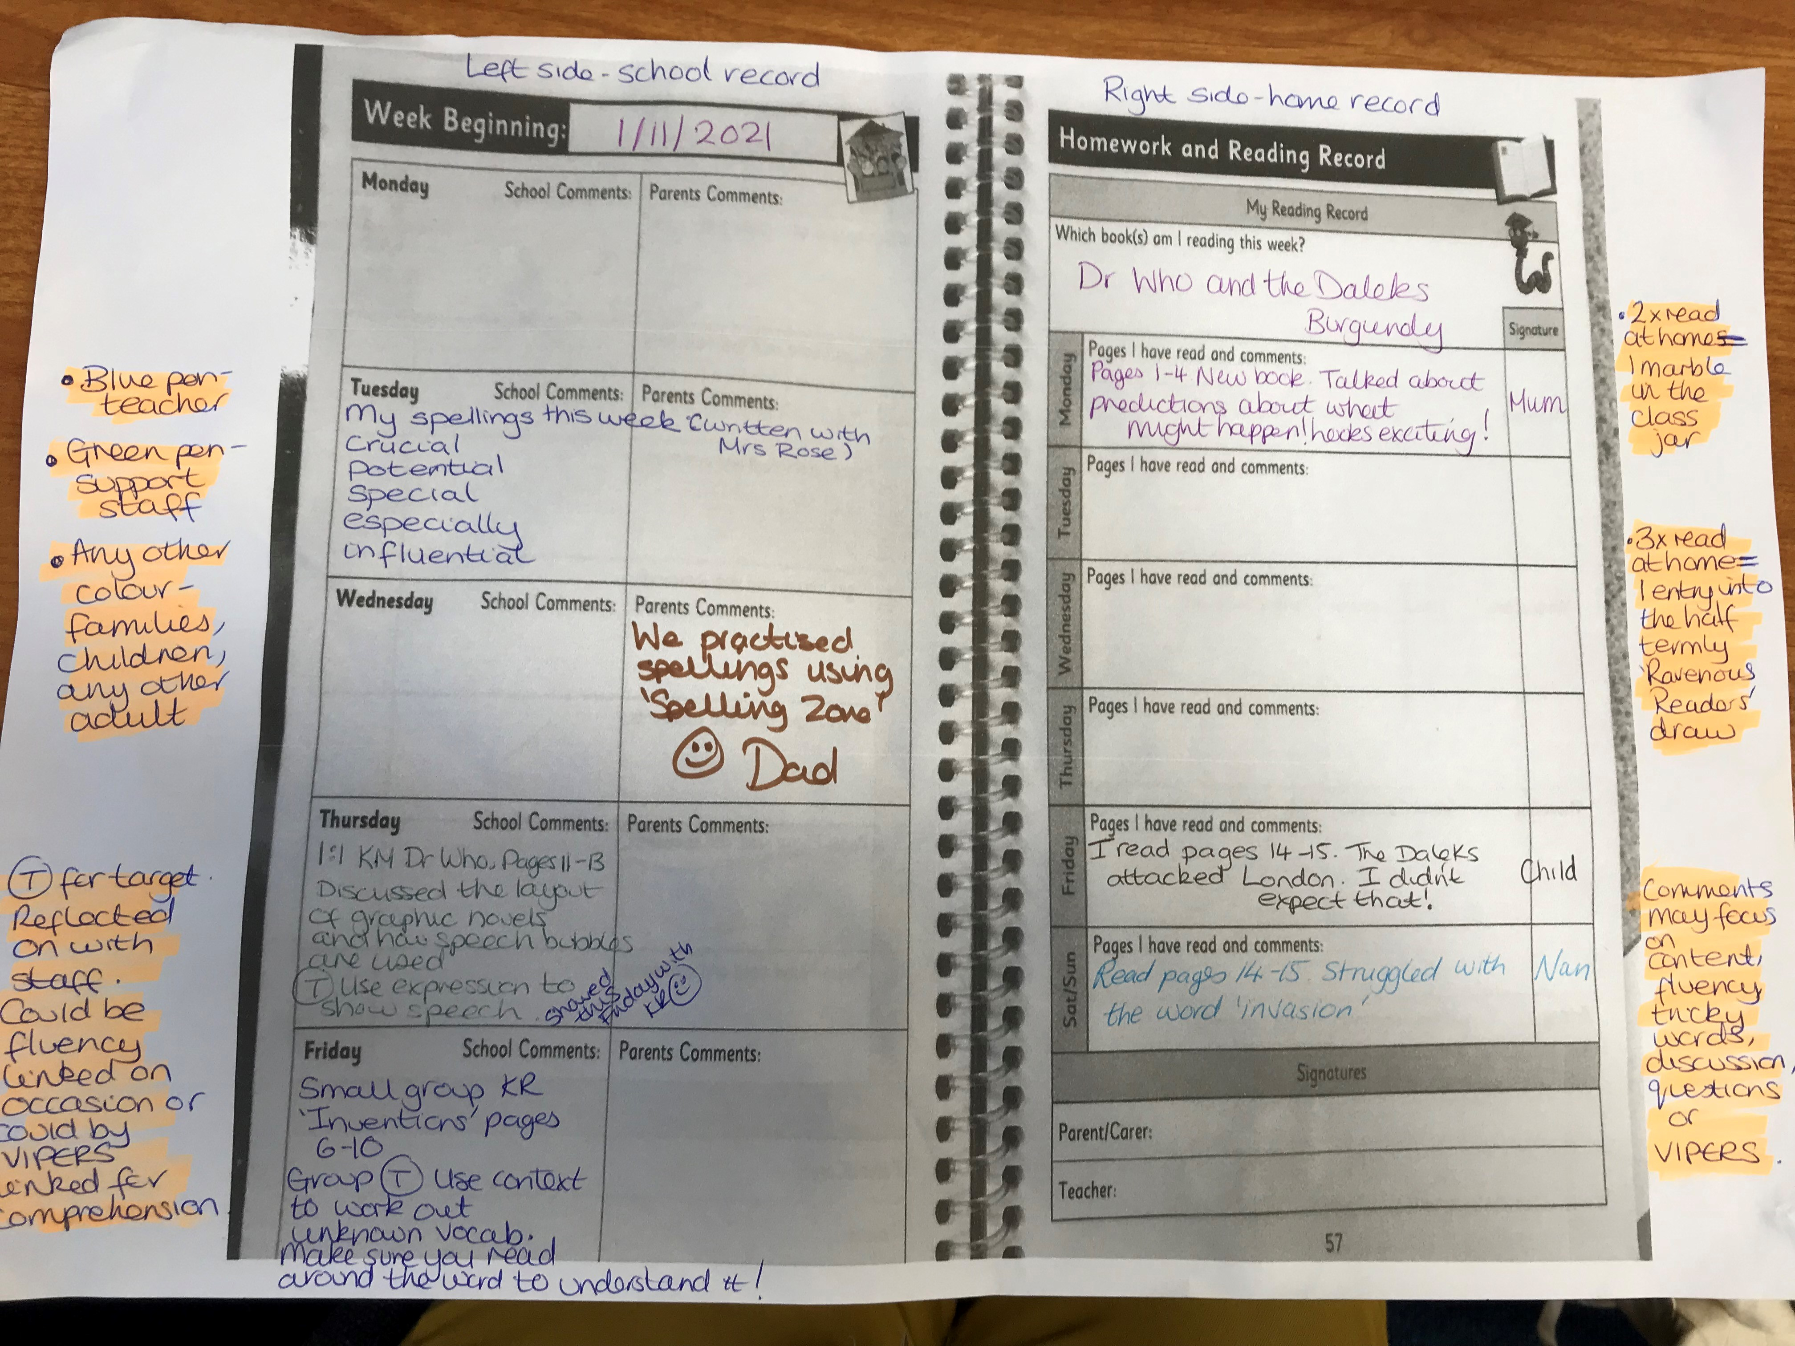
This is the fluency rubric which helps us to give small targets to support your child when reading alpud. Ther numbers do not link to any particular year group, they are just steps of progression.
I can read with fluency. I put my words together so my reading sounds right and makes sense. This means that I am paying attention to my phrasing.
PHRASING
1 | 2 | 3 | 4
I read word-by-word, or one word at a time  I - like - to - read. - It - is - fun. | I am trying to read the way the author wrote the words. Sometimes I read 2 or 3 words at a time. Sometimes I read word by word  I like - to - read. It - is fun. | I am really close to reading the words the way the author wrote them. I usually read in 3 or 4 word groups.  I like to - read. It - is fun. | I put the words together the way the author wrote them. I put the words together so that it makes sense.  I like to read. It is fun!
I can read with fluency. I read at the correct rate. Not too quickly, and not too slowly. My reading sounds right and makes sense.
READING RATE
1 | 2 | 3 | 4
  I am slow when I read aloud and have to figure out each word on the page. This can mean that my reading doesn’t make sense to me or others. | I can be slow because I have to read word-by-word when I don't know the words. I take breaks, pause a lot and repeat words when I read. | I try to read like I talk. Sometimes I go too fast, or too slow. I might slow down when I am trying to figure out a tricky word. Sometimes I pause or stop when it doesn’t make sense.   |   I read like I talk. I only slow down, stop, or repeat words when it make sense and sounds right.

I can read fluently. I use the punctuation to help me know how to read the story, so that it sounds right and makes sense.
PUNCTUATION
1 | 2 | 3 | 4
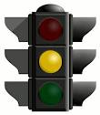    I don’t use full stops, commas, exclamation points, question marks, and speech marks when I read. This might mean that my reading doesn’t sound right or always make sense. | Sometimes I use the punctuation, but I might use it in the wrong way. | I usually pay attention to the punctuation. I may make a mistake every once in a while. | I always pay attention to the punctuation. My reading sounds right and makes sense.

I can read fluently. I read with expression so that it sounds interesting and makes sense.
EXPRESSION
1 | 2 | 3 | 4
My reading doesn’t really make sense because I don’t read with expression.   | I am trying to read with expression, but I may read it the wrong way sometimes.   | I read with expression most of the time. My reading sounds interesting most of the time.   | I always read with expression so it always sounds interesting and exciting where appropriate and I think about my audience.  

