Whole school reading rewards system from Monday 1st November 2021
The Reading Jar and Ravenous Readers
Reading record example

Dear Parents/Carers,

At Summerfields Primary Academy, we are passionate about and prioritise reading. We want to develop a reading culture that celebrates a love of literature at every level. Our Reading Ambassadors have been working hard to come up with ideas to promote reading at home and we are now ready to share them with you ready for the new school term.

The Reading Jar
- Each class will have a large jar with different markers at different levels.
- The different levels each represent a different prize for the whole class.
- Each child in the class will earn a marble to add to the jar if they read at home twice in a week.
- Reading at home can be with a parent (any key stage) or individually (KS2). If the child reads independently, they need to record a sentence to explain what they have read and thoughts about it as evidence of reading.
- Once the class cumulatively reaches a level on the jar, they all receive the identified prize.
Ravenous Readers – a book themed lunch every half term
- Every half term, the Reading Ambassadors will organise a book themed lunch. Ideas so far have included a Harry Potter, a Tiger Who Came to Tea or a Zog themed special lunch.
- Every week that the children read at home three times they will be entered into the half termly draw to win a seat at the special ‘Ravenous Readers’ lunch. The winners will be able to sit at a special table and have special book themed activities on the chosen day to eat their lunch.

These rewards systems will begin from Monday 1st November and will run to the end of the year, where they will be reviewed with the staff and Reading Ambassadors to see how they have worked and if any tweaks need making. We really hope they will enjoy the challenges and will encourage the children to read at home and record their reading in their planners.

We are very aware of the fact that planners haven’t been used to their full potential post Covid and that some parents may have little experience of how to use planners or how best to support reading at home due to starting school during the pandemic. To support with recording in planners, a model example of how planners should be used going forwards can be found on the back of this letter with an explanation. We are aware that some may currently be used slightly differently to this in school currently, but from 1st November, this is how we will be intending on using the planners throughout school for consistency. We are currently in the process of planning parent support sessions for all phases throughout school about ways to support your child with reading at home, so please keep an eye out for these in future communications. These will include ideas for reading materials, phonics, questioning, recording and celebrating reading.

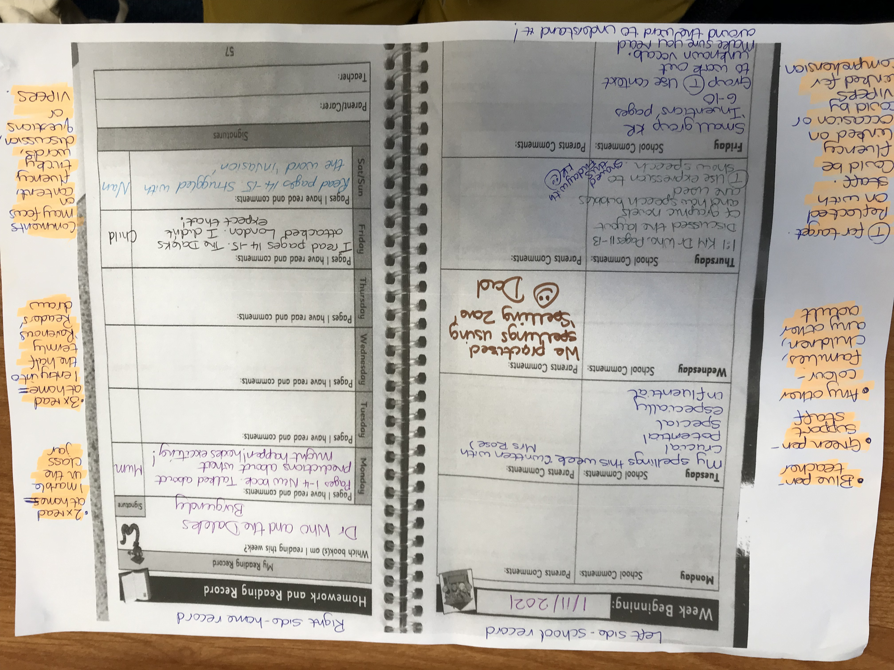

Teachers will always write in blue. Support staff will always write in green. If parents/carers could write in any other colour that would really help us identify who they are reading with quickly and effectively.
The left hand side of the planner will be used for school recordings and any notes – for example, recording spellings, homework, targets, notes to and from staff and parents if Dojo is not used.
The right hand side of the planner will be used for home recordings. This will make it easy to see how often the children are reading to support the reading challenges.
T stands for target – so this will be something the child may be working on in class, as a group as individually.
Comments may link to fluency or VIPERS – which is an acronym that links to the different kinds of questions children may be asked for assessment purposes.
Both fluency and comprehension questions will be covered in the upcoming reading support sessions, but please see the attached sheet for examples of both.

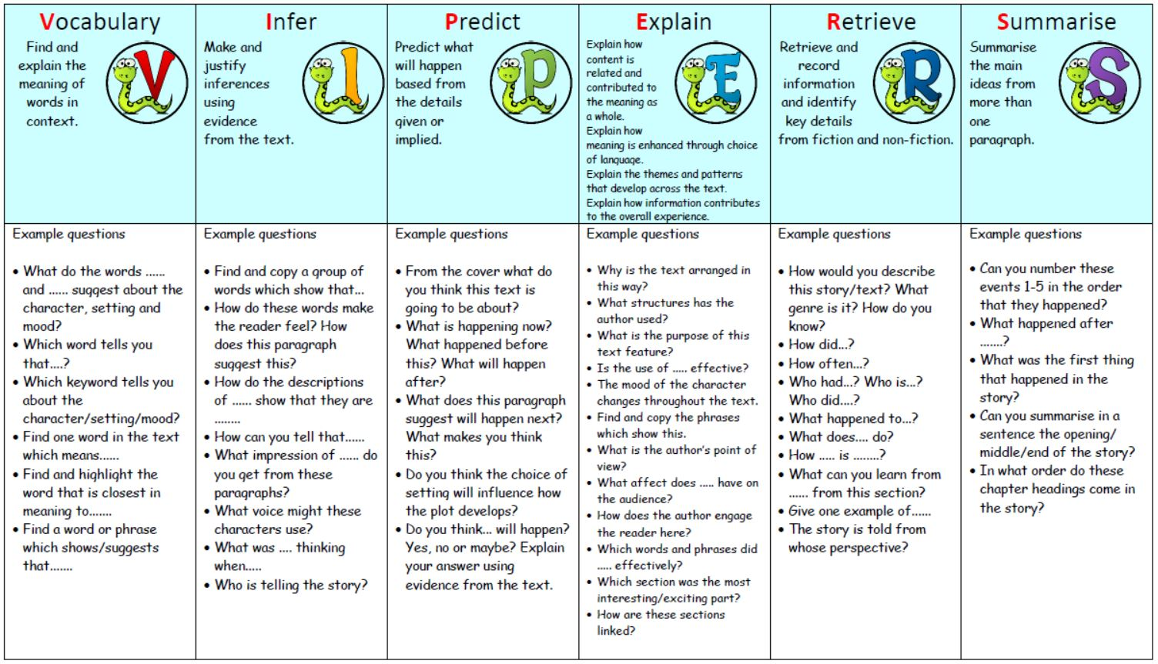
Key stage 2 VIPERS question examples
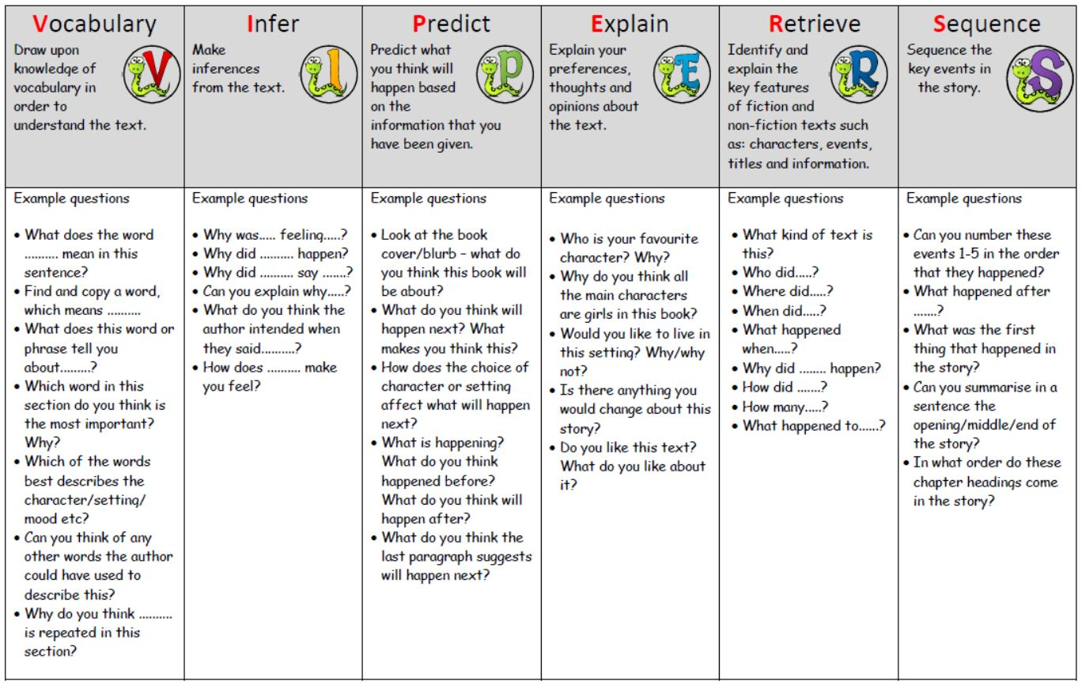
Key stage 1 VIPERS question examples
This is the fluency rubric which helps us to give small targets to support your child when reading aloud. The numbers do not link to any particular year group, they are just steps of progression.
I can read with fluency. I put my words together so my reading sounds right and makes sense. This means that I am paying attention to my phrasing.
PHRASING
1 | 2 | 3 | 4
I read word-by-word, or one word at a time  I - like - to - read. - It - is - fun. | I am trying to read the way the author wrote the words. Sometimes I read 2 or 3 words at a time. Sometimes I read word by word  I like - to - read. It - is fun. | I am really close to reading the words the way the author wrote them. I usually read in 3 or 4 word groups.  I like to - read. It - is fun. | I put the words together the way the author wrote them. I put the words together so that it makes sense.  I like to read. It is fun!

I can read with fluency. I read at the correct rate. Not too quickly, and not too slowly. My reading sounds right and makes sense.
READING RATE
1 | 2 | 3 | 4
  I am slow when I read aloud and have to figure out each word on the page. This can mean that my reading doesn’t make sense to me or others. | I can be slow because I have to read word-by-word when I don't know the words. I take breaks, pause a lot and repeat words when I read. | I try to read like I talk. Sometimes I go too fast, or too slow. I might slow down when I am trying to figure out a tricky word. Sometimes I pause or stop when it doesn’t make sense.   |   I read like I talk. I only slow down, stop, or repeat words when it make sense and sounds right.

I can read fluently. I use the punctuation to help me know how to read the story, so that it sounds right and makes sense.
PUNCTUATION
1 | 2 | 3 | 4
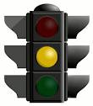  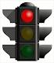  I don’t use full stops, commas, exclamation points, question marks, and speech marks when I read. This might mean that my reading doesn’t sound right or always make sense. | Sometimes I use the punctuation, but I might use it in the wrong way. | I usually pay attention to the punctuation. I may make a mistake every once in a while. | I always pay attention to the punctuation. My reading sounds right and makes sense.
I can read fluently. I read with expression so that it sounds interesting and makes sense.
EXPRESSION
1 | 2 | 3 | 4
I don’t read with expression yet.  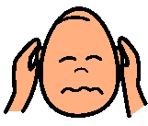 | I am trying to read with expression, but I may read it the wrong way sometimes.   | I read with expression most of the time. My reading sounds interesting most of the time.   | I always read with expression so it always sounds interesting and exciting where appropriate and I think about my audience.  

