DISHES AND THEIR ALLERGEN CONTENT –SUMMERFIELDS PRIMARY ACADEMY

DISHES | 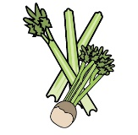 | 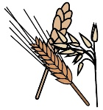 | 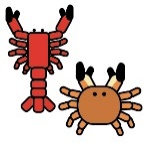 |  |  |  |  |  | 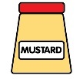 |  | 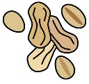 | 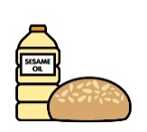 |  | 
Autumn 2026 | Celery | Cereals containing gluten | Crustaceans | Eggs | Fish | Lupin | Milk | Mollusc | Mustard | Nuts | Peanuts | Sesame seeds | Soya | Sulphur Dioxide
Pizza |  | 
All Day Breakfast
Roast Turkey
Chicken Curry and Rice

Breaded Fish Fillet
Butchers Pork Sausages
Salmon and Sweet Potato Fishcake
Gluten Free Chicken Burgers
Spaghetti Bolognese with Pasta
Fish Fingers
Crusty Roll
DISHES
Autumn 2026 | Celery | Cereals containing gluten | Crustaceans | Eggs | Fish | Lupin | Milk | Mollusc | Mustard | Nuts | Peanuts | Sesame seeds | Soya | Sulphur Dioxide
Yorkshire Puddings
Spaghetti Hoops
Beans
Gluten Free and Vegetarian Gravy
Burger Buns
Naan Bread
Jacket Potato
Tuna Mayo
Cheese
Coleslaw
Ice-Cream Tubs
DISHES
Autumn 2026 | Celery | Cereals containing gluten | Crustaceans | Eggs | Fish | Lupin | Milk | Mollusc | Mustard | Nuts | Peanuts | Sesame seeds | Soya | Sulphur Dioxide
Custard
Fruit Sponge Pudding
Yogurt
Chocolate Brownie
Jelly
Apple Crumble
Pineapple Shortbread
Fruit Muffins
Cookies
Iced Sponge
Artic Roll
DISHES
Autumn 2026 | Celery | Cereals containing gluten | Crustaceans | Eggs | Fish | Lupin | Milk | Mollusc | Mustard | Nuts | Peanuts | Sesame seeds | Soya | Sulphur Dioxide
Quorn Fillet
Ham Sandwich
Cheese Sandwich

Review date: | 3/9/2026 | Reviewed by: | Mrs Smith |  | You can find this template, including more information at www.food.gov.uk/allergy

