I have a dream speech (2020 edition)

I have a dream that black people and white people are all beloved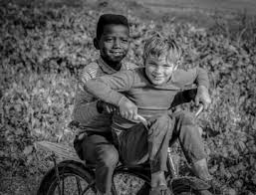

I have a dream that terrorists will be stopped and justice will be brought

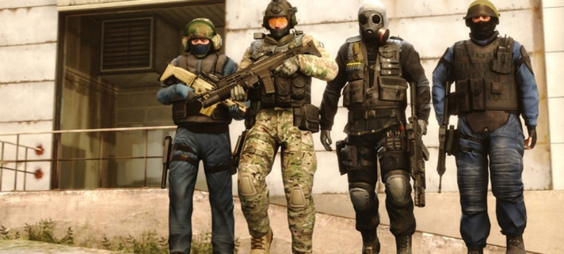

I have a dream that nations will stop fighting each other and start working together
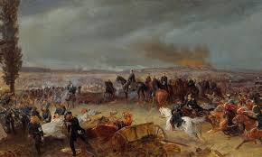

I have a dream that rioting isn’t around anymore 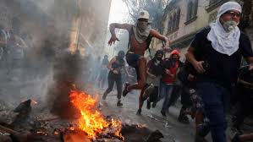

I have a dream that we can all have fun with each other and live in harmony.



