I HAVE A DREAM!
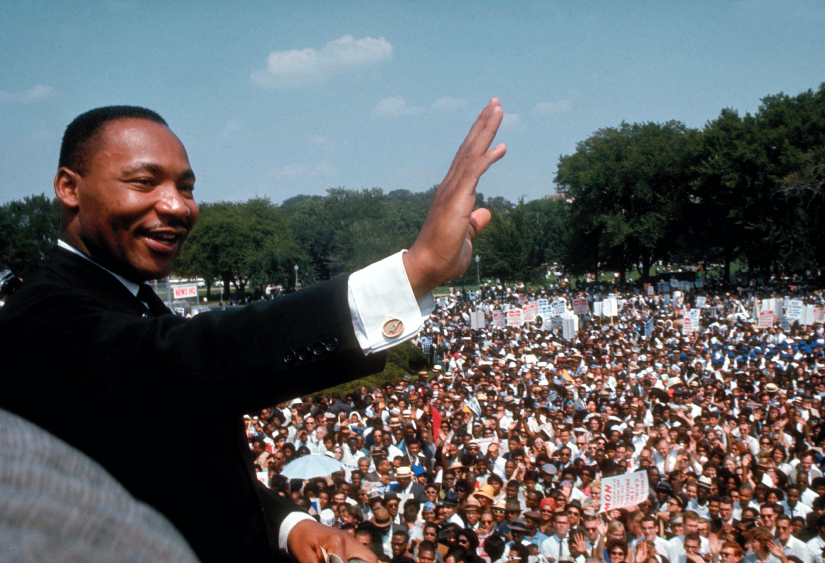
I have a dream that everyone can stand together and treat each over how you want to be treated.
I have a dream that people won’t feel invisible anymore.
I have a dream that people with difficulties won’t be treated awfully but helped.
I have a dream that we all can be free and do whatever we always wanted to do.
I have a dream that COVID-19 hadn’t ever existed because MILLIONS of people are dying by this day.

