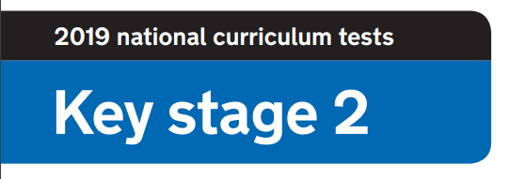
2020 National Curriculum Tests

KS2 Lockdown SATs

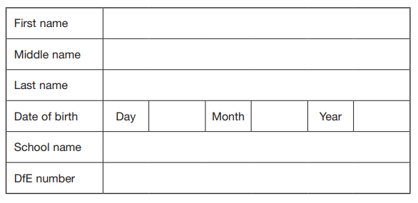



Questions and Answers
You have until 4pm Thursday 14th May to complete the booklet and send me your answers and times.
Work as quickly and as carefully as you can.
If you cannot do a question, go on to the next one. You can come back to it later, if you have time.
If you finish before the end, go back and check your work.

Marks
The number under each question at the side of the page tells you the number of marks available for each question.
All scores will be converted to a standardised score to determine whether you are ‘Working Towards’, ‘Working At’ or ‘Working Above’ the Year 6 Standard.

Results
You will be notified of your results once all papers are marked.
All participants will be awarded with a ‘Lockdown SATs’ certificate.

Paper 1: How well do you know your school?

- What is the name of the trust Summerfields is in? 1mark
- How many trees are there in the school quad? 1 mark

- Can you name the school values? 1 mark

- There are some outdoor taps in school, how many are there? 1 mark

- How many benches are in the school hall? 1 mark

- How many doors are in the school hall? 1 mark

- Which class is names South America? 1 mark

- What image in on the garage wall? 1 mark

- Which person sleeps in the school grounds? 1 mark

- What is the name of the person and animal that visit school on Thursdays? 1 mark

Paper 2: How well do you know chocolate?

Can you name the chocolate bars below?
You will be awarded 1 mark for each correct answer.
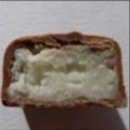 | 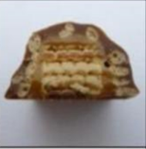 | 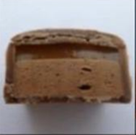 | 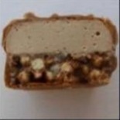
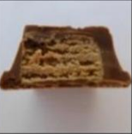 | 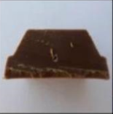 | 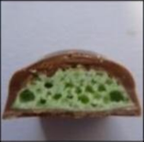 | 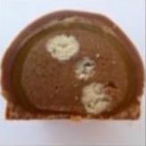
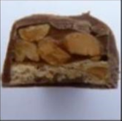 | 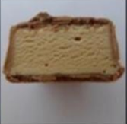 | 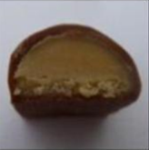 | 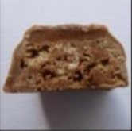
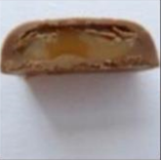 | 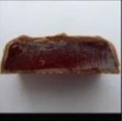 | 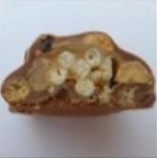 | 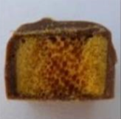

Paper 3: Where’s Wally?

Timed paper. You will need a stopwatch.
Time how many seconds it takes to find Wally.


The times will be ordered and you will receive up to 10 marks.

Paper 4: How well do you know the teachers?

Match the boxes to make the sentences true
1 mark for each correct answer
is the best looking in school

has travelled around Australia

has two sons

is the first and last in school

is an amazing baker

has a convertible car

Mrs Snowden

Mrs Whitehead
Mrs Rose

Mrs Wakefield

Mrs Whitehead

Mrs Cooper

Mr Marsh

Miss Wroe

Mrs Tabbner
Mr Harris

Mrs Haynes

Mrs Moxon

is the last one to join Summerfields

loves to buy shoes

is finishing a first year as a teacher

Loves to draw, paint and be creative

went to school with Mr Marsh

has a husband called Ash

Paper 5: Scavenger Hunt

Timed paper. You will need a stopwatch.
Starting in the room of your choice, ask a member of your household to time how long it takes to find the objects below. You can find the items in any order. Submit your time and if possible a photograph of the objects found. Add a 10 second penalty for any objects not found.

FIND THE FOLLOWING OBJECTS:

- An unused toilet roll

- An item of clothing that is the colour you would get if you mixed blue and yellow together

- An item of clothing that has at least 4 buttons on

- A pen, pencil or crayon that is the top colour of a rainbow

- The word ‘SCHOOL’ - look in a book, magazine or newspaper

- Your favourite cereal

- Your school jumper

- A dessert spoon

- A photograph of yourself

- Something that will hold everything you’ve found

The times will be ordered and you will receive up to 10 marks.

Paper 6: Spelling Test

You will need a member of your household to read the spelling list attached separately.
- ____________________ 1 mark
- ____________________ 1 mark
- ____________________ 1 mark
- ____________________ 1 mark
- ____________________ 1 mark
- ____________________ 1 mark
- ____________________ 1 mark
- ____________________ 1 mark
- ____________________ 1 mark
- ________________ 1 mark

Paper 7: Art

There
‘Everyday object’ art challenge. Select an object to include in a drawing. Your drawing will be assessed by a panel of adjudicators and given a score out of 5 for each area: creativity, artistic style and humour!
15 marks
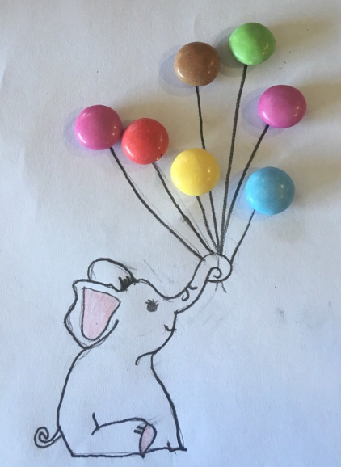
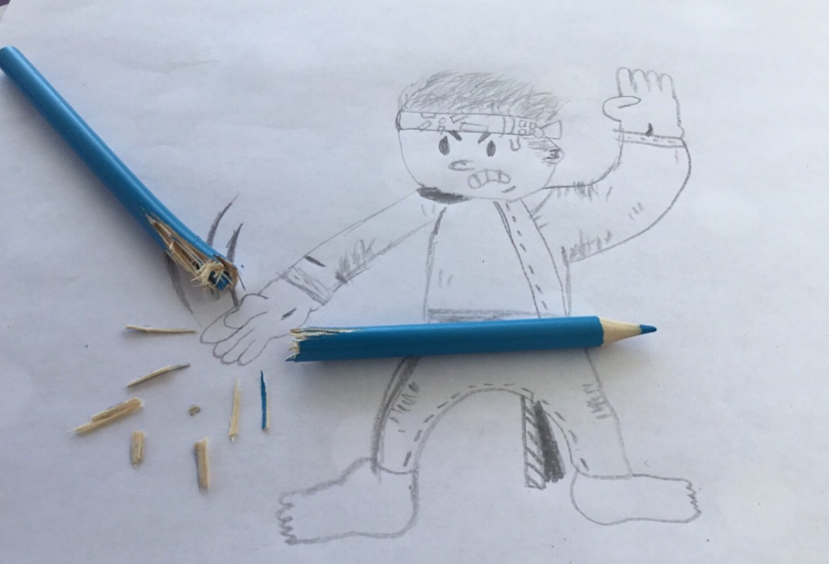
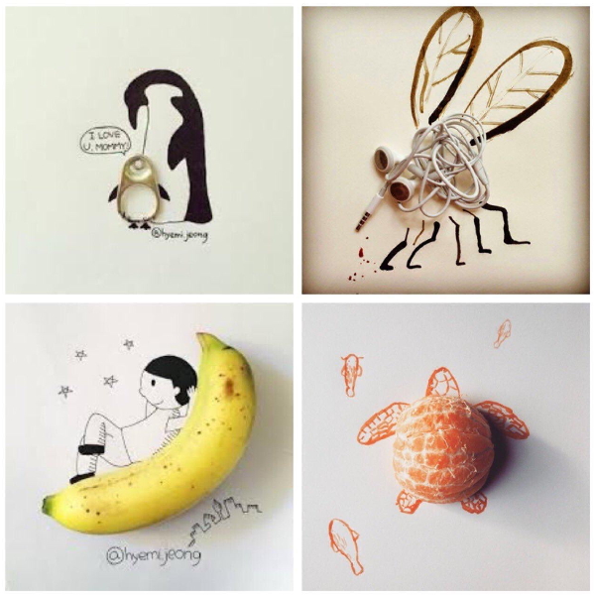
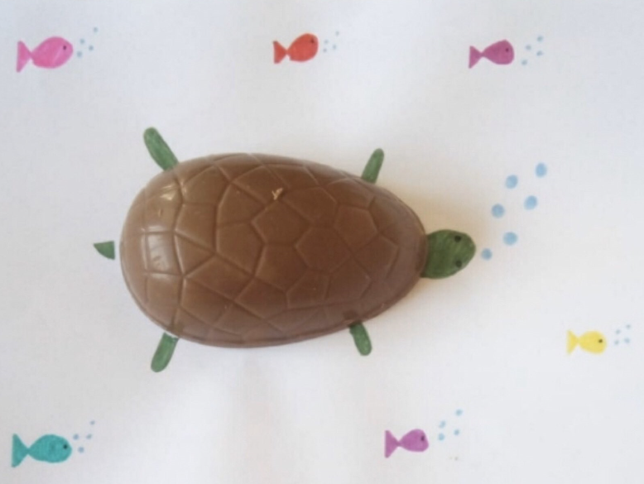
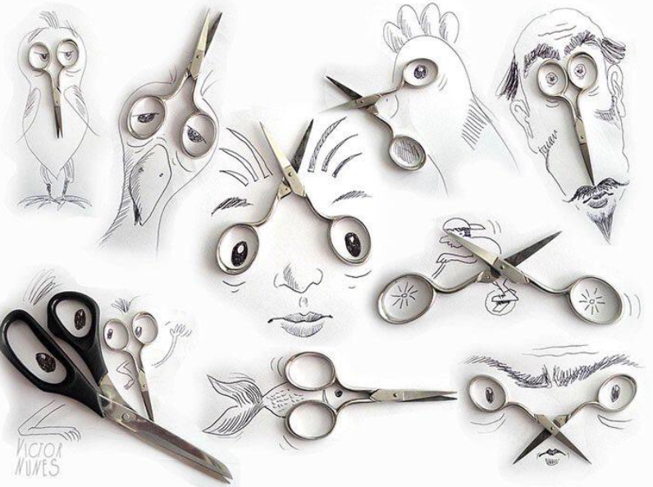

Paper 8: Maths

Solve the maths problems
- Crossing the River
A farmer is trying to cross a river. He is taking with him a rabbit, carrots and a fox and he has a small raft. He can only bring 1 item a time across the river because his raft can only fit either a rabbit, the carrots or the fox. How does he cross the river? (You can assume that nothing is eaten or escapes!)
3 marks
- You are driving a bus to St Barnabas. You drive through Hanham and pick 1 child up, you drive through Kingswood and pick 1 child up, you drive through Oldland Common and pick 5 children up, you drive through Cadbury Heath and pick 4 children up. You drive through Warmley and pick up 10 children. 6 children get off because they decide to walk the rest of the way. Before reaching school, you pick up 14 children from North Common. Who is the bus driver?
1 mark
- How many squares are in the picture?


3 marks

Paper 9: Reading

Name the books using the emoji clue
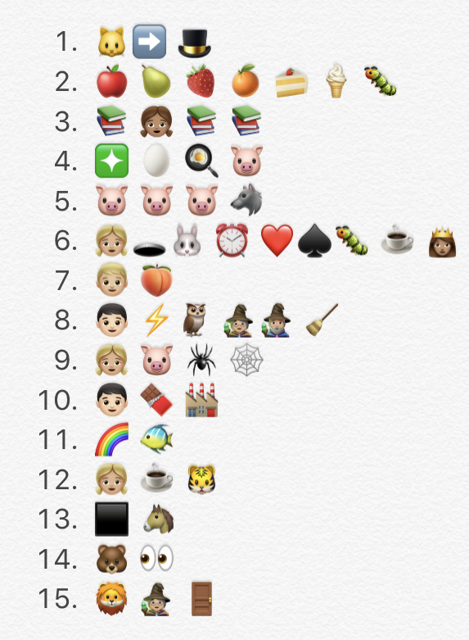
1 mark
1 mark
1 mark
1 mark
1 mark
1 mark
1 mark
1 mark
1 mark
1 mark
1 mark
1 mark
1 mark
1 mark
1 mark

Paper 10: Secondary School

Visit your secondary school’s website and answer the following questions.

- What is your secondary school’s website?
1 mark
- What is the motto or key values? E.g. St Barnabas is ‘Aspire, Believe, Together Achieve’
1 mark
- What is the principal/ head teacher’s name?
1 mark
- What are the house groups?
1 mark
- Name 3 exciting facts.
3 marks
- Draw the school logo.
1 mark
- What is the school uniform?
2 marks
- Do they have a social media page to share information?
1 mark
- Find a quote from a pupil at your secondary school. What do they think of the school?
1 mark
- What sports facilities does your secondary school have?
1 mark
Paper 11: End of SATs celebration

Crazy hair celebration. Your hair style will be assessed by a panel of adjudicators and given a score out of 5 for each area: creativity, artistic style and humour!
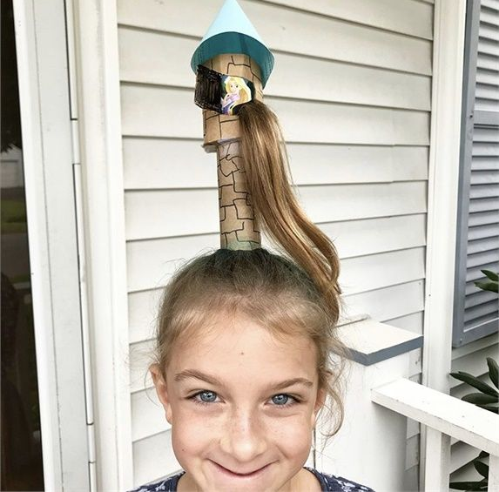
15 marks



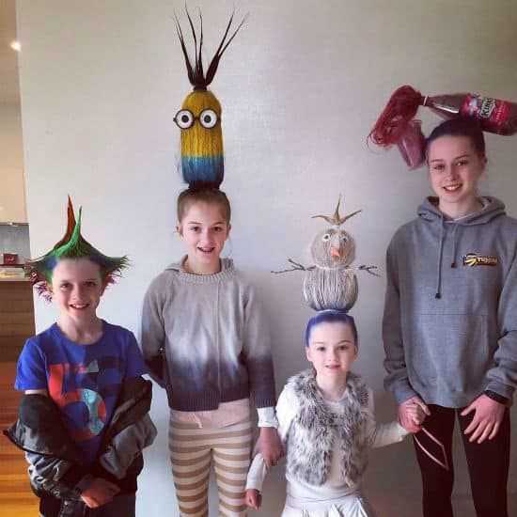


CONGRATULATIONS!

You have completed the Lockdown SATs – CONGRATULATIONS!
Summerfields, I am proud of what you have achieved so far in Year 6. It’s a pleasure to teach a class full of 31 amazing individuals. Even though SAT’s was cancelled, I know how hard you worked during the lead up and nothing will take that away. You are a determined class who are so enthusiastic about learning. Not only that you work well as a team and support and encourage each other. It’s an absolute pleasure to watch you grow into mature young people with individual qualities and personalities. Although we are not currently at school, we will celebrate your time at Summerfields because no one deserves it more than you!

Keep smiling and stay positive!

Mr Marsh -

‘Working hard is important but there is something that matters even more: believing in yourself
Spellings
- There
- Are
- No
- Spellings
- to
- have
- a
- go
- at
- Summerfields

