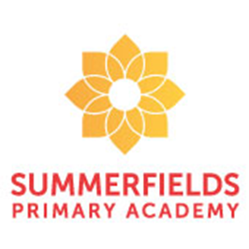
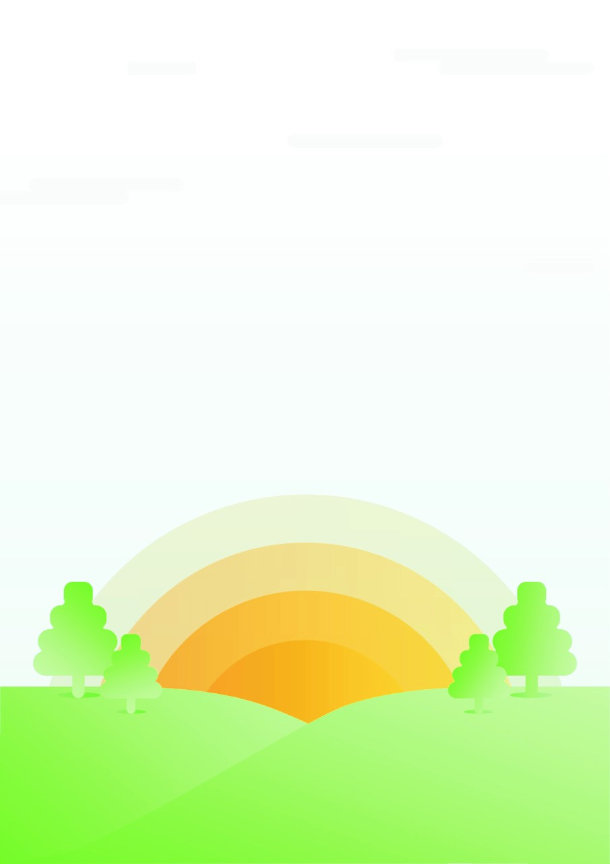
Miss Foster, Mrs Shaw and Mrs Brown

Year 4 - Rowlings Class
Our class novel to support our Explore unit is Norse Myths: Tales of Odin, Thor and Loki. As well as reading this book for enjoyment, parts of the text will also be used to support our Guided Reading sessions.
During this Explore, Year 4 will be writing; a newspaper report based on the Viking raids of Lindisfarne Priory; Kennings style poetry inspired by the Vikings love of naming their victories and weapons plus, a narrative written in the style of a Norse Myth.

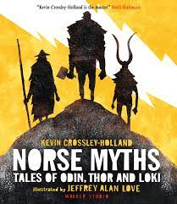

Throughout our exploration, children continue to learn about themselves and the world in which they live. In our science driver, they will learn about how electricity is generated, build their own circuits and test conductive and non-conductive materials. Through the history driver, we will be learning about the Vikings: where they came from, the reasons for their raids, how they lived and the impact that they left behind. In art, we will be exploring Celtic patterns and using these to create original patterns and prints.

What have you done today to make you feel proud?

In maths this half term, we are learning about fractions. Children will explore fractions in different representations, for example, fractions of shapes, quantities and fractions on a number line. They will explore and recap the meaning of numerator and denominator, non-unit and unit fractions as well as deepen their understanding of equivalent fractions. Not only will we count in fractions, but we will also learn how to add and subtract them.
We will then move on to working with tenths and hundredths as we build up to working with decimals.
All of our maths sessions explore these concepts through fluency, reasoning and problem solving.



