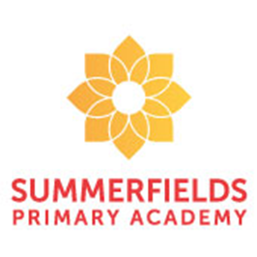

Miss Foster and Miss Hunter

Year 4 Italy Class
Our class novel to support our Explore unit is: “The Butterfly Lion” by Michael Morpurgo. As well as being read for enjoyment, part of the text will also be used to support our Guided Reading sessions. During this Explore, the children will be writing a narrative based on the journey of “Rosie the Raindrop” describing her adventure as part of the water cycle. Year 4 will also be writing an explanation text describing how a river is formed and the journey that it takes.

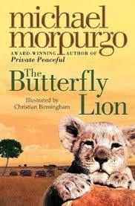

Throughout our exploration, children continue to learn about themselves and the world in which they live. In our science driver, they will learn about diversity within the natural world through the study of living things and their habitats. Through the geography driver, they will learn about the importance of water though the study of the water cycle, rivers, oceans, mountains and valleys along with life, which can be found there. They will also learn about man’s negative impact on the environment through plastic and pollution.

What on Earth is going on?

In maths this half term, we are continuing with our work on multiplication and division. We will be focusing on the skills of x and $÷by 10, 100 \& 100.$ We will then be reinforcing our understanding of written methods for X and ÷ by 2 and 3-digit numbers using a range of strategies. Following this, we will then be investigating how to calculate the perimeter of rectangles and rectilinear shapes. All our maths sessions explore these concepts through fluency, reasoning and problem solving.



