
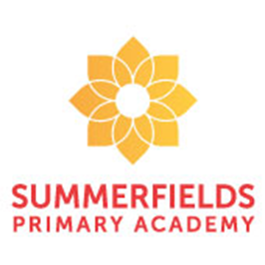
Miss Foster and Miss Hunter

Year 4 - Italy Class
Our class novel to support our Explore unit is, “The Iron Man” by Ted Hughes. As well as being read for enjoyment, part of the text will also be used to support our Guided Reading sessions. As a class, we will also be reading ‘Aunty Dot’s Incredible Adventures Atlas’ a beautiful book written as a series of postcards home from her travels. During this Explore, the children will be writing a narrative based on the journey of food as it travels through the human digestive system and a non- chronological report about the main tourist attractions in Italy.
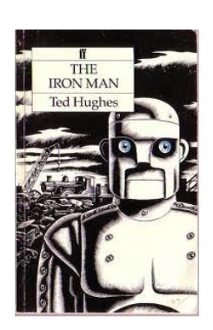

Throughout our exploration, children continue to learn about themselves and the world in which they live. In our science driver, they will learn about the human digestive system; how it works and how to care for it. Through the geography driver, they will learn about Italy: be able to locate it on a map of Europe, name its capital and major cities, research and discuss its physical features such as mountain ranges, main rivers and how the country contributes to the rest of the world all the while comparing it to the UK. The Children will also be leaning about Italy’s long and historically significant past, as well as its present-day culture through learning some Italian phrases and cooking some traditional Italian dishes. In Art, children will study the Italian artist Giuseppe Arcimboldo, who is famous for creating portraits using a variety of fruit and vegetables.

I Wonder…?

In maths this half term, we are reinforcing work on place value and the number system up to 10,000. To support this we will be looking at partitioning numbers in to Thousands, Hundreds, Tens and Ones; finding more then, less than a given number; rounding to the nearest 10, 100, 100; reading numbers on a number line; comparing and ordering numbers; Roman Numerals; adding and subtracting up to four 4-digit numbers. All our maths sessions explore these concepts through fluency, reasoning and problem solving.



