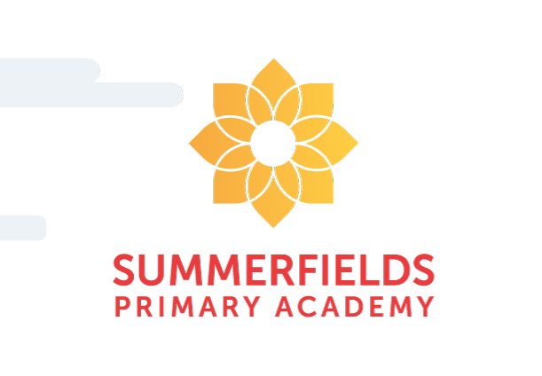
Summerfields Primary Academy

Early Years
2023-2024

‘Welcome to Early Years’
Meet the Staff



Miss S Foster (Mrs S Davis)
Teaching Assistant
Mrs K Haynes
Class Teacher



Mrs L Tabbner
Head Teacher
Mrs C Harris
Parent Support Adviser

Dear Teacher,

I know you’re rather busy
First day back, there’s just no time
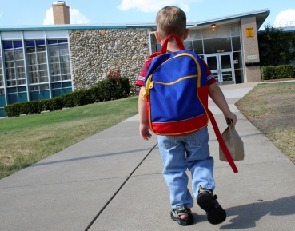
A whole new class of little ones
And this one here is mine.
I’m sure you have things covered
And have done this lots before
But my child is very little
They haven’t long turned four
In their uniform this morning
They looked so tall and steady
But now beside your great school
I’m not quite sure they’re ready
Do you help them eat their lunch?
Are you quick to soothe their fears?
And if they fall and hurt their knee
Will someone dry their tears?
And what if no-one plays with them?
What if someone’s mean?
What if two kids have a fight
And my child is caught in between?
You’re right, I have to leave now
It’s time for them to go
I’m sure they’ll lean so much from you
Things that I don’t know
Yes, I’m sure they settle quickly
That they’re fine now without me
I know they have to go to school
It’s just so fast , you see
It seems like just a blink ago
I held my baby in my arms
It’s been my job to love, to teach
To keep the safe from harm
So, when I wave goodbye in a moment
And they turn to walk inside
Forgive me if I crumple
Into tears of loss and pride
I know as I give one more kiss
And watch them walk away
That they’ll never again be wholly mine
As they were before today.

Dear Parent,

I understand that you are scared
To wave your child goodbye

And leave them in a teacher’s hand
Don’t worry if you cry!
I’m used to weeping parents
It’s hard to leave I know.
But it’s time to share them (just a bit)
To help them learn and grow.
Let me reassure you
That I’ll give your child my best
I’ll wipe their tears, soothe their fears
And change their dirty vest!
If your darling child is full of cold
I’ll blow their nose all day
Just like you, I’ll care for them
In a special way.
I’ll treat them like I would my own
I’ll catch them from a fall and
If there is ANY problem
I’ll be sure to tell you all.
It’s true they’ll grow to love us
They’ll talk of school a lot
It doesn’t mean they hate you
And that you should lose the plot!
I’ll tell you a secret.
That when your child is here
They talk to me as much of you
Of this please have no fear.
You’ll always be their adult
Whilst teachers come and go
To them you are their number one
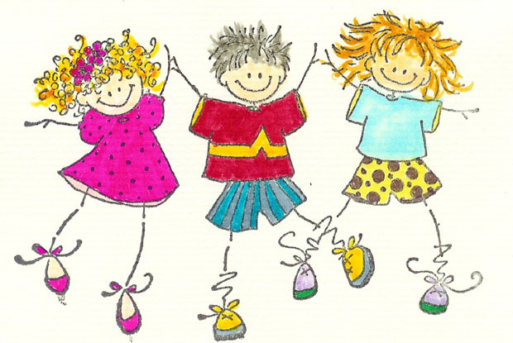
This I truly know.
Soon you’ll see some changes
In your little one
They’ll become more independent
And to see this, it’s a joy!
I’ll teach them all I have to give
To share, climb and to write
But to you they safely will return
To tuck them in at night.

With love from a teacher…

In the Early Years Foundation Stage (EYFS) there are 7 areas of learning which are spilt up into Prime Areas and Specific Areas.
The Prime Areas are;
- Personal, Social and Emotional Development
- Communication and Language
- Physical Development

The Specific Areas are;
- Literacy
- Mathematics
- Understanding the World
- Expressive Arts and Design

- Communication and language (CL) development involves giving children opportunities to experience a rich language environment; to develop their confidence and skills in expressing themselves; and to speak and listen in a range of situations.

- Physical development (PD) involves providing opportunities for young children to be active and interactive; and to develop their co-ordination, control, and movement. Children must also be helped to understand the importance of physical activity, and to make healthy choices in relation to food.

- Personal, social and emotional development (PSED) involves helping children to develop a positive sense of themselves, and others; to form positive relationships and develop respect for others; to develop social skills and learn how to manage their feelings; to understand appropriate behaviour in groups; and to have confidence in their own abilities.

- Literacy (L) development involves encouraging children to link sounds and letters and to begin to read and write. Children must be given access to a wide range of reading materials (books, poems, and other written materials) to ignite their interest.

- Mathematics (M) involves providing children with opportunities to develop and improve their skills in counting, understanding and using numbers, calculating simple addition and subtraction problems; and to describe shapes, spaces, and measures.

- Understanding the world (UW) involves guiding children to make sense of their physical world and their community through opportunities to explore, observe and find out about people, places, technology and the environment.

- Expressive arts and design (EAD) involves enabling children to explore and play with a wide range of media and materials, as well as providing opportunities and encouragement for sharing their thoughts, ideas and feelings through a variety of activities in art, music, movement, dance, role-play, and design and technology.

These 17 areas of learning will be delivered through a variety of focused activities and through play (planned and spontaneous), both inside and outside.

Your child will work with every member of the team as we feel it is important that every adult gets to know and work with every child to help them achieve their full potential.

Here we have tried to answer any questions that you may have but please feel free to ask any member of the EYFS team if there is ANYTHING that you are unsure of.

What will my child need?
In the Early Years your child will work and play outside so please provide a warm waterproof coat with your child’s name clearly labelled on it.
Your child will also need;
- A pair of wellies with their name in
- Full waterproofs to stay at school with their name in
- Gloves
- Hats – for winter and summer
- Sensible shoes they can fasten themselves (no laced shoes)
- On hot sunny days please put sun cream on your child at home in the morning which will protect them all day.
- A PE kit which consists of black shorts, a red t-shirt and pair of named black indoor pumps-they will come dressed in this on their PE day
- A clearly named water bottle
- A book bag. These can be bought from school if you wish. Please do not send your child with a rucksack as we do not have room to store them.
Please put your child’s name in every item of clothing

Will my child get a school dinner?
All children in Key Stage 1 (Reception, Year 1 and Year 2) are entitled to a free hot meal in school. If you do not wish your child to have a school dinner then you can provide a packed lunch for them. However, as we are a healthy school we do not allow juice, pop or sweets in their lunch boxes. If your child has ANY allergies please inform a member of the EYFS team.
Please see a copy of the lunch time menu that is included in your pack for examples of the meals on offer to your child.

You may be entitled to free school meals so please complete the online form at www.barnsley.gov.uk
If you find you are entitled to free school meals or claim benefits please visit the school office to inform them.

What uniform will my child need?
Our uniform consists of a charcoal grey jumper or cardigan, a white polo shirt and grey trousers, skirt or pinafore dress, your child will be given a red school tie. In summer red and white summer dresses or grey shorts can be worn. School ties can be purchased through school but logo is not essential on uniform. Please complete an order form and speak to the school office if you wish to order any uniform.
Please expect your child to come home ‘messy’ on occasions as they have access to creative materials and outdoors. We make every effort for your child to have fun when they are learning and this often results in mess.

Will my child get milk?
Your child will have free milk provided by school until the term your child turns 5. At the beginning of the term your child turns five, you will need to register and pay for their milk on www.schoolmilkuk.co.uk
Payment is made online and needs to be ordered termly once you start paying if your child wants to continue to have milk. If you are unsure of whether your child is entitled to milk then please ask at the school office.
.

Will my child get a snack?
Along with milk children in Early Years will get fruit. You do not need to pay for this. Children can bring a named water bottle to school which they have access to at all times when in class. Please note these bottles can only have water in them. You will need to take them home each night to clean and refill.
If your child has ANY allergies please inform a member of the EYFS team.

Where do I drop off and pick up my child?
Our school doors open at 8.25am. Children in Reception are dropped off at the gate near the main school entrance and a member of the team will be there if you have any messages or need to speak to someone. However, if you need to discuss anything at length or in confidence then please make an appointment to speak to a member of the team at a mutually convenient time. School finishes at 3pm and you pick your child up at the same gate. In Reception your child’s safety is of great importance so we let the children out one at a time, sending them to the adult who is collecting them. If we need to speak to you then we will keep your child to the back of the line. We ask that if you have several different people collecting your child that you set up a password. We also ask that if you have a regular collection routine for your child that you let us know who will be picking your child up on the different days, including arrangements with Child minders and Out of school clubs.

Will my child get homework?
We send books home for your child to read with you. At first, this will be telling stories using pictures and will progress to spotting sounds and words to eventually reading words and sentences. We also send handwriting books home for the children to rehearse their letter formation. Throughout each half term we will send challenges such as collecting conkers in Autumn or spotting signs of Spring. Our main aim is to engage the children in learning and encourage them to love their learning journey with us at school and you at home.

Will my child bring a reading book home?
We will be sending reading books home with your child once we have allocated every child with a book. Obviously, this doesn’t mean your child will be able to read the words in it. We will share more information on supporting your child’s reading through phonics in the first half term. It is important that you regularly share your child’s reading book with them and complete their school planner when they have read to you.

We will also complete this in school when we have heard your child read.
Your child will read once a week to an adult in school. This planner also has the consent for media, local visits and home/school agreements, please ensure that you have signed these.

When are the school holidays?
We have included a holiday list in your folder. This can also be viewed on the school website.
Will my child be assessed?
In EYFS we have focused activities which will be 1:1 or small groups with an adult. We also observe the children when they are in Provision. Our main aim is to interact with the children and have knowledge of what they can do and support their individual progress. We will report to you at parents evening and share an end of year report. We will keep you updated with photos and achievements on our class dojo page.
Is there a school website?
Yes! You can visit our website at www.summerfieldsacademy.co.uk where we regularly have updates, messages and photos. If you do not wish your child’s photos to appear on the website then you MUST ensure this is clear on your consent forms which you will receive.
Our main communication will be through class dojo, which we will set up in due course.

What do I do if my child is poorly?
If your child is poorly and is unable to come to school you must inform the school office of your child’s reason for absence as soon as possible. If your child is sick or has an episode of diarrhoea then they are to remain off school for 48 hours from the last episode.

What can I do over the holidays to support my child?
- Regular sharing of stories.
- Help your child to start to recognise their name.
- Spot words and letters wherever you go.
- Give your child access to tools for writing like sticks, paintbrushes, pens and pencils, chalk.
- Help your child to recognise digits 1 to 10
- Play counting games and sing counting songs, e.g ‘1, 2, 3, 4, 5 once I caught a fish alive.’
- Help your child to recognise 2D shapes, i.e. circles, squares, triangles.
- Encourage them to dress and undress independently.
- Encourage them to go to the toilet independently and clean themselves afterwards.
- Encourage them to use a knife and fork independently.
- Most of all have fun with your child and develop their confidence in having a go at things. They are more likely to do this is they feel good about themselves and are encouraged positively.

When will my child start school?
We know how important it is to support your child in their transition to school. We have planned this very carefully to ensure they have the time to get to know their new classroom with their parent/s so that when they do start, they have the confidence and security to succeed. Mrs Haynes is visiting your child in their Nursery setting to get to know them before they come to school. We will keep you updated of any changes.
- Tuesday 20th June 2023 – Parents Evening 5.00pm

- W.C: Monday 17th July 2023 – Nursery Visits
HOME VISITS: (only if deemed necessary)
- Induction Half Days – Wednesday 6th & Thursday 7th September 2023
Children come to school for one morning and one afternoon session and stay without their grown up. We offer your child a school dinner on one of the days AM session. (Your transition dates and enclosed in this pack).
- First Full Day of school – Friday 8th September 2023

