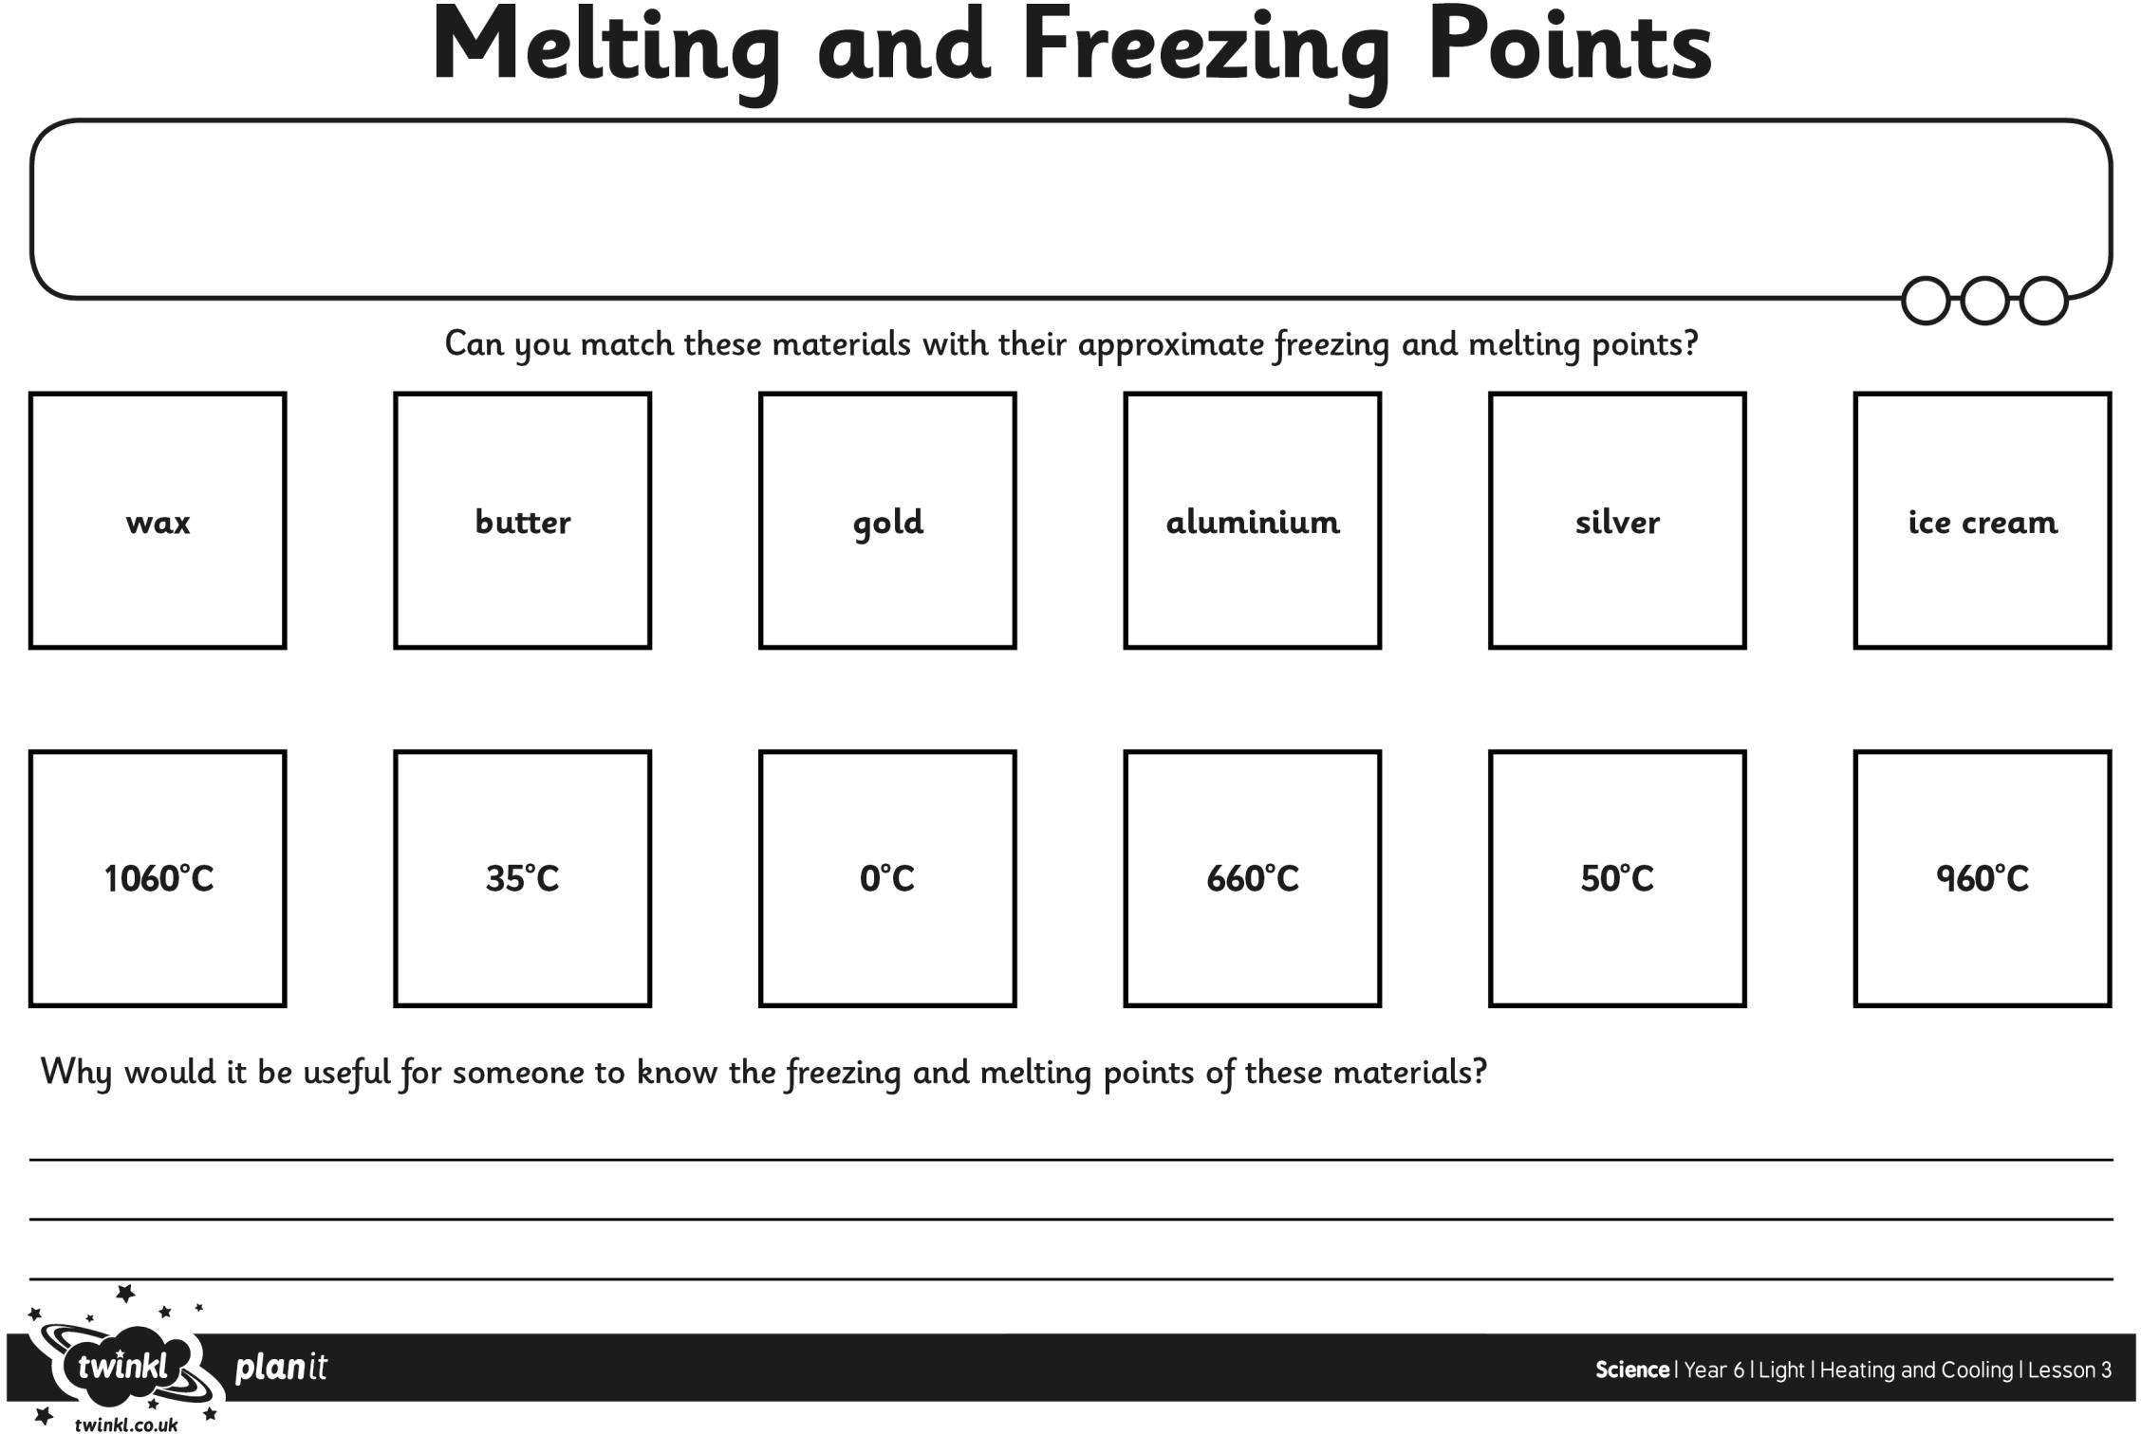

I can identify materials that melt at different temperatures.

Melting and Freezing Points Answers

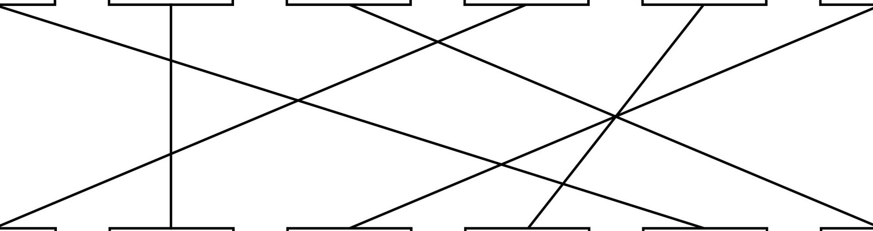butter gold a.luminium silver

ice crea.m

wa.x

35°c 0°C 660°C S0°C 

1060°C

-.If, twink l. c:o.uk *
it
plan
•

ScienceI Year 61Light I Heating and Cooling I Lesson 3

