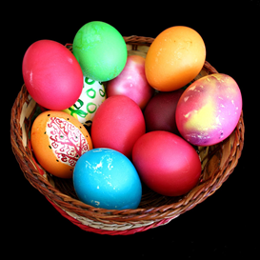CHOCOLATE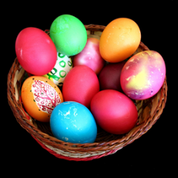
As you all know, like you I love chocolate. I thought I would set you some tasks based on something we all love! Enjoy xx
Design a new chocolate bar and create a new label for it. | What interesting recipes for chocolate can you find and make? | Where does chocolate come from? Research its story. | Learn about the rock cycle by making chocolate rocks –  http://www.sciencemadesimple.co.uk/curriculum-blogs/geology-blogs/geology-rocks-the-choc-cycle
Have a go at the chocolate based maths sheets on the website | Write 5 word problems involving chocolate. Remember to include +, -, x and division. | Read a book that involves chocolate and write a book review about it. | Thinking about Charlie and the Chocolate Factory  - Write a description of your chocolate factory  - Write a modern day version of the story  - Think about the ending, re write it as if one of the other characters had gone into the elevator, not Charlie.

