CHOCOLATE MATHS

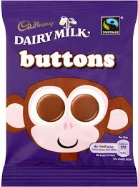
Buttons Mars Bar Heroes Creme Egg Fudge
50p 60p £2.50 40p 30p

1. 1 packet of Buttons and 1 Creme Egg.
2. 1 Fudge and 2 Creme Eggs.
3. 4 x Mars Bars
4. 2 x Fudge
5. 3 x Creme Eggs and 1 packet of buttons.
6. 2 x Heroes
7. 3 x Buttons
8. 1 Mars Bar and 2 x Fudges
9. 2 x Fudges and Heroes.
10. 1 of everything.

........................................................................................................................................................................................................................................................................................................................................

