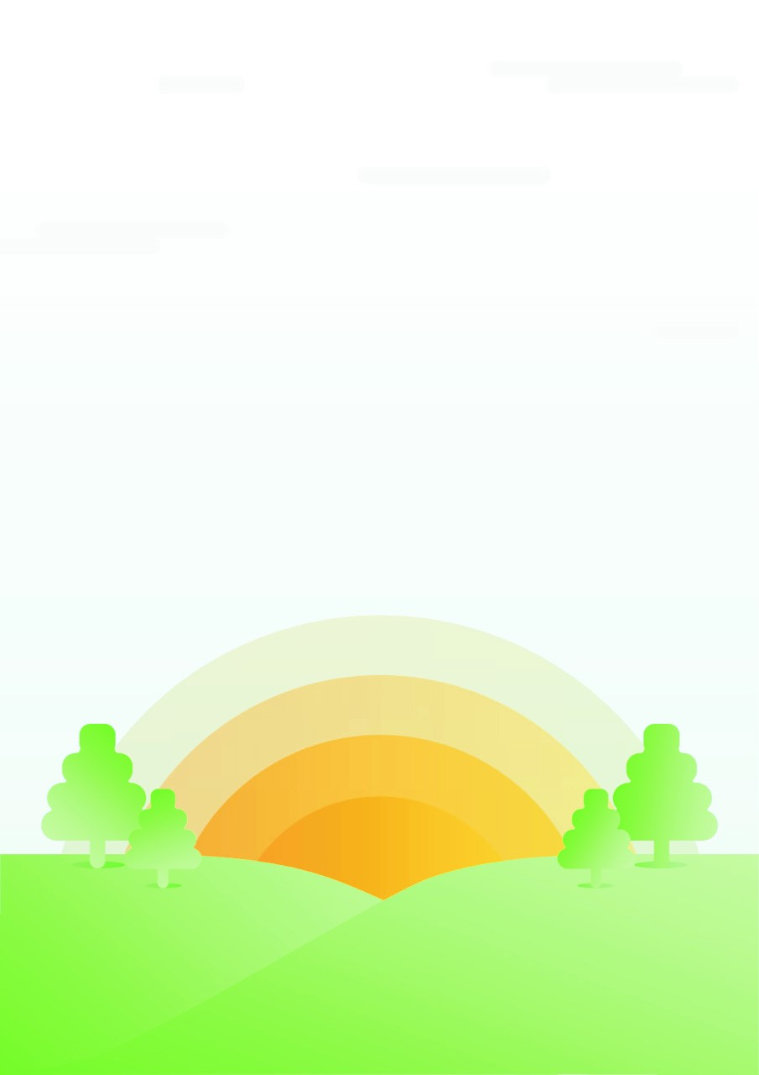
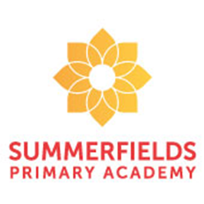
Mrs Wakefield, Mrs Yates and Mrs. Cuthbert
Year 2- Spain Class
In English this half term, we are looking at hospitals in the past and hospitals now and writing a comparative piece of writing. After that we will look at a famous nurse called Florence Nightingale and write a diary of a day in her life.
Can a person change the world?
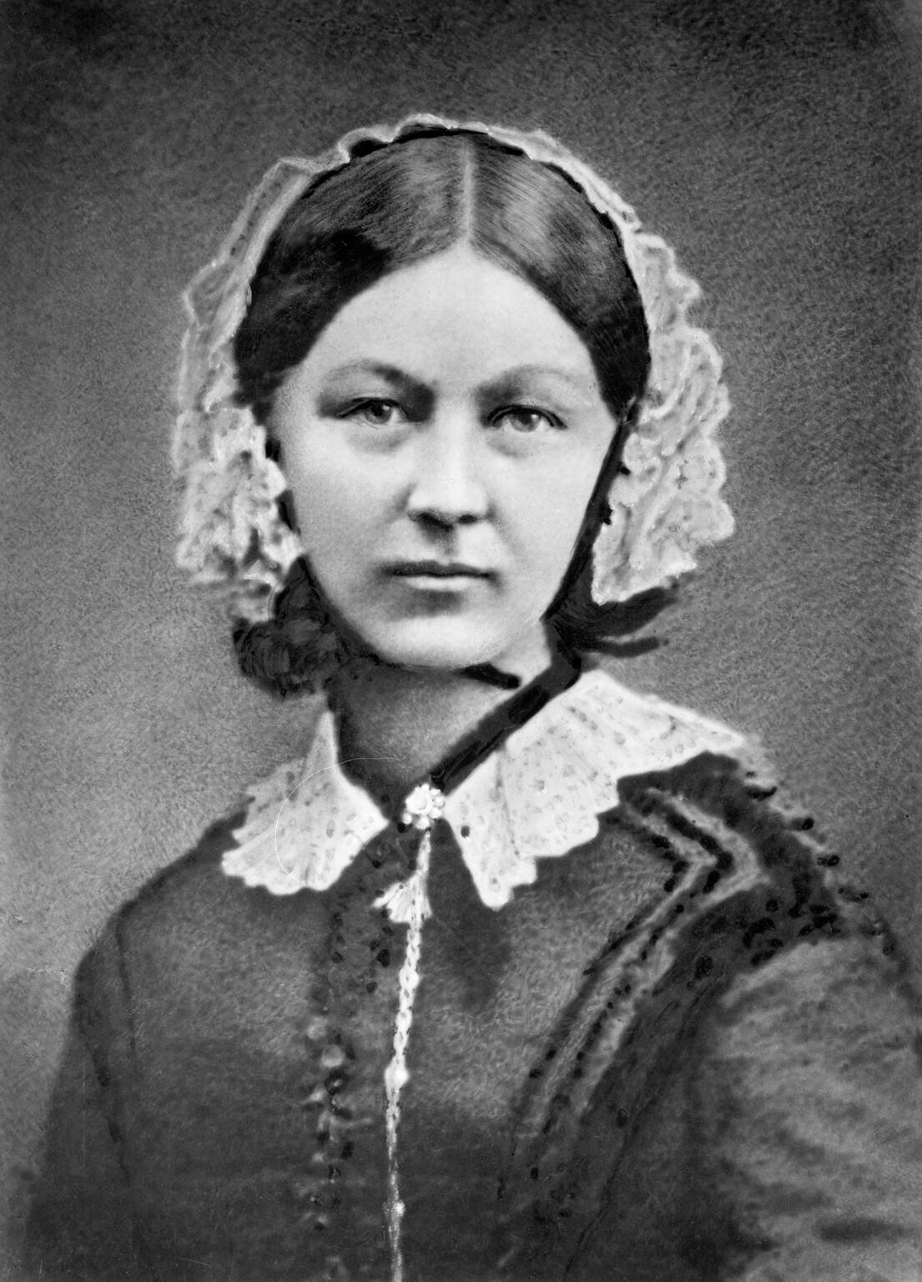

Our Explore will be History, DT and ICT.
Through DT we will be looking at cooking and nutrition and baking a festive surprise with Mrs. Snowden and creating a box for it to be placed in. As well as sewing with Mrs. Bates to make a festive decoration.
In ICT and art we will be working with Mrs. Cuthbert on our photography skills and using them to make a collage and some artwork based on remembrance. As well as using collage to create some lamps for the lady of the lamp.
In History we will be linking our explore with our literacy and looking at hospitals and medicines from the past and comparing them to modern day. As well as looking at Guy Fawkes, Florence Nightingale and thinking about World War one and how these changed the world.


In maths for this cycle, we will be looking at Addition and subtraction before moving onto multiplying and dividing.
This half term we will be introducing a weekly mental arithmetic test as well as looking at our multiplication tables and learning them in order, out of order and corresponding division facts too – keep an eye out for challenges coming home for us to practice.

